**HOROVOD:**

**4 node 512 batch size**

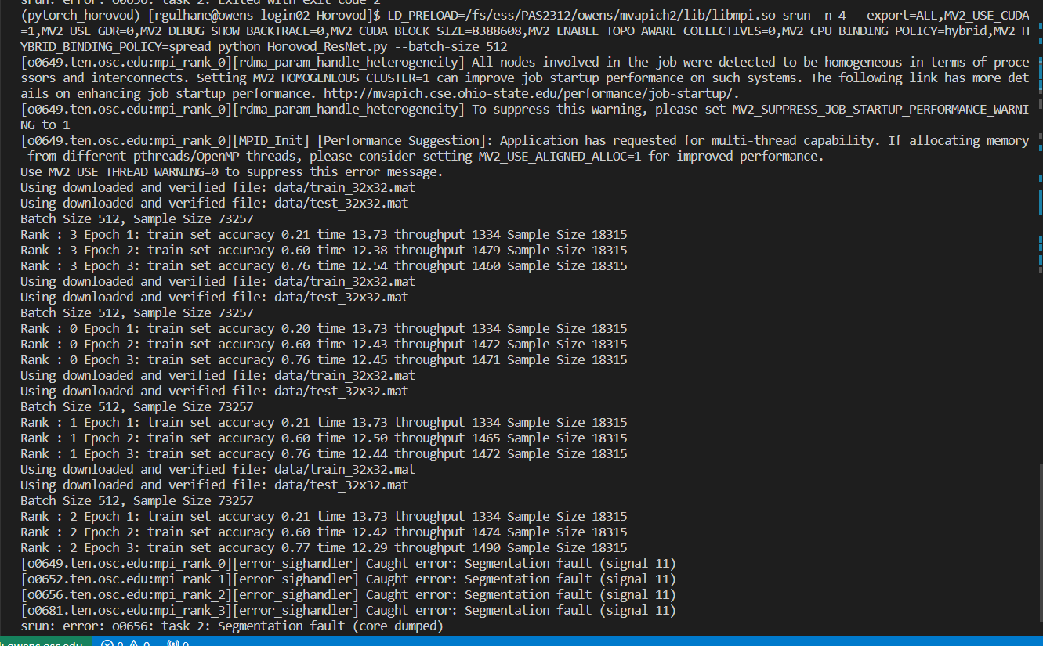

**4 node 128 batch size**

**2 node 512** **batch size**

**2 node 256 batch size**

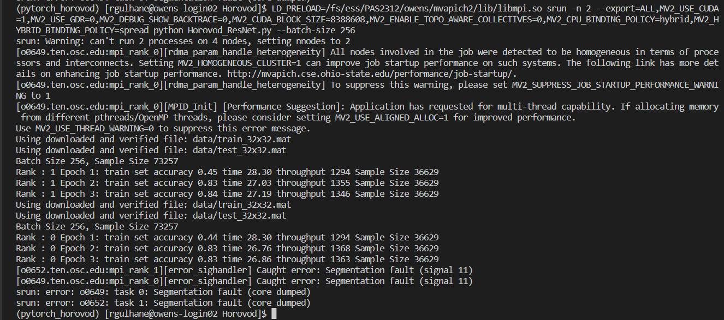

**1 node 512 batch size:**

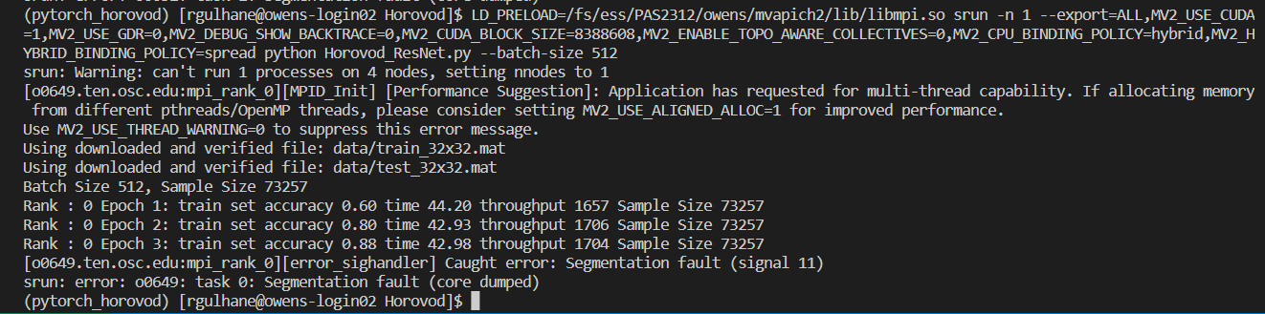

**PYTOCH DDP:**

**4 node 512 batch size**

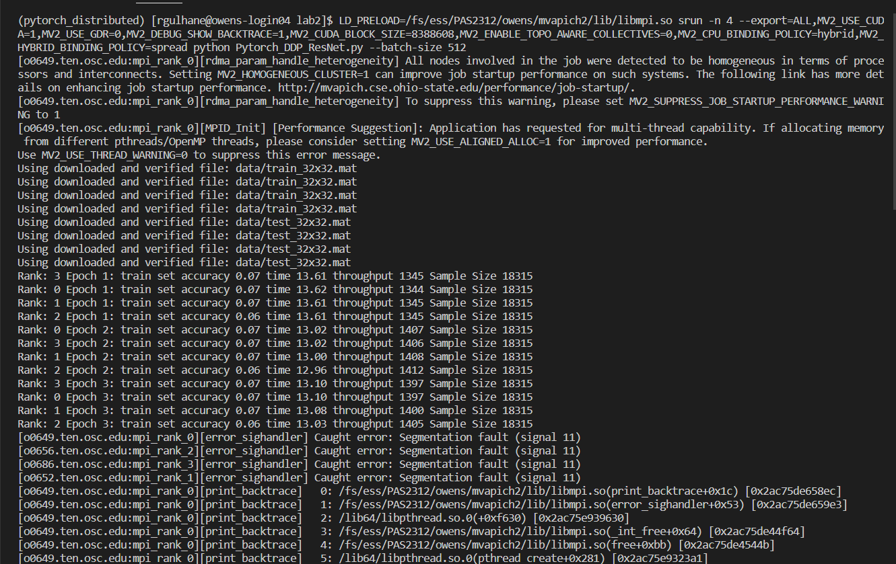

**4 node 128 batch size**

**2 node 512 batch size**

**2 node 256** **batch size**

**1 node 512 batch size**

