Regression Anlaysis of 'mtcars

Radha

22 November 2015

## Introduction :

As an exployee for Motor Trend, a magazine about the automobile industry, I analysed the 'mtcars' dataset (a data set 32 cars across 11 measures, captured between 1974-1975), to explore the relationship between a set of variables and miles per gallon (MPG) (outcome). I have tried to answer the following two questions: 1. "Is an automatic or manual transmission better for MPG" 2. "Quantify the MPG difference between automatic and manual transmissions"

## Executive Summary :

Following are the findings from the analysis: . The impact of manual vs. automatic transmission on MPG is statistically significant.

. Manual Transmission cars tend to have higher MPG than Automatic Transmission ones.

. However, as the car weight increases, with every 1000lb increase in weight, MPG for manual transmission cars falls faster than that for automatic transmission cars (all other factors remaining constant).

. At about 2800lb weight, the MPG for both Manual and Automatic Transmission cars is same (all other factors remaining constant).

. Below this weight, Manual Transmission Cars are better.

. Above this weight, Automatic Transmission Cars are better.

. Qsec (which indicates how fast car is driven) also impacts MPG in a significant way.

## Analysis and Data Processing

First, the library "datasets" was loaded, and then "mtcars" dataset was copied into another variable cars_data. Next, correlation between variables was checked (results shown in Table 1) and the following was observed. This could potentially help when adding / removing variables to the regression model:

* MPG seemed to be highly negatively correlated with Cyl, Disp, HP and WT
* Cyl seemed to be highly correlated with Disp, HP, WT and VS (negatively) To check the high-level impact of transmission type, a box plot was drawn (Figure

1. It indicated that the impact is significant visually. But the same was tested for statistical significance too (assuming normal distribution and IID), using a Welch 2-sample T-test. A p-value of 0.0013 indicated that the different in impact was > 0 at least 95% times.

Hence, manual transmission cars are better than automatic transmission cars in 95% cases.

On closer analysis, it would be proved that the result obtained about was merely a start. A regression analysis between mpg (outcome) and am (variable) would give R-square of 0.36 only. Which means there is scope for addition of more variable, as well as for interaction between few variables. Hence, more models were chosen. Following code snippet demonstrates the logic used when selecting / Rejecting models:

##   
## Call:  
## lm(formula = mpg ~ am + cyl, data = cars_data)  
##   
## Residuals:  
## Min 1Q Median 3Q Max   
## -5.6856 -1.7172 -0.2657 1.8838 6.8144   
##   
## Coefficients:  
## Estimate Std. Error t value Pr(>|t|)   
## (Intercept) 34.5224 2.6032 13.262 7.69e-14 ***  
## am 2.5670 1.2914 1.988 0.0564 .   
## cyl -2.5010 0.3608 -6.931 1.28e-07 ***  
## ---  
## Signif. codes: 0 '***' 0.001 '**' 0.01 '*' 0.05 '.' 0.1 ' ' 1  
##   
## Residual standard error: 3.059 on 29 degrees of freedom  
## Multiple R-squared: 0.759, Adjusted R-squared: 0.7424   
## F-statistic: 45.67 on 2 and 29 DF, p-value: 1.094e-09

##   
## Call:  
## lm(formula = mpg ~ am + disp, data = cars_data)  
##   
## Residuals:  
## Min 1Q Median 3Q Max   
## -4.6382 -2.4751 -0.5631 2.2333 6.8386   
##   
## Coefficients:  
## Estimate Std. Error t value Pr(>|t|)   
## (Intercept) 27.848081 1.834071 15.184 2.45e-15 ***  
## am 1.833458 1.436100 1.277 0.212   
## disp -0.036851 0.005782 -6.373 5.75e-07 ***  
## ---  
## Signif. codes: 0 '***' 0.001 '**' 0.01 '*' 0.05 '.' 0.1 ' ' 1  
##   
## Residual standard error: 3.218 on 29 degrees of freedom  
## Multiple R-squared: 0.7333, Adjusted R-squared: 0.7149   
## F-statistic: 39.87 on 2 and 29 DF, p-value: 4.749e-09

##   
## Call:  
## lm(formula = mpg ~ am + hp, data = cars_data)  
##   
## Residuals:  
## Min 1Q Median 3Q Max   
## -4.3843 -2.2642 0.1366 1.6968 5.8657   
##   
## Coefficients:  
## Estimate Std. Error t value Pr(>|t|)   
## (Intercept) 26.584914 1.425094 18.655 < 2e-16 ***  
## am 5.277085 1.079541 4.888 3.46e-05 ***  
## hp -0.058888 0.007857 -7.495 2.92e-08 ***  
## ---  
## Signif. codes: 0 '***' 0.001 '**' 0.01 '*' 0.05 '.' 0.1 ' ' 1  
##   
## Residual standard error: 2.909 on 29 degrees of freedom  
## Multiple R-squared: 0.782, Adjusted R-squared: 0.767   
## F-statistic: 52.02 on 2 and 29 DF, p-value: 2.55e-10

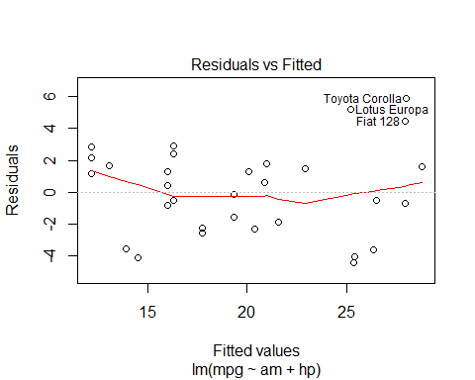 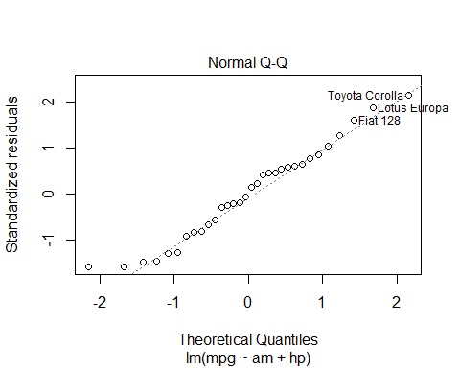 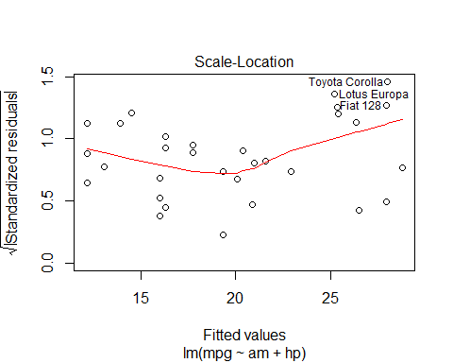 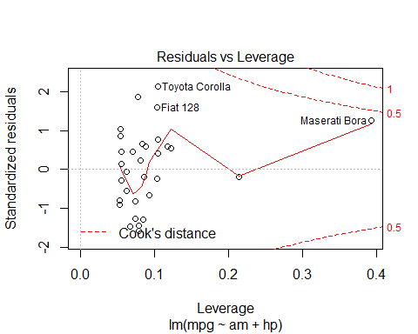

##   
## Call:  
## lm(formula = mpg ~ am + hp + drat, data = cars_data)  
##   
## Residuals:  
## Min 1Q Median 3Q Max   
## -4.0797 -1.6355 -0.2626 1.7048 5.8111   
##   
## Coefficients:  
## Estimate Std. Error t value Pr(>|t|)   
## (Intercept) 19.665041 5.687565 3.458 0.00176 **   
## am 3.974658 1.489316 2.669 0.01252 *   
## hp -0.054562 0.008508 -6.413 6.07e-07 ***  
## drat 1.894724 1.508615 1.256 0.21952   
## ---  
## Signif. codes: 0 '***' 0.001 '**' 0.01 '*' 0.05 '.' 0.1 ' ' 1  
##   
## Residual standard error: 2.881 on 28 degrees of freedom  
## Multiple R-squared: 0.7937, Adjusted R-squared: 0.7716   
## F-statistic: 35.9 on 3 and 28 DF, p-value: 9.877e-10

##   
## Call:  
## lm(formula = mpg ~ am + hp + qsec, data = cars_data)  
##   
## Residuals:  
## Min 1Q Median 3Q Max   
## -4.4560 -1.6704 0.2195 1.6448 5.5397   
##   
## Coefficients:  
## Estimate Std. Error t value Pr(>|t|)   
## (Intercept) 16.63207 11.16842 1.489 0.147612   
## am 5.98311 1.33813 4.471 0.000117 ***  
## hp -0.04912 0.01343 -3.659 0.001040 **   
## qsec 0.46130 0.51338 0.899 0.376552   
## ---  
## Signif. codes: 0 '***' 0.001 '**' 0.01 '*' 0.05 '.' 0.1 ' ' 1  
##   
## Residual standard error: 2.919 on 28 degrees of freedom  
## Multiple R-squared: 0.7881, Adjusted R-squared: 0.7654   
## F-statistic: 34.72 on 3 and 28 DF, p-value: 1.424e-09

##   
## Call:  
## lm(formula = mpg ~ am + hp + vs, data = cars_data)  
##   
## Residuals:  
## Min 1Q Median 3Q Max   
## -5.0175 -1.7433 0.1203 1.4900 5.5150   
##   
## Coefficients:  
## Estimate Std. Error t value Pr(>|t|)   
## (Intercept) 23.33420 2.23293 10.450 3.61e-11 ***  
## am 5.29854 1.03757 5.107 2.07e-05 ***  
## hp -0.04472 0.01078 -4.150 0.000281 ***  
## vs 2.65885 1.44247 1.843 0.075901 .   
## ---  
## Signif. codes: 0 '***' 0.001 '**' 0.01 '*' 0.05 '.' 0.1 ' ' 1  
##   
## Residual standard error: 2.796 on 28 degrees of freedom  
## Multiple R-squared: 0.8056, Adjusted R-squared: 0.7848   
## F-statistic: 38.68 on 3 and 28 DF, p-value: 4.31e-10

##   
## Call:  
## lm(formula = mpg ~ am + hp + gear, data = cars_data)  
##   
## Residuals:  
## Min 1Q Median 3Q Max   
## -3.975 -2.357 0.105 1.953 6.237   
##   
## Coefficients:  
## Estimate Std. Error t value Pr(>|t|)   
## (Intercept) 23.186368 3.898969 5.947 2.11e-06 ***  
## am 3.956119 1.777326 2.226 0.0342 *   
## hp -0.059737 0.007925 -7.537 3.28e-08 ***  
## gear 1.100938 1.175271 0.937 0.3569   
## ---  
## Signif. codes: 0 '***' 0.001 '**' 0.01 '*' 0.05 '.' 0.1 ' ' 1  
##   
## Residual standard error: 2.915 on 28 degrees of freedom  
## Multiple R-squared: 0.7887, Adjusted R-squared: 0.766   
## F-statistic: 34.83 on 3 and 28 DF, p-value: 1.377e-09

##   
## Call:  
## lm(formula = mpg ~ am + hp + carb, data = cars_data)  
##   
## Residuals:  
## Min 1Q Median 3Q Max   
## -4.5177 -2.6847 0.2868 1.9040 5.3248   
##   
## Coefficients:  
## Estimate Std. Error t value Pr(>|t|)   
## (Intercept) 26.34511 1.41173 18.662 < 2e-16 ***  
## am 5.88019 1.14459 5.137 1.91e-05 ***  
## hp -0.04491 0.01257 -3.573 0.0013 **   
## carb -0.73074 0.51838 -1.410 0.1697   
## ---  
## Signif. codes: 0 '***' 0.001 '**' 0.01 '*' 0.05 '.' 0.1 ' ' 1  
##   
## Residual standard error: 2.861 on 28 degrees of freedom  
## Multiple R-squared: 0.7965, Adjusted R-squared: 0.7747   
## F-statistic: 36.53 on 3 and 28 DF, p-value: 8.16e-10

##   
## Call:  
## lm(formula = mpg ~ am + hp + wt, data = cars_data)  
##   
## Residuals:  
## Min 1Q Median 3Q Max   
## -3.4221 -1.7924 -0.3788 1.2249 5.5317   
##   
## Coefficients:  
## Estimate Std. Error t value Pr(>|t|)   
## (Intercept) 34.002875 2.642659 12.867 2.82e-13 ***  
## am 2.083710 1.376420 1.514 0.141268   
## hp -0.037479 0.009605 -3.902 0.000546 ***  
## wt -2.878575 0.904971 -3.181 0.003574 **   
## ---  
## Signif. codes: 0 '***' 0.001 '**' 0.01 '*' 0.05 '.' 0.1 ' ' 1  
##   
## Residual standard error: 2.538 on 28 degrees of freedom  
## Multiple R-squared: 0.8399, Adjusted R-squared: 0.8227   
## F-statistic: 48.96 on 3 and 28 DF, p-value: 2.908e-11

##   
## Call:  
## lm(formula = mpg ~ am + wt, data = cars_data)  
##   
## Residuals:  
## Min 1Q Median 3Q Max   
## -4.5295 -2.3619 -0.1317 1.4025 6.8782   
##   
## Coefficients:  
## Estimate Std. Error t value Pr(>|t|)   
## (Intercept) 37.32155 3.05464 12.218 5.84e-13 ***  
## am -0.02362 1.54565 -0.015 0.988   
## wt -5.35281 0.78824 -6.791 1.87e-07 ***  
## ---  
## Signif. codes: 0 '***' 0.001 '**' 0.01 '*' 0.05 '.' 0.1 ' ' 1  
##   
## Residual standard error: 3.098 on 29 degrees of freedom  
## Multiple R-squared: 0.7528, Adjusted R-squared: 0.7358   
## F-statistic: 44.17 on 2 and 29 DF, p-value: 1.579e-09

The model, which made sense was the one with high R2, AM as a significant variable, homoscedasticity, and no variable insignificant. Since none of the variable combinations chosen had helped, interaction variables were introduced. Interaction between AM and WT seemed to be interesting, a seen from regression analysis, as well as by plotting on a graph.

##   
## Call:  
## lm(formula = mpg ~ am * wt, data = cars_data)  
##   
## Residuals:  
## Min 1Q Median 3Q Max   
## -3.6004 -1.5446 -0.5325 0.9012 6.0909   
##   
## Coefficients:  
## Estimate Std. Error t value Pr(>|t|)   
## (Intercept) 31.4161 3.0201 10.402 4.00e-11 ***  
## am 14.8784 4.2640 3.489 0.00162 **   
## wt -3.7859 0.7856 -4.819 4.55e-05 ***  
## am:wt -5.2984 1.4447 -3.667 0.00102 **   
## ---  
## Signif. codes: 0 '***' 0.001 '**' 0.01 '*' 0.05 '.' 0.1 ' ' 1  
##   
## Residual standard error: 2.591 on 28 degrees of freedom  
## Multiple R-squared: 0.833, Adjusted R-squared: 0.8151   
## F-statistic: 46.57 on 3 and 28 DF, p-value: 5.209e-11

##   
## Call:  
## lm(formula = mpg ~ wt * am, data = cars_data)  
##   
## Residuals:  
## Min 1Q Median 3Q Max   
## -3.6004 -1.5446 -0.5325 0.9012 6.0909   
##   
## Coefficients:  
## Estimate Std. Error t value Pr(>|t|)   
## (Intercept) 31.4161 3.0201 10.402 4.00e-11 ***  
## wt -3.7859 0.7856 -4.819 4.55e-05 ***  
## am 14.8784 4.2640 3.489 0.00162 **   
## wt:am -5.2984 1.4447 -3.667 0.00102 **   
## ---  
## Signif. codes: 0 '***' 0.001 '**' 0.01 '*' 0.05 '.' 0.1 ' ' 1  
##   
## Residual standard error: 2.591 on 28 degrees of freedom  
## Multiple R-squared: 0.833, Adjusted R-squared: 0.8151   
## F-statistic: 46.57 on 3 and 28 DF, p-value: 5.209e-11

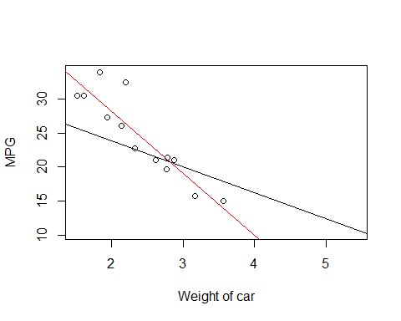

To see, if any other variable improved the R2, without compromising on the variable significance or homoscedasticity, multiple models were chosen. The results are as follows:

##   
## Call:  
## lm(formula = mpg ~ am * wt + cyl, data = cars_data)  
##   
## Residuals:  
## Min 1Q Median 3Q Max   
## -3.4621 -1.4913 -0.7879 1.3959 5.3499   
##   
## Coefficients:  
## Estimate Std. Error t value Pr(>|t|)   
## (Intercept) 34.2830 2.7965 12.259 1.52e-12 ***  
## am 11.9385 3.8453 3.105 0.00444 **   
## wt -2.3689 0.8244 -2.874 0.00782 **   
## cyl -1.1814 0.3803 -3.106 0.00442 **   
## am:wt -4.1974 1.3115 -3.200 0.00350 **   
## ---  
## Signif. codes: 0 '***' 0.001 '**' 0.01 '*' 0.05 '.' 0.1 ' ' 1  
##   
## Residual standard error: 2.265 on 27 degrees of freedom  
## Multiple R-squared: 0.877, Adjusted R-squared: 0.8588   
## F-statistic: 48.13 on 4 and 27 DF, p-value: 6.643e-12

##   
## Call:  
## lm(formula = mpg ~ am * wt + disp, data = cars_data)  
##   
## Residuals:  
## Min 1Q Median 3Q Max   
## -2.8556 -1.6062 -0.7542 1.6198 5.3870   
##   
## Coefficients:  
## Estimate Std. Error t value Pr(>|t|)   
## (Intercept) 28.83107 3.02619 9.527 3.97e-10 ***  
## am 15.01017 3.96925 3.782 0.000786 ***  
## wt -1.74592 1.14758 -1.521 0.139789   
## disp -0.01758 0.00762 -2.307 0.028987 *   
## am:wt -5.27454 1.34472 -3.922 0.000543 ***  
## ---  
## Signif. codes: 0 '***' 0.001 '**' 0.01 '*' 0.05 '.' 0.1 ' ' 1  
##   
## Residual standard error: 2.412 on 27 degrees of freedom  
## Multiple R-squared: 0.8605, Adjusted R-squared: 0.8399   
## F-statistic: 41.64 on 4 and 27 DF, p-value: 3.563e-11

##   
## Call:  
## lm(formula = mpg ~ am * wt + hp, data = cars_data)  
##   
## Residuals:  
## Min 1Q Median 3Q Max   
## -3.0639 -1.3315 -0.9347 1.2180 5.0822   
##   
## Coefficients:  
## Estimate Std. Error t value Pr(>|t|)   
## (Intercept) 30.947333 2.723411 11.363 8.55e-12 ***  
## am 11.554813 4.023277 2.872 0.00784 **   
## wt -2.515586 0.844497 -2.979 0.00605 **   
## hp -0.026949 0.009796 -2.751 0.01048 *   
## am:wt -3.577910 1.442796 -2.480 0.01968 *   
## ---  
## Signif. codes: 0 '***' 0.001 '**' 0.01 '*' 0.05 '.' 0.1 ' ' 1  
##   
## Residual standard error: 2.332 on 27 degrees of freedom  
## Multiple R-squared: 0.8696, Adjusted R-squared: 0.8503   
## F-statistic: 45.01 on 4 and 27 DF, p-value: 1.451e-11

##   
## Call:  
## lm(formula = mpg ~ am * wt + drat, data = cars_data)  
##   
## Residuals:  
## Min 1Q Median 3Q Max   
## -4.1982 -1.4632 -0.6669 0.9714 6.1346   
##   
## Coefficients:  
## Estimate Std. Error t value Pr(>|t|)   
## (Intercept) 25.9354 6.3628 4.076 0.000362 ***  
## am 13.9149 4.3793 3.177 0.003703 **   
## wt -3.5119 0.8346 -4.208 0.000255 ***  
## drat 1.3535 1.3827 0.979 0.336349   
## am:wt -5.1731 1.4514 -3.564 0.001385 **   
## ---  
## Signif. codes: 0 '***' 0.001 '**' 0.01 '*' 0.05 '.' 0.1 ' ' 1  
##   
## Residual standard error: 2.593 on 27 degrees of freedom  
## Multiple R-squared: 0.8388, Adjusted R-squared: 0.8149   
## F-statistic: 35.11 on 4 and 27 DF, p-value: 2.464e-10

##   
## Call:  
## lm(formula = mpg ~ am * wt + qsec, data = cars_data)  
##   
## Residuals:  
## Min 1Q Median 3Q Max   
## -3.5076 -1.3801 -0.5588 1.0630 4.3684   
##   
## Coefficients:  
## Estimate Std. Error t value Pr(>|t|)   
## (Intercept) 9.723 5.899 1.648 0.110893   
## am 14.079 3.435 4.099 0.000341 ***  
## wt -2.937 0.666 -4.409 0.000149 ***  
## qsec 1.017 0.252 4.035 0.000403 ***  
## am:wt -4.141 1.197 -3.460 0.001809 **   
## ---  
## Signif. codes: 0 '***' 0.001 '**' 0.01 '*' 0.05 '.' 0.1 ' ' 1  
##   
## Residual standard error: 2.084 on 27 degrees of freedom  
## Multiple R-squared: 0.8959, Adjusted R-squared: 0.8804   
## F-statistic: 58.06 on 4 and 27 DF, p-value: 7.168e-13

##   
## Call:  
## lm(formula = mpg ~ am * wt + vs, data = cars_data)  
##   
## Residuals:  
## Min 1Q Median 3Q Max   
## -3.6148 -1.6820 -0.7623 1.2926 5.1013   
##   
## Coefficients:  
## Estimate Std. Error t value Pr(>|t|)   
## (Intercept) 26.2539 3.3458 7.847 1.95e-08 ***  
## am 14.3204 3.8658 3.704 0.000962 ***  
## wt -2.7026 0.8183 -3.303 0.002703 **   
## vs 2.9297 1.0945 2.677 0.012487 *   
## am:wt -4.6634 1.3292 -3.508 0.001599 **   
## ---  
## Signif. codes: 0 '***' 0.001 '**' 0.01 '*' 0.05 '.' 0.1 ' ' 1  
##   
## Residual standard error: 2.346 on 27 degrees of freedom  
## Multiple R-squared: 0.8681, Adjusted R-squared: 0.8485   
## F-statistic: 44.41 on 4 and 27 DF, p-value: 1.698e-11

##   
## Call:  
## lm(formula = mpg ~ am * wt + gear, data = cars_data)  
##   
## Residuals:  
## Min 1Q Median 3Q Max   
## -3.4521 -1.7682 -0.4178 0.9777 6.3028   
##   
## Coefficients:  
## Estimate Std. Error t value Pr(>|t|)   
## (Intercept) 28.9679 5.2368 5.532 7.33e-06 ***  
## am 14.9125 4.3163 3.455 0.001834 **   
## wt -3.6775 0.8172 -4.500 0.000117 ***  
## gear 0.6353 1.1034 0.576 0.569540   
## am:wt -5.5608 1.5317 -3.631 0.001166 **   
## ---  
## Signif. codes: 0 '***' 0.001 '**' 0.01 '*' 0.05 '.' 0.1 ' ' 1  
##   
## Residual standard error: 2.623 on 27 degrees of freedom  
## Multiple R-squared: 0.8351, Adjusted R-squared: 0.8106   
## F-statistic: 34.17 on 4 and 27 DF, p-value: 3.333e-10

##   
## Call:  
## lm(formula = mpg ~ am * wt + carb, data = cars_data)  
##   
## Residuals:  
## Min 1Q Median 3Q Max   
## -3.4928 -1.3574 -0.5405 1.4872 5.2298   
##   
## Coefficients:  
## Estimate Std. Error t value Pr(>|t|)   
## (Intercept) 30.8833 2.9720 10.392 6.19e-11 ***  
## am 13.0145 4.3429 2.997 0.00579 **   
## wt -3.1781 0.8652 -3.673 0.00104 **   
## carb -0.6423 0.4216 -1.523 0.13931   
## am:wt -4.1334 1.6056 -2.574 0.01585 *   
## ---  
## Signif. codes: 0 '***' 0.001 '**' 0.01 '*' 0.05 '.' 0.1 ' ' 1  
##   
## Residual standard error: 2.532 on 27 degrees of freedom  
## Multiple R-squared: 0.8463, Adjusted R-squared: 0.8235   
## F-statistic: 37.15 on 4 and 27 DF, p-value: 1.307e-10

Only the model with interaction between AM and WT, and with QSEC added made sense. The results on running that model are shown in Table 3. Its plots are shown in Figure 2. Following are the takeaway from this model: - The model explains 90% of the results - Increase in WT decreases MPG of the car - Manual Transmission is better than Automatic Transmission - But with increase in WT, manual tranmission car's performance starts to decrease (by a factor of 4.141) per 1000lb increase in WT - There is no heteroscedasticity or outlier in the residual plot

ANOVA analysis of model with and without interaction indicates significant different (since P < 0.05). VIF analysis of the 2 models indicates an increase in variance in the model with interaction, as compared to the one without interaction, but given all other benefits seem from the model, we can live with this variance. Detailed results for ANOVA and VIF analysis are shown in Table 4.

## Appendix

Table 1

## mpg cyl disp hp drat wt qsec vs am gear carb  
## Mazda RX4 21.0 6 160 110 3.90 2.620 16.46 0 1 4 4  
## Mazda RX4 Wag 21.0 6 160 110 3.90 2.875 17.02 0 1 4 4  
## Datsun 710 22.8 4 108 93 3.85 2.320 18.61 1 1 4 1  
## Hornet 4 Drive 21.4 6 258 110 3.08 3.215 19.44 1 0 3 1  
## Hornet Sportabout 18.7 8 360 175 3.15 3.440 17.02 0 0 3 2  
## Valiant 18.1 6 225 105 2.76 3.460 20.22 1 0 3 1

## mpg cyl disp hp drat wt qsec vs am gear carb  
## mpg 1.00 -0.85 -0.85 -0.78 0.68 -0.87 0.42 0.66 0.60 0.48 -0.55  
## cyl -0.85 1.00 0.90 0.83 -0.70 0.78 -0.59 -0.81 -0.52 -0.49 0.53  
## disp -0.85 0.90 1.00 0.79 -0.71 0.89 -0.43 -0.71 -0.59 -0.56 0.39  
## hp -0.78 0.83 0.79 1.00 -0.45 0.66 -0.71 -0.72 -0.24 -0.13 0.75  
## drat 0.68 -0.70 -0.71 -0.45 1.00 -0.71 0.09 0.44 0.71 0.70 -0.09  
## wt -0.87 0.78 0.89 0.66 -0.71 1.00 -0.17 -0.55 -0.69 -0.58 0.43  
## qsec 0.42 -0.59 -0.43 -0.71 0.09 -0.17 1.00 0.74 -0.23 -0.21 -0.66  
## vs 0.66 -0.81 -0.71 -0.72 0.44 -0.55 0.74 1.00 0.17 0.21 -0.57  
## am 0.60 -0.52 -0.59 -0.24 0.71 -0.69 -0.23 0.17 1.00 0.79 0.06  
## gear 0.48 -0.49 -0.56 -0.13 0.70 -0.58 -0.21 0.21 0.79 1.00 0.27  
## carb -0.55 0.53 0.39 0.75 -0.09 0.43 -0.66 -0.57 0.06 0.27 1.00

Figure 1

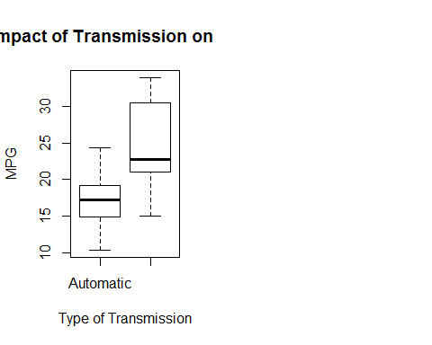 Table 2

## Estimate Std. Error t value Pr(>|t|)  
## (Intercept) 9.723053 5.8990407 1.648243 0.1108925394  
## amManual 14.079428 3.4352512 4.098515 0.0003408693  
## wt -2.936531 0.6660253 -4.409038 0.0001488947  
## qsec 1.016974 0.2520152 4.035366 0.0004030165  
## amManual:wt -4.141376 1.1968119 -3.460340 0.0018085763

## [1] "R square:"

## [1] 0.8958514

Figure 2

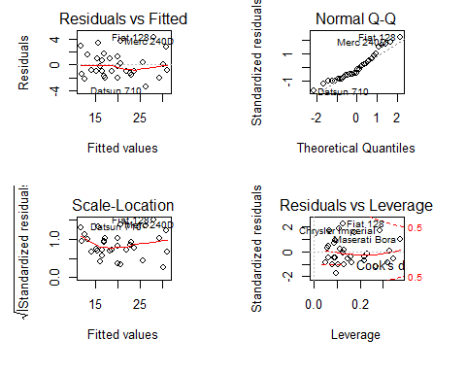

Table 3

## Analysis of Variance Table  
##   
## Model 1: mpg ~ am * wt + qsec  
## Model 2: mpg ~ am + wt + qsec  
## Res.Df RSS Df Sum of Sq F Pr(>F)   
## 1 27 117.28   
## 2 28 169.29 -1 -52.01 11.974 0.001809 **  
## ---  
## Signif. codes: 0 '***' 0.001 '**' 0.01 '*' 0.05 '.' 0.1 ' ' 1