**LINUX FILE SYSTEM**

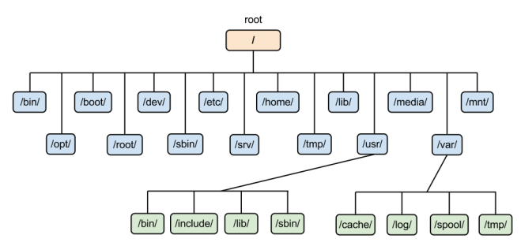

The Linux file system organizes and manages files and directories on a storage device. It follows a hierarchical structure, starting from the root directory (/). The file system is case-sensitive and supports a variety of file types, permissions, and attributes.

**The Hierarchical Structure of the Linux File System**

**The Linux file system is organized in a hierarchical structure, with the root directory (/) at the top. Here’s a brief explanation of some key directories:**

1. **/bin**
   * **Contains essential user binaries (executables) that are necessary for system booting and basic operations, such as commands like ls, cp, and mv.**
2. **/boot**
   * **Holds files required for booting the system, including the Linux kernel, initial RAM disk images, and boot loader configuration files.**
3. **/etc**
   * **Contains system-wide configuration files and directories. This is where settings for system services, user accounts, and system configurations are stored.**
4. **/home**
   * **The home directory for users. Each user has a subdirectory (e.g., /home/username) to store personal files, settings, and configurations.**
5. **/lib**
   * **Contains essential shared libraries and kernel modules required for the binaries in /bin and /sbin to run.**
6. **/media**
   * **A mount point for removable media like USB drives and CDs. Devices are automatically mounted here when inserted.**
7. **/mnt**
   * **A temporary mount point for mounting filesystems manually, often used by system administrators.**
8. **/opt**
   * **Contains optional software packages and applications that are not part of the default installation.**
9. **/root**
   * **The home directory for the root user (administrator). It is separate from /home for regular users.**
10. **/sbin**
    * **Contains system binaries that are typically used by the system administrator for system maintenance and configuration, such as shutdown and ifconfig.**
11. **/tmp**
    * **A temporary directory for storing transient files created by applications. Files here are usually deleted on reboot.**
12. **/usr**
    * **Contains user-related programs and data. It has its own subdirectories, such as /usr/bin for user binaries and /usr/lib for libraries.**
13. **/var**
    * **Stores variable data files, such as logs, databases, and spool files. The contents of this directory can change frequently.**