Kubernetes-01

- Setup Minikube in your local machine.
Install Docker on windows:
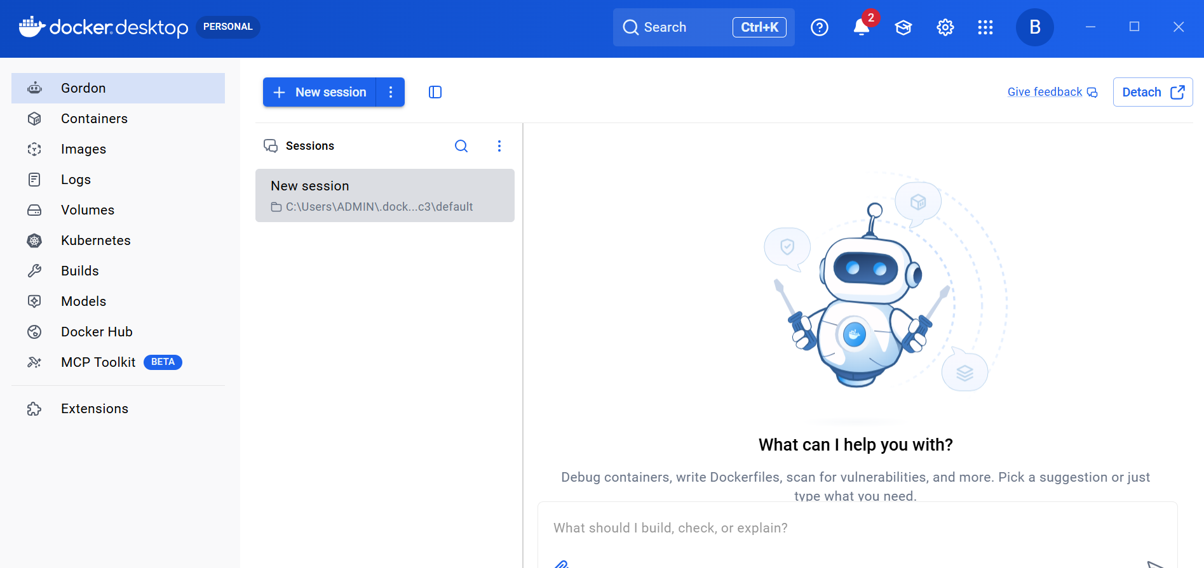
Install Oracle box on windows:
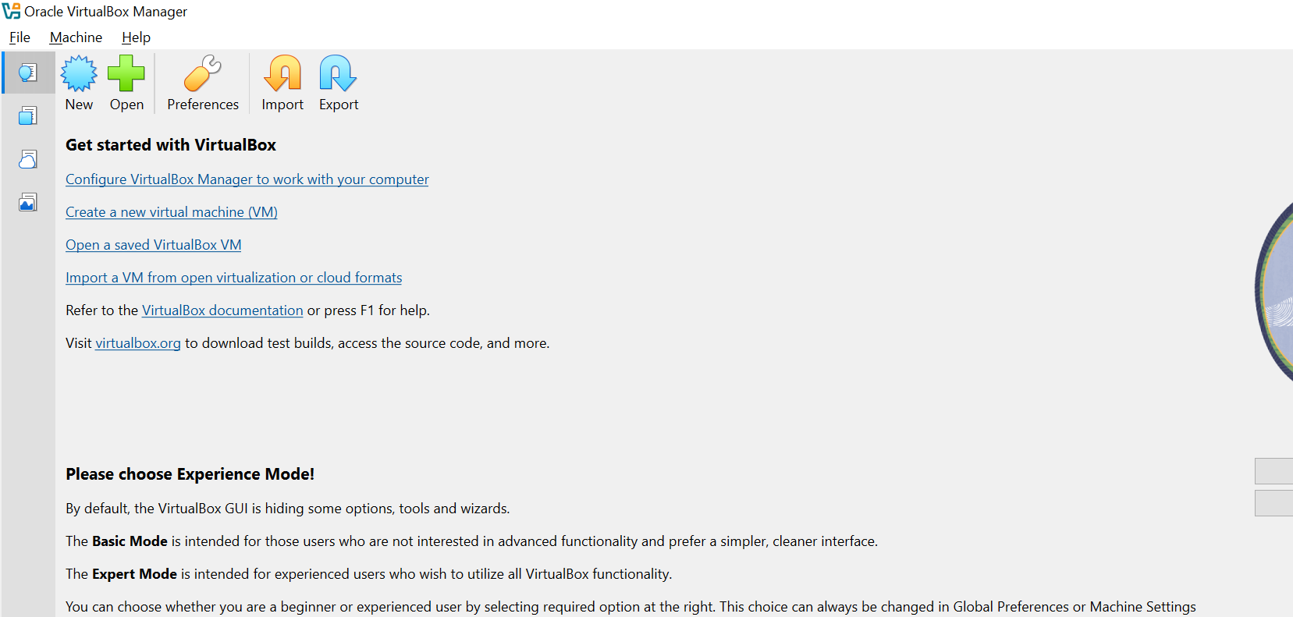
Check system info in CMD
Systeminfo
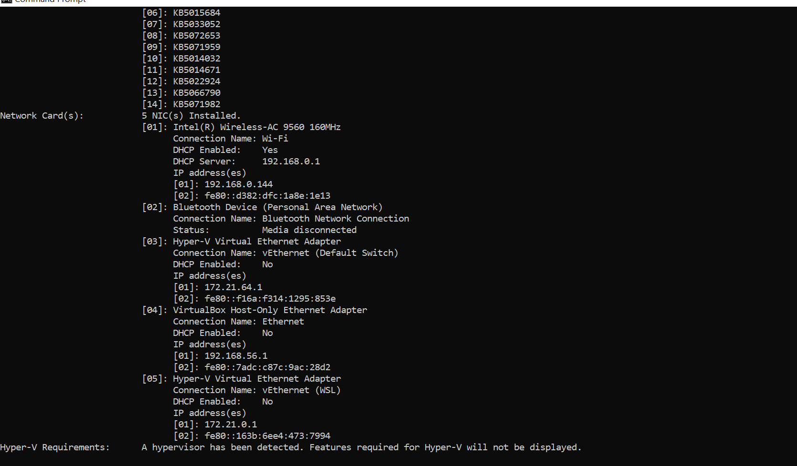
Install Minikube using powershell:
New-Item -Path 'c:\' -Name 'minikube' -ItemType Directory -Force
$ProgressPreference = 'SilentlyContinue'; Invoke-WebRequest -OutFile 'c:\minikube\minikube.exe' -Uri 'https://github.com/kubernetes/minikube/releases/latest/download/minikube-windows-amd64.exe' -UseBasicParsing
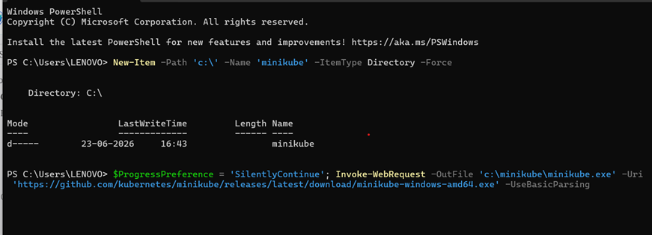

$oldPath = [Environment]::GetEnvironmentVariable('Path', [EnvironmentVariableTarget]::Machine)
if ($oldPath.Split(';') -inotcontains 'C:\minikube'){
[Environment]::SetEnvironmentVariable('Path', $('{0};C:\minikube' -f $oldPath), [EnvironmentVariableTarget]::Machine)
}
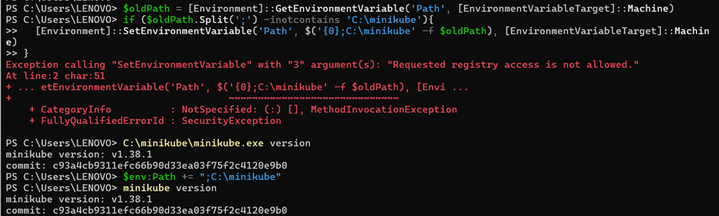

Set the minikube path to environmental variable:
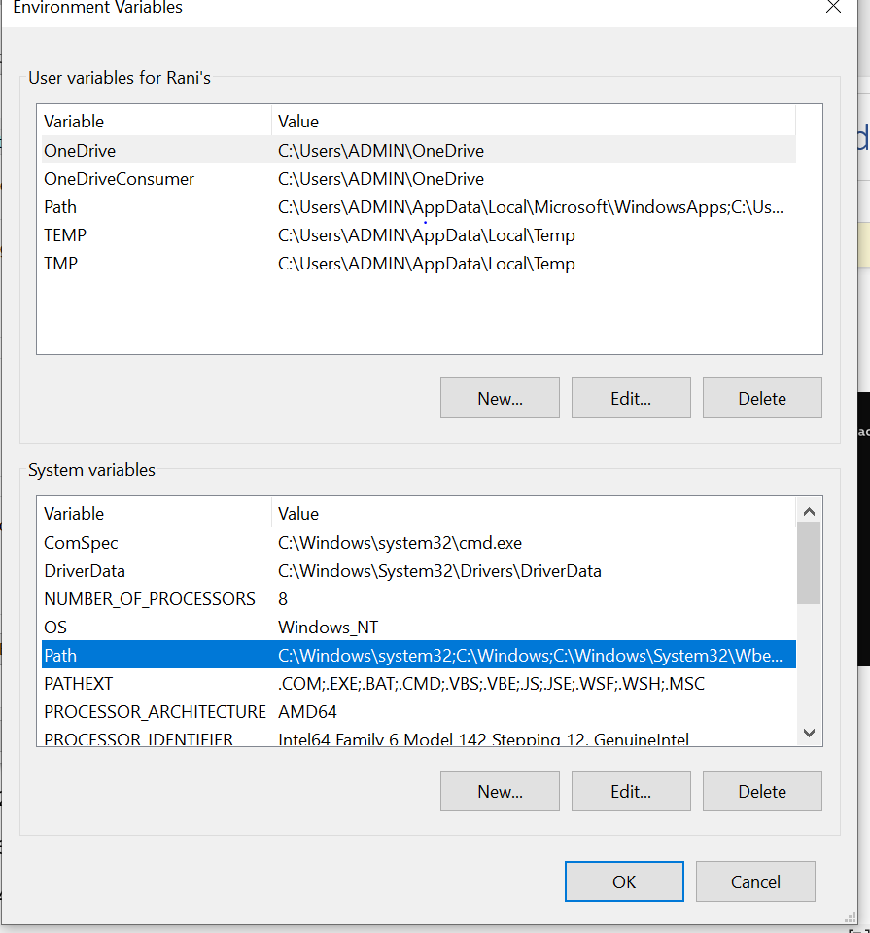
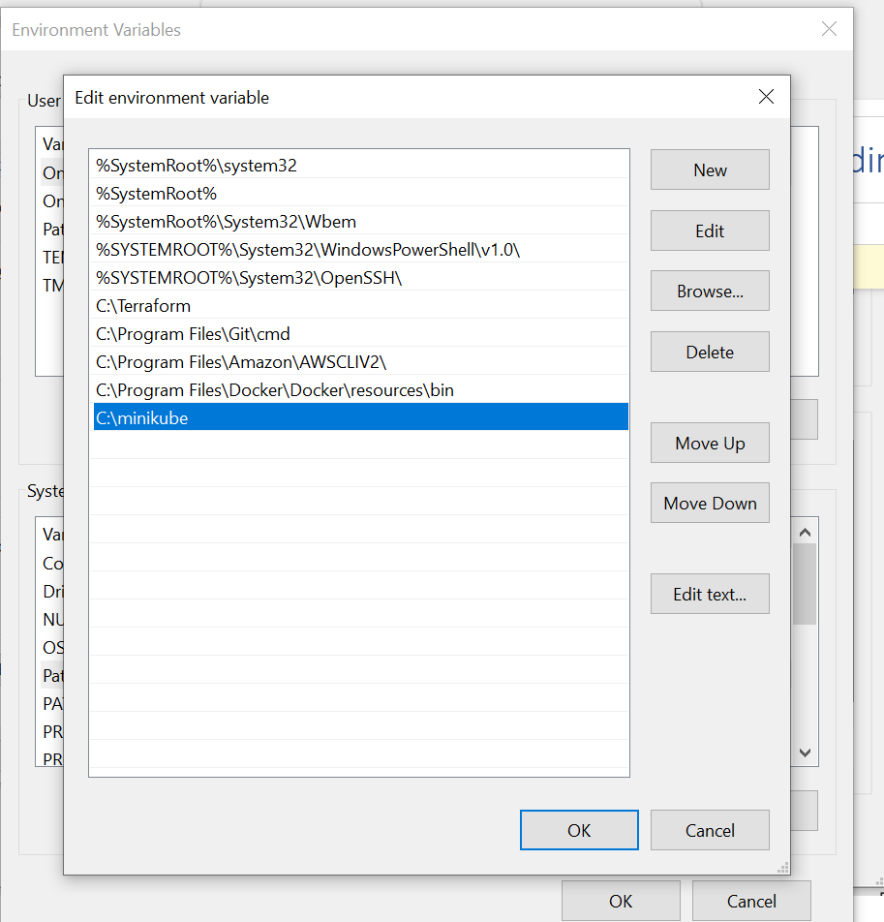

Start the minikube:
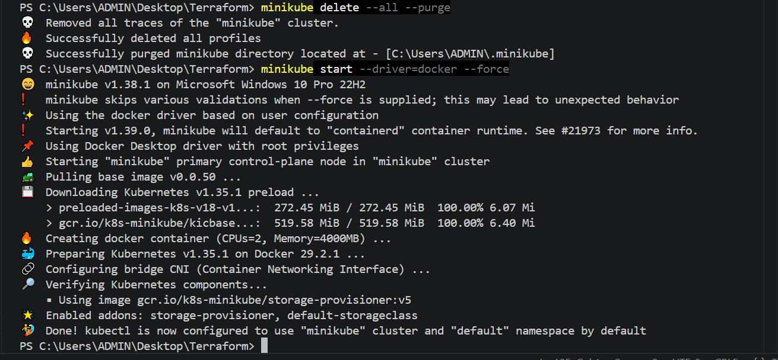
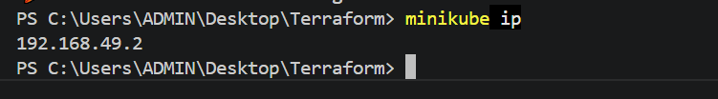

- Setup k8s master and two worker nodes on ubuntu.
Launch 3 instances:
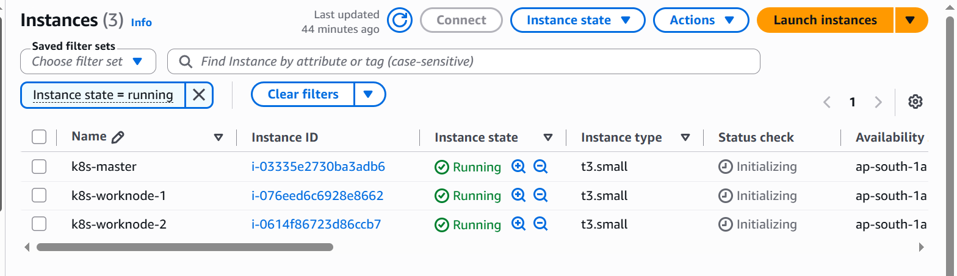

Install docker in master and worker nodes:
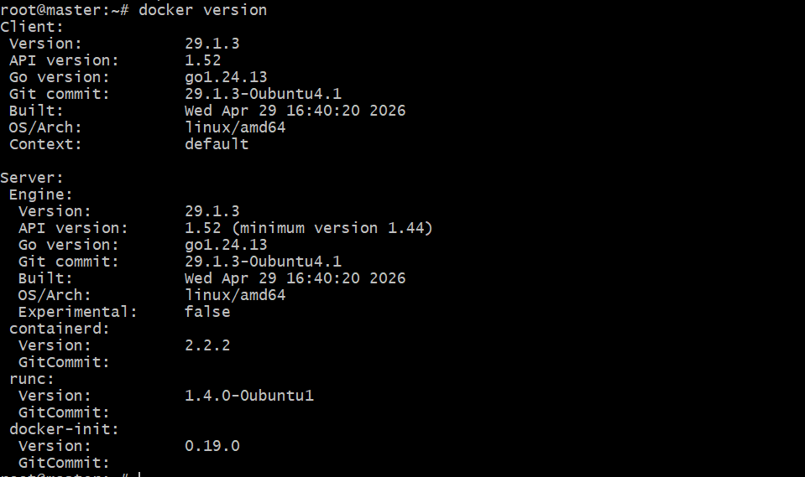
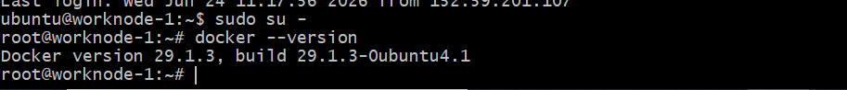
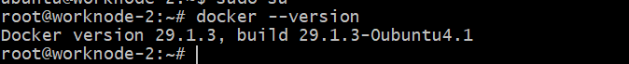
To setup k8s cluster we have different tools like kops and kubeadm.:
https://kubernetes.io/docs/setup/production-environment/tools/kubeadm/install-kubeadm/
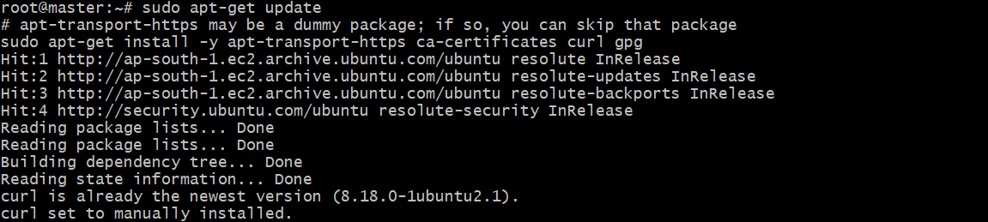
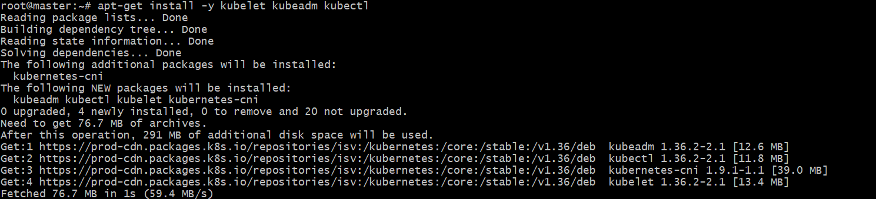
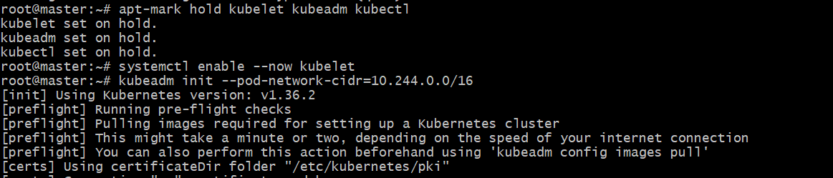
Follow the same steps in work nodes as well.

TO configure master, we need to initialize with CIDR:
kubeadm init --pod-network-cidr=10.244.0.0/16
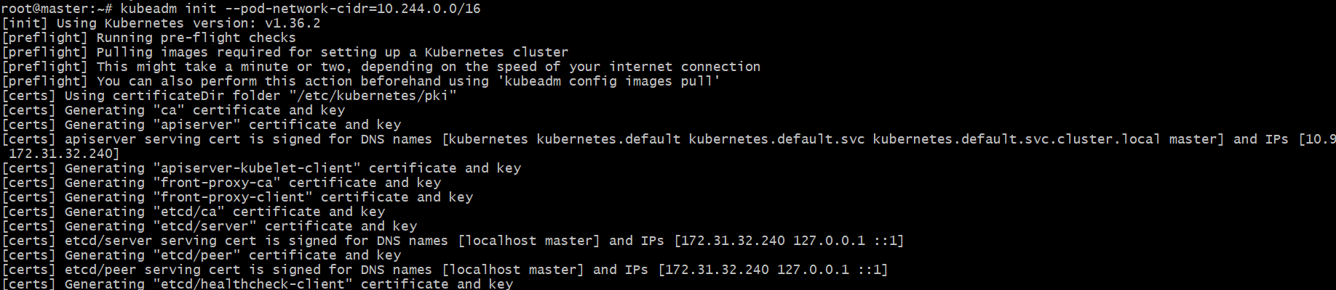
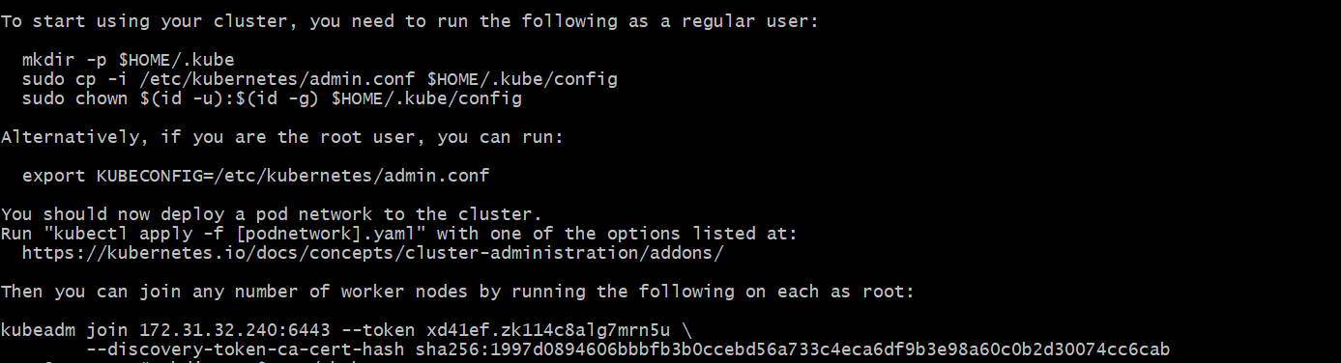
Run 3 commands and execute the kubectl get nodes :
If we execute kubectl get nodes we can see the status as notready because we haven't installed flannel
workernode-01:
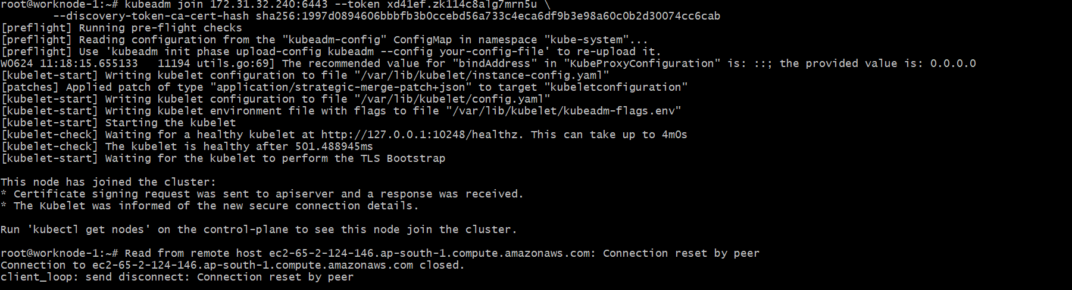
Worknode-2
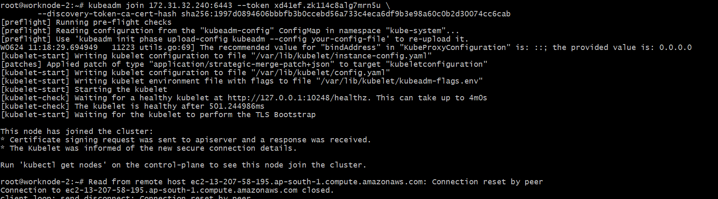
Connect successfully and check n the master server :
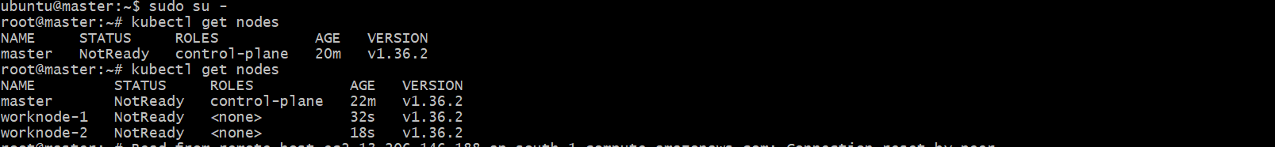
Install Flannel and check the status of nodes:
kubectl apply -f https://github.com/flannel-io/flannel/releases/latest/download/kube-flannel.yml

Now execute command kubectl get nodes in master server:
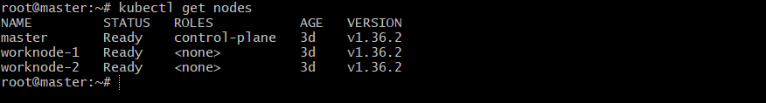
- Run one nginx pod.
To run one NGINX Pod in Kubernetes, use the following command:
kubectl run nginx --image=nginx --restart=Never
Verify the Pod:
Kubectl get pods
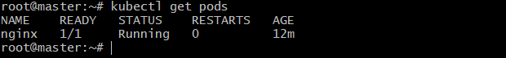
Describe the Pod:
kubectl describe pod nginx
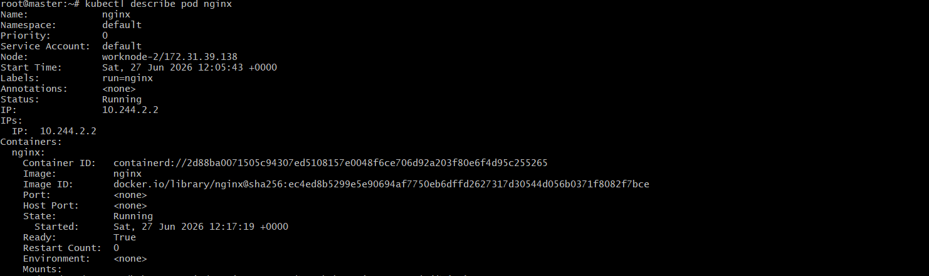

- Mugup Master and slave components on k8s.

