Kubernetes-03

- Create a ClusterIP service for an Apache web server pod.

Create firtstpod.yaml file
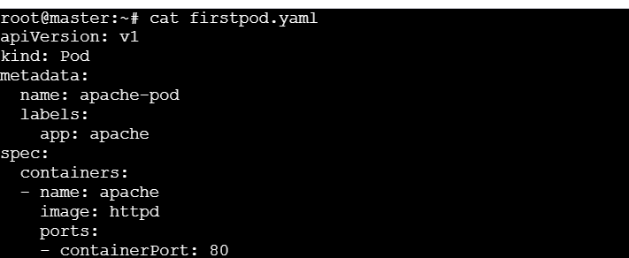
Apply:
Create service.yaml file:
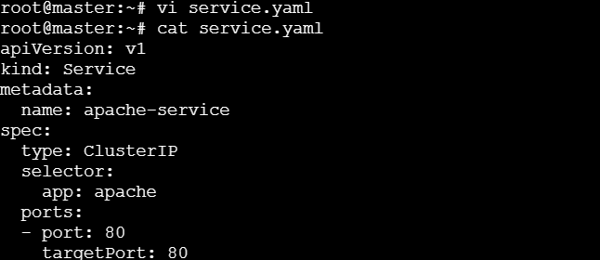
Apply:
Verify:
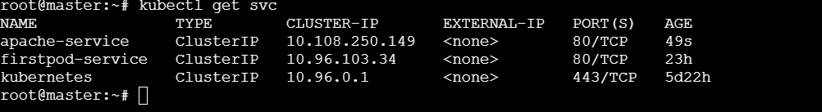

- Expose an Nginx pod externally using a NodePort service.

Create yaml file
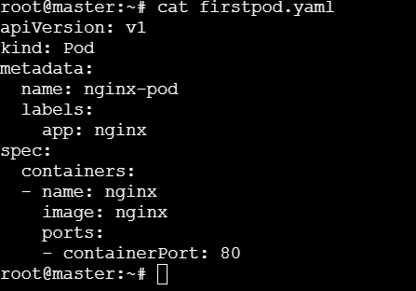
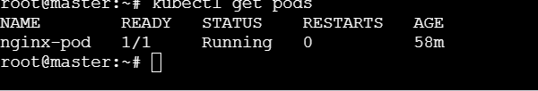
Create service file
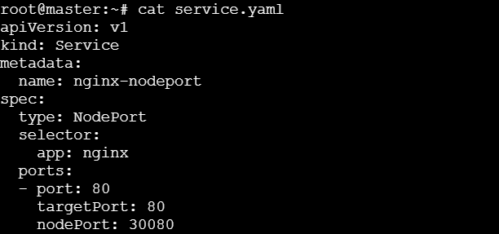
Apply:
Verify:

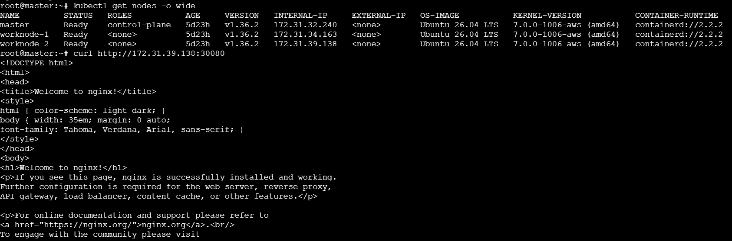
- Deploy a ReplicationController to maintain 3 replicas of an Nginx pod.
Create rc.yaml file
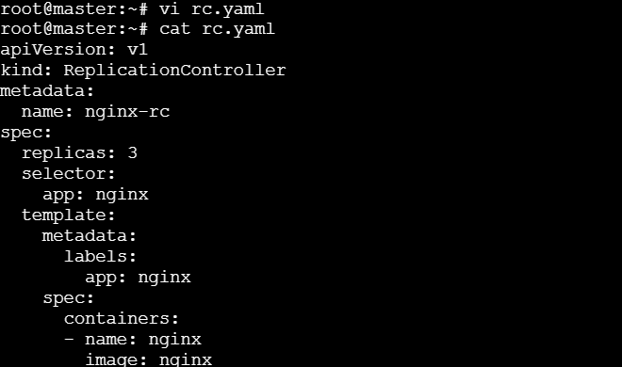
Apply:
Verify:
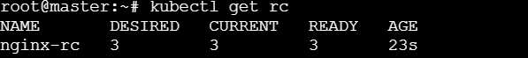

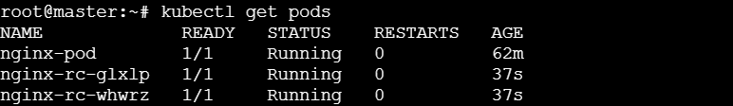

If we delete a pod and it will create one pod automatically
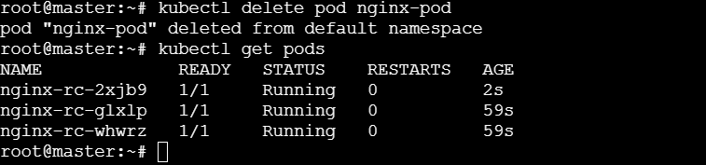
- Scale the ReplicationController from 3 replicas to 5 replicas.

Changed 3 to 5:
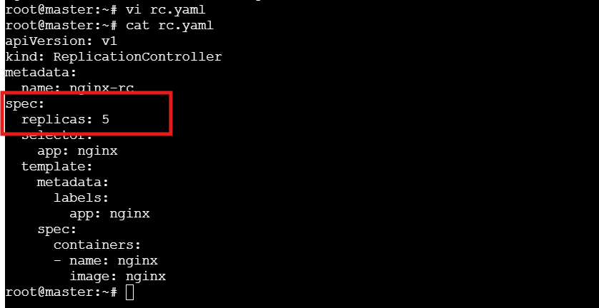
Apply:
Verify:
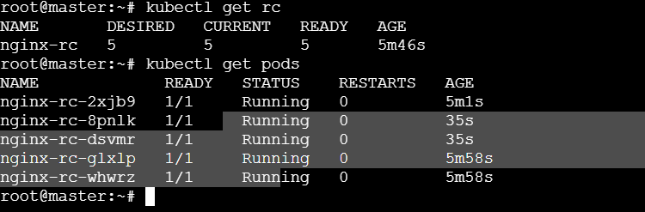

- Create a ReplicaSet to manage pods based on multiple labels (prod and test).
Create rs.yaml file:
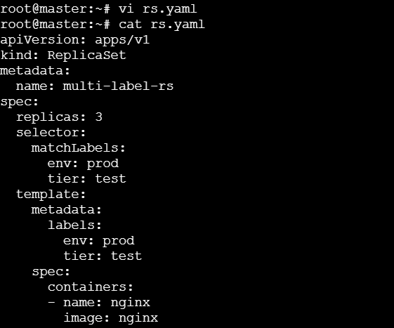
Apply:
Verify:

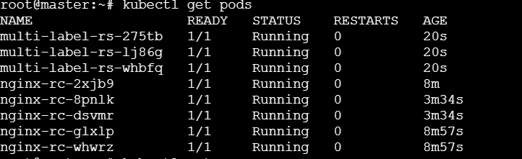
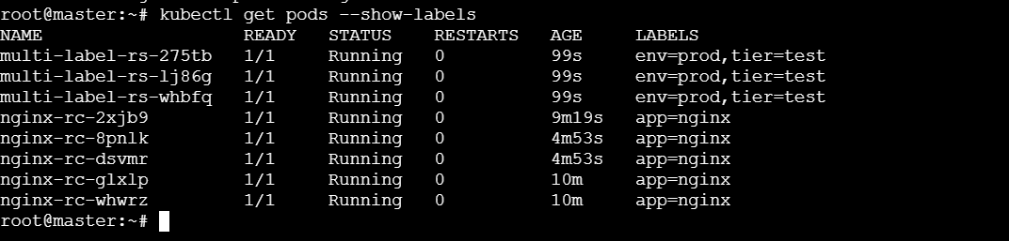
- Deploy a ReplicaSet that excludes pods with the label backend.
Create rs.yaml file:
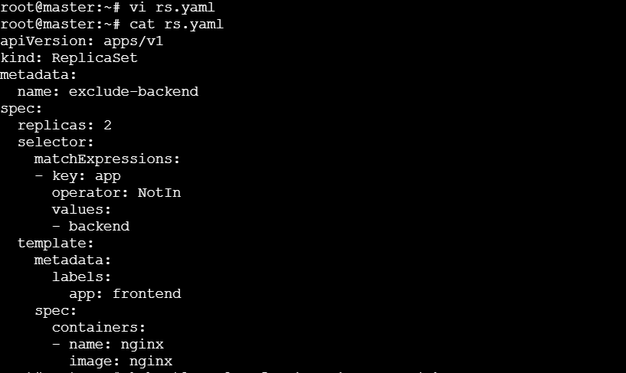
Apply:
verify:
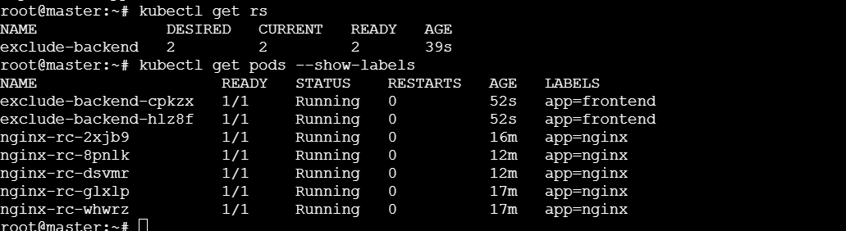

- Test load balancing across multiple pods using a NodePort service.
Create a Deployment:
Expose it:
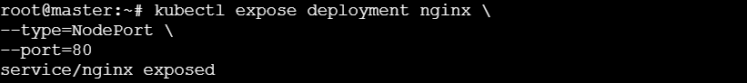
Check Service:
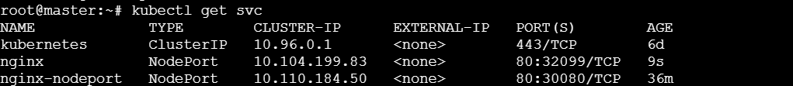
Find NodePort:
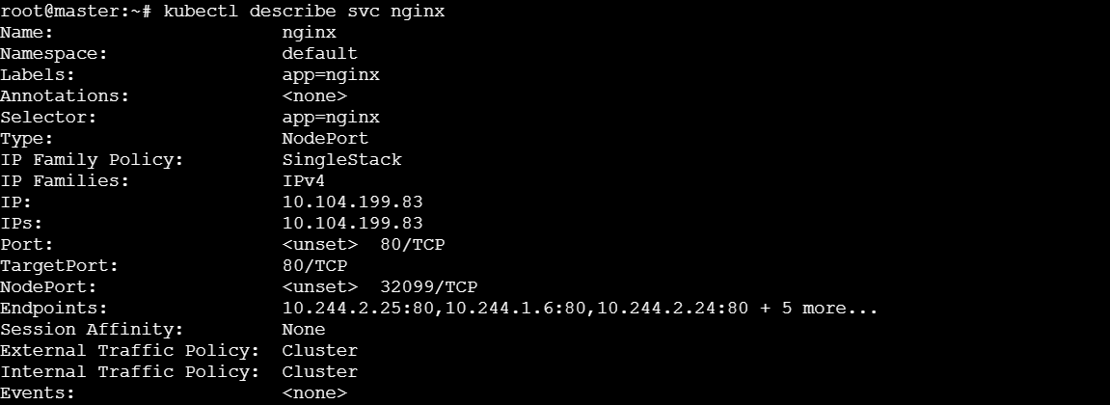
Find node ip & Test with curl
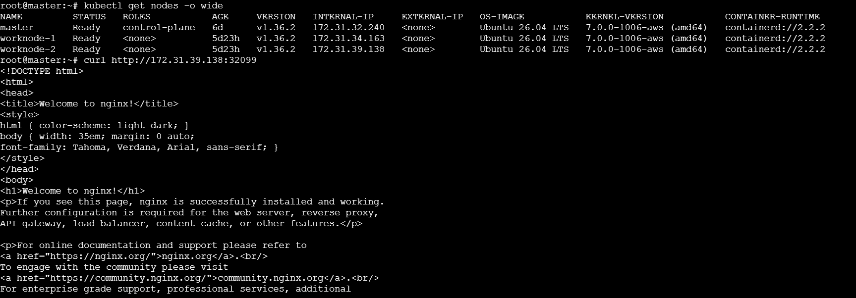

- Delete a ReplicationController without affecting the running pods.
Delete only the ReplicationController:
Verify:
Pods should still exist:
