Kubernetes-04

- Deploy an application using a Deployment with 3 replicas and a rolling update strategy.

deployment.yaml
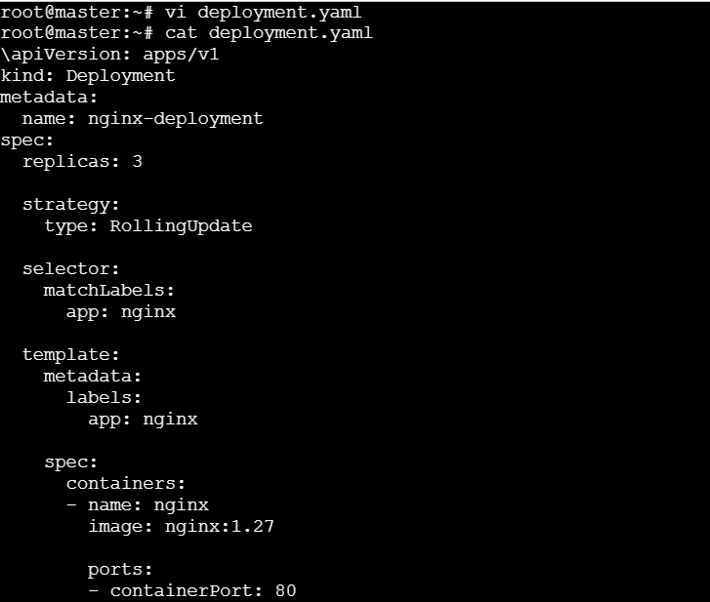
Deploy

Verify
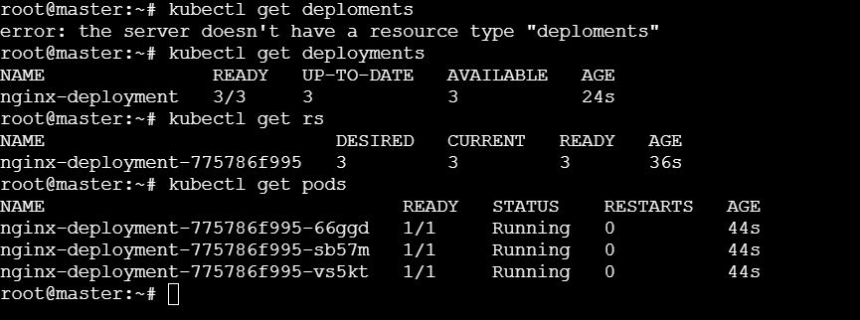
- Configure a Deployment with a Recreate strategy and observe the downtime.
Deployment.yaml
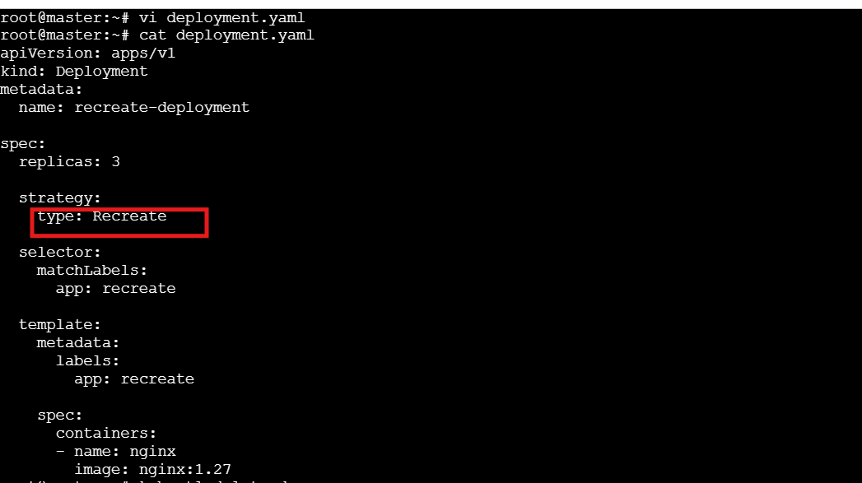
Deploy

Update image

Verify:
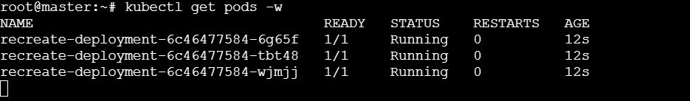
- Update an existing Deployment and perform a rollback to the previous version.
Create Deployment:

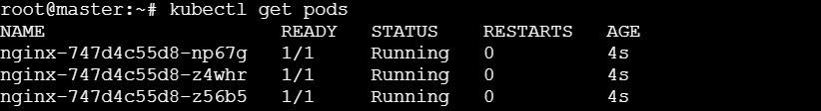

Update Image:
Check rollout status:
View rollout history:
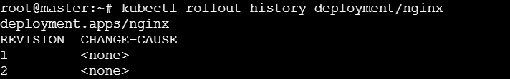
Rollback:
Verify:
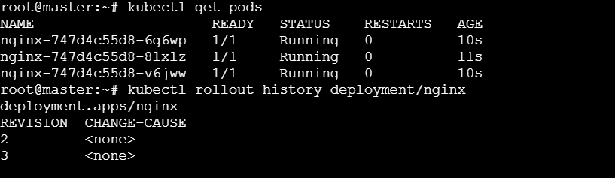

- Modify a Deployment to add resource requests and limits for CPU and memory.
Create deploymet.yaml:
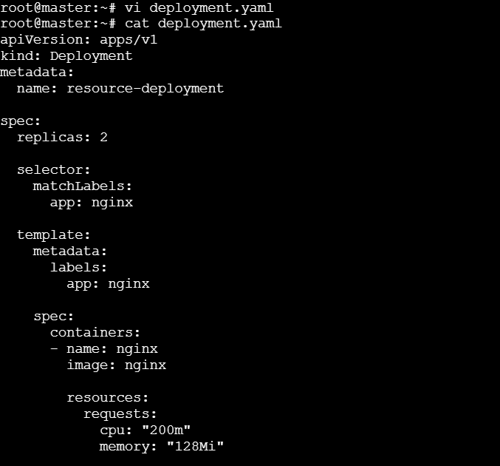
Deploy:
Verify:
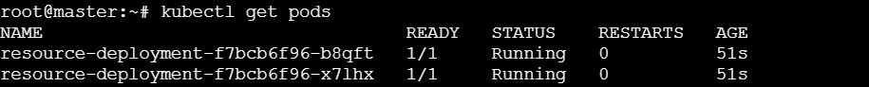

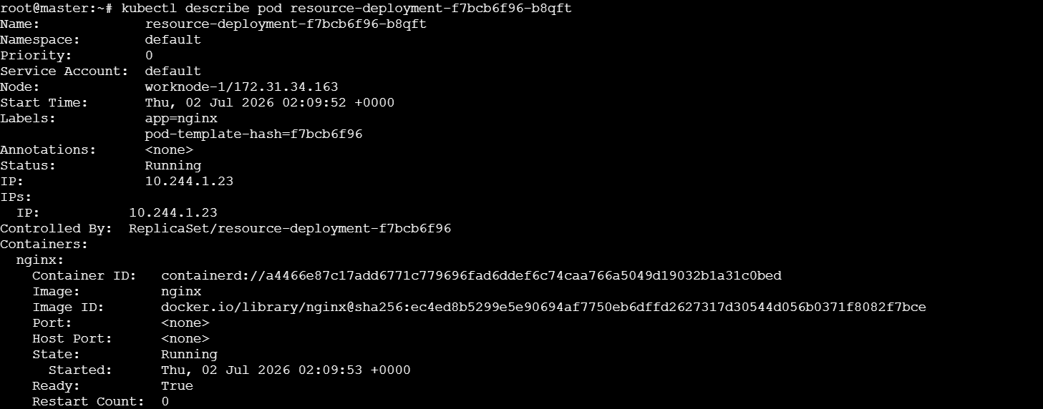
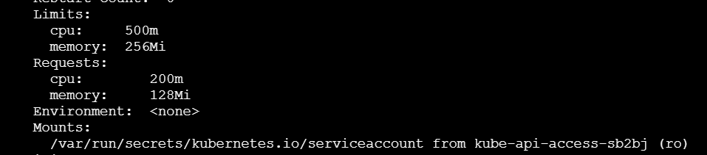

- Create a Deployment with MaxSurge and MaxUnavailable configurations.
Create:
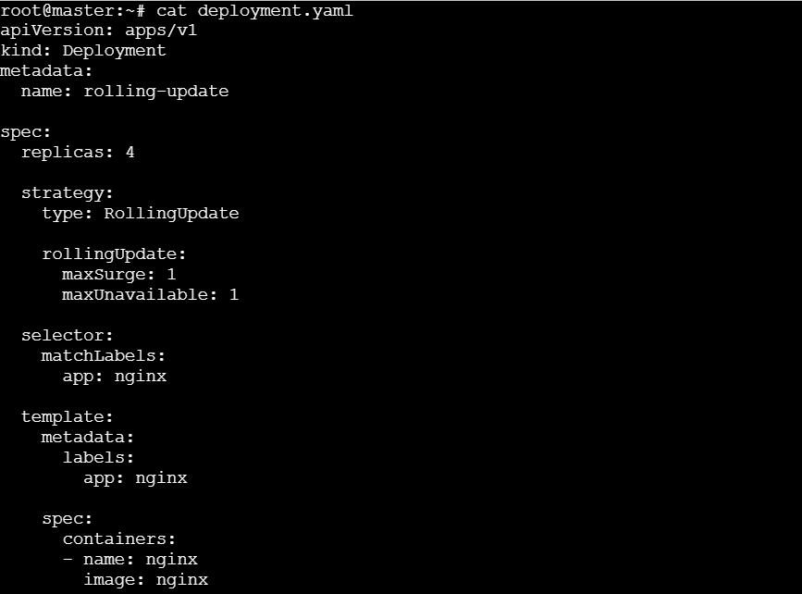
Deploy:

Verify:
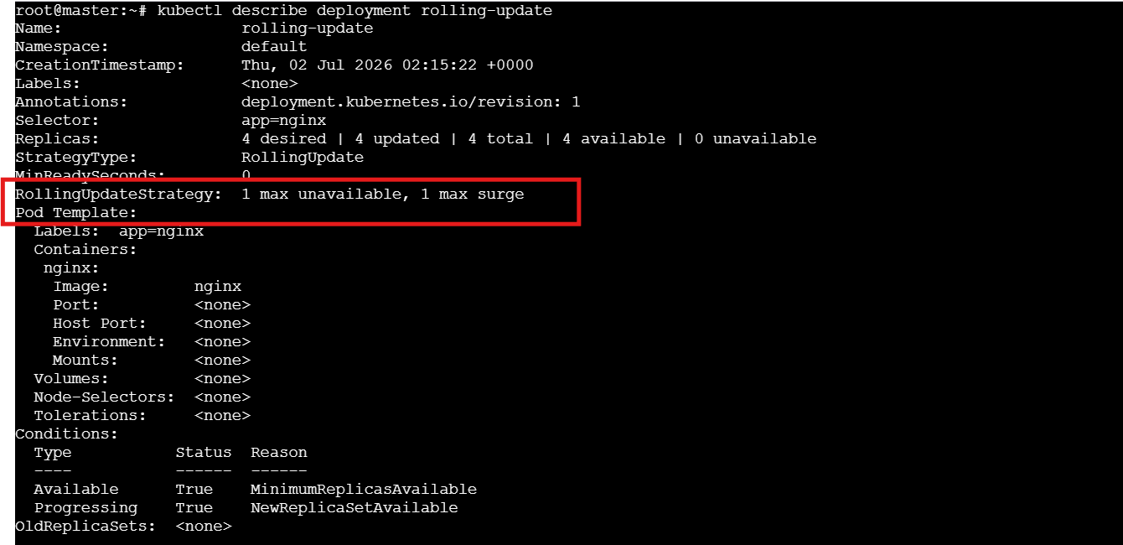
maxSurge: 1 → Create 1 extra Pod during updates.
maxUnavailable: 1 → At most 1 Pod can be unavailable.

- Set up a Deployment with a custom revision history limit.
Deploymet.yaml:
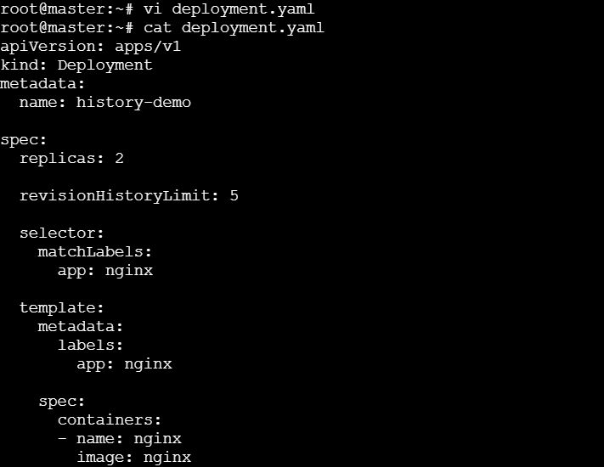
Deploy:
Verify:
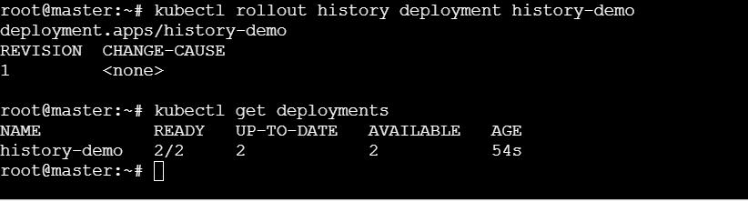
Only the latest 5 revisions are retained.

- Pause a Deployment during an update, and then resume it.
Pause:
Verify
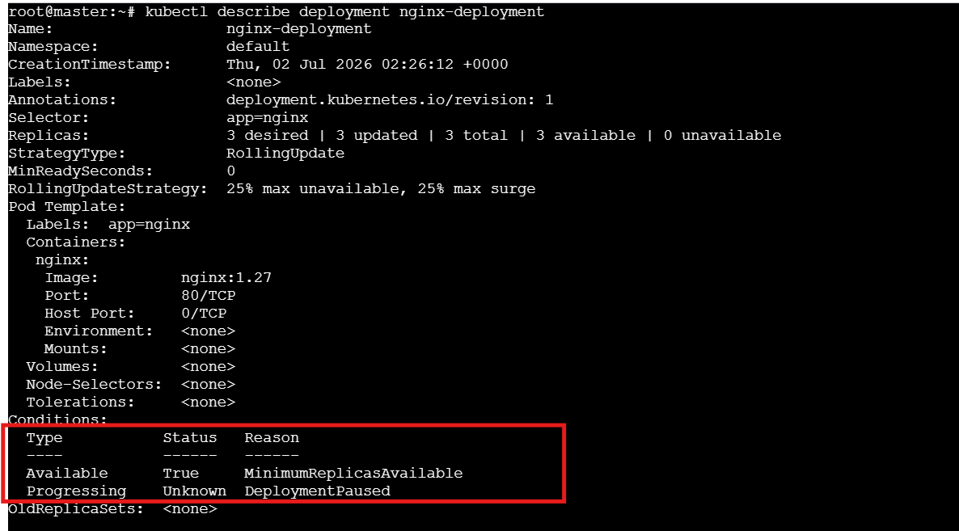
Update image
Resume & Watch rollout
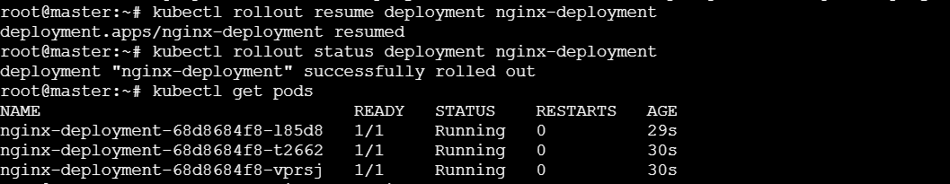

- Create a pod using resource requests for memory and CPU, and observe how the scheduler assigns it to a node.
Create firstpod.yaml:
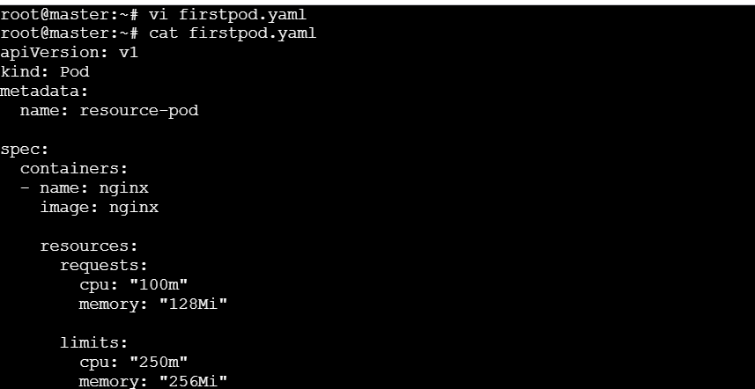
Apply:
Verify:

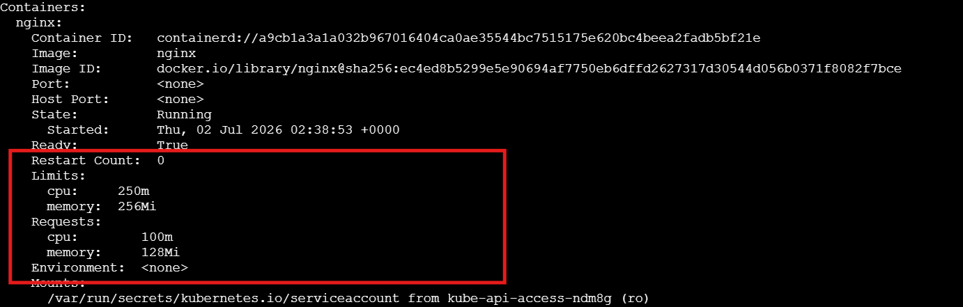

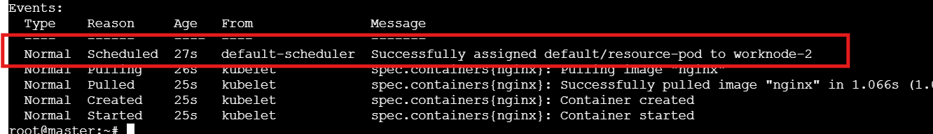
The Events section shows successful scheduling, and the Resources section shows the configured CPU and memory requests/limits.

Command: | Use Case :
kubectl get deployments | Lists all Deployments and their replica status.
kubectl get rs | Displays all ReplicaSets managed by Deployments.
kubectl get pods | Lists all Pods and their current status.
kubectl get pods -o wide | Shows Pod details including IP address and assigned node.
kubectl describe deployment <deployment-name> | Displays detailed Deployment configuration, events, and update status.
kubectl describe pod <pod-name> | Shows detailed Pod information for troubleshooting.
kubectl rollout status deployment <deployment-name> | Monitors the progress of a Deployment rollout.
kubectl rollout history deployment <deployment-name> | Displays the revision history of a Deployment.
kubectl rollout undo deployment <deployment-name> | Rolls back the Deployment to the previous revision.
kubectl rollout undo deployment <deployment-name> --to-revision=<n> | Rolls back the Deployment to a specific revision.
kubectl rollout pause deployment <deployment-name> | Pauses the Deployment rollout to delay updates.
kubectl rollout resume deployment <deployment-name> | Resumes a paused Deployment rollout.
kubectl scale deployment <deployment-name> --replicas=<n> | Increases or decreases the number of Pod replicas.
kubectl set image deployment/<deployment-name> <container>=<image> | Updates the container image in a Deployment.
kubectl apply -f deployment.yaml | Creates or updates a Deployment from a YAML file.
kubectl delete deployment <deployment-name> | Deletes a Deployment and its managed Pods.
kubectl edit deployment <deployment-name> | Opens the Deployment configuration for live editing.
kubectl rollout restart deployment <deployment-name> | Restarts all Pods in a Deployment without changing its configuration.
kubectl get deployment <deployment-name> -o yaml | Displays the complete Deployment definition in YAML format.
kubectl explain deployment | Shows documentation and available fields for the Deployment resource.

