Jenkins-04

2) Setup a Jenkins CICD pipeline using Declarative pipeline using feature-1.1 branch.
Source Code: https://github.com/betawins/sabear_simplecutomerapp/tree/feature-1.1
stages:
- Git Clone
- SonarQube Integration
- Maven Compilation
- Nexus Artifactory
- Slack Notification
- Deploy On tomcat

Create a new item→name & select pipeline→click on configure
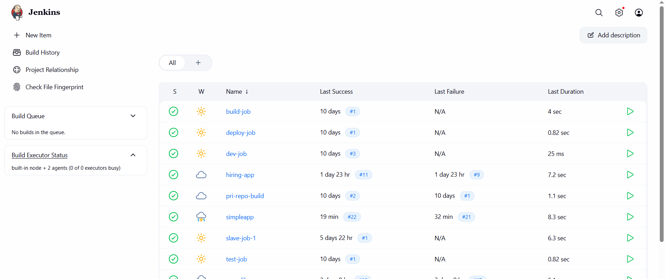
Write the declarative pipeline
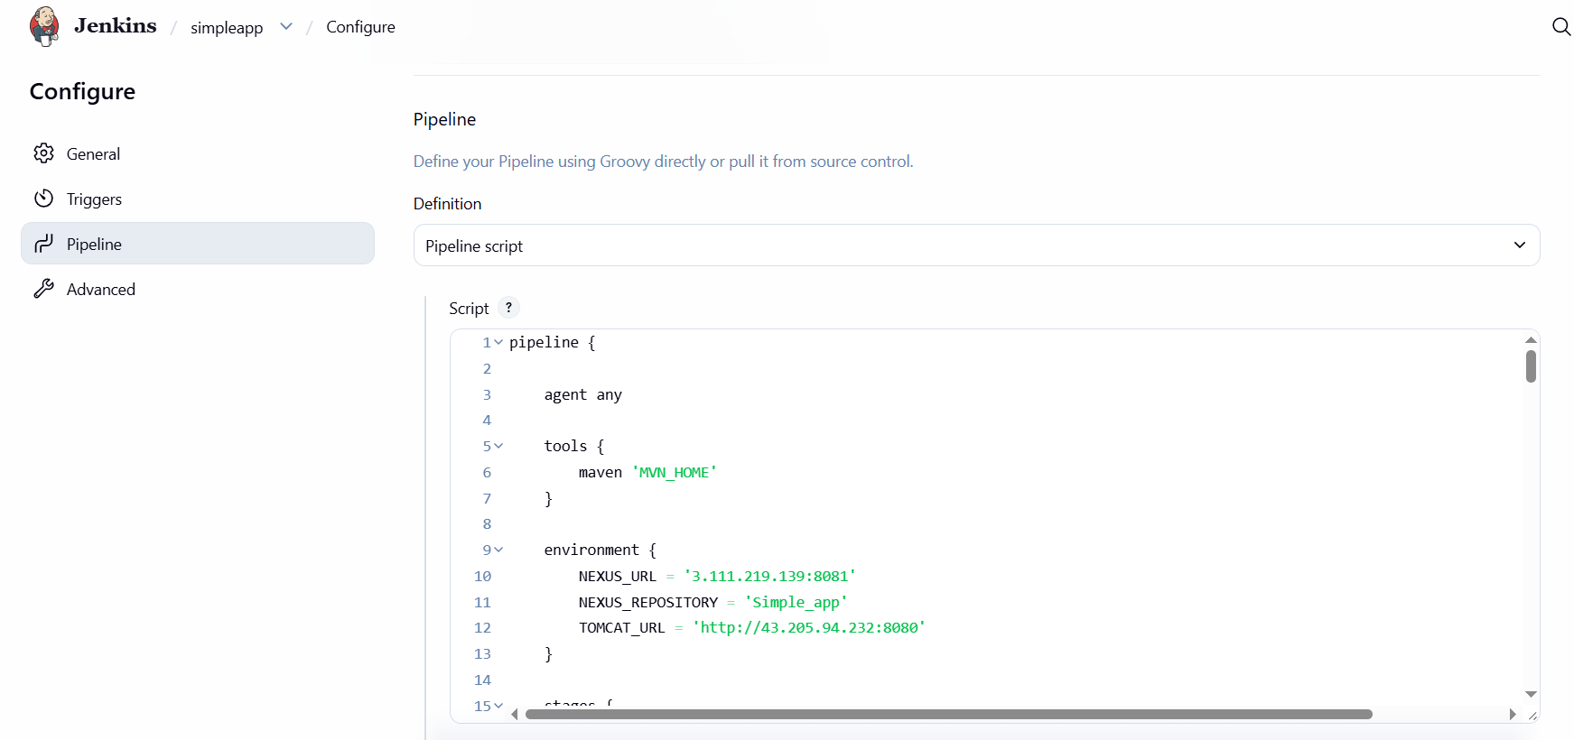

pipeline {

agent any

tools {
maven 'MVN_HOME'
}

environment {
NEXUS_URL = '3.111.219.139:8081'
NEXUS_REPOSITORY = 'Simple_app'
TOMCAT_URL = 'http://43.205.94.232:8080'
}

stages {

stage('Clean Workspace') {
steps {
cleanWs()
}
}

stage('Clone Code') {
steps {
git branch: 'master',
url: 'https://github.com/Radharapubhargav/sabear_simplecutomerapp.git'
}
}

stage('Build Application') {
steps {
sh 'mvn clean install'
}
}

stage('Verify WAR File') {
steps {
sh 'ls -lrth target/'
}
}

stage('Read Maven Details') {

steps {

script {

env.ARTIFACT_ID = sh(
script: "grep -m1 '<artifactId>' pom.xml | head -1 | sed -e 's/.*<artifactId>\\(.*\\)<\\/artifactId>.*/\\1/'",
returnStdout: true
).trim()

env.VERSION = sh(
script: "grep -m1 '<version>' pom.xml | head -1 | sed -e 's/.*<version>\\(.*\\)<\\/version>.*/\\1/'",
returnStdout: true
).trim()

env.GROUP_ID = sh(
script: "grep -m1 '<groupId>' pom.xml | head -1 | sed -e 's/.*<groupId>\\(.*\\)<\\/groupId>.*/\\1/'",
returnStdout: true
).trim()

echo "GROUP_ID = ${env.GROUP_ID}"
echo "ARTIFACT_ID = ${env.ARTIFACT_ID}"
echo "VERSION = ${env.VERSION}"
}
}
}

stage('Upload Artifact To Nexus') {

steps {

script {

def artifactPath = "target/${env.ARTIFACT_ID}-${env.VERSION}.war"

echo "Uploading Artifact: ${artifactPath}"

nexusArtifactUploader(
nexusVersion: 'nexus3',
protocol: 'http',
nexusUrl: "${env.NEXUS_URL}",
repository: "${env.NEXUS_REPOSITORY}",
groupId: "${env.GROUP_ID}",
version: "${env.VERSION}",
credentialsId: 'nexus-server',

artifacts: [
[
artifactId: "${env.ARTIFACT_ID}",
classifier: '',
file: artifactPath,
type: 'war'
]
]
)
}
}
}

stage('Deploy On Tomcat') {

steps {

script {

sh 'ls target/*.war | head -1 > warfile.txt'

def warFile = readFile('warfile.txt').trim()

echo "Deploying WAR File: ${warFile}"

deploy adapters: [
tomcat9(
credentialsId: 'tomcat_server',
path: '',
url: "${env.TOMCAT_URL}"
)
],
contextPath: 'simpleapp',
war: warFile
}
}
}
}

post {

success {

slackSend(
tokenCredentialId: 'Slack',
channel: 'C0B4T7U5J3B',
color: 'good',
message: ":white_check_mark: SUCCESS: ${env.JOB_NAME} #${env.BUILD_NUMBER}\n${env.BUILD_URL}"
)
}

failure {

slackSend(
tokenCredentialId: 'Slack',
channel: 'C0B4T7U5J3B',
color: 'danger',
message: ":x: FAILED: ${env.JOB_NAME} #${env.BUILD_NUMBER}\n${env.BUILD_URL}"
)
}
}
}

Build success full→ check the console output
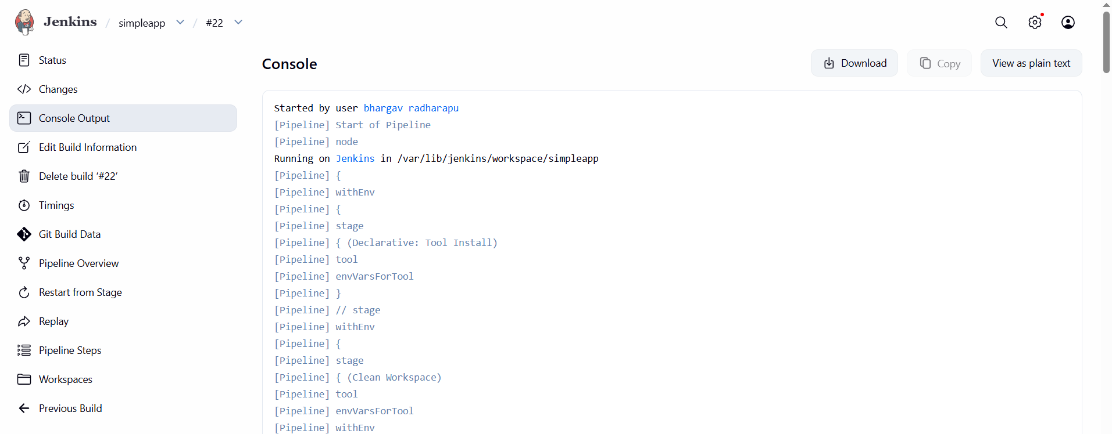

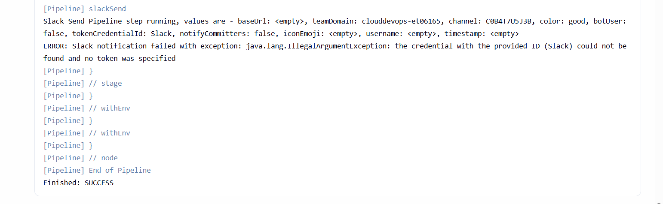

3) Setup a Jenkins CICD pipeline using Scripted pipeline using feature-1.1 branch.
Source Code: https://github.com/betawins/sabear_simplecutomerapp/tree/feature-1.1
stages:
- Git Clone
- SonarQube Integration
- Maven Compilation
- Nexus Artifactory
- Slack Notification
- Deploy On tomcat

Create new item→select pipeline project→click on configure→write a scripted pipeline

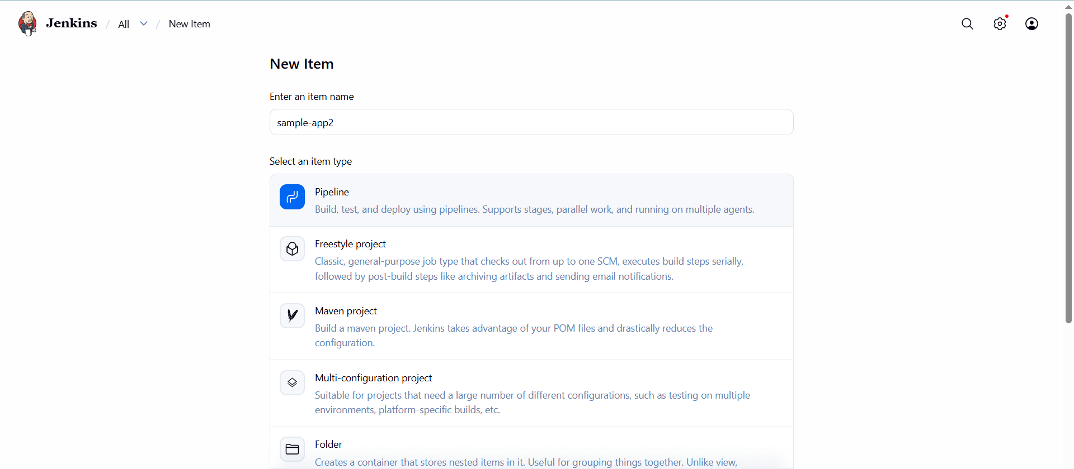
node {

def mvnHome = tool 'MVN_HOME'

env.PATH = "${mvnHome}/bin:${env.PATH}"

env.NEXUS_URL = '13.233.131.240:8081'
env.NEXUS_REPOSITORY = 'simple_app'
env.TOMCAT_URL = 'http://65.2.171.246:8080/'

try {

stage('Clean Workspace') {

cleanWs()
}

stage('Clone Code') {

git branch: 'master',
url: 'https://github.com/Radharapubhargav/sabear_simplecutomerapp.git'
}

stage('Build Application') {

sh 'mvn clean install'
}

stage('Verify WAR File') {

sh 'ls -lrth target/'
}

stage('Read Maven Details') {

env.ARTIFACT_ID = sh(
script: "grep -m1 '<artifactId>' pom.xml | head -1 | sed -e 's/.*<artifactId>\\(.*\\)<\\/artifactId>.*/\\1/'",
returnStdout: true
).trim()

env.VERSION = sh(
script: "grep -m1 '<version>' pom.xml | head -1 | sed -e 's/.*<version>\\(.*\\)<\\/version>.*/\\1/'",
returnStdout: true
).trim()

env.GROUP_ID = sh(
script: "grep -m1 '<groupId>' pom.xml | head -1 | sed -e 's/.*<groupId>\\(.*\\)<\\/groupId>.*/\\1/'",
returnStdout: true
).trim()

echo "GROUP_ID = ${env.GROUP_ID}"
echo "ARTIFACT_ID = ${env.ARTIFACT_ID}"
echo "VERSION = ${env.VERSION}"
}

stage('Upload Artifact To Nexus') {

def artifactPath = "target/${env.ARTIFACT_ID}-${env.VERSION}.war"

echo "Uploading Artifact: ${artifactPath}"

nexusArtifactUploader(
nexusVersion: 'nexus3',
protocol: 'http',
nexusUrl: "${env.NEXUS_URL}",
repository: "${env.NEXUS_REPOSITORY}",
groupId: "${env.GROUP_ID}",
version: "${env.VERSION}",
credentialsId: 'nexus',

artifacts: [
[
artifactId: "${env.ARTIFACT_ID}",
classifier: '',
file: artifactPath,
type: 'war'
]
]
)
}

stage('Deploy On Tomcat') {

sh 'ls target/*.war | head -1 > warfile.txt'

def warFile = readFile('warfile.txt').trim()

echo "Deploying WAR File: ${warFile}"

deploy adapters: [
tomcat9(
credentialsId: 'tomcat',
path: '',
url: "${env.TOMCAT_URL}"
)
],
contextPath: 'simpleapp',
war: warFile
}

stage('Slack Success Notification') {

slackSend(
tokenCredentialId: 'slack',
channel: 'C0B5TC66QJ2',
color: 'good',
message: ":white_check_mark: SUCCESS: ${env.JOB_NAME} #${env.BUILD_NUMBER}\n${env.BUILD_URL}"
)
}

} catch (Exception e) {

stage('Slack Failure Notification') {

slackSend(
tokenCredentialId: 'slack',
channel: 'C0B5TC66QJ2',
color: 'danger',
message: ":x: FAILED: ${env.JOB_NAME} #${env.BUILD_NUMBER}\n${env.BUILD_URL}"
)
}

throw e
}
}

Save & build
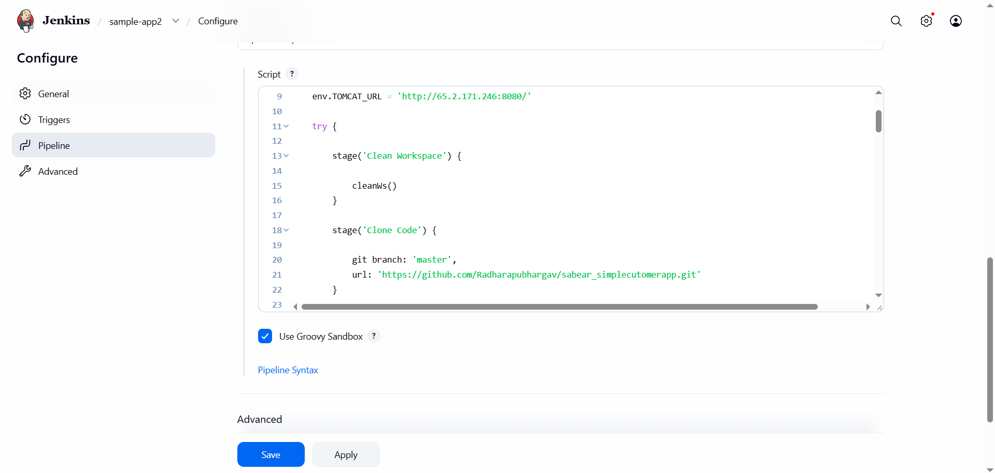

Build successfull
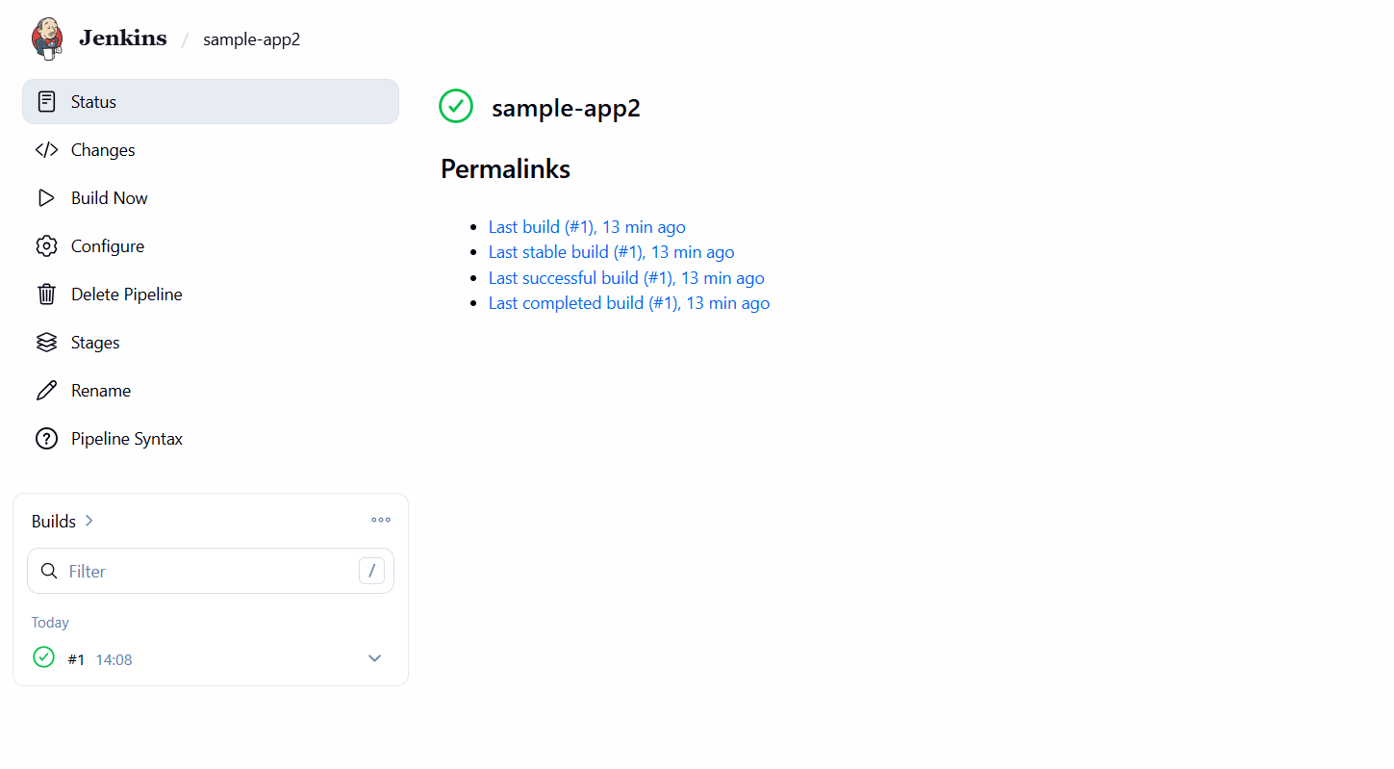
Check the console output
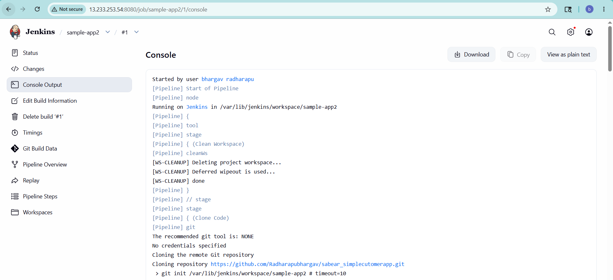

4) Write sample skeleton of pipelines.

pipeline {

agent any

tools {
maven 'MVN_HOME'
}

environment {
NEXUS_URL = '3.111.219.139:8081'
NEXUS_REPOSITORY = 'Simple_app'
TOMCAT_URL = 'http://43.205.94.232:8080'
}

stages {

stage('Clean Workspace') {
steps {
cleanWs()
}
}

stage('Clone Code') {
steps {
git branch: 'master',
url: 'https://github.com/Radharapubhargav/sabear_simplecutomerapp.git'
}
}

stage('Build Application') {
steps {
sh 'mvn clean install'
}
}

stage('Verify WAR File') {
steps {
sh 'ls -lrth target/'
}
}

stage('Read Maven Details') {

steps {

script {

env.ARTIFACT_ID = sh(
script: "grep -m1 '<artifactId>' pom.xml | head -1 | sed -e 's/.*<artifactId>\\(.*\\)<\\/artifactId>.*/\\1/'",
returnStdout: true
).trim()

env.VERSION = sh(
script: "grep -m1 '<version>' pom.xml | head -1 | sed -e 's/.*<version>\\(.*\\)<\\/version>.*/\\1/'",
returnStdout: true
).trim()

env.GROUP_ID = sh(
script: "grep -m1 '<groupId>' pom.xml | head -1 | sed -e 's/.*<groupId>\\(.*\\)<\\/groupId>.*/\\1/'",
returnStdout: true
).trim()

echo "GROUP_ID = ${env.GROUP_ID}"
echo "ARTIFACT_ID = ${env.ARTIFACT_ID}"
echo "VERSION = ${env.VERSION}"
}
}
}

stage('Upload Artifact To Nexus') {

steps {

script {

def artifactPath = "target/${env.ARTIFACT_ID}-${env.VERSION}.war"

echo "Uploading Artifact: ${artifactPath}"

nexusArtifactUploader(
nexusVersion: 'nexus3',
protocol: 'http',
nexusUrl: "${env.NEXUS_URL}",
repository: "${env.NEXUS_REPOSITORY}",
groupId: "${env.GROUP_ID}",
version: "${env.VERSION}",
credentialsId: 'nexus-server',

artifacts: [
[
artifactId: "${env.ARTIFACT_ID}",
classifier: '',
file: artifactPath,
type: 'war'
]
]
)
}
}
}

stage('Deploy On Tomcat') {

steps {

script {

sh 'ls target/*.war | head -1 > warfile.txt'

def warFile = readFile('warfile.txt').trim()

echo "Deploying WAR File: ${warFile}"

deploy adapters: [
tomcat9(
credentialsId: 'tomcat_server',
path: '',
url: "${env.TOMCAT_URL}"
)
],
contextPath: 'simpleapp',
war: warFile
}
}
}
}

post {

success {

slackSend(
tokenCredentialId: 'Slack',
channel: 'C0B4T7U5J3B',
color: 'good',
message: ":white_check_mark: SUCCESS: ${env.JOB_NAME} #${env.BUILD_NUMBER}\n${env.BUILD_URL}"
)
}

failure {

slackSend(
tokenCredentialId: 'Slack',
channel: 'C0B4T7U5J3B',
color: 'danger',
message: ":x: FAILED: ${env.JOB_NAME} #${env.BUILD_NUMBER}\n${env.BUILD_URL}"
)
}
}
}

5) Create a parameterized job in Jenkins.
Source Code: https://github.com/betawins/spring3-mvc-maven-xml-hello-world-1.git

Fork the repo on your account
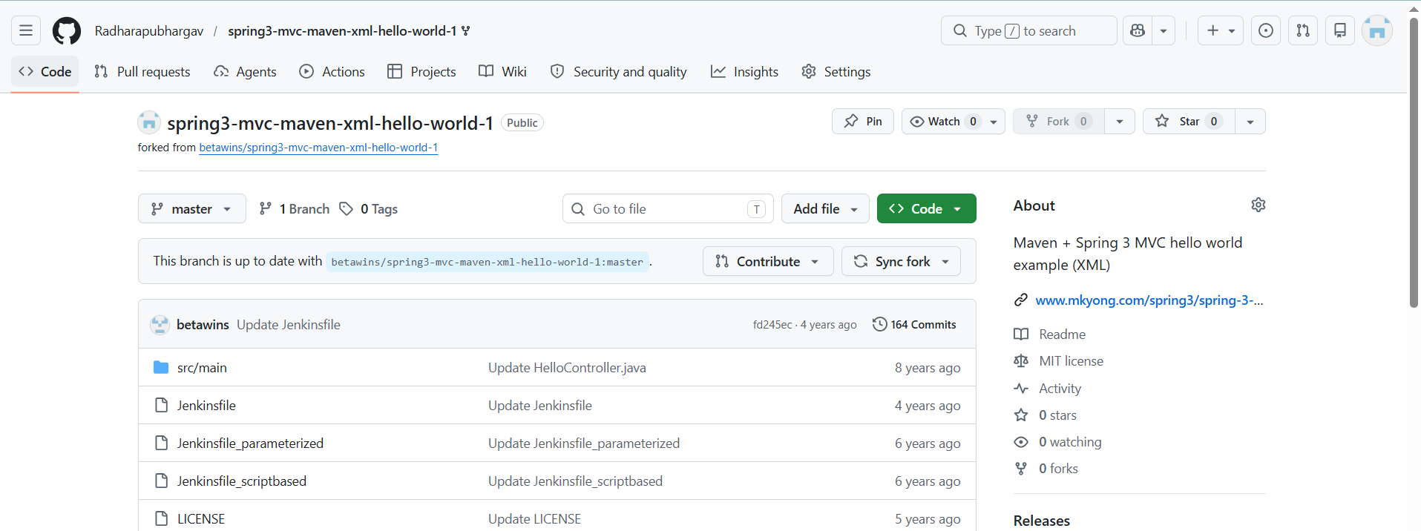
Create new item→configure→select parameterized option→add parameters
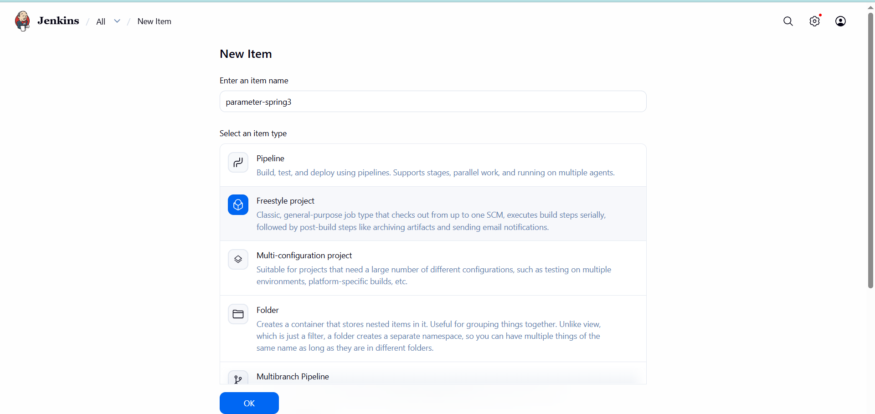

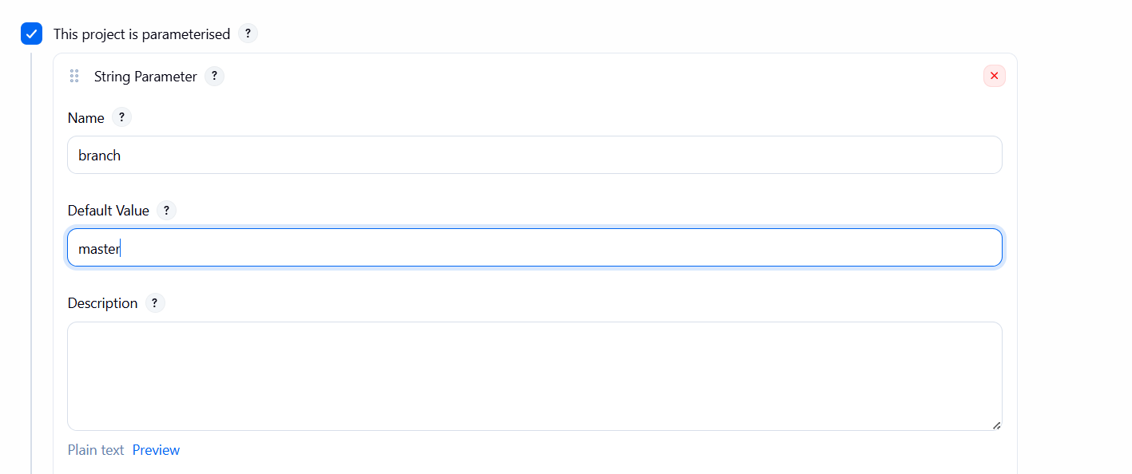

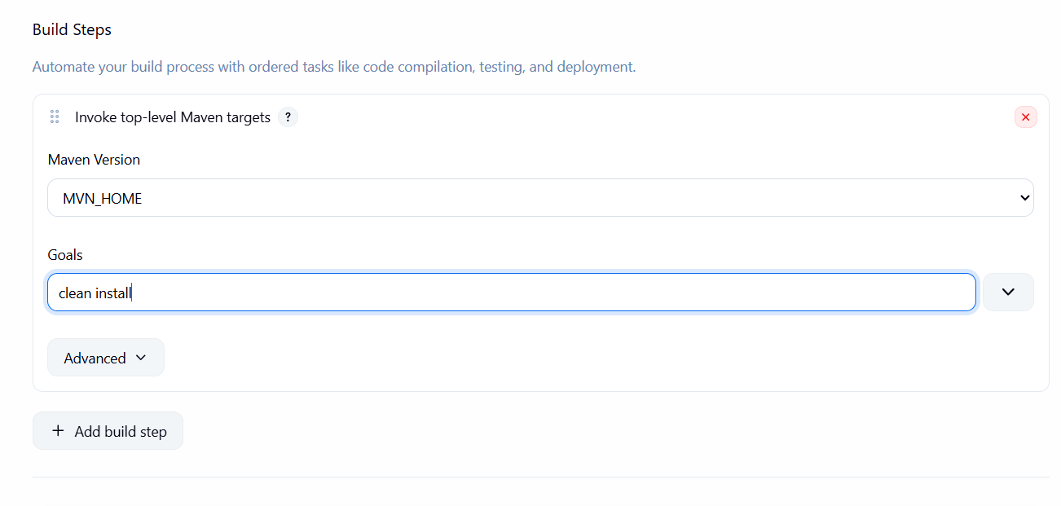

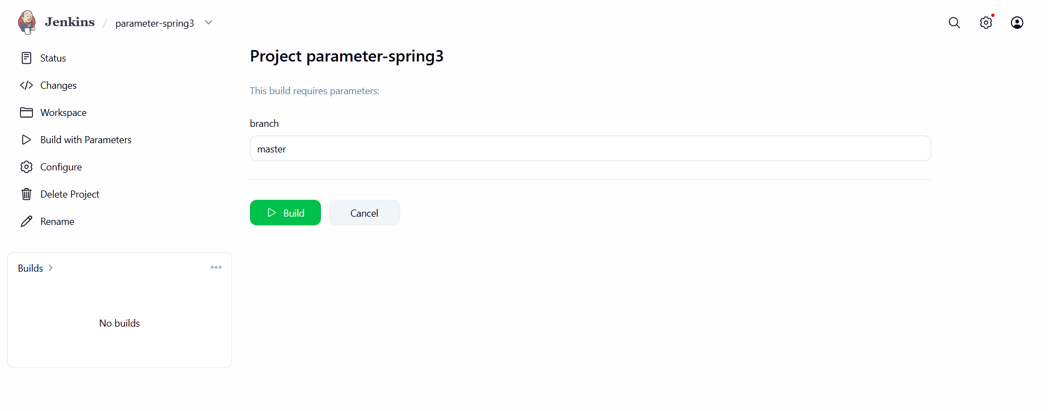

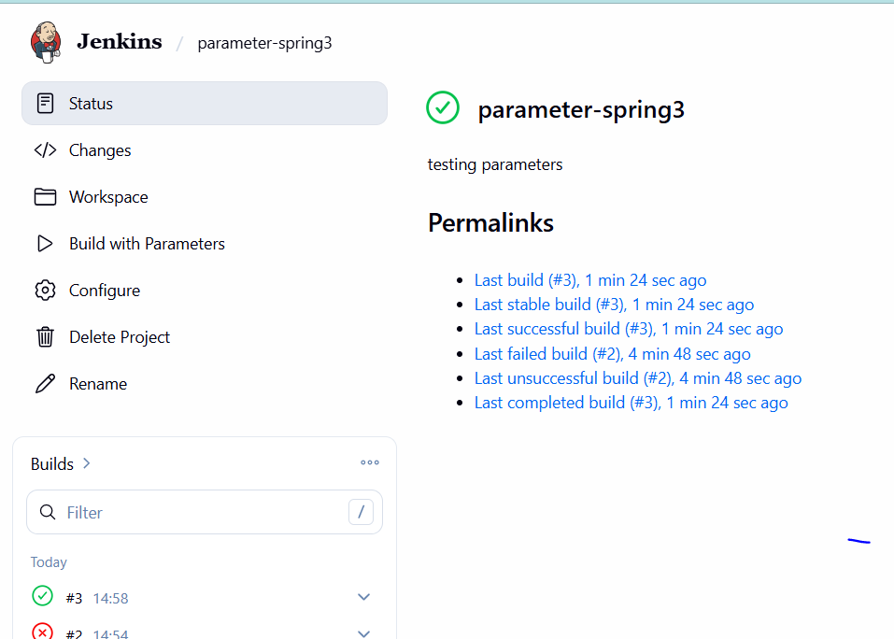

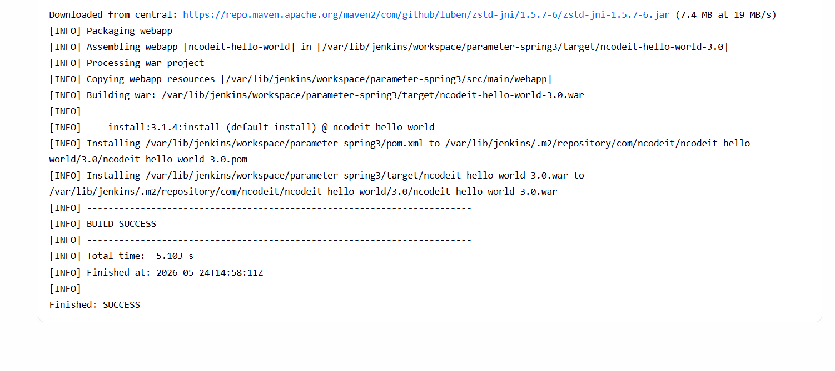

6) Setup one slave machine for Jenkins.

⦁Configure 2 slave machines in the Jenkins master.
Launched 3instance Maste,slave1 and slave2
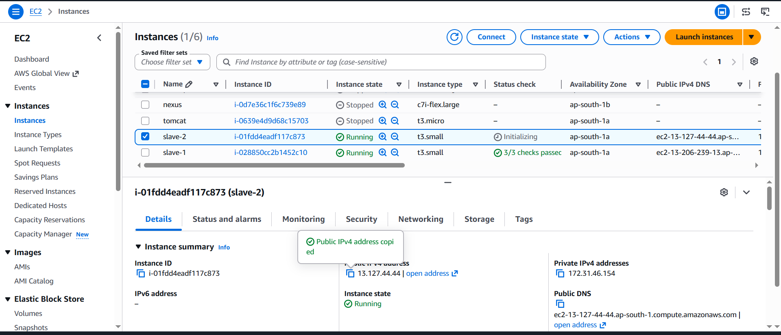

Installed Jenkins on master
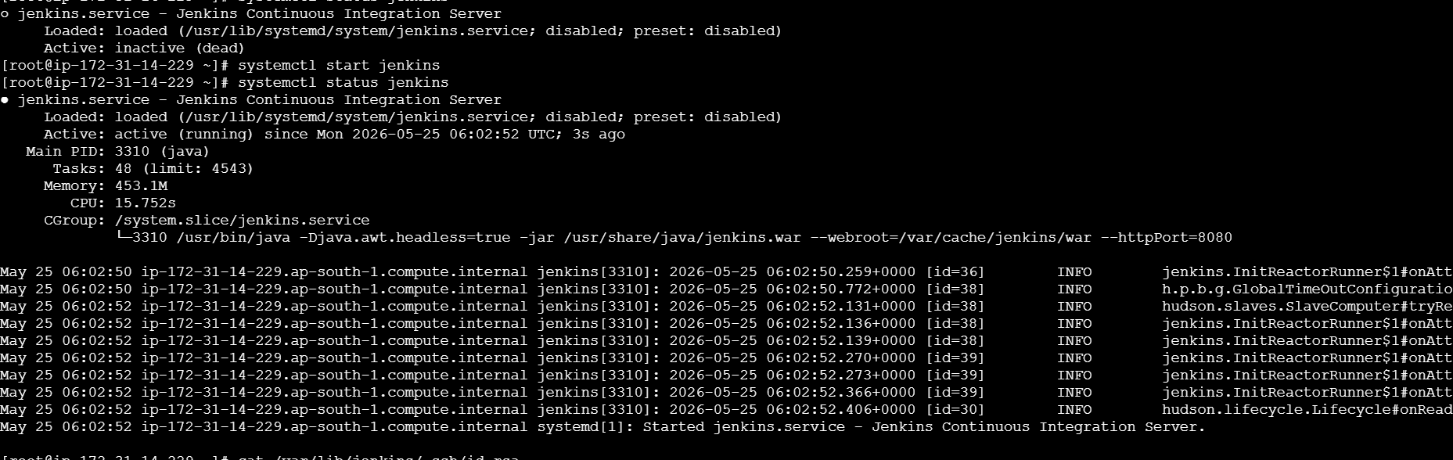
Installed Java on both Slave1 & Slave2
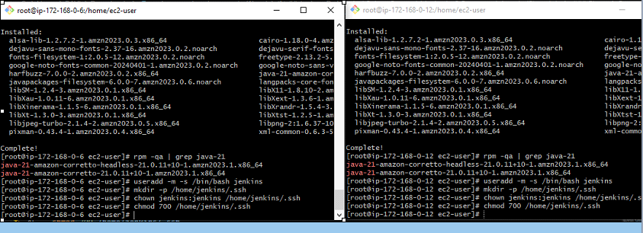

Prepare the Jenkins Controller (Master) – we need to do in Jenkins-
master server
Ensure the 'jenkins' user exists
# The Jenkins RPM package normally creates this user automatically.
# This command checks and creates it only if missing.

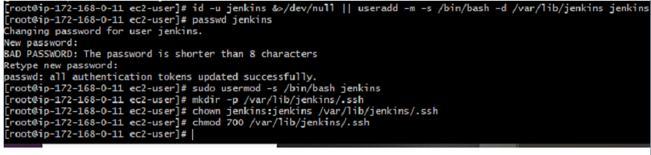
Now switch to Jenkins user Navigate to .ssh directory
Generate RSA key pair
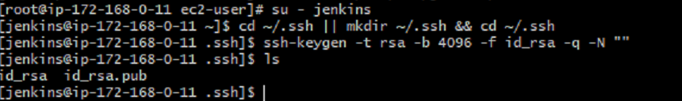
Set correct permissions
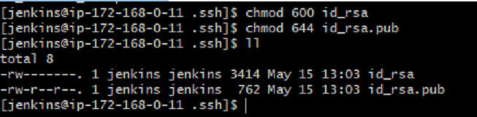
Display the public key (you will need it for slaves) exit back to root
Public key: `/var/lib/jenkins/.ssh/id_rsa.pub`

Private key: `/var/lib/jenkins/.ssh/id_rsa

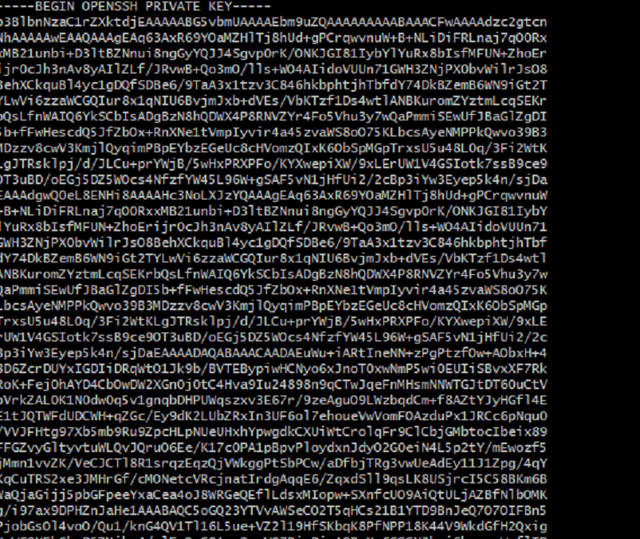
Copy the Public Key to Both Agents
In both slave1 & slave2
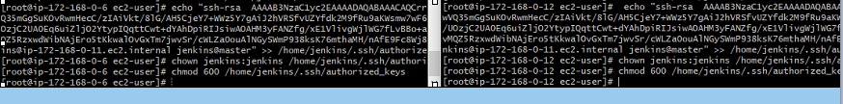

Add Agents' Host Keys to known hosts
Go to Jenkins server
Slave-1&Slave-2
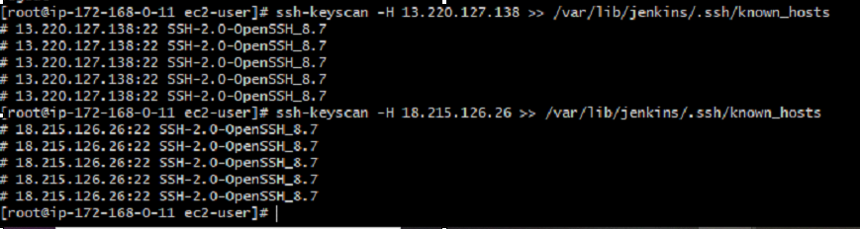
Fix ownership and permissions
Add Agents' Host Keys to known_hosts (Avoid Host Key Verification Prompts)

# Run as root
ssh-keyscan -H <agent-1-ip-or-hostname> >> /var/lib/jenkins/.ssh/known_hosts
ssh-keyscan -H <agent-2-ip-or-hostname> >> /var/lib/jenkins/.ssh/known_hosts
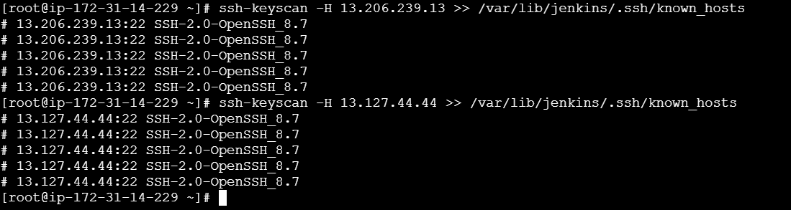
Fix ownership and permissions
chown jenkins:jenkins /var/lib/jenkins/.ssh/known_hosts
chmod 600 /var/lib/jenkins/.ssh/known_hosts

Open Jenkins in browser:
Go to **Manage Jenkins → Nodes and Clouds → New Node**
For Agent-1
- **Node name**: `agent-1` (or descriptive name)
- **Type**: Permanent Agent
- Click **Create**
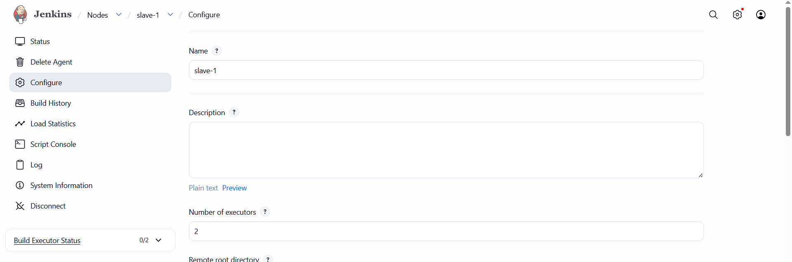
**Configuration**:
- **# of executors**: 2–4 (depending on CPU)
- **Remote FS root**: `/home/jenkins` (or where you created jenkins user)
- **Labels**: `linux agent-1 docker` (use meaningful labels)
- **Usage**: "Use this node as much as possible"
- **Launch method**: **Launch agents via SSH**
- **Host**: Private or public IP of agent-1 (use private if in same VPC)
- **Credentials**: Click **Add** → **Jenkins**
- **Kind**: SSH Username with private key
- **Scope**: Global
- **ID**: e.g., `agent-ssh-key`
- **Username**: `jenkins` (the user we created on agent)
- **Private Key**: From file on server → `/var/lib/jenkins/.ssh/id_rsa` (this is where the key lives on the jenkins master server).
- Select the credential
- **Host Key Verification Strategy**: "Known hosts file" (recommended)
- Click **Save**
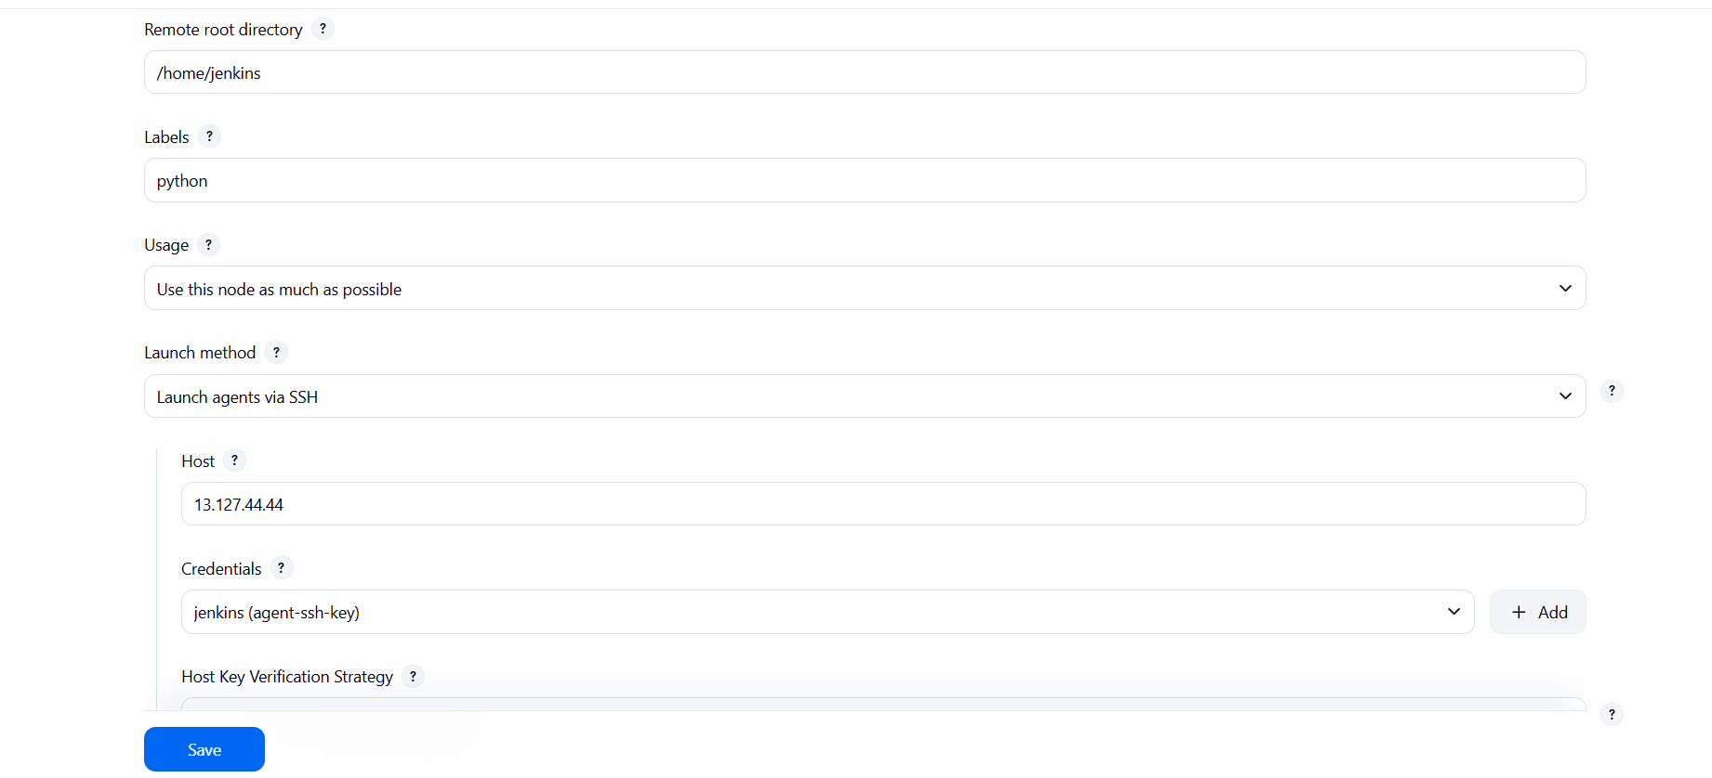
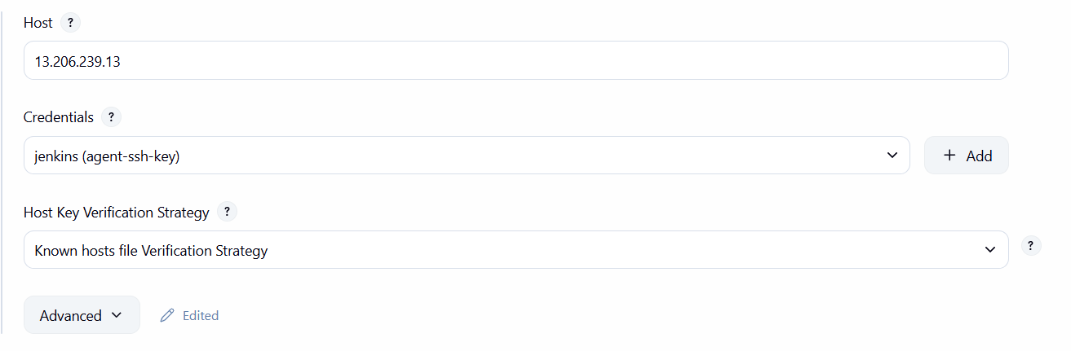
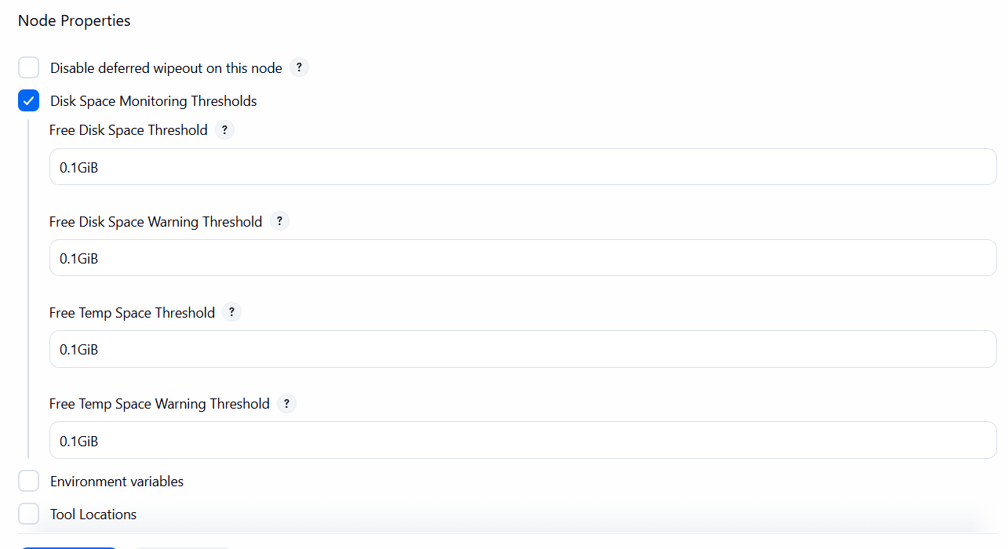
Same configurations for slave-2
