Linux operating system
- Linux is a free and open-source operating system used to run computers, servers, mobile devices, and cloud systems.
- An Operating System (OS) is software that connects hardware (CPU, memory, disk) with users and applications.
Examples :
- Windows
- macOS
- Linux

Create User & Give Sudo Access:
Create user: to use useradd command and set a password for that user to use passwd command
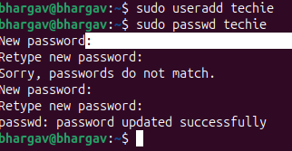

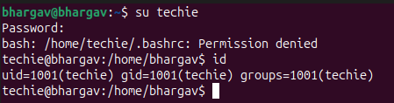
Give sudo permission: to give sudo permissions that user, we want add the user in the sudoers file.

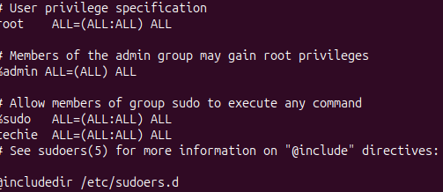
Create user and give the sudo permissions to that user
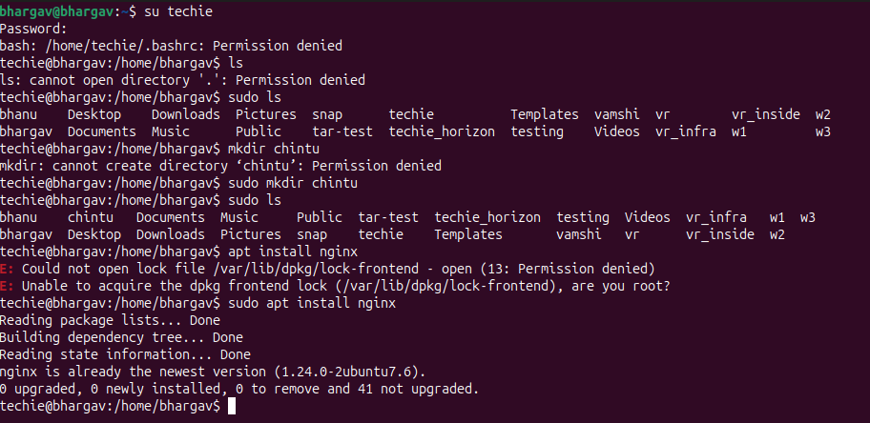

Create Directory:
mkdir command is used for creating the new directory
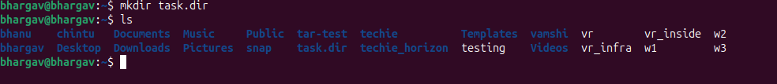

Change Directory:
cd command is used for changing the directory
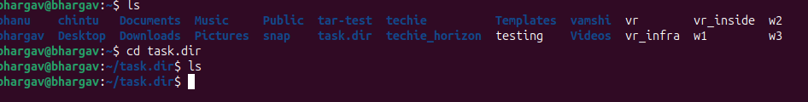
List the conents of the a directory:
ls or ll command is used for list the conents of the a directory
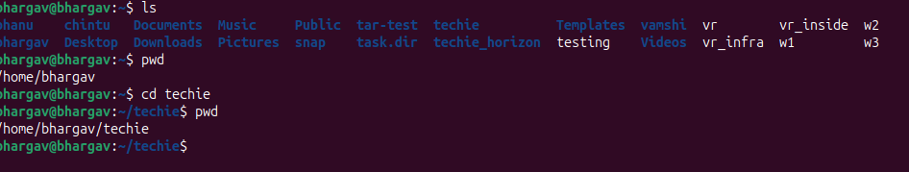

Create a new empty file:
touch is the command is used for creating a new empty files
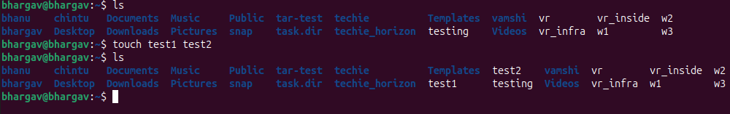
View File:
cat command used for view the content of the file


Copy File:
cp command is used for copy a file into a directory
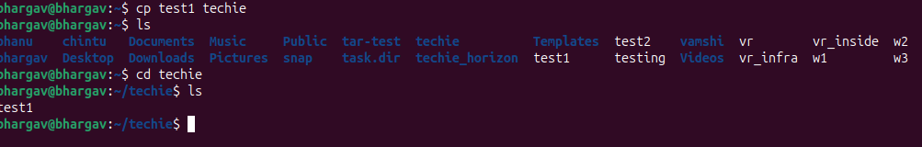

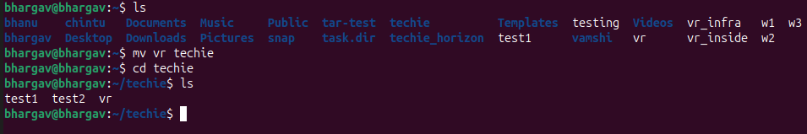

Move file:
mv command is used for moving the file one location to another location
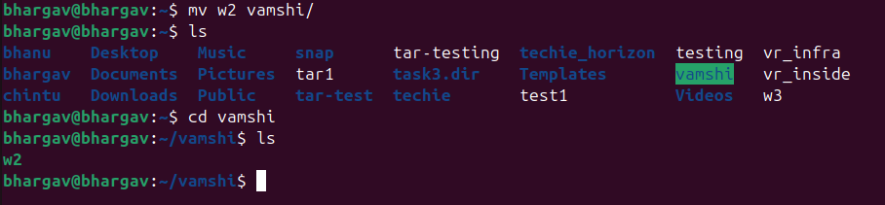

Rename File:
mv command is used for renaming the file or directory
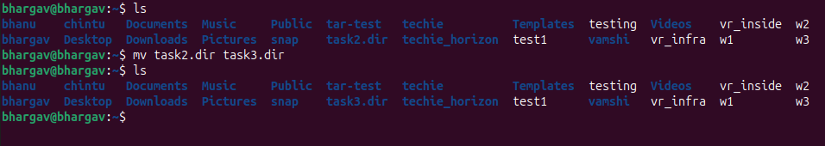
Delete the file:
Permanently deletes file is using rm -rf command
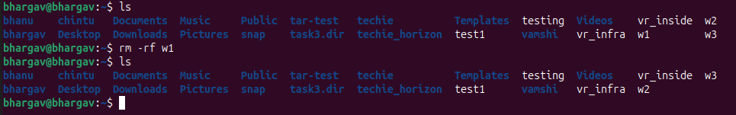

Permissions:
chmod command is used for changing the permission to any file or directory
777 Meaning
User | Permission
Owner | read + write + execute
Group | read + write+ ececute
Others | read + write+ execute

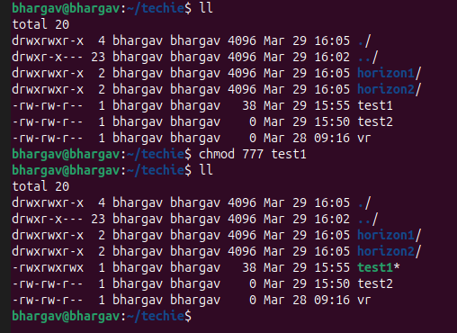

To revoke the permission:

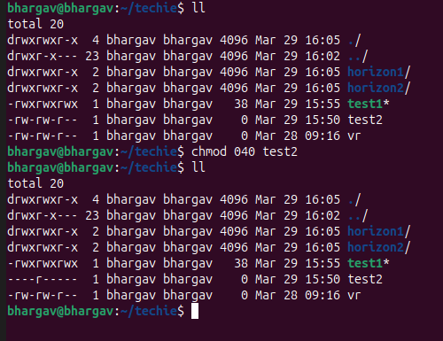

Date & Time:
date command is shows systems date and time
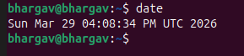
Uptime:
uptime command is used for system running time , user logged and load average
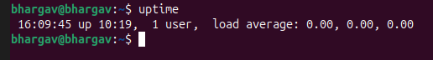

Running Processes:
ps -ef command is shows lists all processes.
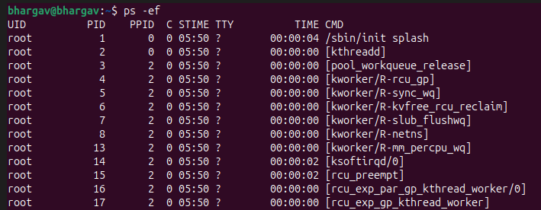

Install Package:
sudo apt install nginx -y is the command is used for installing packages.
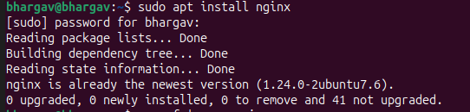
To start the installing service is sudo systemctl start service name command used
Check status of the service : sudo systemctl status servicename
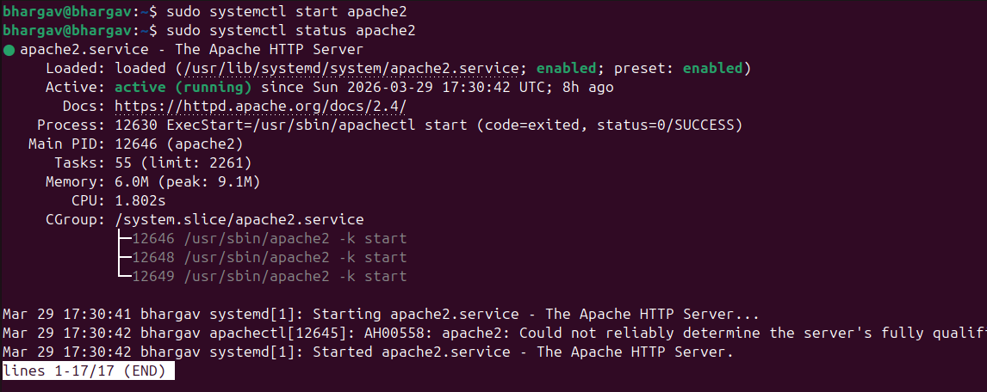

Update System:
sudo apt upgrade -y :Updates installed software.
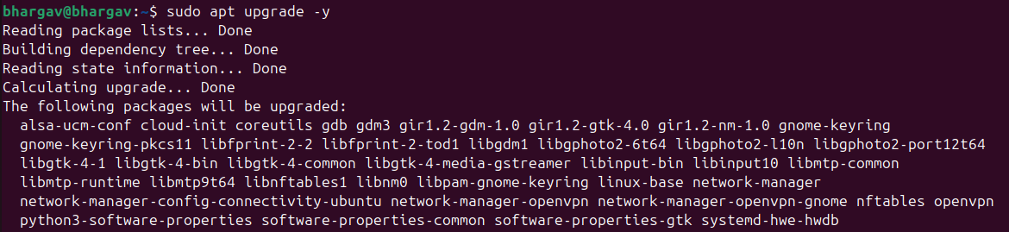

Find File:
find / -name filename: Searches file by name.
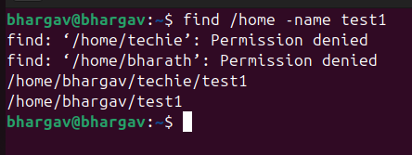

Tar Compress & Extract:
Compress: tar cvf tar file name directoryname
Ex: tar cvf tar1 techie_horizon
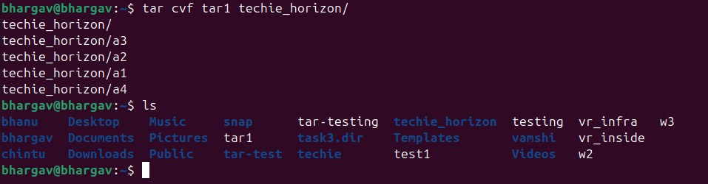

Extract: tar xvf tar firename
Ex : tar xvf tar1
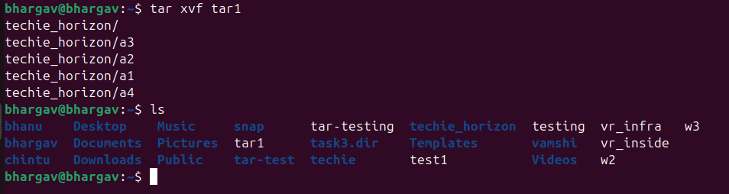

Monitor Resources:
Monitor resources by using top or htop command
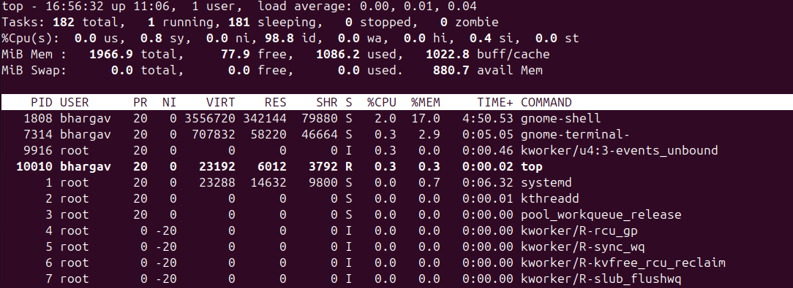

Kill Process:
kill -9 pid: Force stops program.
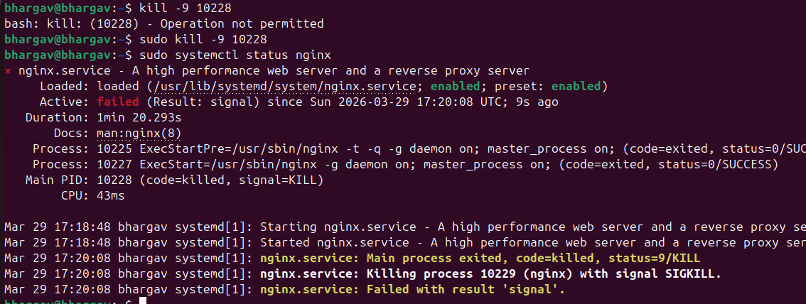

Install Package:
sudo apt install apache2 -y : to install the package
and check the localhost
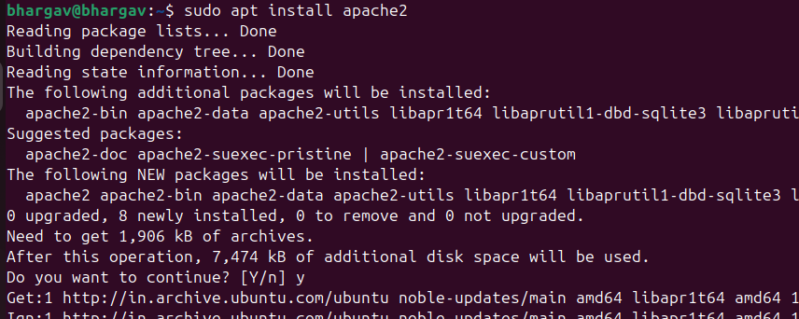

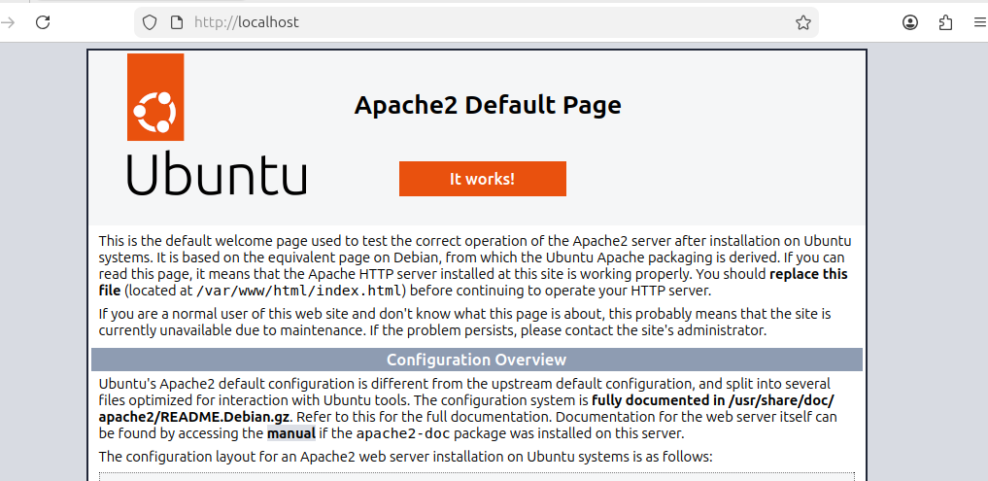

Monitor Logs:
tail -f /var/log/syslog : Live log monitoring.
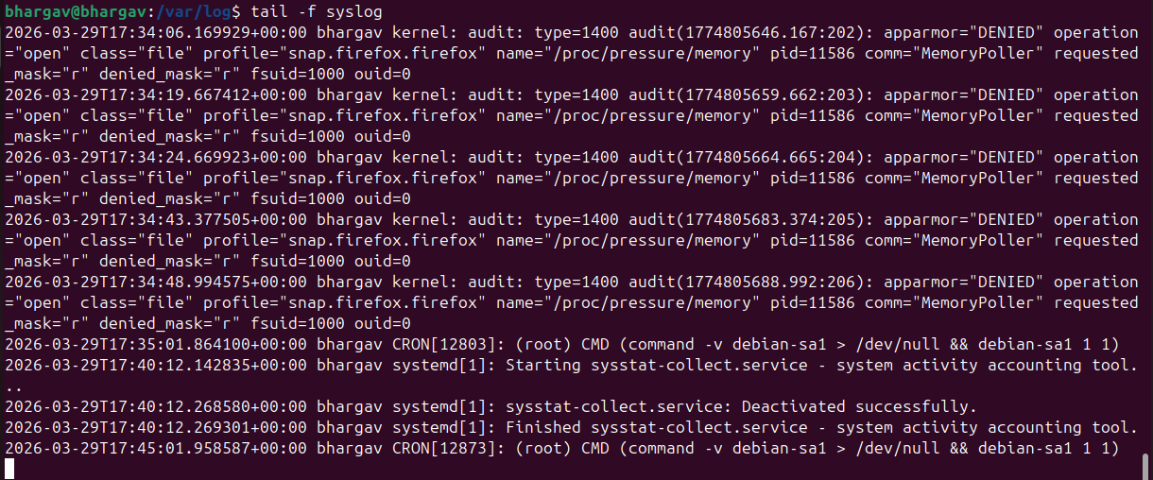
Install MySQL:
sudo apt install mysql-server -y: use this command to install mysql service
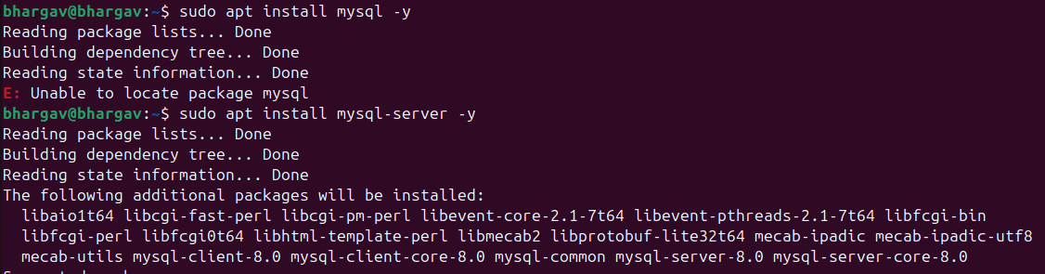
To start the service : sudo systemctl mysql
To check the status of the service: sudo systemctl mysql
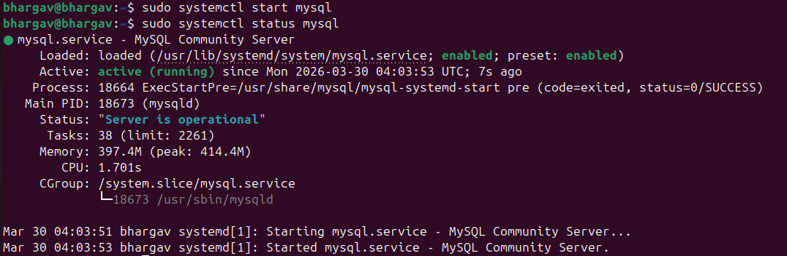

To enter the mysql : sudo mysql
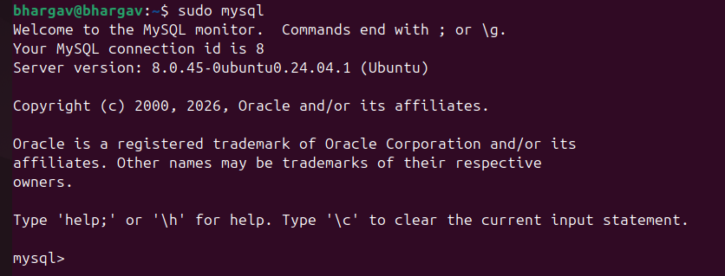

Create and manage user groups.

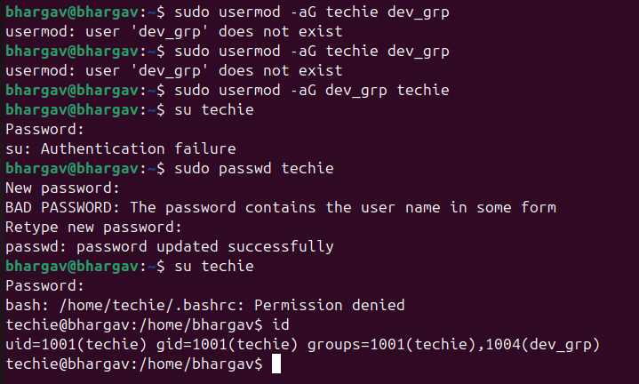

Create a symbolic link:
ln -s filename softlinkname: to use this command to create softlink
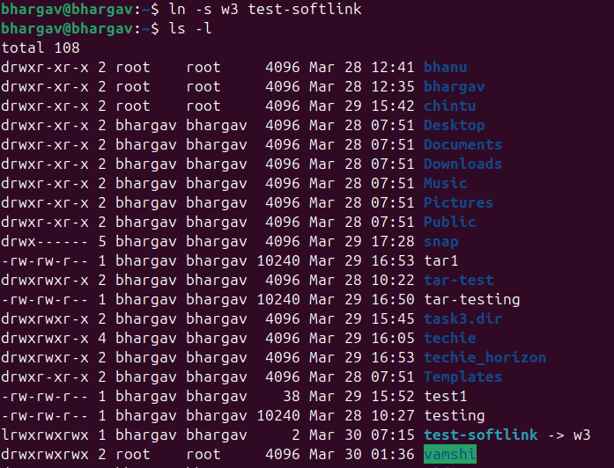
To create softlink for directory same command using : ln -s directoryname softlinkname
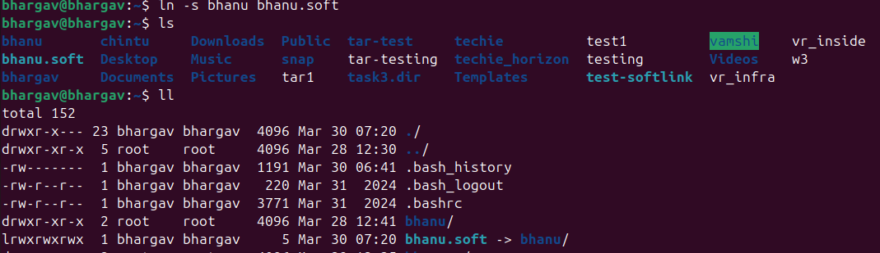

Search for files using the find command:
find /home -name file name: using this command to find the filepath
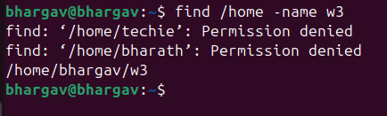

Set up SSH password less authentication:
To do this passwd less authentication follow the steps
create a sshkeygen in your local file copy the public-key
Login into server change to .ssh directory under there we will have authorized_keys
open it and paste the public key you copied from local
and the try to login using command ssh ubuntu@ip

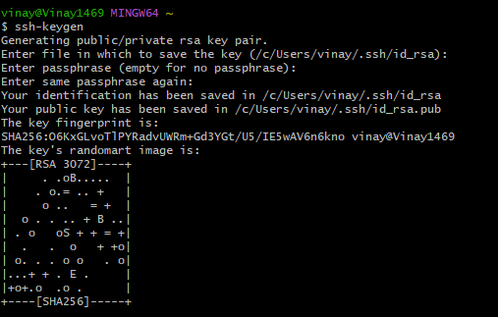

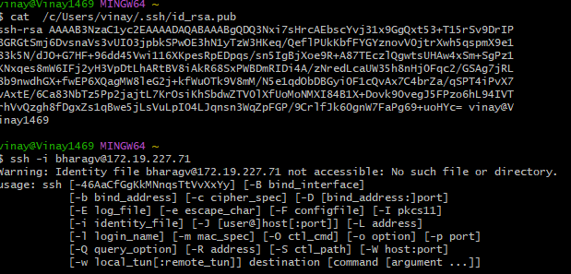

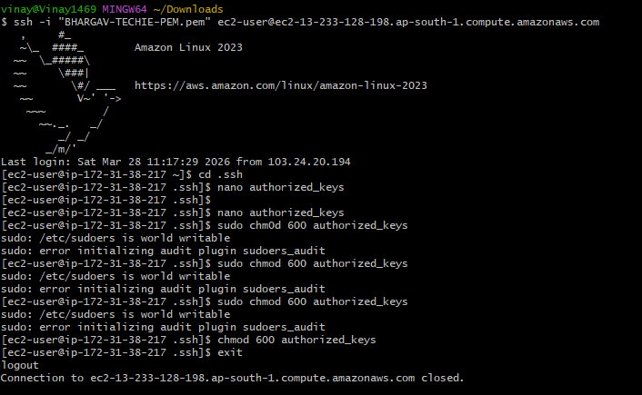
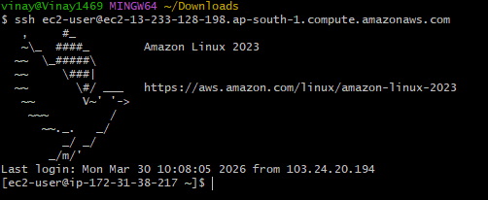
Set up a Application Server:
Follow the steps to setup the apache tomcat
wget https://dlcdn.apache.org/tomcat/tomcat-9/v9.0.116/bin/apache-tomcat-9.0.116.tar.gz used to downloadn tomcat and extract using tar xvf command and cd in bin give command sh startup.sh tomcat will now be started
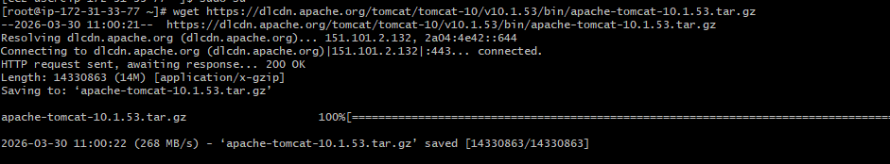

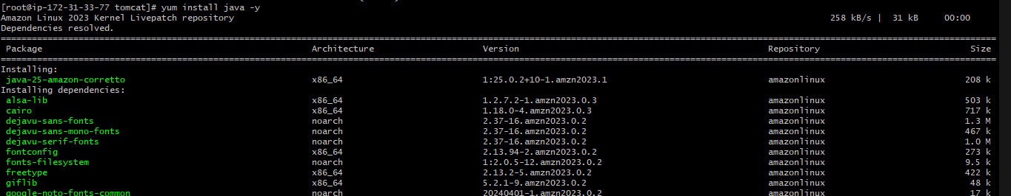
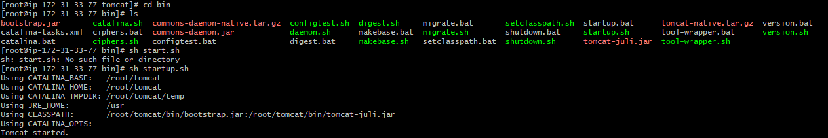

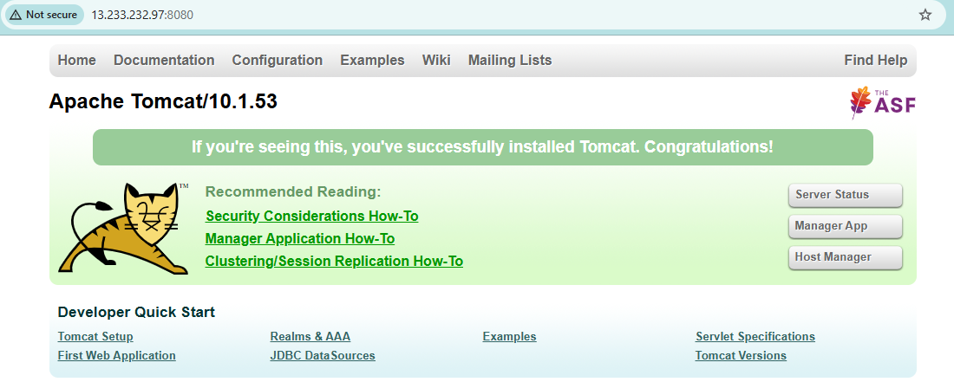

create a service file for Apache Tomcat.(Should execute by using systemtctl command):
Used this configuration service file to make work the systemctl start tomcat

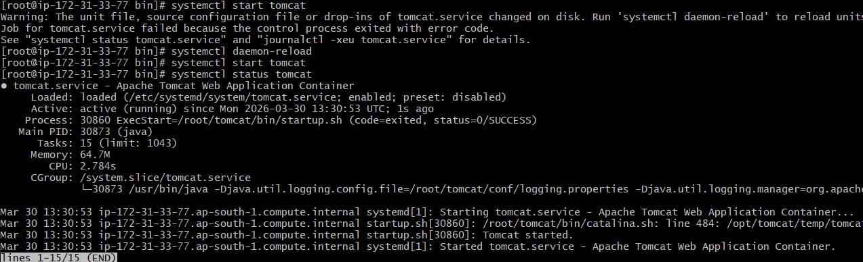

Print specific columns from a delimited file:
Print Column Range: cut -d "," -f2-3 data.txt use this command

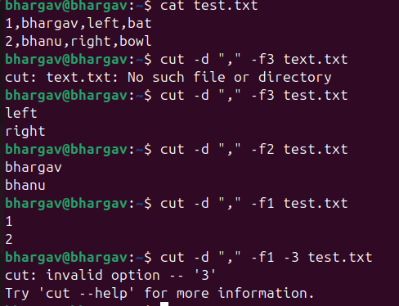

Filter and print lines based on a specific pattern or condition:
Using grep: grep "pattern" filename
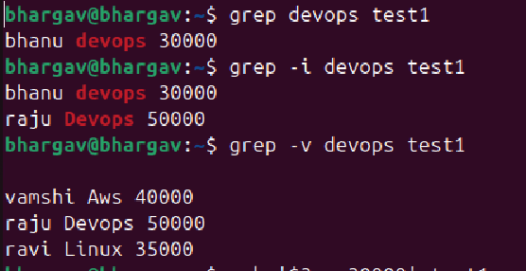
Using awk: awk '$3 > 30000' filename
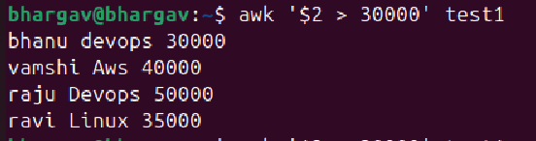

Calculate and print the average, sum, or other statistics of a column:
Calculate SUM of a Column: awk '{sum += $2} END {print sum}' filename
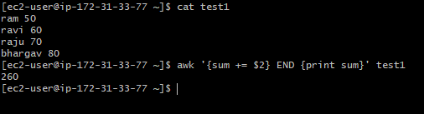
Calculate AVERAGE of a Column: awk '{sum += $2; count++} END {print sum/count}' filename
Print COUNT (Number of Rows): awk 'END {print NR}' filename
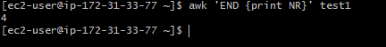

Find MAX Value: awk 'max<$2 {max=$2} END {print max}' filename
Find MIN Value: awk 'NR==1 || $2<min {min=$2} END {print min}' filename

Count the occurrences of a specific pattern in a file:
Count Pattern Using grep -c: grep -c "linux" file.txt
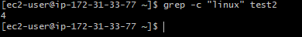
Count Using awk: awk '{for(i=1;i<=NF;i++) if($i=="linux") count++} END{print count}' filename
Sort lines based on a specific field or column:
Sort by First Column: sort filename
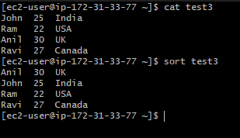
Sort by Specific Column: sort -k2 filename
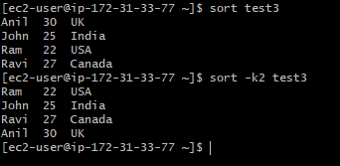

Merge multiple files based on a common field or column:
Merge Files Using ‘join’:
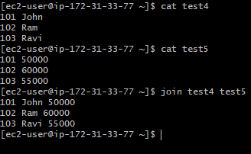
Join Using Different Columns:
- file1 → common field column 1
- file2 → common field column 2
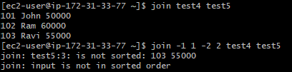

Merge Using awk:
Works even if files are not sorted.
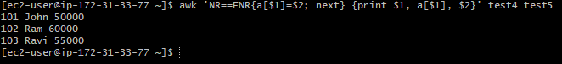

Substitute text in a file using search and replace:
Replace First Occurrence in Each Line:
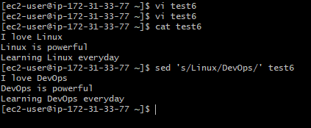

Replace Only Specific Line Number:
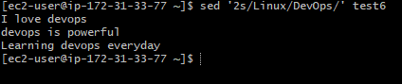
Replace Word Only:
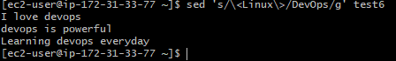

Delete specific lines based on a pattern or line number:
Delete a Specific Line Number:
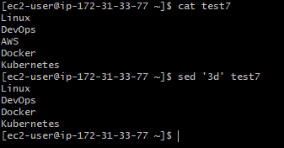

Delete Multiple Lines:
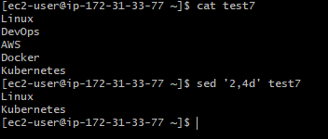
Delete Last Line:
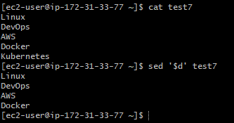
Delete Lines Matching a Pattern:
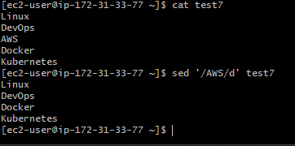

Append or insert text before or after a specific pattern or line:
Append Text AFTER a Specific Line Number:
Add text after line 2:
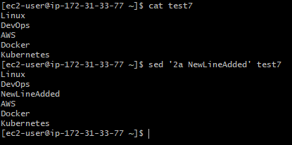
Append Text After a Pattern:
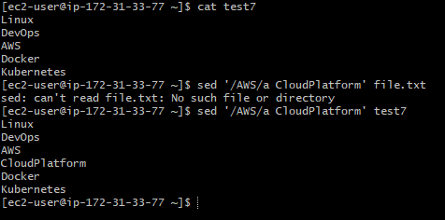
Insert Text Before a Pattern
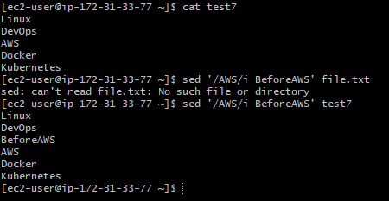

Print only specific lines from a file:
Print a Specific Line (sed):
Print line 3:
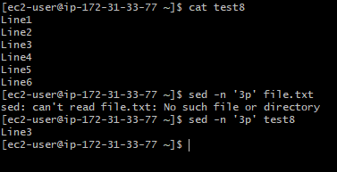
Print Multiple Lines:
Print lines 2 to 5:
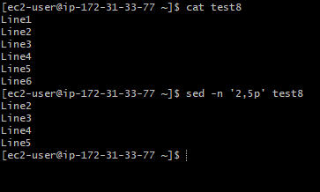
Print Last Line:
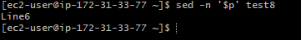

Copy file from linux to windows machine:
Using scp: scp -i /c/Users/vinay/Downloads/BHARGAV-TECHIE-PEM.pem ec2-user@13.233.232.97:/home/ec2-user/test8 /c/Users/vinay/Downloads
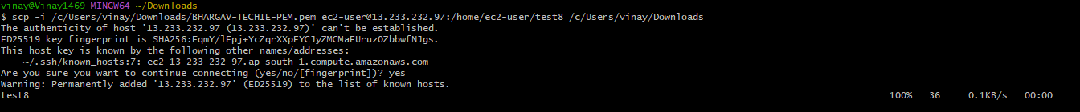

5 Use Cases of AWK:

