Q1. Create a Service Account in Google Cloud Platform

Step 1:- Go to the GCP Console.

Step 2:- Navigate to API & Services > Library.

Step 3:- Search for Cloud Vision API and click Enable.

Step 4 :- Navigate to IAM & Admin . Create a Service Accounts.

Step 5 :- Provide a name and click Create.

Step 6 :- Assign the Project.

Step 7:- Generate the Key

Step 8:- Click on the newly created service account.

Step 9:- Go to the Keys tab.

Step 10:- Click Add Key After Create New Key.

Step 11:- Select file and click Create. This downloads a file that is JSON file to your computer.

Step 12 :- Implementation (Python)

Step 13 :- Implement Json File

Q2.
git hub Url :- https://github.com/Radhepatel19/065_A.git

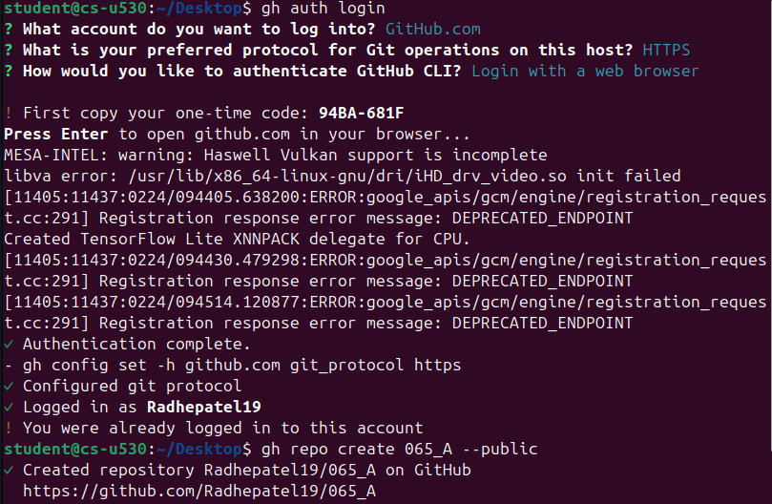
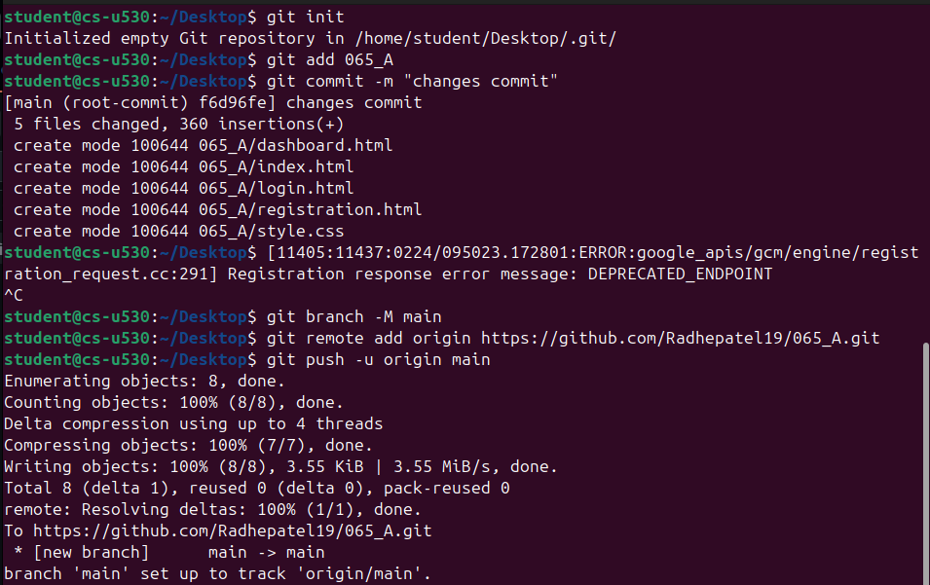

Login.html:-

<!DOCTYPE html>
<html lang="en">
<head>
<meta charset="UTF-8">
<meta name="viewport" content="width=device-width, initial-scale=1.0">
<title>Student Login</title>
<link rel="stylesheet" href="style.css">
</head>
<body>
<div class="container">
<h2>Student Login</h2>
<form id="loginForm" action="dashboard.html">
<label for="enrolment">Enrolment Number</label>
<input type="text" id="enrolment" name="enrolment" placeholder="Enter your enrolment number" required>

<label for="password">Password</label>
<input type="password" id="password" name="password" placeholder="Enter your password" required>

<button type="submit" >Login</button>
</form>
<p class="link-text">Forgot password? <a href="registration.html">Click here</a></p>
</div>
</body>
</html>

Reregistration.html
<!DOCTYPE html>
<html lang="en">
<head>
<meta charset="UTF-8">
<meta name="viewport" content="width=device-width, initial-scale=1.0">
<title>Student Registration</title>
<link rel="stylesheet" href="style.css">
</head>
<body>
<div class="container">
<h2>Student Registration</h2>
<form action="login.html" method="POST">
<label for="studentname">Student Name</label>
<input type="text" id="studentname" name="studentname" placeholder="Enter your full name" required>
<label for="enrolment">Enrolment Number</label>
<input type="text" id="enrolment" name="enrolment" placeholder="Enter your enrolment number" required>
<label for="email">Email ID</label>
<input type="email" id="email" name="email" placeholder="Enter your email address" required>
<label for="password">Password</label>
<input type="password" id="password" name="password" placeholder="Enter your password" required>
<button type="submit" >Register</button>
</form>
<p class="link-text">Already registered? <a href="home/student/Desktop/065_A/login.html">Login here</a></p>
</div>
</body>
</html>

Dashboard.html

<!DOCTYPE html>
<html lang="en">
<head>
<meta charset="UTF-8">
<meta name="viewport" content="width=device-width, initial-scale=1.0">
<title>Student Dashboard</title>
<link rel="stylesheet" href="style.css">
</head>
<body>
<div class="container">
<h2>Student Dashboard</h2>
<div class="enrolment-display">
<p>Welcome, Student!</p>
<p><strong>Enrolment Number:</strong> <span id="displayEnrolment">-</span></p>
</div>
<hr>
<h3>Elective Subject Selection</h3>
<form id="electiveForm">
<p class="instruction">Select one elective subject:</p>
<div class="elective-options">
<label class="elective-option">
<input type="radio" name="elective" value="NLP" required>
<span>NLP (Natural Language Processing)</span>
</label>
<label class="elective-option">
<input type="radio" name="elective" value="IoT">
<span>IoT (Internet of Things)</span>
</label>
<label class="elective-option">
<input type="radio" name="elective" value="DevOps">
<span>DevOps</span>
</label>
</div>
<button type="submit">Save Selection</button>
</form>
<p id="successMessage" class="success-message" style="display: none;">
Elective subject saved successfully!
</p>
<p class="link-text">
<a href="login.html">Logout</a>
</p>
</div>
<script>
// Display the enrolment number from localStorage
document.addEventListener('DOMContentLoaded', function() {
var enrolment = localStorage.getItem('enrolmentNumber');
if (enrolment) {
document.getElementById('displayEnrolment').textContent = enrolment;
} else {
document.getElementById('displayEnrolment').textContent = 'Not logged in';
}
});
// Handle elective form submission
document.getElementById('electiveForm').addEventListener('submit', function(e) {
e.preventDefault();
var selectedElective = document.querySelector('input[name="elective"]:checked');
if (selectedElective) {
localStorage.setItem('selectedElective', selectedElective.value);
// Show success message
var successMsg = document.getElementById('successMessage');
successMsg.style.display = 'block';
successMsg.textContent = 'Elective subject "' + selectedElective.value + '" saved successfully!';
// Optionally hide message after 3 seconds
setTimeout(function() {
successMsg.style.display = 'none';
}, 3000);
} else {
alert('Please select an elective subject!');
}
});
</script>
<style>
.enrolment-display {
background: #f5f5f5;
padding: 15px;
border-radius: 8px;
margin-bottom: 20px;
text-align: center;
}
.enrolment-display p {
margin: 5px 0;
color: #333;
}
hr {
border: none;
border-top: 1px solid #ddd;
margin: 20px 0;
}
h3 {
text-align: center;
color: #333;
margin-bottom: 15px;
}
.instruction {
color: #666;
margin-bottom: 15px;
font-size: 14px;
}
.elective-options {
margin: 15px 0;
}
.elective-option {
display: block;
padding: 12px;
margin: 8px 0;
border: 1px solid #ddd;
border-radius: 6px;
cursor: pointer;
transition: 0.3s;
}
.elective-option:hover {
background-color: #f9f9f9;
border-color: #764ba2;
}
.elective-option input[type="radio"] {
width: auto;
margin-right: 10px;
}
.elective-option span {
color: #333;
}
.success-message {
background-color: #d4edda;
color: #155724;
padding: 12px;
border-radius: 6px;
text-align: center;
margin-top: 15px;
border: 1px solid #c3e6cb;
}
</style>
</body>
</html>

Index.html
<!DOCTYPE html>
<html lang="en">
<head>
<meta charset="UTF-8">
<meta name="viewport" content="width=device-width, initial-scale=1.0">
<title>Student Management System</title>
<link rel="stylesheet" href="style.css">
</head>
<body>
<div class="container">
<h2>Student Management System</h2>
<div class="welcome-message">
<p>Welcome to the Student Portal</p>
<p class="subtitle">Manage your profile and select your elective subjects</p>
</div>
<div class="home-buttons">
<a href="login.html" class="btn">Login</a>
<a href="registration.html" class="btn">Register</a>
</div>
<div class="features">
<h3>Features</h3>
<ul>
<li>Student Registration</li>
<li>Secure Login</li>
<li>Elective Subject Selection</li>
<li>Profile Management</li>
</ul>
</div>
</div>
<style>
.welcome-message {
text-align: center;
margin: 20px 0;
}
.welcome-message p {
margin: 10px 0;
color: #333;
}
.subtitle {
font-size: 14px;
color: #666 !important;
}
.home-buttons {
display: flex;
flex-direction: column;
gap: 12px;
margin: 25px 0;
}
.btn {
display: block;
width: 100%;
padding: 12px;
background-color: #764ba2;
color: white;
border: none;
border-radius: 6px;
cursor: pointer;
font-size: 16px;
text-align: center;
text-decoration: none;
transition: 0.3s;
box-sizing: border-box;
}
.btn:hover {
background-color: #5a3782;
}
.features {
margin-top: 25px;
padding-top: 20px;
border-top: 1px solid #ddd;
}
.features h3 {
text-align: center;
color: #333;
margin-bottom: 15px;
}
.features ul {
list-style: none;
padding: 0;
}
.features li {
padding: 8px 0;
color: #666;
text-align: center;
}
.features li::before {
content: "✓ ";
color: #764ba2;
}
</style>
</body>
</html>

Style.html
body {
font-family: 'Segoe UI', Tahoma, Geneva, Verdana, sans-serif;
display: flex;
justify-content: center;
align-items: center;
height: 100vh;
margin: 0;
}

.container {
background: white;
padding: 2rem;
border-radius: 12px;
box-shadow: 0 10px 25px rgba(0,0,0,0.2);
width: 350px;
}

h2 { text-align: center; color: #333; }

input, select {
width: 100%;
padding: 12px;
margin: 10px 0;
border: 1px solid #ddd;
border-radius: 6px;
box-sizing: border-box;
}

.link-text {
text-align: center;
margin-top: 15px;
font-size: 14px;
}

label {
display: block;
margin: 10px 0 5px;
color: #333;
font-weight: 500;
}

Dashboard:-
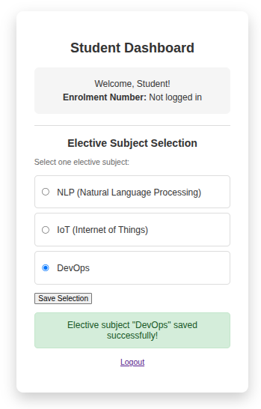

Login

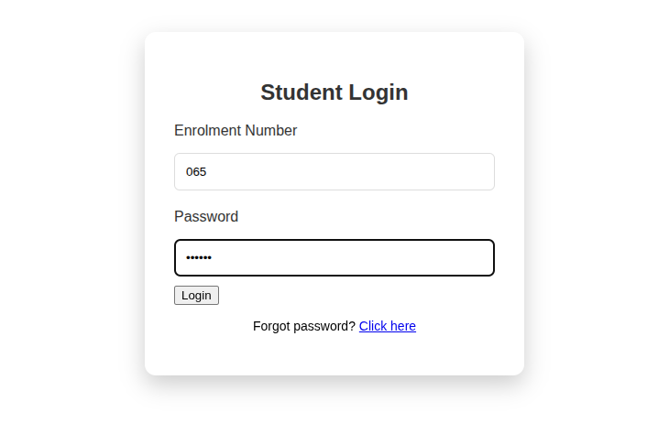

Registration

