**1. Redirect to GitUser component which includes List of Git user list.**

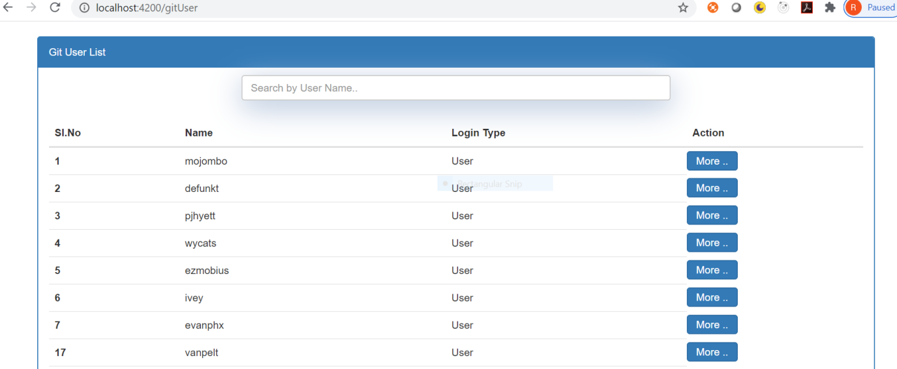

**2.Git User List is shown using GIT third party API (**https://api.github.com/users)

**3. Click on more button, Pop up will appear along with particular user repository URL and Org URL as shown below screenshot.**

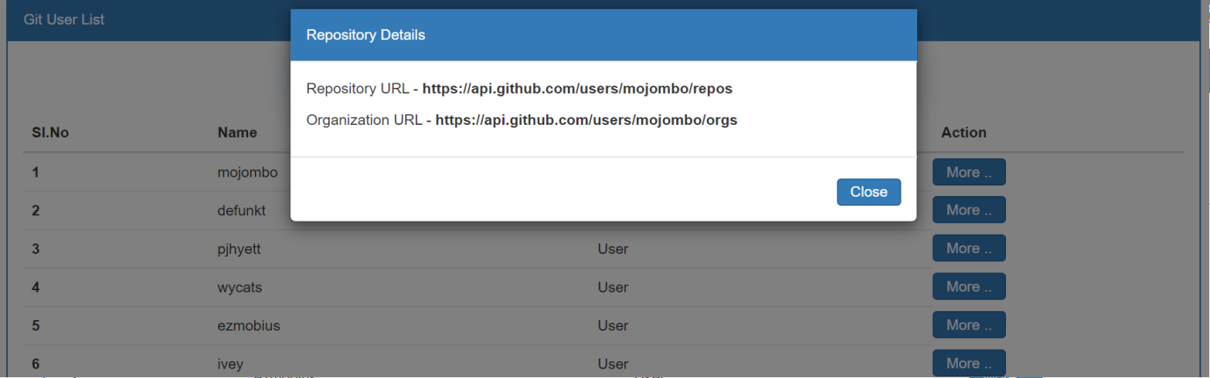

**4.**