PROGRAM NO 1

//Java program to print used different characters (letters) in a string

import java.util.Scanner;

class prog1

{

public static void main(String args[])

{

String str, s;

int i;

char c;

Scanner scan=new Scanner(System.in);

System.out.print("ENTER THE STRING:");

str=scan.nextLine();

s=str.toLowerCase();

System.out.println("USED CHARACTERS IN THE STRINGS ARE:-");

for( c='a'; c<='z';c++)

{

for(i=0;i<s.length();i++)

{

if(c==s.charAt(i))

{

System.out.print(c + " ");

break;

}

}

}

}

}

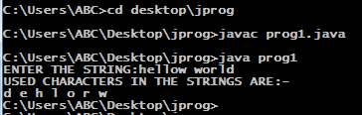

PROGRAM NO 2

//Java program to print table of integer number.

import java.util.Scanner;

class prog2

{

public static void main(String a[])

{

int k,j,i=0;

Scanner scan=new Scanner(System.in);

System.out.println("ENETR THE INTEGER NUMBER:");

j=scan.nextInt();

System.out.println("TABLE IS:");

for(i=0;i<=10;i++)

{

k=j\*i;

System.out.println(j+" \* "+i+" = "+k);

}

}

}

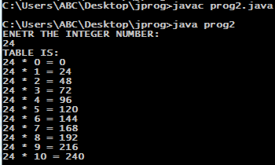

PROGRAM NO 3

//Java program count the number of divisor.

import java.util.Scanner;

class prog3

{

public static void main(String a[])

{

int i,j,k=0;

Scanner scan=new Scanner(System.in);

System.out.println("ENTER THE INTEGER NUMBER:");

j=scan.nextInt();

for (i = 1; i <=j; i++)

{

if (j % i == 0)

{

k++;

}

}

System.out.print("Total Number Of Divisor Are: "+k);

}

}

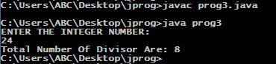

PROGRAM NO 4

//Java program to count total number of words in strings.

import java.util.Scanner;

public class prog4

{

public static void main(String args[])

{

Scanner scan=new Scanner(System.in);

String str;

int i,n = 1;

System.out.println("ENTER THE STRING:");

str=scan.nextLine();

for (i=0; i < str.length()-1; i++)

{

if ((str.charAt(i) == ' ') && (str.charAt(i+1) != ' '))

{

n++;

}

}

System.out.print("NUMBRE OF WORDS ARE :");

System.out.print(n);

}

}

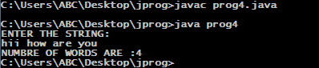

PROGRAM NO 5

//JAva prog to print all prime numbers form 1 to n.

import java.util.Scanner;

public class prog5

{

public static void main(String args[])

{

Scanner scan=new Scanner(System.in);

int i,n,k;

System.out.println("ENTER THE NUMBER:");

k=scan.nextInt();

if(k<=1)

{

System.out.println("PLEASE ENTER VALID NUMBER:");

}

else

for (n=2; n<=k; n++)

{

boolean isPrime = true;

for (i=2; i <= n/2; i++)

{

if ( n % i == 0)

{

isPrime = false;

break;

}

}

if ( isPrime == true )

System.out.println(n);

}

}

}

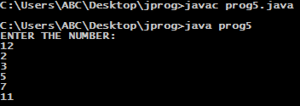

PROGRAM NO 6

//JAva prog to print allstudent details.

import java.util.Scanner;

public class prog6

{

public static void main(String args[])

{

Scanner scan=new Scanner(System.in);

String name;

int dob,age,rollno;

System.out.print("ENTER THE STUDENT NAME: ");

name=scan.nextLine();

System.out.print("ENTER THE ROLL NO: ");

rollno=scan.nextInt();

System.out.print("ENTER THE AGE: ");

age=scan.nextInt();

System.out.println("NAME OF STUDENT IS "+name);

System.out.println("ROLL NO OF STUDENT IS "+rollno);

System.out.println("AGE OF STUDENT IS "+ age);}

}

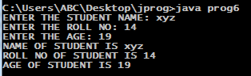

PROGRAM NO 7

\\Java program to print all odd numbers from 1 to n

import java.util.Scanner;

class prog7

{

public static void main(String args[])

{

Scanner scan=new Scanner(System.in);

int i,n = 0;

System.out.println("ENTER THE INTEGER:");

n=scan.nextInt();

System.out.println("ODD NUMBERS ARE: ");

for (i=0;i<=n;i++)

{

if(i%2!=0)

{

System.out.println(i);

}

}

}

}

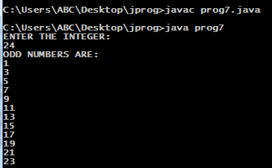

PROGRAM NO 8

//Java program to print all even numbers from 1 to n

import java.util.Scanner;

class prog8

{

public static void main(String args[])

{

Scanner scan=new Scanner(System.in);

int i,n = 0;

System.out.println("ENTER THE INTEGER:");

n=scan.nextInt();

System.out.println("EVEN NUMBERS ARE: ");

for (i=0;i<=n;i++)

{

if(i%2==0)

{

System.out.println(i);

}

}

}

}

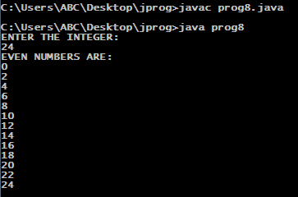

PROGRAM NO 9

//Java program to print reverse of the number

import java.util.Scanner;

class prog9

{

public static void main(String args[])

{

Scanner scan=new Scanner(System.in);

int i=0,n,res=0;

System.out.println("ENTER THE NUMBER:");

n=scan.nextInt();

System.out.print("REVERSED NUMBER IS: ");

while(n>0)

{

res=(res\*10)+(n%10);

n=n/10;

}

System.out.print(res);

}

}

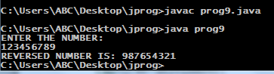

PROGRAM NO 10

//Java program to print reverse of the string.

import java.util.Scanner;

class prog10

{

public static void main(String args[])

{

Scanner scan=new Scanner(System.in);

int i;

String str,res="";

System.out.println("ENTER THE STRING:");

str=scan.nextLine();

System.out.print("REVERSED STRING IS: ");

for(i=str.length()-1;i>=0;i--)

{

res=res+str.charAt(i);

}

System.out.print(res);

}

}

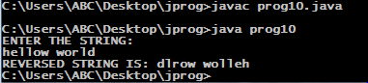

PROGRAM NO 11

//Java program to print reverse of the number

import java.util.Scanner;

class pro11

{

public static void main(String args[])

{

Scanner scan=new Scanner(System.in);

int m,i=0,n,res=0;

System.out.println("ENTER THE NUMBER:");

n=scan.nextInt();

m=n;

System.out.print("REVERSED NUMBER IS:- ");

while(n>0)

{

res=(res\*10)+(n%10);

n=n/10;

}

System.out.print(res);

if(m==res)

{

System.out.print("----->THIS STRING Is A PALINDROME.");

}

else

{

System.out.print("----->THIS STRING Is NOT A PALINDROME.");

}

}

}

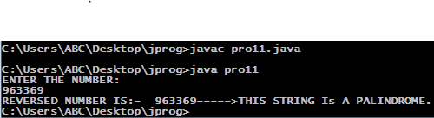

PROGRAM NO 12

\\ Java prog to fint the factorial.

import java.util.Scanner;

class pro12

{

public static void main(String a[])

{

int f=1,n,i;

Scanner scan=new Scanner(System.in);

System.out.println("ENTER THE NUMBER TO FIND THE FACTORIAL");

n=scan.nextInt();

for(i=1;i<=n;i++)

{

f=f\*i;

}

System.out.print("FACTORIAL OF THIS NUMBER IS====>");

System.out.print(f);

}

}

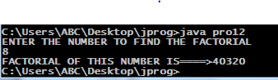

PROGRAM NO 13

/\*Java program for fibonacci series\*/

import java.util.Scanner;

class pro13

{

public static void main(String a[])

{

int e=0,f=1,g,h,i;

Scanner scan=new Scanner(System.in);

System.out.println("ENTER THE LAST NUMBER: ");

g=scan.nextInt();

System.out.println("FIBONACCI SERIES IS====>");

System.out.println(e);

for(i=2;i<=g;++i)

{

h=e+f;

System.out.println(h);

e=f;

f=h;

}

}

}

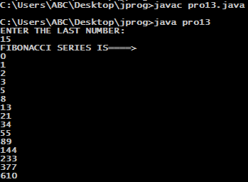

PROGRAM NO 14

/\*Java program for simple interest\*/

import java.util.Scanner;

class pro14

{

public static void main(String a[])

{

Scanner scan=new Scanner(System.in);

int p,r,n,si;

System.out.print("Enter principal amount: ");

p=scan.nextInt();

System.out.print("Enter rate of interest: ");

r=scan.nextInt();

System.out.print("Enter number of years: ");

n=scan.nextInt();

si=(p\*r\*n)/100;

System.out.print("Simple interest is "+si);

}

}

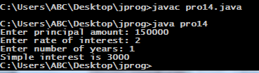

PROGRAM NO 15

import java.util.Scanner;

class pro15

{

public static void main(String args[])

{

Scanner scan=new Scanner(System.in);

double p, r, t,ci;

System.out.println("ENTER THE VALUES ::");

System.out.print("PRINCIPLE AMOUNT : ");

p=scan.nextInt();

System.out.print("RATE OF INTEREST : ");

r=scan.nextInt();

System.out.print("TIME:");

t=scan.nextInt();

ci = p\*(Math.pow((1 + r/ 100),t));

System.out.println("Compound Interest is "+ ci);

}

}

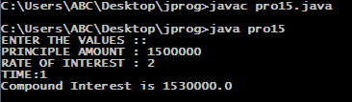

PROGRAM NO 16

\\Java prog to print largest among 3 numbers

import java.util.Scanner;

class pro16

{

public static void main(String args[])

{

Scanner scan=new Scanner(System.in);

int a,b,c;

System.out.print("ENTER THE VALUE OF a : ");

a=scan.nextInt();

System.out.print("ENTER THE VALUE OF b : ");

b=scan.nextInt();

System.out.print("ENTER THE VALUE OF c : ");

c=scan.nextInt();

if(a>=b && a>=c)

{

System.out.println("Largest number is====>" +a);

}

else if(b>=a && b>=c)

{

System.out.println("Largest number is====>" +b);

}

else

{

System.out.println("Largest number is====>" +c);

}

}

}

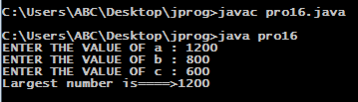

PROGRAM NO 17

\\ Java prog calculate bill .

import java.util.Scanner;

class pro17

{

public static void main(String args[])

{

Scanner scan=new Scanner(System.in);

float a,b,c;

System.out.print("Enter the Amount of per unit : ");

a=scan.nextInt();

System.out.print("How many units is used in this month: ");

b=scan.nextInt();

c=a\*b;

System.out.print("YOU HAVE TO PAY RUPEES:- "+c);

}

}

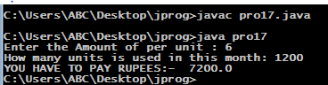

PROGRAM NO 18

// Java prog for sum of digits of number.

import java.util.Scanner;

class pro18

{

public static void main(String args[])

{

Scanner scan=new Scanner(System.in);

int i,n,m=0;

System.out.print("Enter the number : ");

n=scan.nextInt();

while(n>0)

{

i=n%10;

m=m + i;

n=n/10;

}

System.out.print("SUM OF DIGITS OF NUMBER IS:- "+m);

}

}

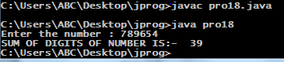

PROGRAM NO 19

//java prog for depreciation of machinery.

import java.util.Scanner;

class pro19

{

public static void main(String arg[])

{

Scanner scan=new Scanner(System.in);

long amt,dep,yr,n;

System.out.print("Enter the amount of machinery.: ");

amt=scan.nextLong();

System.out.print("Enter the depercent : ");

dep=scan.nextLong();

System.out.print("Enter the year : ");

yr=scan.nextLong();

n=amt;

for(int i=0;i<yr;i++)

n=((100-dep)\*n)/100;

System.out.println("DEPRIACIATION= "+n);

}

}

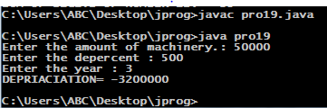

*PROGRAM NO 20 \\ Java prog to calculate cgpa.*

*import java.util.Scanner;*

*class pro20*

*{*

*public static void main(String arg[])*

*{*

*Scanner scan=new Scanner(System.in);*

*int m1,m2,m3,m4,m5,tm;*

*System.out.print("Enter the marks of physics : ");*

*m1=scan.nextInt();*

*System.out.print("Enterthe marks of geometry : ");*

*m2=scan.nextInt();*

*System.out.print("Enter the marks of algebra : ");*

*m3=scan.nextInt();*

*System.out.print("Enter the marks of history : ");*

*m4=scan.nextInt();*

*System.out.print("Enter the marks of geography: ");*

*m5=scan.nextInt();*

*tm=((m1+m2+m3+m4+m5)\*100)/500;*

*if(tm>=0 && tm<=10)*

*{*

*System.out.print("YOUR CGPA IS 1");*

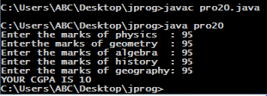

*}*

*else if(tm>=11 && tm<=20)*

*{*

*System.out.print("YOUR CGPA IS 2");*

*}*

*else if(tm>=21 && tm<=30)*

*{*

*System.out.print("YOUR CGPA IS 3");*

*}*

*else if(tm>=31 && tm<=40)*

*{*

*System.out.print("YOUR CGPA IS 4");*

*}*

*else if(tm>=41 && tm<=50)*

*{*

*System.out.print("YOUR CGPA IS 5");*

*}*

*else if(tm>=51 && tm<=60)*

*{*

*System.out.print("YOUR CGPA IS 6");*

*}*

*else if(tm>=61 && tm<=70)*

*{*

*System.out.print("YOUR CGPA IS 7");*

*}*

*else if(tm>=71 && tm<=80)*

*{*

*System.out.print("YOUR CGPA IS 8");*

*}*

*else if(tm>=81 && tm<=90)*

*{*

*System.out.print("YOUR CGPA IS 9");*

*}*

*else*

*{*

*System.out.print("YOUR CGPA IS 10");*

*}*

*}*

*}*