PROGRAM NO: 1

import java.util.Scanner;

import java.util.Random;

class randomcheck{

public static void main(String a[])

{

Random rd=new Random();

int rd_num=rd.nextInt(10);

Scanner scan=new Scanner(System.in);

int n;

for(int i=0;i<3;i++)

{

System.out.print("Enter any integer from 0 to 10:- ");

n=scan.nextInt();

if(rd_num==n)

{

System.out.println("YOU WIN");

break;

}

else

{

System.out.println("You Loose");

}

}

}

}

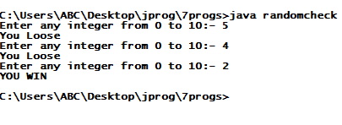

PROGRAM NO:- 2

import java.util.Scanner;

import java.util.Random;

class duplicate

{

public static void main(String args[])

{

Random rd=new Random();

int a=rd.nextInt(10);

int b=rd.nextInt(10);

int c=rd.nextInt(10);

int d=rd.nextInt(10);

int e=rd.nextInt(10);

System.out.println("RANDOM NUMBERS CREATED BY COMPUTER ARE:-");

System.out.println(a);

System.out.println(b);

System.out.println(c);

System.out.println(d);

System.out.println(e);

if(a==b ||a==c|| a==d || a==e || b==c || b==d || b==e || c==d || c==e || d==e){

System.out.println("\t\tNumbers In This List Are Duplicate");

}

else{

System.out.println("\t\tNumbers In This List Are Not Duplicate");

}

}

}

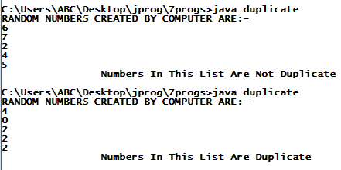

PROGRAM NO:-3

import java.util.Scanner;

class movie

{

public static void main(String args[])

{

System.out.println("");

System.out.println("\tMOVIE GUESS GAME");

System.out.println("-->YOU wILL GET FIVE CHANCE TO GUESS THE MOVIE");

System.out.print("HINT----->");

System.out.println("D _ _ _ _ N _ _ E");

String movi="deathnote";

Scanner sc=new Scanner(System.in);

String name,n;

for(int i=1;i<6;i++)

{

System.out.println("");

System.out.println("\tCHANCE NO."+i);

System.out.println("Enter the name of movie:-");

name=sc.nextLine();

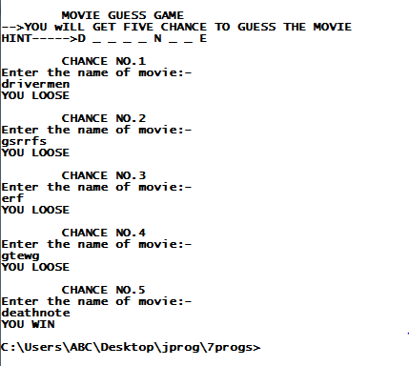

n=name.toLowerCase();

if(movi.equals(n))

{

System.out.println("YOU WIN");

break;

}

else

{

System.out.println("YOU LOOSE");

}

}

}

}

PROGRAM NO:-4

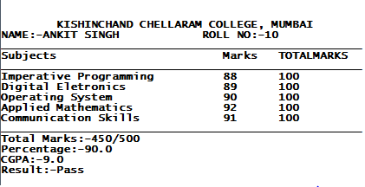

import java.util.Scanner;

class marksheet{

public static void main(String

args[])

{

String name,college;

int total,ip,de,os,cs,am,rollno;

float cgpa, per;

college="KISHINCHAND CHELLARAM

COLLEGE, MUMBAI";

name="ANKIT SINGH";

rollno=10;ip=88;de=89;

os=90;cs=91;am=92;

total=ip+de+os+cs+am;

per=total/5;

cgpa=per/10;

System.out.println("");

System.out.println("");

System.out.println("\t"+college);

System.out.println("NAME:-"+name+"\t ROLL NO:-"+rollno);

System.out.println("____________________________________________________");

System.out.println("Subjects Marks\tTOTALMARKS");

System.out.println("____________________________________________________");

System.out.println("Imperative Programming "+ip+"\t100");

System.out.println("Digital Eletronics "+de+"\t100");

System.out.println("Operating System "+os+"\t100");

System.out.println("Applied Mathematics "+am+"\t100");

System.out.println("Communication Skills "+cs+"\t100");

System.out.println("____________________________________________________");

System.out.println("Total Marks:-"+total+"/500");

System.out.println("Percentage:-"+per);

System.out.println("CGPA:-"+cgpa);

if (cgpa<3){

System.out.println("Result:-Fail");

}

else{

System.out.println("Result:-Pass");

}

}}

PROGRAM NO:- 5

import java.util.Scanner;

import java.util.ArrayList;

class attendence

{

public static void main(String args[])

{

Scanner scan=new Scanner(System.in);

String name;

System.out.println("");

System.out.println("\tATTENDENCE FOR THE YEAR 2019-2020");

System.out.println("Total number of days college was open :-300");

System.out.print("Enter name of student:-");

name=scan.nextLine();

System.out.print("Enter the number of days student attended lectures:-");

int n;

n=scan.nextInt();

if(n<225)

{

System.out.println("You are blacklisted");

}

else

{

System.out.println("You are not blacklisted");

}

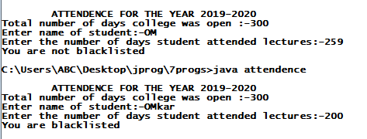

}

}

PROGRAM NO:-6

import java.util.Scanner;

import java.util.Random;

class largesmall

{

public static void main(String args[])

{

Random rd=new Random();

int a=rd.nextInt(12);

int b=rd.nextInt(12);

System.out.print("Your Number is :- ");

System.out.println(a);

System.out.print("Computer's Number is :- ");

System.out.println(b);

if(a>b)

{

System.out.println("------------->Hooray! YOU WIN");

}

else

{

System.out.println("-------------->BETTER LUCK NEXT TIME____YOU LOOSE");

}

}

}

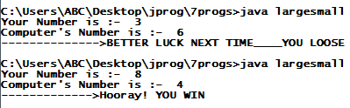

//Program no:-7

//WAJP to convert number to words....

import java.util.Scanner;

import java.io.*;

class numtowrds{

public static void main(String args[])throws IOException{

String units[]= {""," one"," two"," three"," four"," five"," six"," seven"," eight"," nine"};

String twoDigits[]= {" ten"," eleven"," twelve"," thirteen"," fourteen"," fifteen"," sixteen"," seventeen"," eighteen"," nineteen"};

String tenMultiples[]= {"",""," twenty"," thirty"," forty"," fifty"," sixty"," seventy"," eighty"," ninety"};

String placeValues[]= {""," thousand"," million"," billion"," trillion"};

BufferedReader in = new BufferedReader(new InputStreamReader(System.in));

String[] input = new String[4];

int a,b,c,d;

System.out.println();

System.out.print("Please ENter only Four digit number:-");

input = in.readLine().split("");

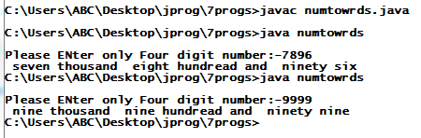

a = Integer.parseInt(input[0]);

b = Integer.parseInt(input[1]);

c = Integer.parseInt(input[2]);

d = Integer.parseInt(input[3]);

System.out.print(units[a]+" thousand ");

System.out.print(units[b]+" hundread ");

System.out.print(tenMultiples[c]);

System.out.print(units[d]);

}}