nyass.org Learning Platform
Architecture, Hosting & Feature Plan
Prepared: September 2026

1. Overview
This document outlines the recommended technology, structure, and hosting approach for a login-gated learning platform on nyass.org. The platform will host five subject courses — Dnyaneshwari, Gatha, Dasbodh, Vaidik Knowledge, and Gondavalekar Maharaj Pravachane — each containing roughly 30–40 modules of Marathi-language text and video content, with progress tracking, periodic knowledge tests, and an advanced Trainer Course for candidates who complete a base course.

2. Recommended Technology Stack
Layer | Choice | Why
Frontend/Backend | Next.js (React) | Larger ecosystem than Vue/Nuxt, best-documented Supabase integration, easier to hand off to future developers
Database, Auth, Storage | Supabase (Postgres) | Bundles relational DB, Google SSO + email auth, and file storage in one managed service; generous free tier
Hosting | Vercel | Built by the Next.js team; zero DevOps, push-to-deploy, free tier covers this project's expected scale
Video | YouTube (unlisted) | Free, reliable streaming; access still gated by the app's own login wall
Transactional email | Resend | Simple API, free tier comfortably covers completion-email volume at this scale
Content editing | Supabase Table Editor → custom admin panel later | Avoids building a full admin UI before it's needed; upgrade path stays open

3. Course & Module URL Structure
Path-based routing under the main domain, rather than subdomains:
- nyass.org/dnyaneshwari — Dnyaneshwari course landing page
- nyass.org/dnyaneshwari/module-12 — an individual module within the course
- nyass.org/gatha, nyass.org/dasbodh, nyass.org/vaidik-gnan, nyass.org/pravachane — the remaining courses
- nyass.org/trainer-course — the advanced course, unlocked after prerequisite completion
Reasoning:
- A single login session works across all courses without cross-subdomain cookie configuration
- One codebase and one deployment to maintain
- Simpler, cheaper DNS/SSL management — no per-subdomain certificates
- Course slugs stay in transliterated English for clean, shareable URLs, even though displayed content is in Marathi

4. Data Model (summary)
Table | Purpose
courses | Course name, description, display order
modules | Belongs to a course; title, content type (text/video), video URL or text body, order
enrollments | Links a user to a course with status: interested / active / completed
module_progress | Tracks per-user, per-module completion and timestamp
quizzes / quiz_questions | Test questions tied to a module or end-of-course
quiz_attempts | User's score, pass/fail, and attempt timestamp

Trainer Course unlock rule: a user becomes eligible once all modules in the prerequisite course are marked complete and the final quiz is passed above the required threshold.

5. Login & Access
- Authentication via Supabase Auth, supporting both Google SSO and individual email/password sign-in
- Course access begins as “interested” and is upgraded to “active” access per course, allowing staged rollout of content to users
- Row-level security ensures a user can only read their own progress and profile data

6. SEO Considerations
- Pages tagged with lang="mr" so search engines correctly index Marathi-language content
- Next.js server-side rendering gives crawlable, indexable course pages if public discovery is desired
- Course landing pages (not gated content) can be public-facing to aid discoverability, with module content itself behind login
- Devanagari-supporting font (e.g. Noto Sans Devanagari) included in the site's font stack for clean rendering across devices
- YouTube videos can include Marathi captions/subtitles, aiding both accessibility and searchability

7. Completion Email
When a user completes all modules and passes the final quiz for a course, a Supabase database trigger fires a call to Resend, which sends a completion notification email automatically. A downloadable PDF certificate is a natural phase-2 addition but is not required initially.

8. Hosting & Estimated Costs
Service | Free tier covers | Paid tier (if outgrown)
Vercel (hosting) | Expected traffic for this project (5–10 concurrent users) | ~$20/month (Pro)
Supabase (DB/Auth/Storage) | 500MB database, auth, and storage — ample for ~10,000 users' worth of progress records | ~$25/month
YouTube (video) | Unlimited, free | N/A
Resend (email) | Thousands of emails/month | Pay-as-you-grow, negligible at this scale
Domain (nyass.org) | Already owned | Annual renewal only

Estimated realistic cost: $0–25/month at launch, scaling to roughly $50–100/month only if usage grows well beyond the currently expected 100–10,000 total users with 5–10 concurrent sessions.
Vercel vs. Azure/AWS/GCP: general-purpose cloud platforms (Azure App Service, AWS, GCP) offer more control but require dedicated DevOps effort for CI/CD, scaling, and SSL configuration. Vercel is purpose-built for Next.js and was chosen for its operational simplicity given no dedicated DevOps resource on this project. The choice is not a one-way door — migrating to another cloud remains possible later if needs like heavy video processing or data residency requirements arise.

9. Architecture Diagram
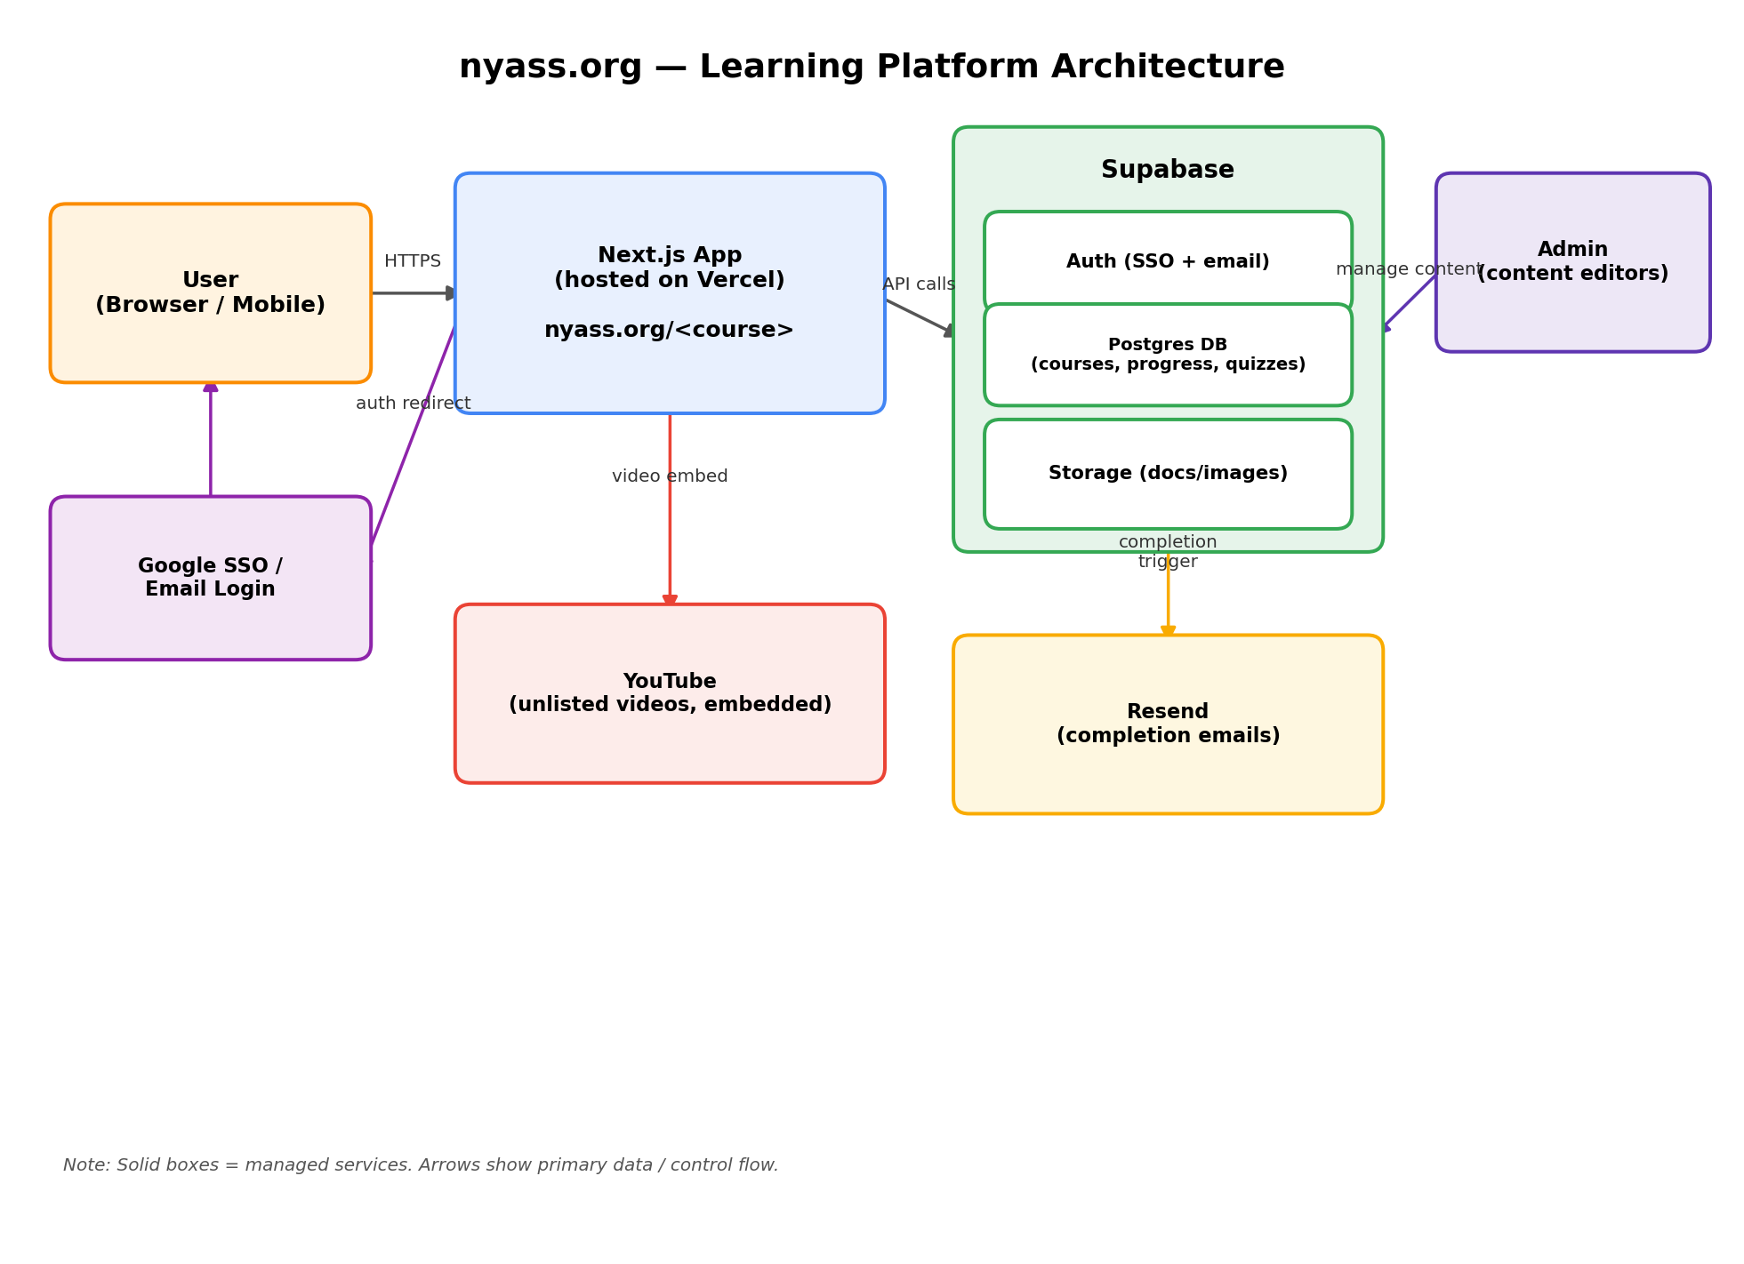

10. Open Items for Later Phases
- Number and structure of quiz questions per module/course
- Whether a downloadable PDF certificate should be added
- Whether a custom admin UI is needed once Supabase's Table Editor becomes cumbersome for editors
- Marathi input workflow for content editors (OS-level Marathi keyboard/input method)

