coding challenge 4_markdown
Radhika
2026-02-19

. Explain
- YAML header: YAML contains the arguements like title, author, date demarcated by three dashes — on both ends. this is displayed at the begining of the document.
- Literate programming :

. Question
data for the manuscript is here.
df<- read.csv("MycotoxinData.csv", na.strings = "na")
library(ggplot2)
## Warning: package 'ggplot2' was built under R version 4.5.2
plot_box<- ggplot(df, aes(x = Treatment, y= DON, fill= Cultivar))+
geom_boxplot()+
scale_fill_manual(values = c("#0072B2","#E69F00"))+
geom_point( position= position_jitterdodge(), color="black", alpha= 0.6)+
xlab("")+
ylab("DON (ppm)")+
facet_wrap(~Cultivar)+
theme_classic()
plot_box
## Warning: Removed 8 rows containing non-finite outside the scale range
## (`stat_boxplot()`).
## Warning: Removed 8 rows containing missing values or values outside the scale range
## (`geom_point()`).
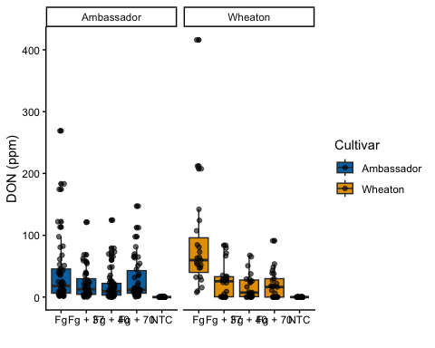
plot_X <- ggplot(df, aes(x = Treatment, y= X15ADON , fill= Cultivar))+
geom_boxplot()+
scale_fill_manual(values = c("#0072B2","#E69F00"))+
geom_point( position= position_jitterdodge(), color="black", alpha= 0.6)+
xlab("")+
ylab("15ADON")+
facet_wrap(~Cultivar)+
theme_classic()
plot_X
## Warning: Removed 10 rows containing non-finite outside the scale range
## (`stat_boxplot()`).
## Warning: Removed 10 rows containing missing values or values outside the scale range
## (`geom_point()`).
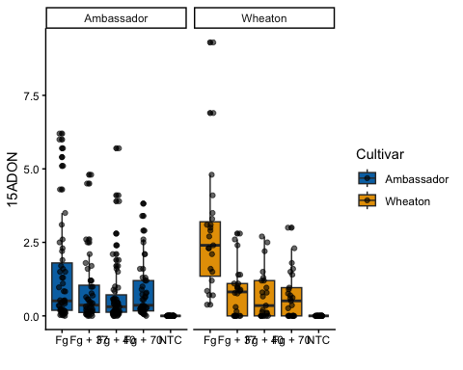
Plot_M<- ggplot(df, aes(x = Treatment, y= MassperSeed_mg , fill= Cultivar))+
geom_boxplot()+
scale_fill_manual(values = c("#0072B2","#E69F00"))+
geom_point( position= position_jitterdodge(), color="black", alpha= 0.6)+
xlab("")+
ylab("Seed Mass (mg)")+
facet_wrap(~Cultivar)+
theme_classic()
Plot_M
## Warning: Removed 2 rows containing non-finite outside the scale range
## (`stat_boxplot()`).
## Warning: Removed 2 rows containing missing values or values outside the scale range
## (`geom_point()`).
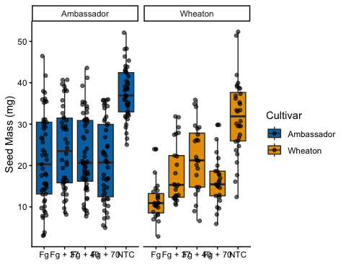
library(ggplot2)
library(ggpubr)
P1<-plot_box +
geom_pwc(aes(group = Treatment ),method = "t_test", label = "p.adj.format")
P2<-plot_X +
geom_pwc(aes(group = Treatment ),method = "t_test", label = "p.adj.format")
P3<-Plot_M+
geom_pwc(aes(group = Treatment ),method = "t_test", label = "p.adj.format")
# ARRANGING ALL IN 1 FIGURE
fig2 <- ggarrange( plotlist = P1, P2, P3,
labels ="auto",
nrow = 1,
ncol = 3,
common.legend = T
)
fig2
