**RADHIKA**

**(DRONACHARYA COLLEGE OF ENGINEERING, GURGAON)**

**Project Name:** Tip Calculator

**Technology:** JavaScript

**Project Duration:** 2 days(15 Nov - 17 Nov)

**Test Cases**

**Functional Test Cases**

1. Check if fields provided for user to specify the Bill amount, Tip percentage and Number of people are present.
2. Check if fields Tip per person and Total per person are present.
3. Check the digit 0 is displayed in the fields Bill, Tip %, Tip per person and Total per person.
4. Check the digit 1 is displayed in the field Number of person.
5. Check if **$** sign is present in front of Amount in Bill, Tip per person and Total per person field.
6. Check if **%** sign in Tip % field is present with the digit.
7. Check if the digit in the bill field is having two digits after decimal.
8. Check if by sliding the range slider to right, the value of Tip % field is increasing and by sliding to left it is decreasing accordingly.
9. Check if by sliding the range slider to right, the value of Number of people field is increasing and by sliding to left it is decreasing accordingly.
10. Check if range is from 1-100 in the Tip % field.
11. Check if range is from 1-50 in the No. of people field.
12. Check if the result is mathematically correct for Tip per person and Total per person.
13. Check if by changing the values in user specified fields the result is changing accordingly.
14. Check if result is containing a number with two digits after decimal for Tip per person and Total per person.
15. Check if the user can delete digits one by one using the backspace key from right to left.

**UI Test Cases**

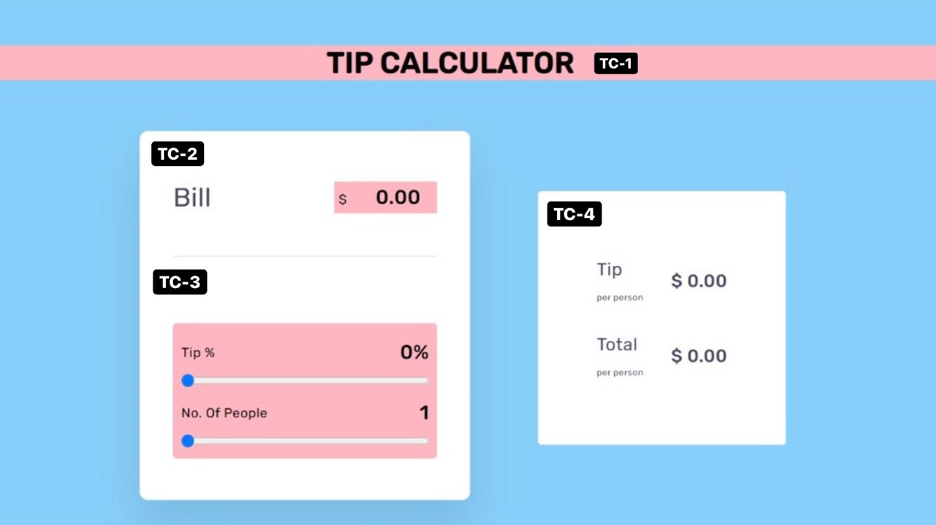

1. Check if the page is loading without any error.
2. Check if the Labels are visible clearly.
3. **TC-1**

* Whether the page heading is correct.
* Check the font used.

1. **TC-2**

* Check the position and alignment of the text and input field.
* Verify symbol position.
* Test the Bill field by inserting value.
* Check the acceptance of both valid and invalid data type in the field.

1. **TC-3**

* Check field labels.
* Check the position and alignment of the text and Range field.
* Verify symbol position
* Verify the acceptance of range.

1. **TC-4**

* Check the position and alignment of the box.
* Check the position and alignment of the text.
* Check field labels.
* Verify symbol position.