###### Emerging Pattern-Based Clustering of Web Users Utilizing a Simple Page-Linked Graph

###### A PROJECT REPORT (Project Phase - I)

###### SUBMITTED IN PARTIAL FULFILLMENT OF THE REQUIREMENTS FOR THE AWARD OF BACHELOR OF TECHNOLOGY

###### IN

###### COMPUTER SCIENCE AND ENGINEERING

###### BY

###### K. RADHIKA 2210313732

###### J. SRI CHARAN 2210313725

###### M. NEERAJ 2210313737

###### B. RAHUL 2210313209

###### 

**UNDER THE GUIDANCE OF**

**Ms. G. RATHNAMMA**

**Asst.Professor**



**DEPARTMENT OF COMPUTER SCIENCE AND ENGINEERING**

**SCHOOL OF TECHNOLOGY**

**GITAM UNIVERSITY**

**HYDERABAD**



**DEPARTMENT OF COMPUTER SCIENCE AND ENGINEERING**

**CERTIFICATE**

###### This is to certify that the project titled Emerging Pattern-Based Clustering of Web Users Utilizing a Simple Page-Linked Graph was presented satisfactorily at the Department of Computer Science and Engineering, GITAM School of Technology, GITAM University Hyderabad campus by Radhika, J. Sri Charan, N. Neeraj, B. Rahul in partial fulfillment of requirement for their project work phase-I carried out under our guidance and supervision.

**MS.G. RATHNAMMA**

Rajendra Prasad Babu Dr.S. PhaniKumar

Project Coordinator HOD-CSE

ACKNOLEDGEMENT

The satisfaction that accompanies that the successful completion of any task would be incomplete without the mention of people whose ceaseless cooperation made it possible, whose constant guidance and encouragement crown all efforts with success.

We are grateful to our project guide Ms. Rathnamma for the guidance, inspiration and constructive suggestions that helped us in the preparation of this project.

We thank our project coordinator Mr. Rajendra Prasad, Assistant Professor for his support and encouragement throughout the course of the project work.

At the outset, we thank our Head of the Department Dr. S. Phani Kumar and our Honorable Pro-Vice Chancellor Prof. N. Siva Prasad for the moral support and the excellent facilities provided. I would also like to thank all the teaching and non-teaching staff members of Computer Science department who have extended their full cooperation during course of my industrial training.

We wish to express our warm and grateful thanks to our project coordinator for the guidance and assistance he provided in completing our project successfully.

I thank all my friends who helped me sharing knowledge and by providing material to complete the project in time.

ABSTRACT

**Emerging patterns** are sets of items whose frequency changes significantly from one dataset to another. They are useful as a means of discovering distinctions inherently present amongst a collection datasets and have been shown to be a powerful method for constructing accurate classifiers. Internet has a wide use of data now-a-days. Clustering of webpages in structured manner helps in the efficient usage of internet. This can be possible by the implementation of clustering of webpages by using simple page linked graph(SPLG). In SPLG, the web pages are denoted as the nodes and the edges are drawn if two pages are accessed in one session.

This project includes an efficient way of generating large web pages and figuring out the emerging patterns in them. A user’s favorite web pages are found out and clustered them per the generated patterns. Then the labels are clustered by using Term Frequency-Inverse Document Frequency (TF-IDF). An approach is also used for the analyzing and clearing of data.

INDEX

1.INTRODUCTION...........................................................................................................................1

1.1 MOTIVATION.....................................................................................................................1

* 1. PROBLEM DEFINATION...................................................................................................1
  2. OBJECTIVE OF PROJECT..................................................................................................1

2. LITERATURE SURVEY...............................................................................................................2

* 1. INTRODUCTION..................................................................................................................2

2.2 EXISTING SYSTEM .........................................................................................................2

2.3 DISADVANTAGES OF EXISTING SYSTEM....................................................................2

2.4 PROPOSED SYSTEM...........................................................................................................2

3.ANALYSIS........................................................................................................................................3

3.1INTRODUCTION................................................................................................................3

* 1. SOFTWARE REQUIREMENT SPECIFICATION............................................................3
     1. USER REQUIRMENT
     2. SOFTWARE REQUIRMENT
     3. HARDWARE REQUIRMENT
  2. CONTENT DIAGRAM OF PROJECT.........................................................................................3

3.4 ALGORITHMS AND FLOWCHARTS..............................................................................3

4.DESIGN..............................................................................................................................................5

4.1INTRODUCTION...................................................................................................................5

* 1. DFD DIAGRAM ................................................................................................................5

4.3 MODULE DESIGN AND ORGANIZATION.....................................................................5

4.3.1PREPROCESSING OF DATASET......................................................................5

4.3.2 GETTING LARGE WEB PAGES.......................................................................6

4.3.3 GENERATING SPLG’S......................................................................................6

4.3.4EMERGING PATTERN MINING.......................................................................6

4.3.5WEB USER CLUSTERING.................................................................................6

4.3.6 CLUSTERS ANNOTATION..............................................................................7

5. IMPLEMENTATION AND RESULTS.............................................................................................7

5.1 INTRODUCTION

5.2 EXPLANATION OF KEY FUNCTIONS

5.3 METHODS OF IMPLEMENTATION

5.3.1 FORMS

5.3.2 OUTPUT SCREENS

5.3.3 RESULT ANALYSIS

6. CONCLUSION

LIST OF FIGURES

1. Implementation.........................................................................................................................................6

LIST OF ABBREVATIONS

1.SPLG – SIMPLE PAGE LINKED GRAPH

2.TF-IDF- TERM FREQUENCY-INVERSE DOCUMENT FREQUECNCY

3.LWP- LARGE WEB PAGES

4.WUM-WEB USAGE MINING

1. INTRODUCTION
   1. MOTIVATION:

Discovery of powerful distinguishing features between datasets is an important objective in data mining. Data Mining (sometimes called data or knowledge discovery) is the process of analyzing data from different perspectives and summarizing it into useful information. It allows users to analyze data from many different dimensions or angles, categorize it, and summarize the relationships identified. Technically, data mining is the process of finding correlations or patterns among dozens of fields in large relational databases. An important class of patterns that can represent strong contrasts is known as emerging patterns. Emerging patterns are sets of items whose frequency changes significantly from one dataset to another. They are useful as a means of discovering distinctions inherently present amongst a collection datasets and have been shown to be a powerful method for constructing accurate classifiers. This application when applied to the large usage of web mining, the results are very accurate and useful. Web mining is the use of data mining techniques to automatically discover and extract information from Web documents and services.

In the current era, data is growing rapidly and there is lot of information to be gathered and stored. The main motto of the project is to take a web log file of some certain users, then clean the data. If a user visits some pages frequently, those are to be identified and support count is calculated. Based on the support count, there is a graph generated. From the graph the frequent pages are identified and clustered. By clustering them the user can access the pages in an easy way. Naming the clustering will be the final step of this project.

* 1. PROBLEM DEFINATION:

In the present day, there is a rapid growth of internet, studies on internet revealed some interesting topics such as social networks, web mining etc., focusing on web mining, Web mining is the integration of information gathered by traditional data mining methodologies and techniques with information gathered over the World Wide Web(WWW). It is further classified into 3 types web content mining (WCU), web structure mining (WSU), web usage mining (WMU). Web content mining is used to examine data collected by search engines and Web spiders. Web structure mining is used to examine data related to the structure of a particular Web site and web usage mining is used to examine data related to a particular user's browser as well as data gathered by forms the user may have submitted during Web transactions. This is also called as web access. The information gathered through Web mining is evaluated by using traditional data mining parameters such as clustering and classification, association, and examination of sequential patterns. Due to the rapid growth of internet, there is a huge data generation and most of it is in hidden form. It is essential to learn about the favorite web pages of web users and to cluster web users in order to understand the structures that they use.

Many techniques in web usage mining have been proposed, and this field is still a hot topic for research in data mining. Most existing web mining techniques are performed based on association rule mining or frequent pattern mining, and these methods aim to find relationships among web pages or predict the behavior of web users. Association rule mining is a procedure which is meant to find frequent patterns, correlations, associations, or causal structures from data sets found in various kinds of databases such as relational databases, transactional databases, and other forms of data repositories. Now, consider a web users log history. There might be some pages which are randomly visited by him in a frequent way. The access of such pages is to be made easy. This is possible by the concept of emerging patterns and clustering.

* 1. OBJECTIVE OF PROJECT

In the recent years there is a rapid growth of internet, the result of growth lead to the enormous formation of data. The data that is generated has to be stored for future use, to achieve that there are lot of methods and algorithms. One such method is data mining. It analyzes the data from the different perspectives and creates some useful information out of it.

Emerging patterns based clustering using a graph is a application that runs on the web server, and helps the analyzer to analyze the data of some particular users favorite web pages. Here, every user is having specific user ID using which he/she can be uniquely identified. In this project the source is web log file, which consists of the user ID, IP address and the URL. IP address can also be used to identify the user. The URL is the web pages user tried to access. This information is stored in the database. In the next step the database is cleaned. As the data is not perfect all the time, developer has to take care that the data he is using is clean and clear and do not have any kind of ambiguity. Once the cleaning is done the support count is to be identified. Association rules are created by analyzing data for frequent if/then patterns and using the criteria support and confidence to identify the most important relationships. Support is an indication of how frequently the items appear in the database. Confidence indicates the number of times the if/then statements have been found to be true. So, by calculating the support count frequent patterns are observed. Once the frequent patterns are observed those are to clustered and named. Here each cluster denotes particular user with some set of frequent patterns.

The main motto of the project is to cluster the web pages of the user web log that are frequently visited by Web User. By clustering the web pages, one can understand the structural patterns and their behavior. The work of the user gets easy and he/she can access the web pages easily with just one click. There will be different tools and algorithms used in this project that are detailed in the further sections. Naming of clusters can be can by the Term Frequency- Inverse Document Frequency (TF-IDF).

**2.** LITERATURE SURVEY

2.1 INTRODUCTION

With the rapid growth of the Internet, most research on the Internet has revealed some very hot topics, such as social networks web mining, and so on. In web mining, there are three categories: web content mining, web structure mining and web usage mining. In Web Usage Mining (WUM), also known as web access, web access pattern tracking can be deﬁned as the web page history; the mining task is a process of extracting interesting patterns from web access logs. Web usage mining is still a popular research area in data mining. With the rapid growth of the Internet, more and more useful information is hidden in web log data. It is essential to learn about the favorite web pages of web users and to cluster web users to understand the structures that they use.

* 1. EXISTING SYSTEM:

Present, there is huge web log data the pages can be accessed from the log data.

2.3 DISADVANTAGES OF EXISTING SYSTEM:

In the present system, the following are the disadvantages

* there is lot of noise in the web log data
* the frequent patterns are not observed
* the behavior of pages is not observed

2.4 PROPOSED SYSTEM:

Considering the disadvantages in the proposed system, First the noise in the web log data will be removed. Then the frequent patterns are observed and then they are clustered based on the frequent patterns. The support value is calculated and then they are named based on the TF-IDF.

3.Analysis

3.1INTRODUCTION:

The project uses lot of software and hardware tools that are briefed in this section

* 1. SOFTWARE REQUIREMENT SPECIFICATION:
* WEKA software tool
* SMine algorithm
* Dataset
  1. HARDWARE REQUIREMENT
* CPU: Intel Core i5 (3rd Gen) 3317U / 1.7 GHz
* Max Turbo Speed :2.6 GHz
* Number of Cores: Dual-Core
* Cache: 3 MB
* RAM: 4 GB
* Hard drive: 500 GB
  1. ALGORITHMS AND FLOWCHARTS:

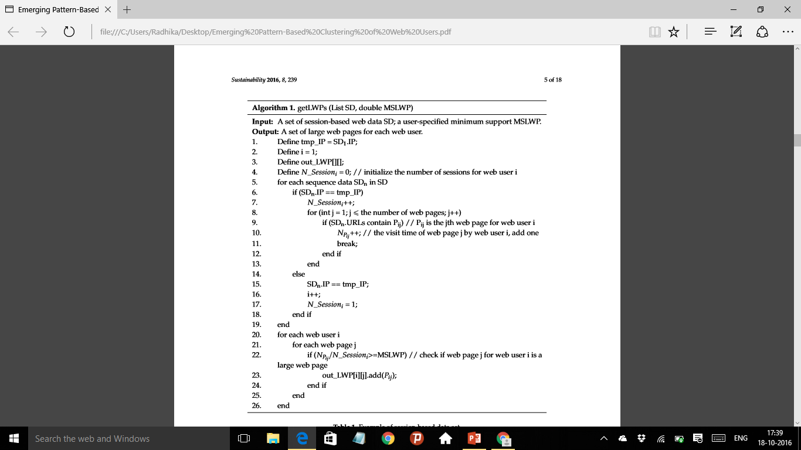

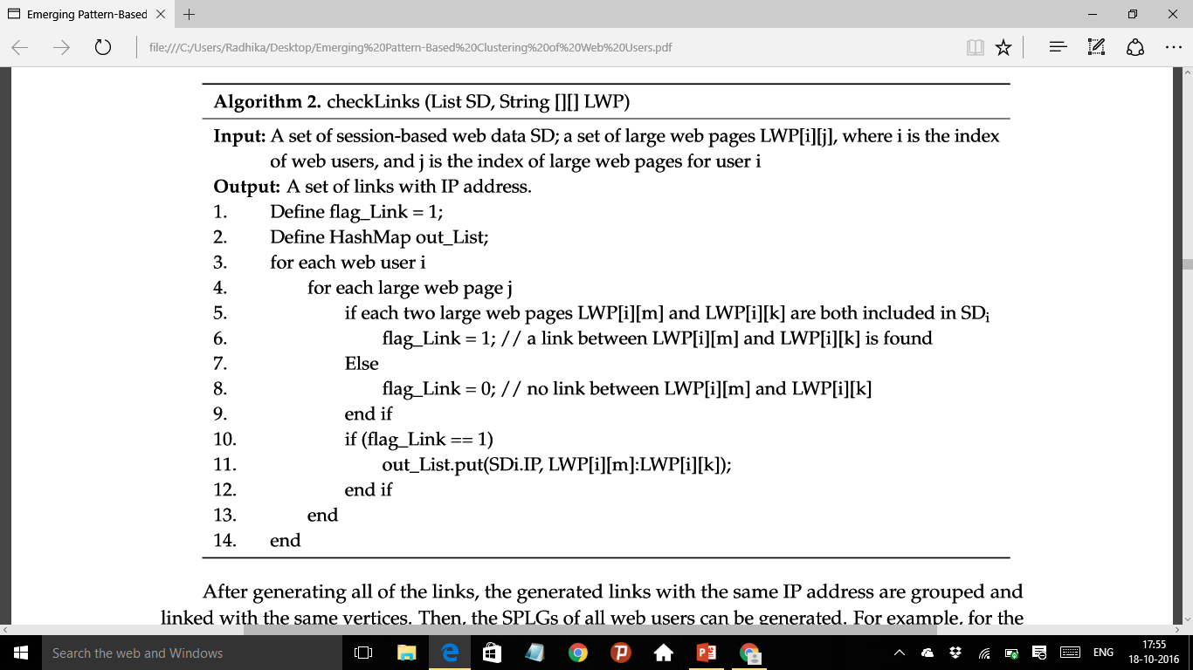

4.DESIGN

4.1INTRODUCTION:

In this section, we generate large web pages from processed web log data, then scan and transform the clean data set into simple page-linked graphs (SPLGs), and then, generate merging patterns in the generated SPLGs. We cluster web users based on generated emerging patterns, and ﬁnally, label the clusters with typical web pages

* 1. DFD DIAGRAM: 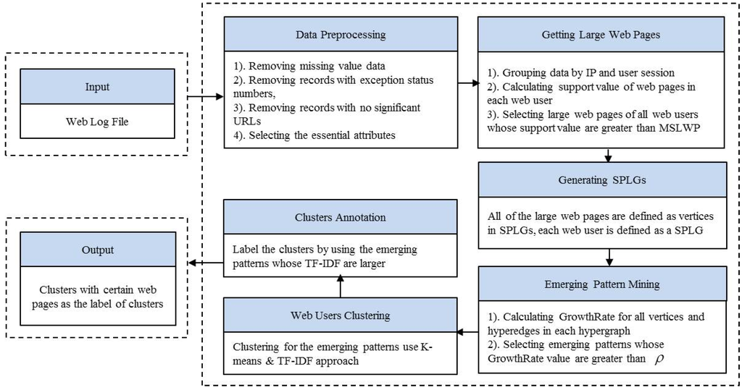

4.1 Implementation

* 1. MODULE DESIGN AND ORGANIZATION:

4.3.1 PREPROCESSING OF DATASET: Web log data is automatically recorded in web log files on web servers when web users access the  web server through their browsers. Not all the records sorted into the web log files have the right format or are necessary for the mining task, so before analyzing the web log data, a data cleaning phase needs to be implemented.

* + - * + Removing Records with Missing Value Data
        + Removing Records with Exception Status Numbers
        + Removing Irrelevant Records with No Significant URLs
        + Selecting the Essential Attributes

4.3.2 GENERATION OF LARGE WEB PAGES:

Large web pages are the set of frequent item sets. From a Large Web Pages (LWP) set frequent item sets are observed with some minimum threshold. After cleaning the data, the frequent pages are observed by the support value. The support value can be calculated by the formula

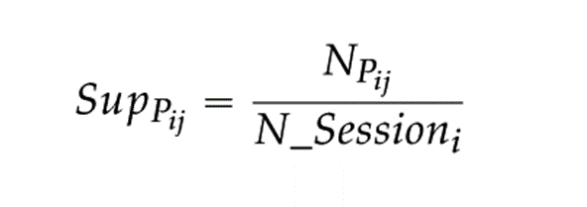

Where, Npij is the no of times a web page j is been visited in the web user i and N_Sessioni is the no of sessions of web user i. Finally, a user specified Minimum Support threshold for Large Web Page (MSLWP)must be defined.  The MSLWP denotes a kind of abstract level that is a degree of generalization. The support value will be determined by the proportion of web users accessing web pages at certain times. The selection of an MSLWP is very important; if it is low, then we can obtain information for a detailed event.

4.3.3 GENERATION OF SIMPLE PAGE LINKED-GRAPH (SPLG):

After generating large web pages for each web user, all the large web pages are deﬁned as vertices in the SPLG. In regular page-linked graphs, each edge consists of every two web pages that are contained in one session. However, in a SPLG, each edge consists of every two-large web page of the web user. Applying the concept of the SPLG to the structure of web page links can reduce large and complex regular page-linked graphs to simple ones to reduce noise web pages. In the SPLG, links between each of the two large web pages should be checked. To check the link between every two vertices, the direction of link does not need to be considered, if the two vertices are visited by one user in one session, then they are connected

4.3.4 GENERATION OF EMERGING PATTERNS:

After generating SPLGs for all web users, we try to ﬁnd emerging patterns in these SPLGs. Examples of SPLGs for some web users. This can be possible by finding the growth and support value of the given item sets. They can be calculated as follows:

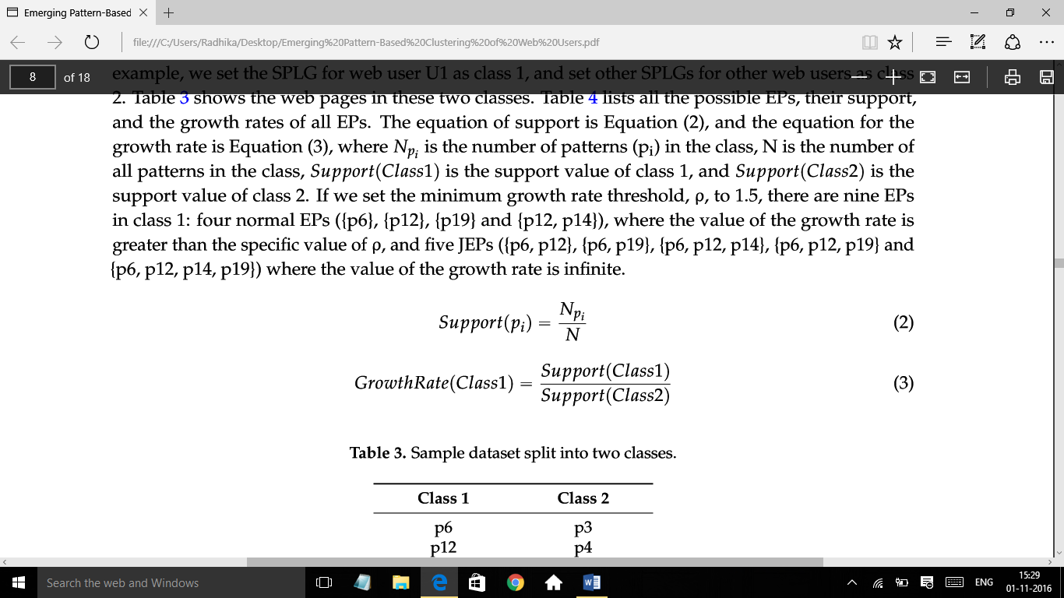

4.3.5 CLUSTERING OF WEB USERS:

we execute a K-means clustering algorithm on emerging patterns to cluster the web users. First, we generate a TF-IDF based weighted matrix which can reﬂect how important a web page is to a web user. we can get the value of the TF-IDF for web page j of web user i, and then the TF-IDF based TM matrix can be obtained. Then, we execute the K-means algorithm on the generated TM with a speciﬁed K value to get the clusters of web users.

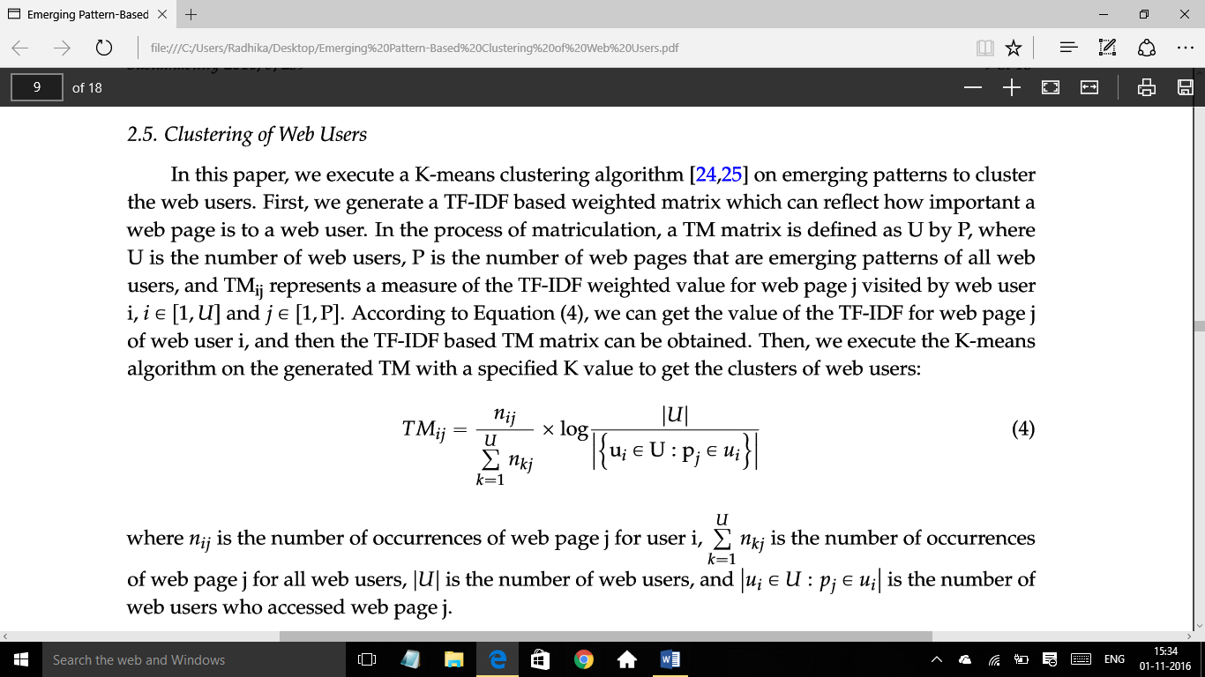

4.3.6 ANNOTATION OF CLUSTERS:

After clustering, we label the clusters based on the concept of Folksonomies. Each cluster is deﬁned as one user group, and the web pages in each cluster are deﬁned as online items, we use TF-IDF to calculate the frequency of each web page in each cluster. we can calculate the TF-IDF value of each web page in each cluster, and then we can select some web pages where TF-IDF values are among the TopN (N can be the number chosen by a user with freedom, where N is smaller than the number of web pages in each cluster) and the largest in each cluster is the label of this cluster.

5.CONCLUSION

In this project, we tried to implement an emerging pattern from large web pages. These can be implemented from the we log data. The pages are implemented as the nodes in the SPLG’s. Then patterns are observed and clustered. The clustered patters are named per the concept of folksonomies. TF-IDF.

The main result of this study is to generate large web pages and emerging patterns to identify the personal favorite web pages of each user by eliminating noise due to overall popular pages.