ASSIGNMENT NO.2

1. Write a program to find sum of all integers greater than 100 and less than 200 that are divisible by 7.

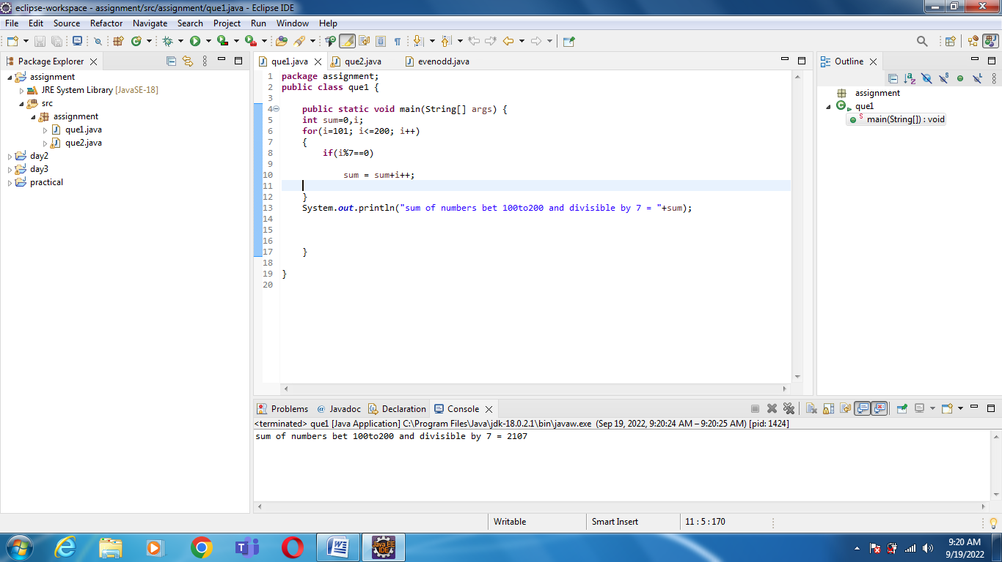

 2 Write a program in java that ask three numbers from user and print the greatest among three .

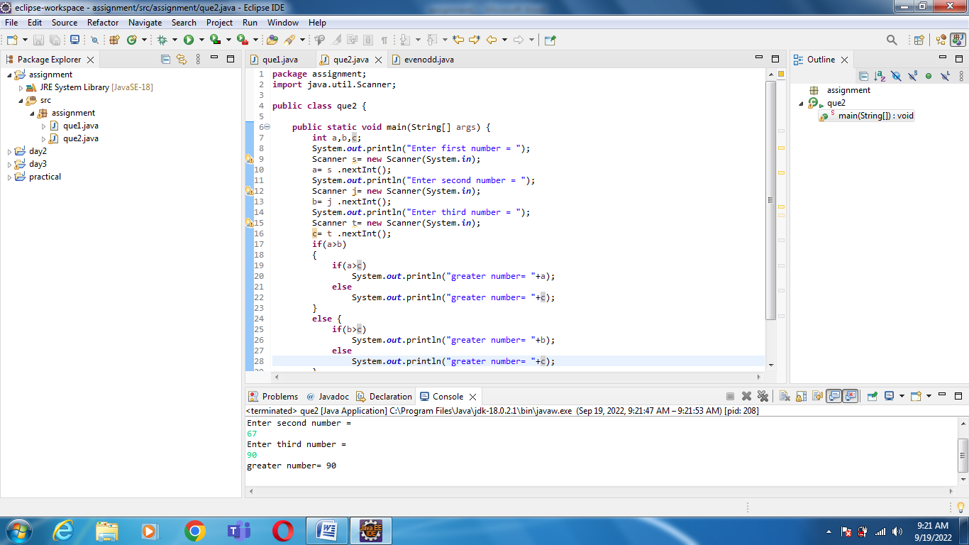

3.WAP to find  ASCII value of a character

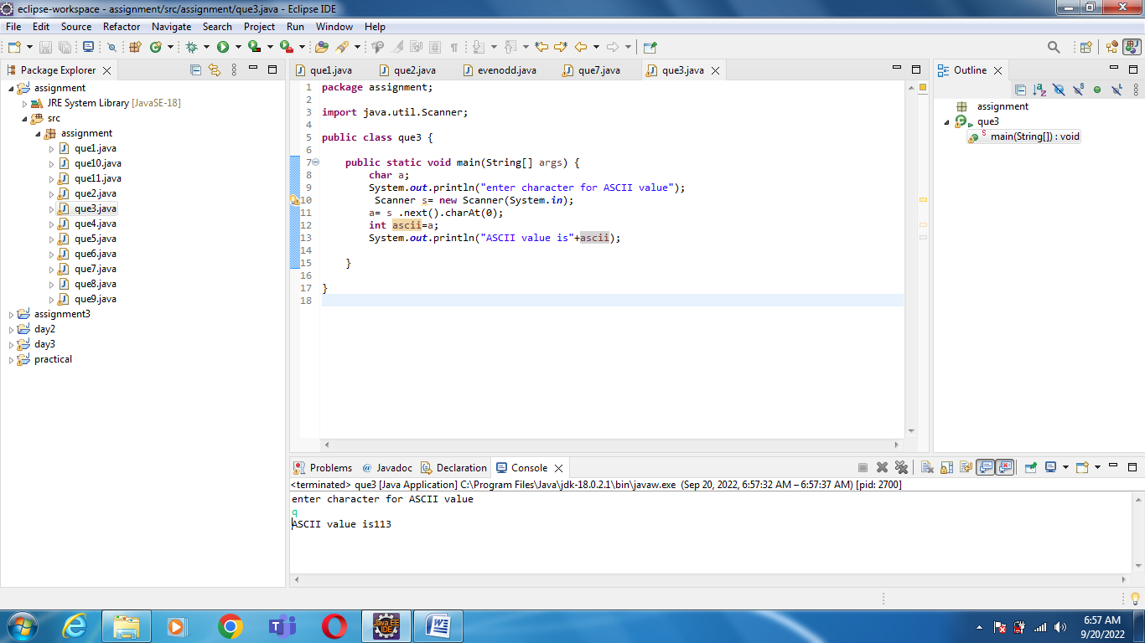

4. Java Program to Check Whether an Alphabet is Vowel or Consonant

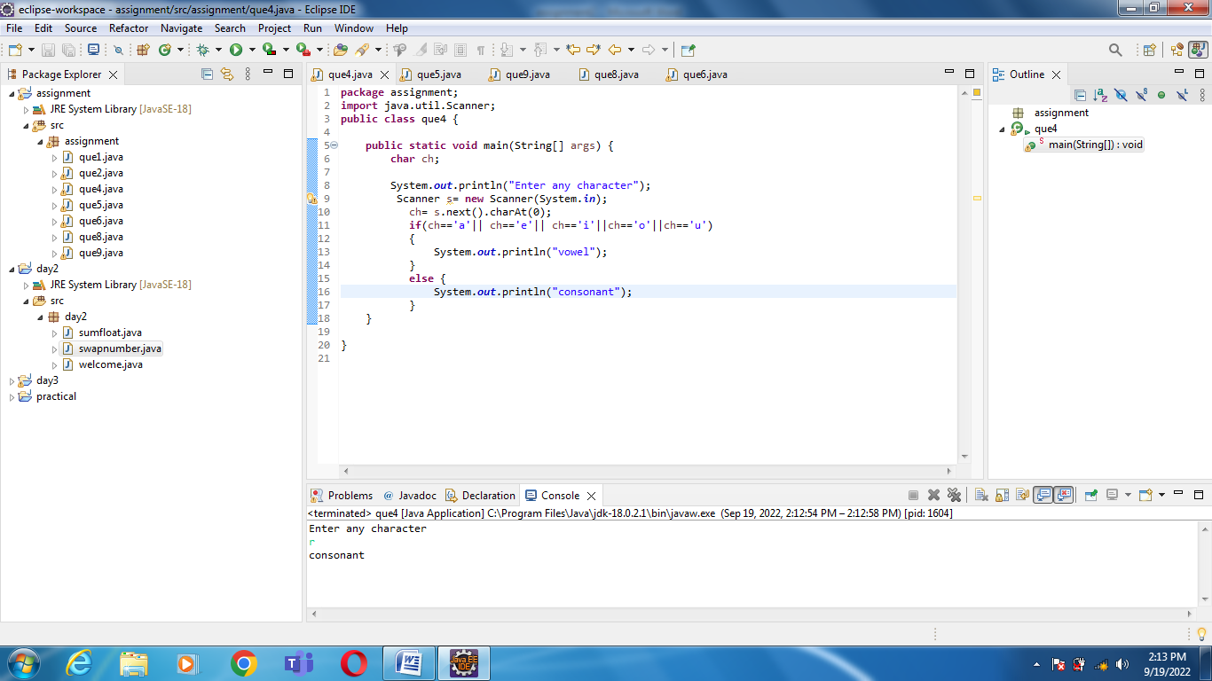

5 Check if a Number is Positive or Negative using if else

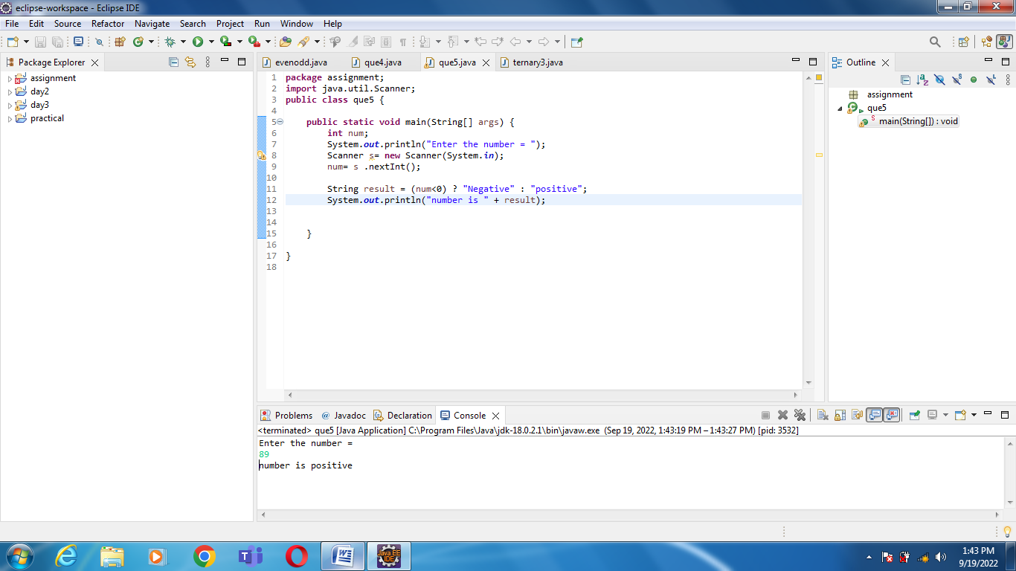

6 WAP for swapping two numbers without using third variable

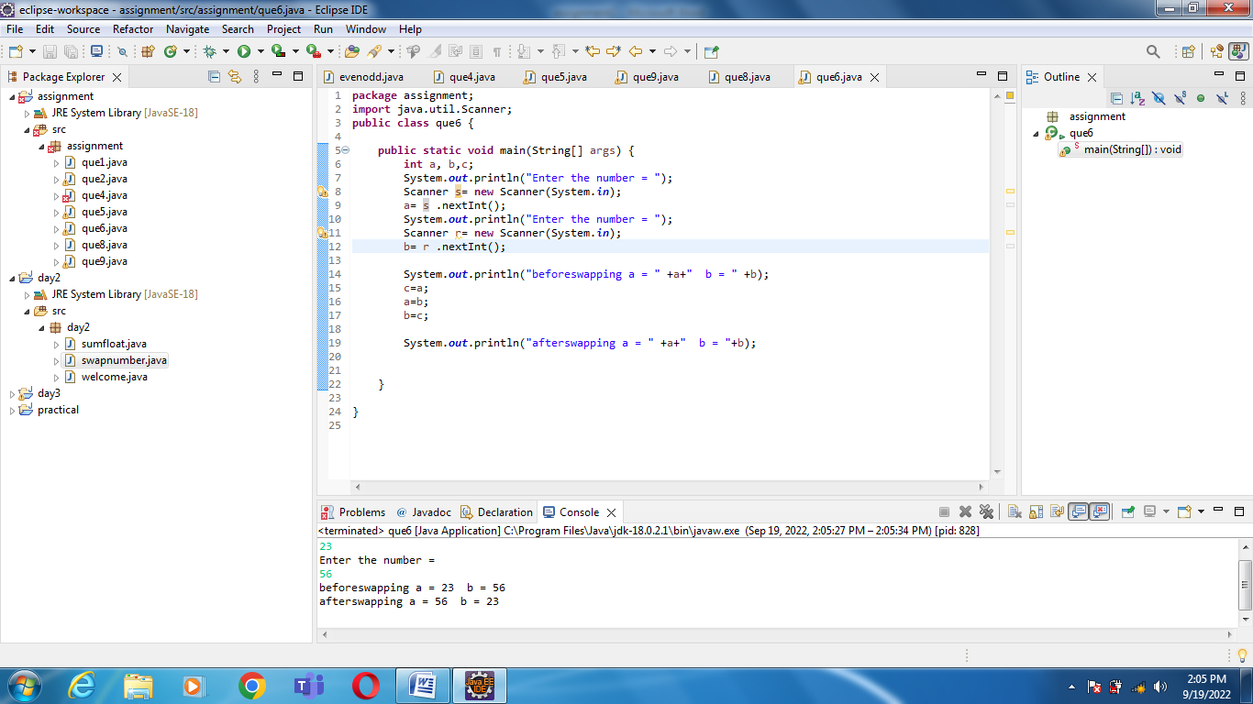

7 Write a program that would print the information (name,

year of joining, salary, address) of three employees by creating a class named

&#39;Employee&#39;. The output should be as follows:

Name            Year of joining        Address

Ashish          1994                    64C- WallsStreat

Sam                2000                    68D- WallsStreat

John                1999                    26B- WallsStreat

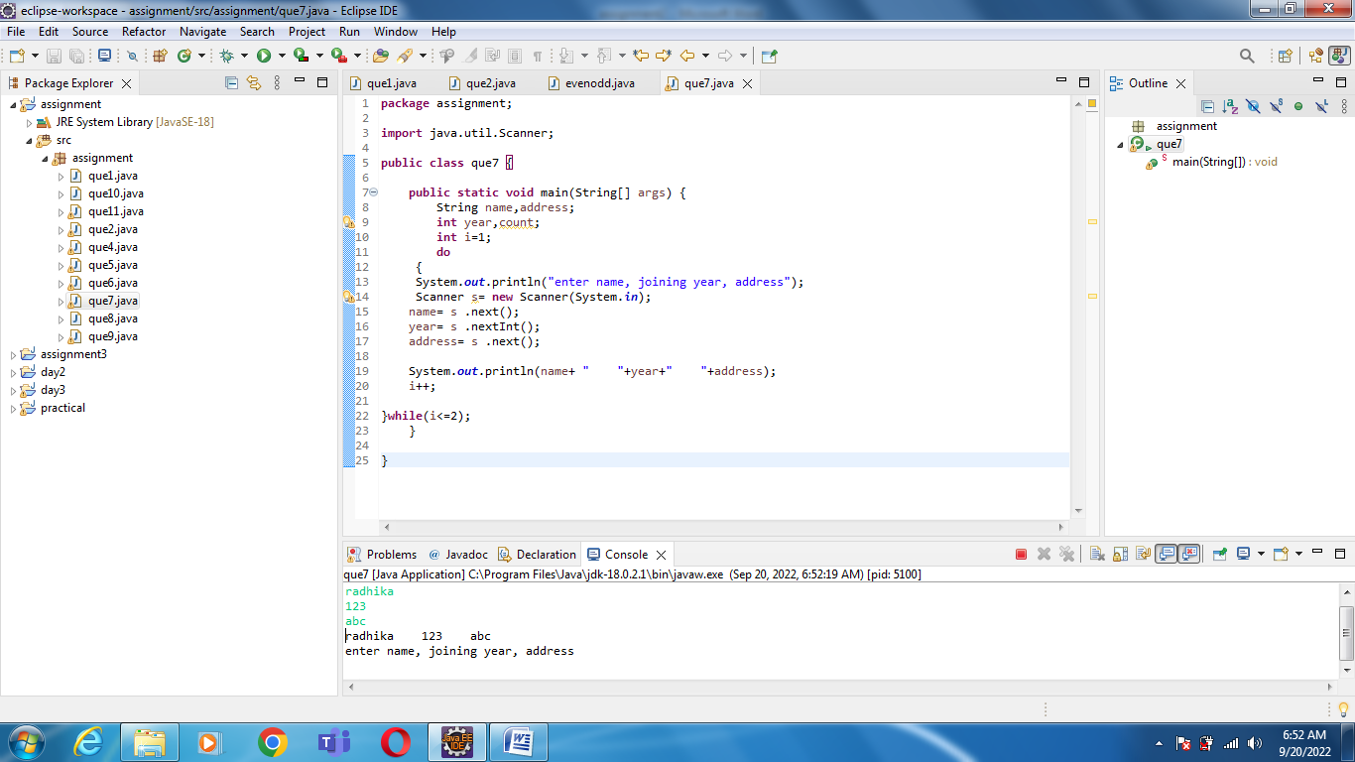

Q  8   wap to print even numbers between 10 to 20

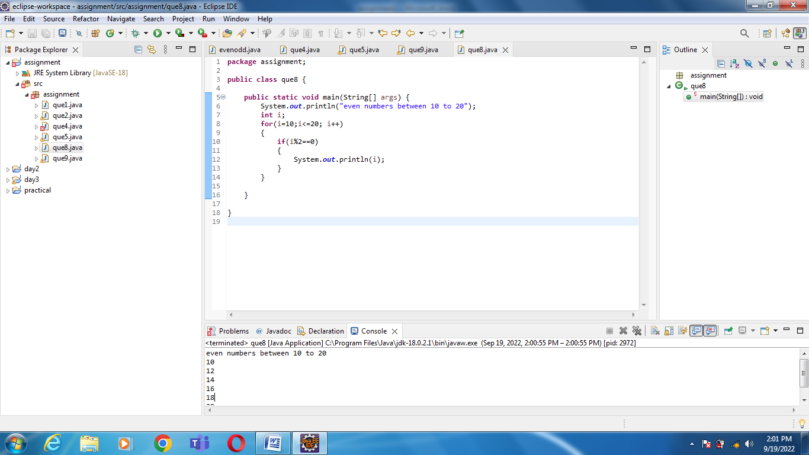

Q  9 wap to check if a number is prime or not

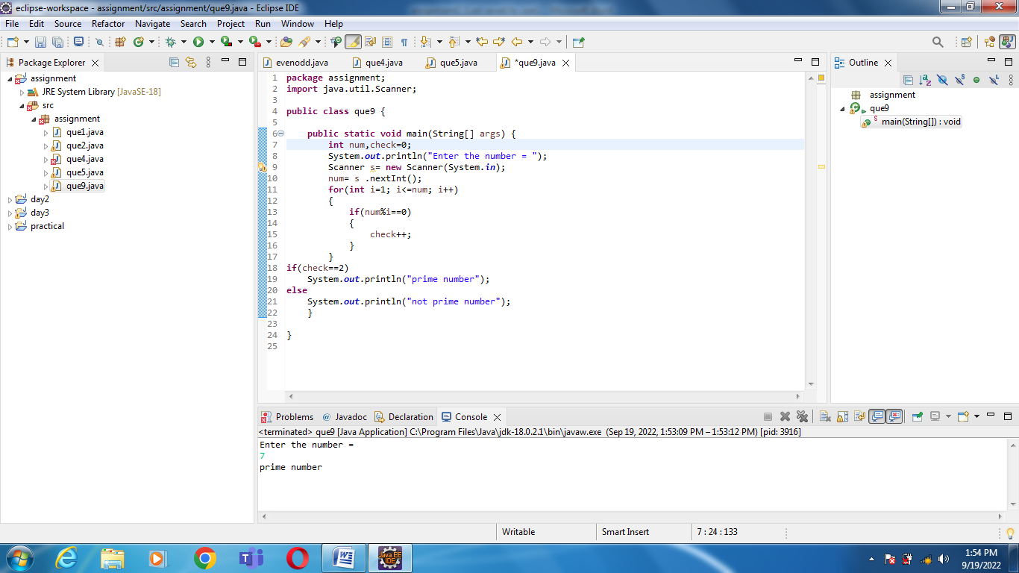

Q 10 wap to reverse a given digit   123   321

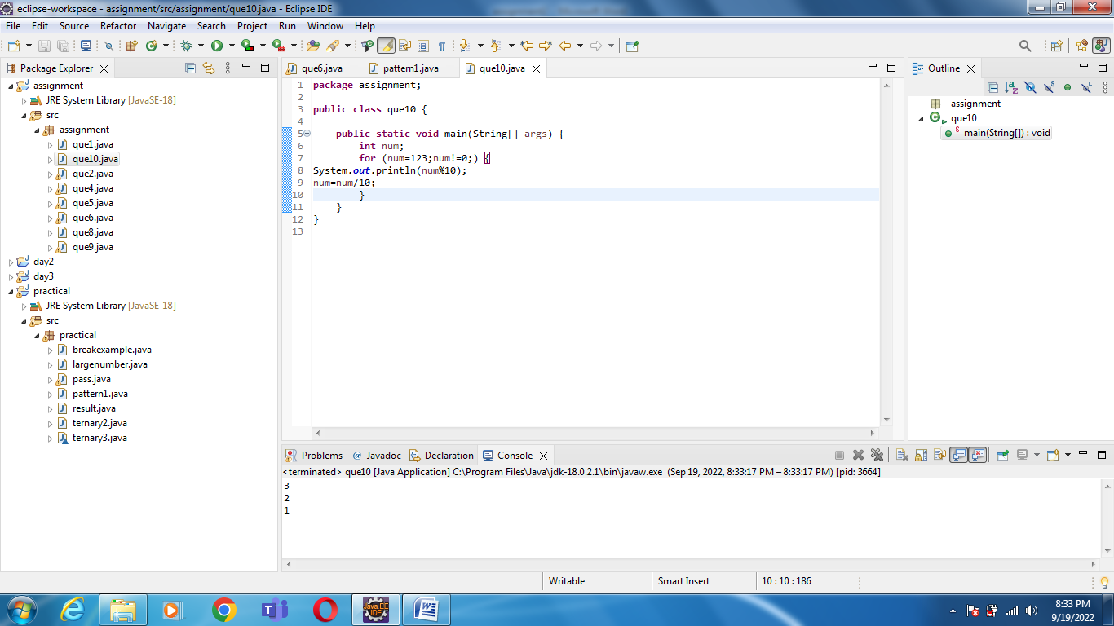

11 WAP to input basic salary of an employee and calculate its Gross salary according to following:

Basic Salary &lt;= 10000 : HRA = 20%, DA = 80%

Basic Salary &lt;= 20000 : HRA = 25%, DA = 90%

Basic Salary &gt; 20000 : HRA = 30%, DA = 95%

