1. **List the features that were implemented (table with ID and title).**

|  |  |  |
| --- | --- | --- |
| **User Requirement** | | |
| ID | Description | User |
| US-01 | As a new user, I should be able to sign-up in the system and create a role based profile | All User |
| US-02 | As an existing user, I should be able to login to the system | All User |
| US-03 | As a customer and receptionist, we want to check room availability so that we can make booking | Customer |
| US-04 | As a customer, I want to view food menu so that I can order food | Customer |
| US-05 | As a customer, I want to view bill so that I can make payment | Customer |
| US-11 | As a housekeeping staff, I want to view the supply inventory and update it | Housekeeping staff |
| US-12 | As a catering staff, I want to view the food inventory and update it | Catering staff |

1. **List the features were not implemented from Part 2 (table with ID and title).**

|  |  |  |
| --- | --- | --- |
| **User Requirement** | | |
| ID | Description | User |
| US-06 | As a customer, I want to give rating so that I can provide feedback to hotel | Customer |
| US-07 | As a manager, I want to view employees attended training list and customer rating so that I can decide promotion and perks | Manager |
| US-08 | As a manager, I want to access leave availability of all staff so that I can approve leave request | Manager |
| US-09 | As an employee, I want to access my leave details so that I can take note of it. | All Staff |
| US-10 | As a housekeeping staff, I want to check room occupancy so that I can clean the room | Housekeeping |
| US-13 | As a HR, I want to check the attendance report of all staff, so that I can create pay-slip | HR |
| US-14 | As a HR, I want to organize role based training workshop, so that new employees can undergo training | HR |
| US-15 | As an Employee, I want to view my pay-slip so that I can print it. | All Staff |
| US-16 | As an Employee, I want to view training schedule so that I can attend the training | All Staff |

**3. Show your Part 2 class diagram and your final class diagram. What changed? Why? If it did not change much, then discuss how doing the design up front helped in the development.**

**Part 2 Class Diagram:**

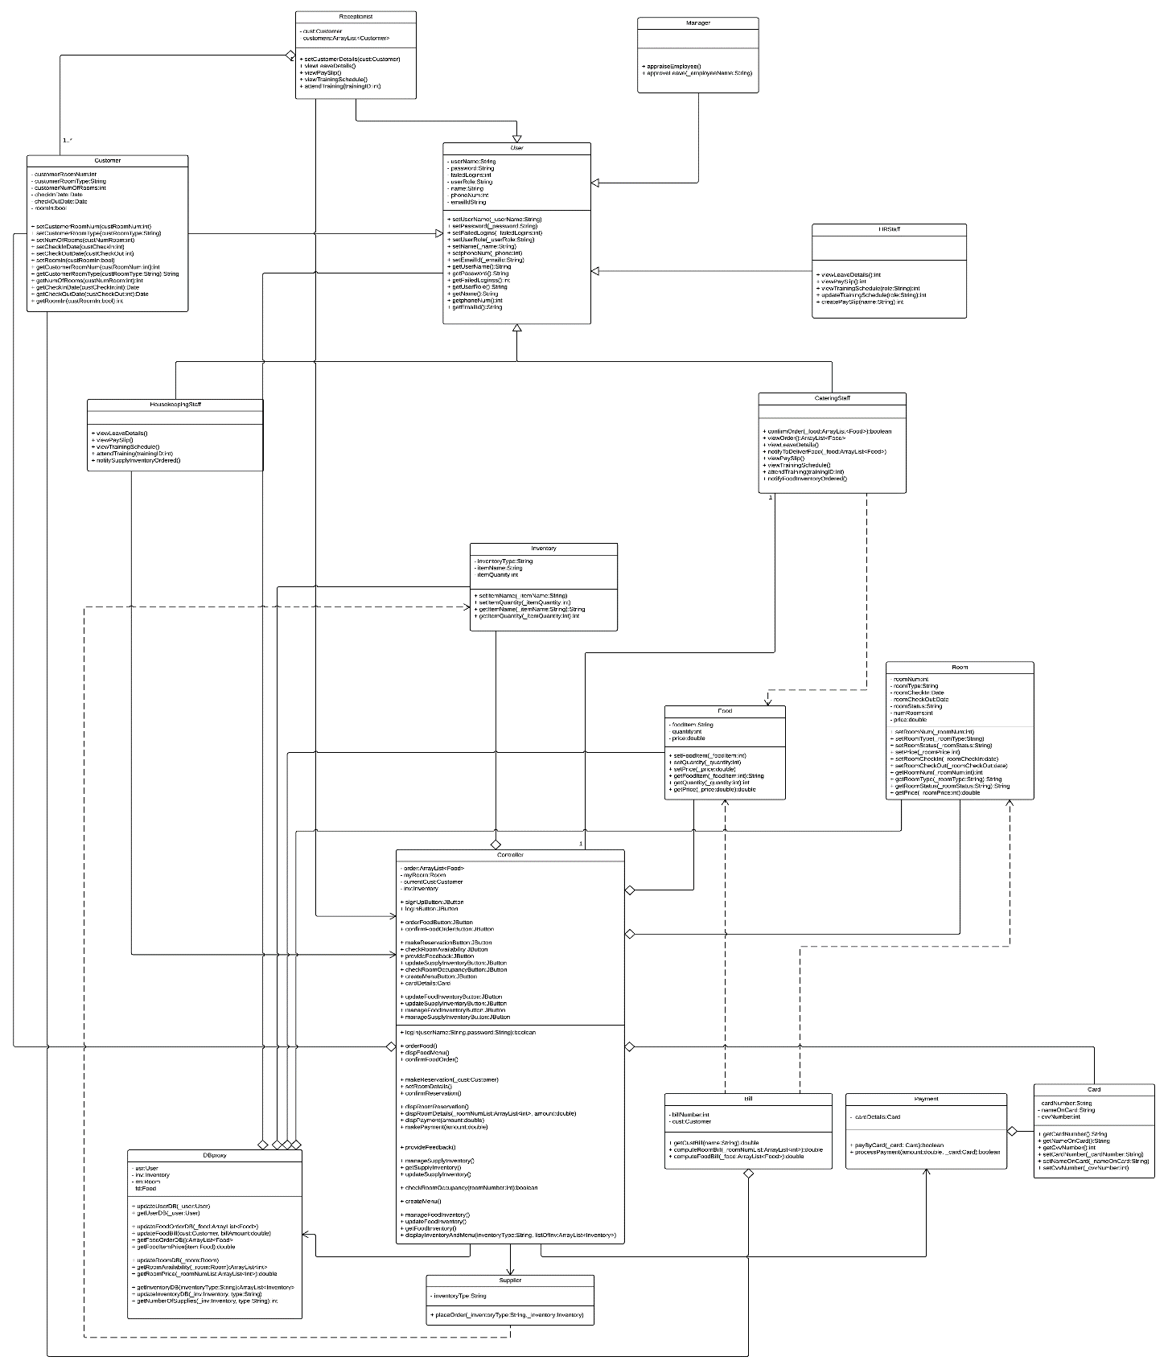

**Final Class Diagram:**

**Our final class diagram changed from the part 2 class diagram. In the part 2 class diagram we encountered the BLOB anti-pattern wherein the Controller class was assigned most of the responsibilities. We segregated this Controller class into different Controllers such that each class performed specific tasks with high cohesion.**

**For the Inventory class, we abstracted the Inventory class such that the FoodInventory class and SupplyInventory class inherit from it. This helped in code reuse and also in instantiating the Inventory object during run time.**

**4. Did you make use of any design patterns in the implementation of your final prototype? If so, how? Show the classes from your class diagram that implement each design pattern (each design pattern as a separate image in the .PDF). If not, where could you make use of design patterns in your system? Show a class diagram of how you could implement each design pattern and compare how it would change from your current class diagram.**

Yes, we made use of design patterns in the implementation of our final prototype. We implemented the following design patterns: Factory Method, Singleton and MVC.

We implemented the Singleton pattern in the Login class to create a single instance of a user, so that only one user can be logged into the system at a time.

Next, we used the Factory Pattern to create the different user views based on the role of the user logged into the system. We created an interface User Role which is implemented by the classes Customer, Manager, Receptionist, HR, Housekeeping and Catering. The sub class to be instantiated is decided according to the user role during run time.

Lastly, we implemented our full program using the Model View Controller design pattern.

**5. What have you learned about the process of analysis and design now that you have stepped through the process to create, design and implement a system?**

The process of analysis and design helped us largely to implement good, maintainable and reusable code. Following the SDLC principle and use of design patterns helped us get a good picture of what we’ll be working on and how to go about the implementation of the application. It helped us prevent smelly code by using object oriented principles and design patterns. It also taught us how to allocate responsibilities to classes following good design principles. During the implementation of the application we came across many anti-patterns. We learned how to rectify these problems and found good design solutions. Further, we also learned that user acceptance testing and continuous refactoring is necessary to ascertain accurate application development and to have maintainable code. The complete process of creating, designing and implementing the system in its entirety has taught us good object oriented programming and designing skills, and enhanced us as programmers.