**Deploy an ASP.NET WebForms Application on Azure**

**GitHub Link:**

**Screenshots:**

1. Student Table

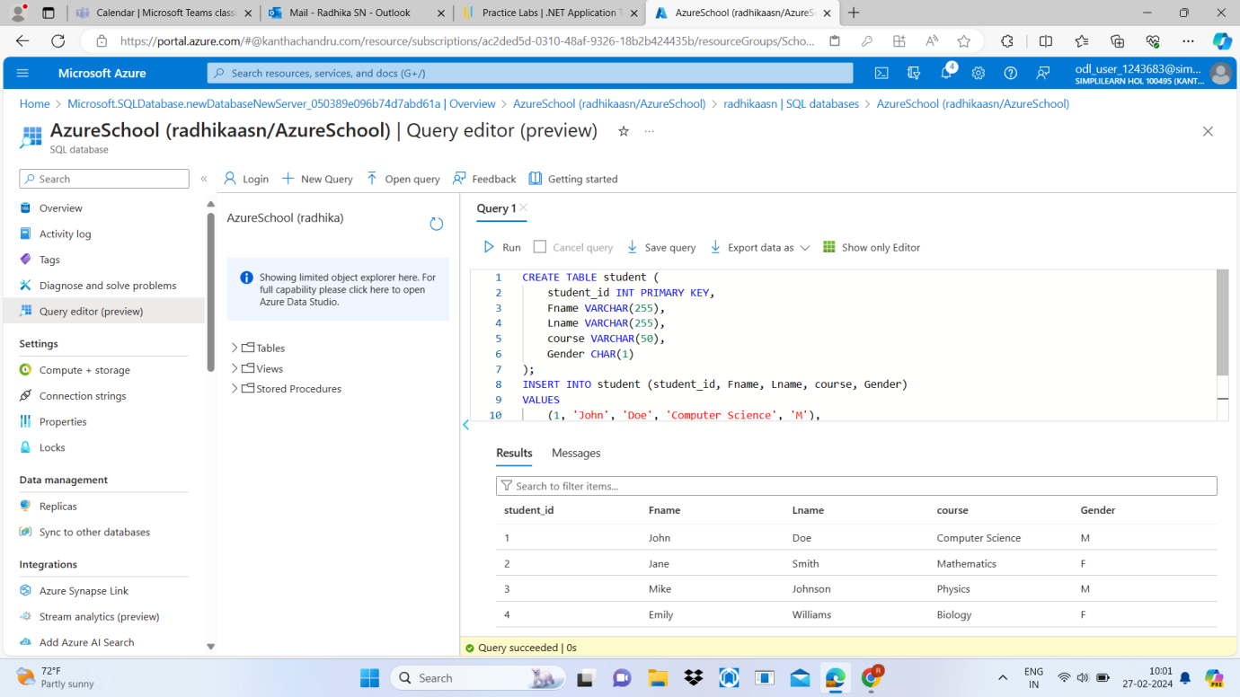

1. Inserted values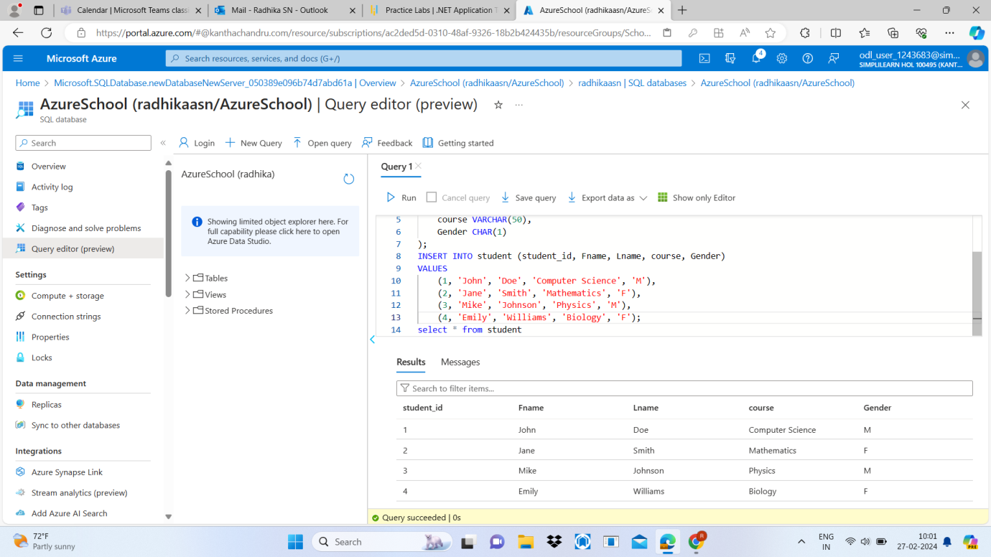
2. Table in mssql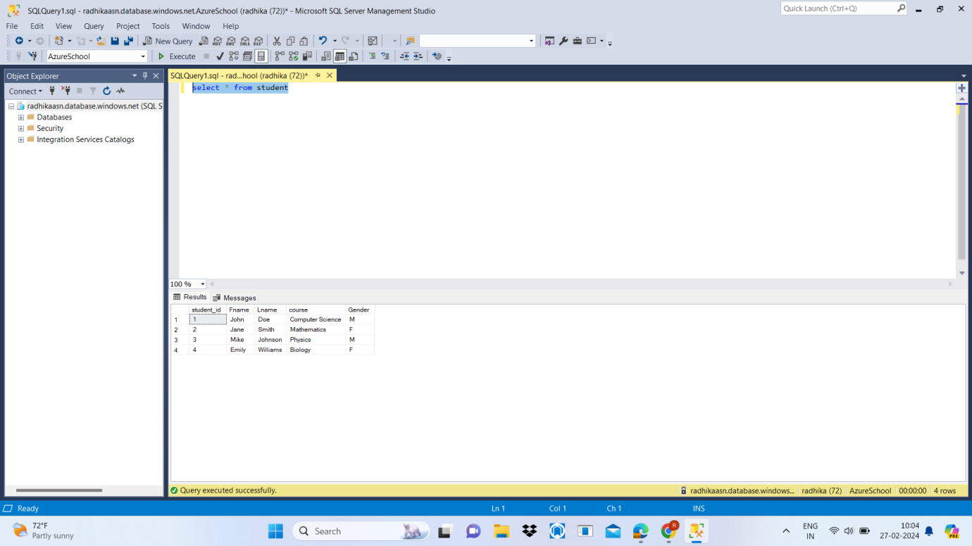
3. Output

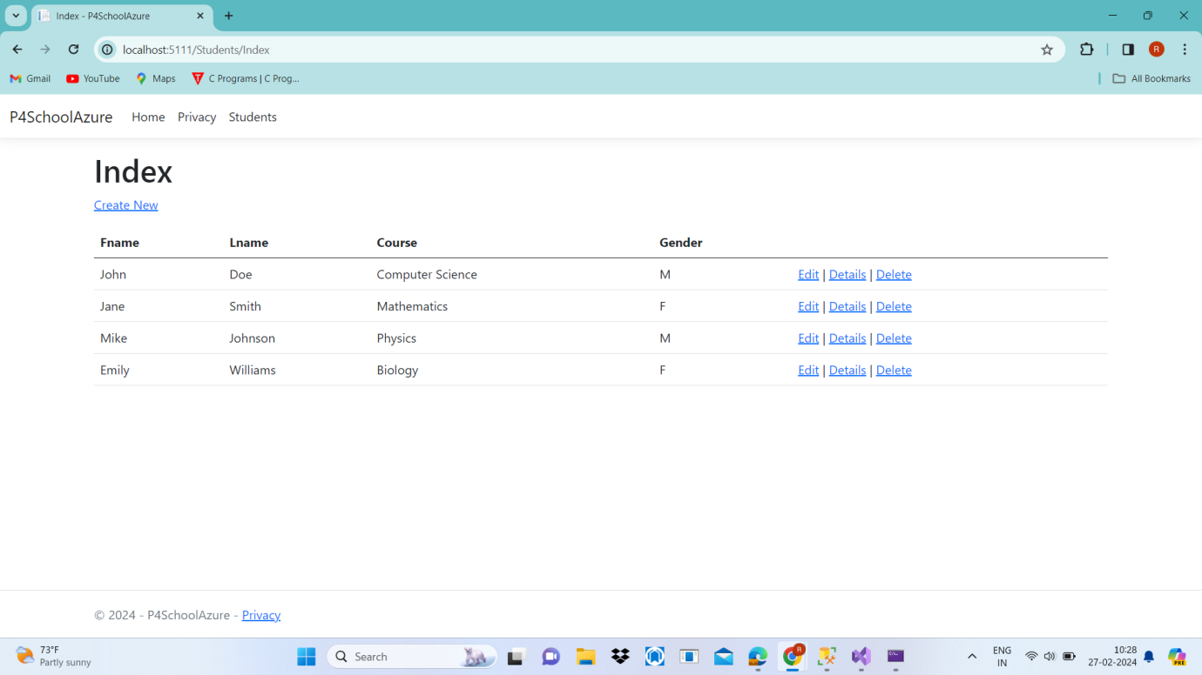

1. Updated Value of SId 7

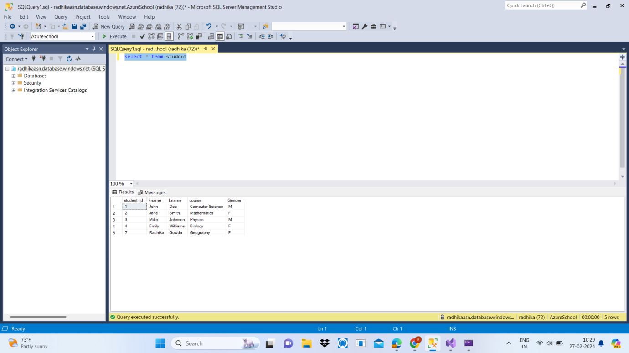

1. Azure 