**Create an ASP.NET WEB API Application to Add Subject Marks to Students and View Their Marks**

Screenshots:

* Get Marks List:

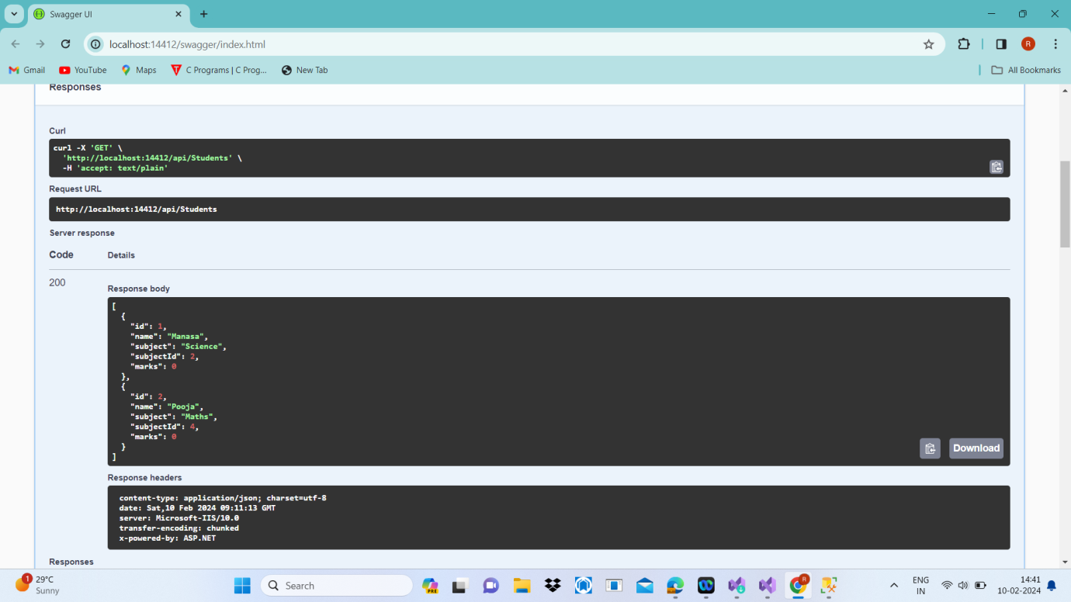

* Add Marks:

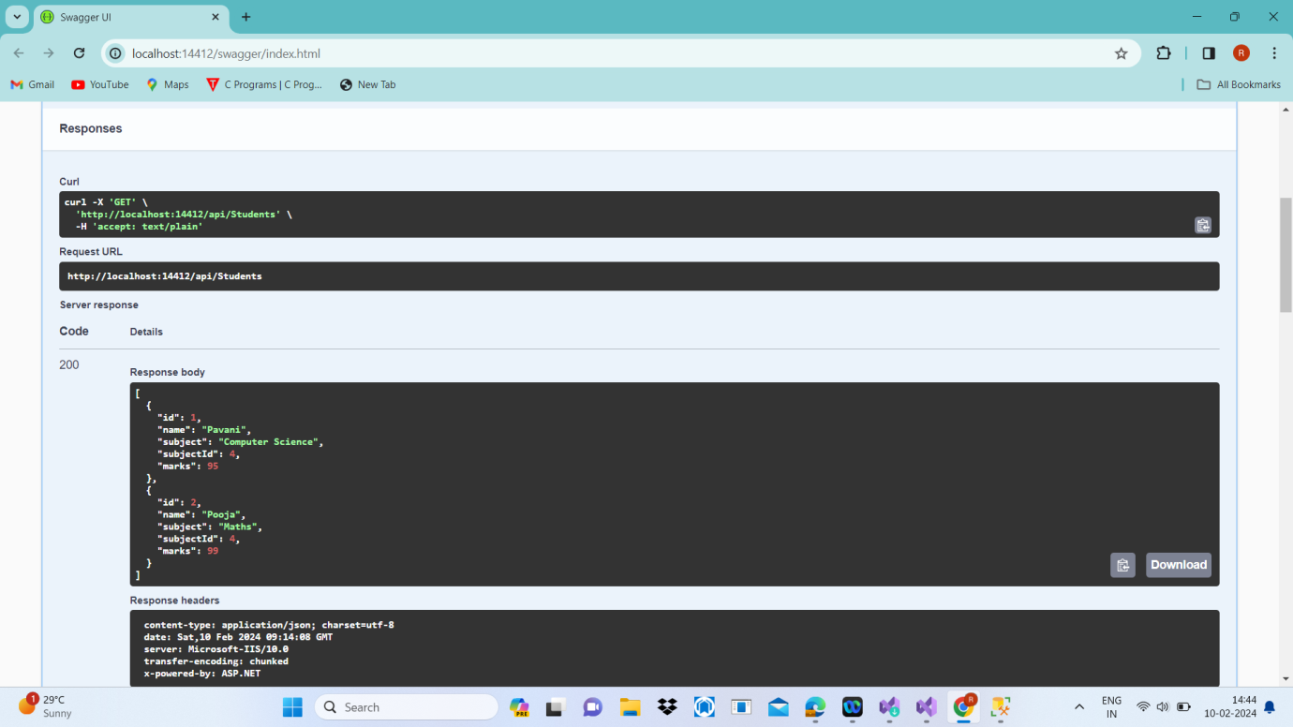

* Update Marks:

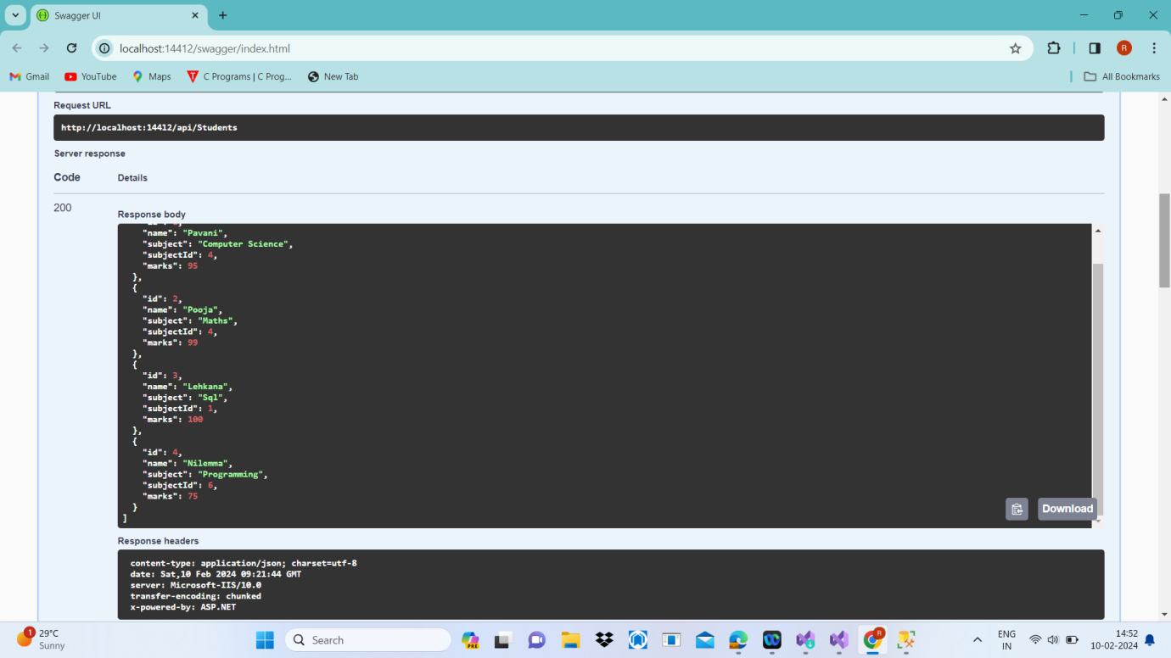

* Updated details:

studentID:3, SubjectId:1, Subject: Sql , Marks: 100

* Delete

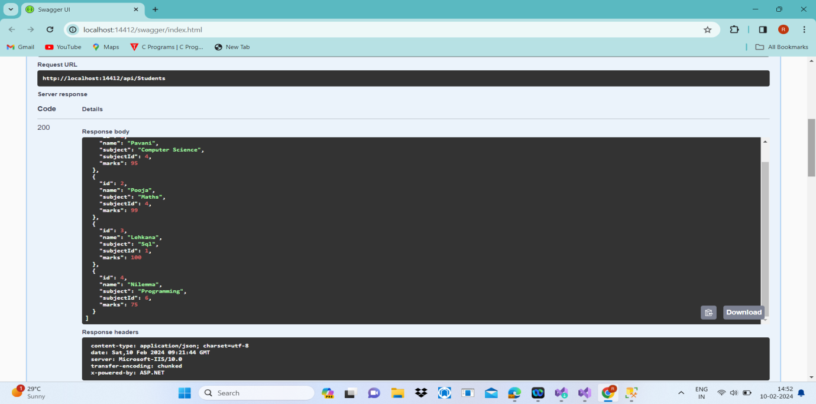

* Deleted details studentId: 4, subjectId:6

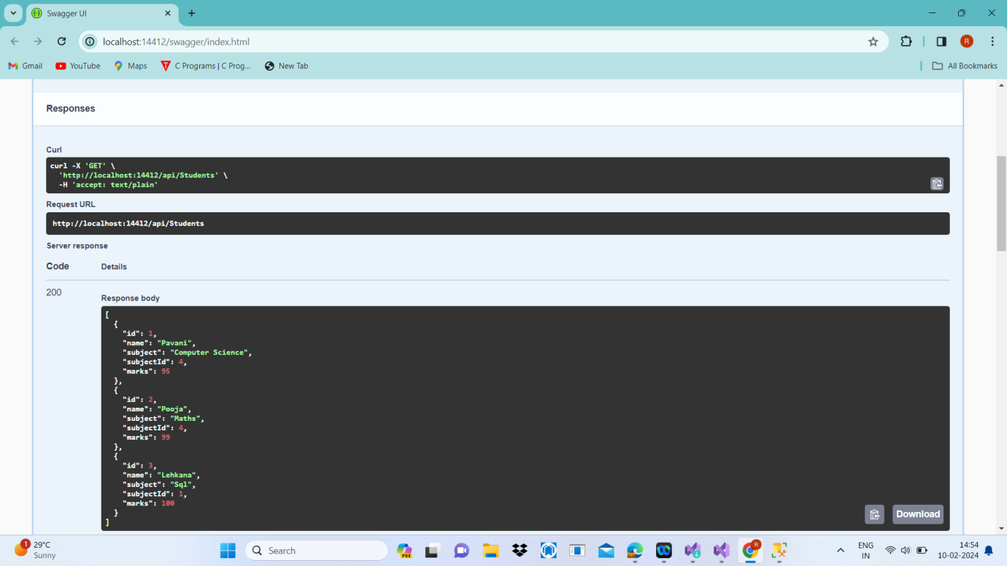

* SqlServer Details:

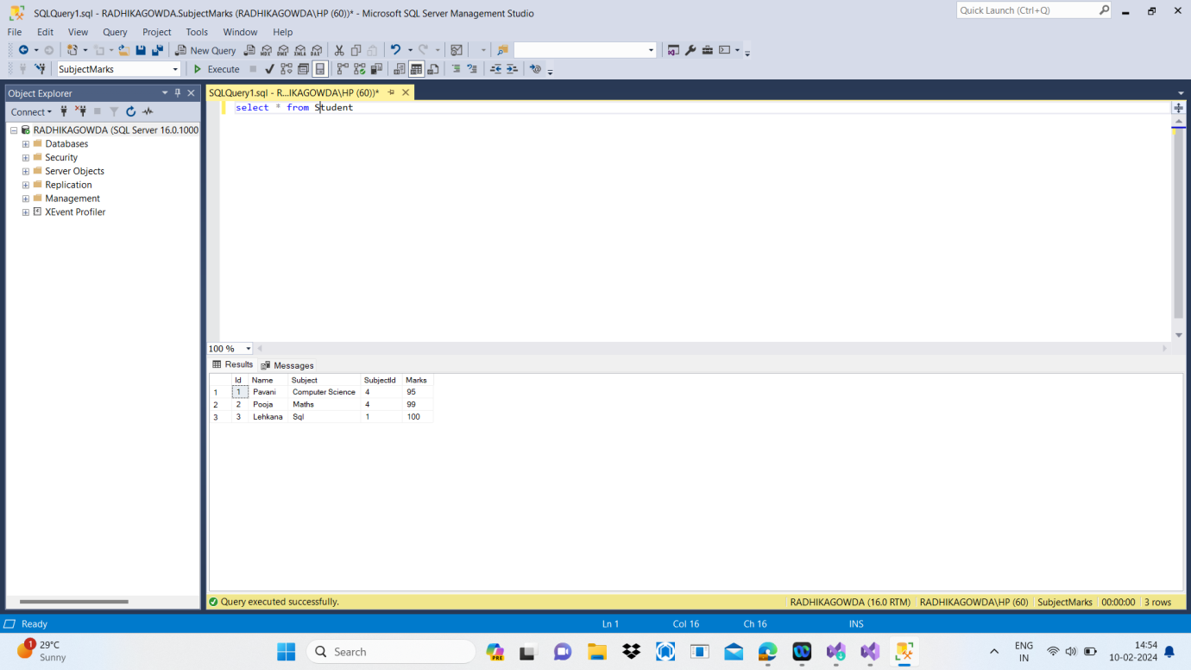

* Student Model class: 