**Create an ASP.NET WEB API Application to Add Subject Marks to Students and View Their Marks**

SourceCode:

* Database:

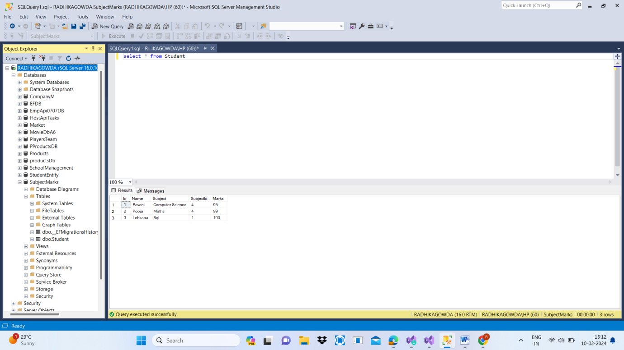

* Student Model class

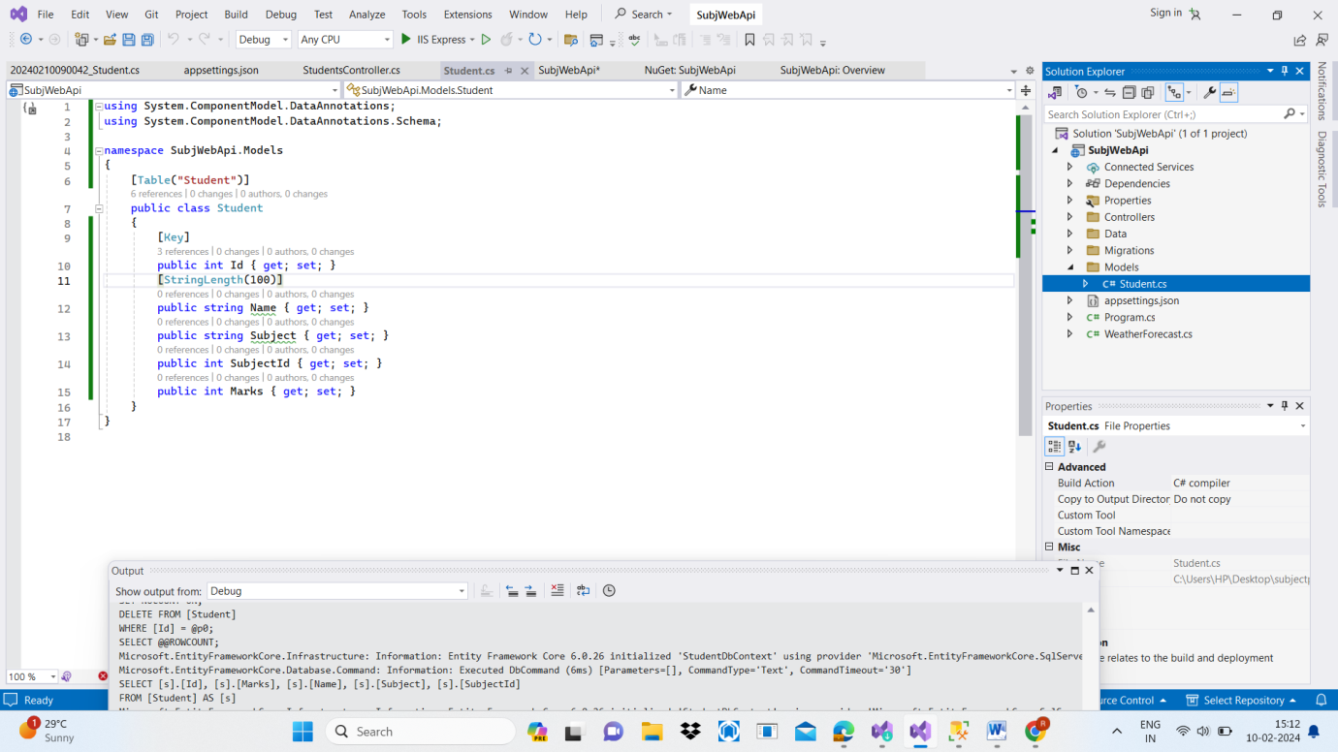

* Api’s

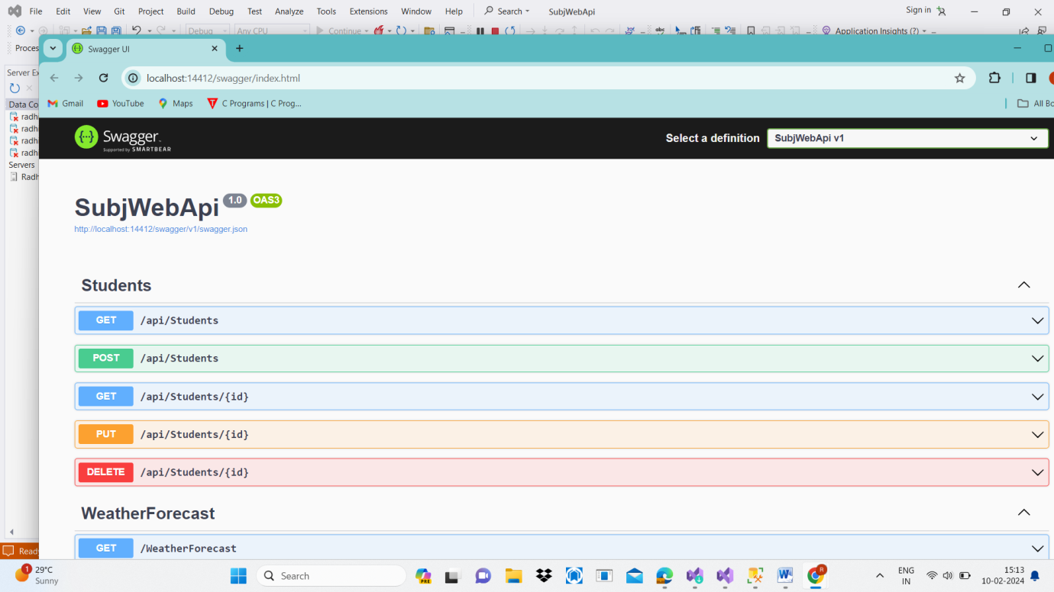

* StudentsApi:

