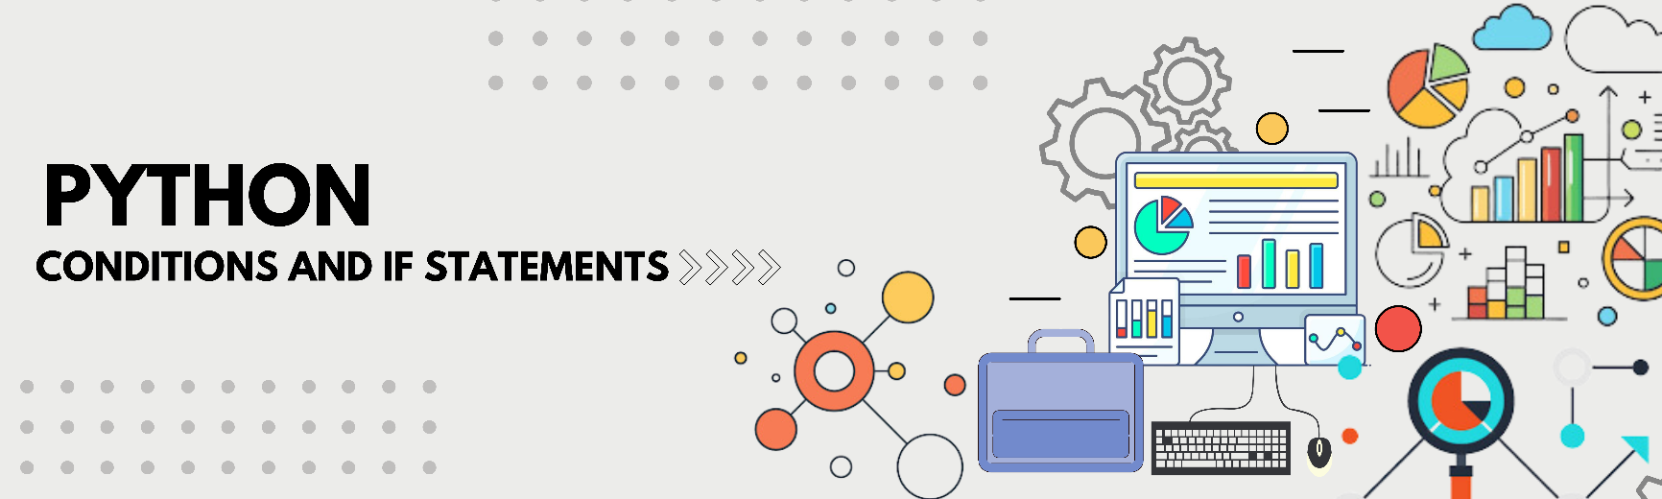

**Table of Contents**

* Introduction
* Directory Attributes
* Python Basic If-Else
* Python Intermediate Conditional Logic
* Python Advanced Decision Structures

**Introduction**

Exploring and mastering conditional statements in Python with extensive collection of challenges, showcasing proficiency in logical branching, decision-making, and control flow.

Addressing a variety of tasks ranging from basic if-else conditions to advanced logical operations, covering topics such as comparisons, nested conditions, and Boolean expressions.

Each solution is provided in Python format, demonstrating problem-solving skills and efficient implementation of conditional statements.

Here, I am showcasing my approaches to diverse Python challenges, utilizing Python’s conditional constructs to solve real-world problems.

**Directory Attributes**

**Python Basic If-Else**

This directory contains beginner-friendly Python challenges focused on fundamental conditional statements. These exercises cover essential concepts such as:

* if, else, and elif structures
* Boolean expressions for decision-making
* Simple comparisons and logical operations

Perfect for beginners looking to strengthen their understanding of Python’s decision-making mechanisms through hands-on practice.

**Python Intermediate Conditional Logic**

This directory includes intermediate-level Python challenges covering:

* Complex conditional expressions
* Logical operators (and, or, not)
* Nested conditions for multi-level decision structures
* Applying conditions in loops and functions

Sharpen your Python skills with practical scenarios that enhance logical reasoning and structured thinking.

**Python Advanced Decision Structures**

This directory contains advanced Python challenges focusing on complex decision structures, including:

* Ternary operators for concise conditional statements
* Advanced Boolean logic and bitwise operations
* Optimized approaches using conditional expressions

Master the art of writing efficient, clean, and optimized conditional statements for robust Python programming!