# **Outline:**

# The client is a leading Fashion retailer in Australia. MiQ runs a display advertising campaign for this brand, where it shows ads to users leading them to make a purchase on the brand's website. The given dataset is the Sales data for all users who made a purchase online in the first half of October ’17.

# **Task:**

Your task consists of three parts:

1. Provide an overview of the brand's sales by the following attributes:

* Overall - Total Sales and Revenue in the given time period

6699843.719999779 ,

Sum_Of_Products 101332

Unique_products 98686

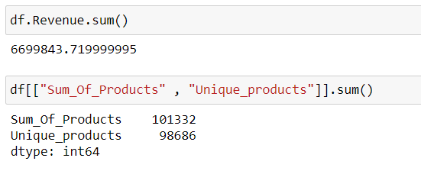

* Basket - Avg. unique quantity, revenue per order.

134.03976

Sum_Of_Products 101332

Unique_products 98686

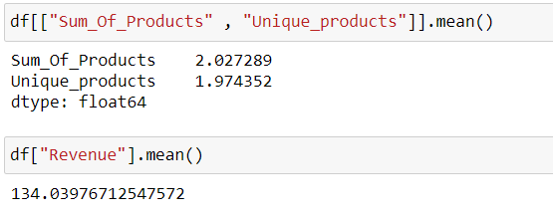

* Attributes - Time of Day, Day of Week, Geography, Payment Type

day 21

weekday 7

hour 24

Morning 5AM – 10AM , Afternoon – 11Am – 5PM, Evening – 6PM – 10PM , Night – 11PM – 4AM

Payment_Type 4

<https://www.mindk.com/blog/payment-gateway-comparison-stripe-vs-paypal-vs-braintree/>

BrainTree 23763

Stripe 13178

Paypal 12059

NoPayment 984

Country_Province 8

Country 2

* Frequency - How many are single/multiple purchasers? What is the frequency of multi-purchase? Any typical attributes?

Single – 52%

Total customers – 49984 , female – 84.1 , male – 15.9

New Customer -- 11431 – 22.9 , female – 74 , male - 26

Old Customer – 38553 – 77.1 , female – 87.2 , male – 12.8

No of unqiue_products for old

Single and Multiple customer with old and new customer ration

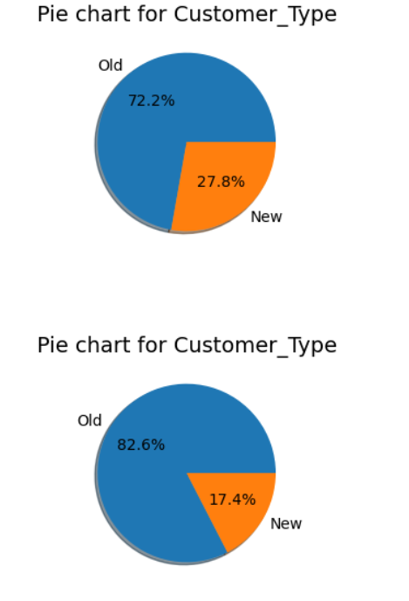

Hcbnc

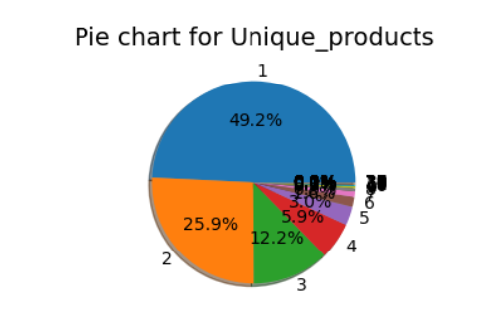

No of unique_products for new

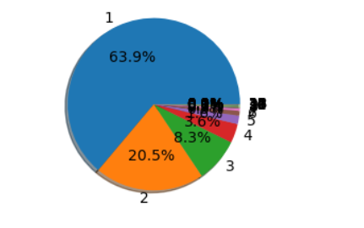

Sun_of_products for old customer

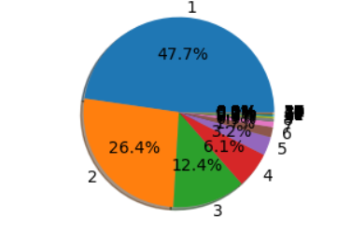

Sum_Of_products for new customers”

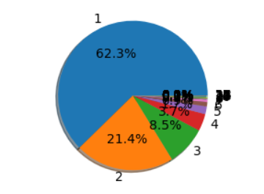

Coupon applied for old customers:

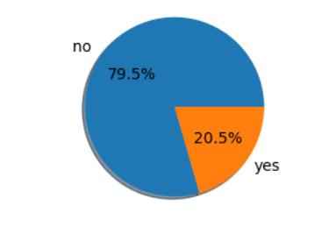

Coupon applied for new customers:

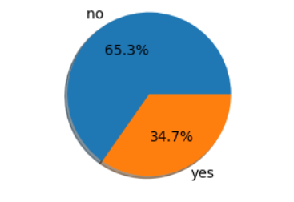

1. Product Affinity – Which products are more likely to sell together?
2. Based on your analysis, arrive at a statistical segmentation of the brand's audience based on Revenue. The number of segments is up to you. Please provide definitions of each group. – segmentation, new customer, weekdays weekend customer pattern, customer base, old customer but 1 purchase, customer promo code, customer order check out, percentage of 1st time, how many are using the promo code, increase the customer rate, at check up, city wise order,

# **Output:**

1. Create a PowerPoint based Report on your findings from the above. Your presentation should have the following 3 sections:

* Overview of the brand's sales performance
* Product Affinity
* Segmentation

1. Please include a slide or two on how would you broadly go about targeting more users for this brand. Come up with a well-defined media strategy.