**1) Explain the graph we received in the simulation that shows the relationship**

**between the received (throughput) and sent (load) packets. Why does the**

**throughput drop when the load is either very low or very high?**

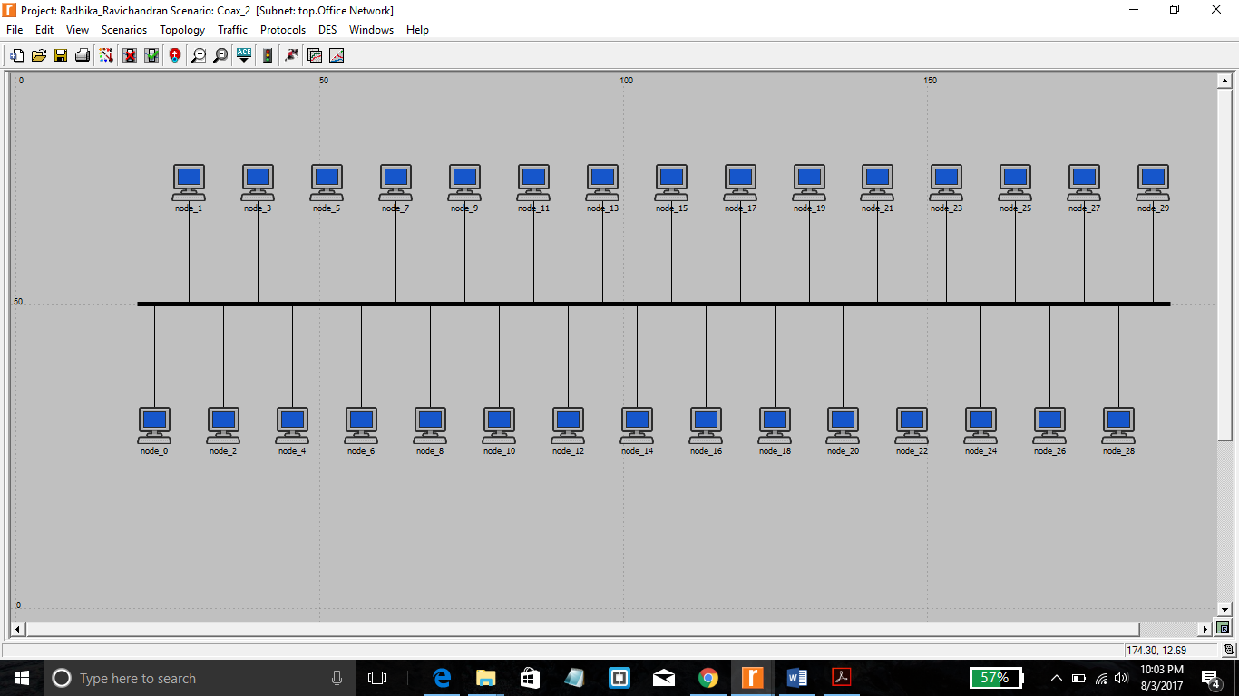

**Figure 1-Network Topology**

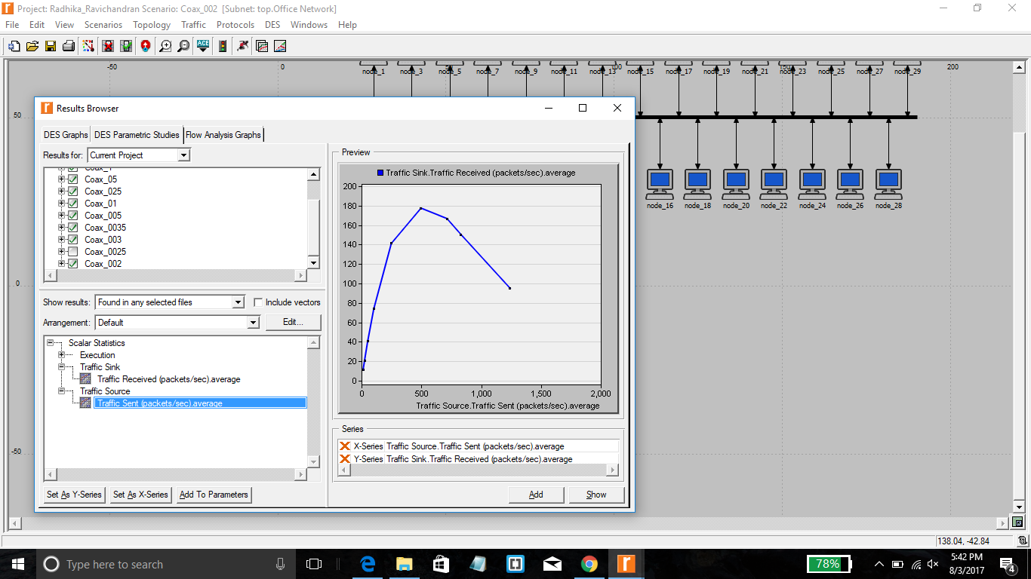

**Figure 2-Simulation Result**

When the received packets is less than 500 then the received packets and the sent packets are positively related, that is the sent packets keep increasing in accordance to the packets received. When the number of packets received is greater than 500 then the number of sent packets decreases when the number of packets received keeps increasing.

**2) Use three duplicates of the simulation scenario implemented in this lab named**

**Coax_01, Coax_005, and Coax_0025. Make sure that the Interarrival Time**

**attribute of the *Packet Generation Arguments* for all nodes in the scenarios are**

**as follows:**

**- Coax_01 scenario: exponential(0.1)**

**- Coax_005 scenario: exponential(0.05)**

**- Coax_0025 scenario: exponential(0.025)**

**Choose the following statistic for node 0: Node Statistics →Ethcoax →Collision**

**Count. Make sure that the following global statistic is chosen: Global**

**Statistics→Traffic Sink→Traffic Received (packet/sec). (Refer to the *Choose***

***the Statistics* section in the lab.)**

**Run the simulation for all three scenarios. Get two graphs: one to compare node**

**0’s collision counts in these three scenarios and the other graph to compare the**

**received traffic from the three scenarios. Explain the graphs and comment on the**

**results. (*Note:* To compare results you need to select Compare Results from**

**Results in the DES menu after the simulation runs is done.)**

Coax_2a scenario: exponential (0.1)

Coax_2b scenario: exponential (0.05)

Coax_2c scenario: exponential (0.025)

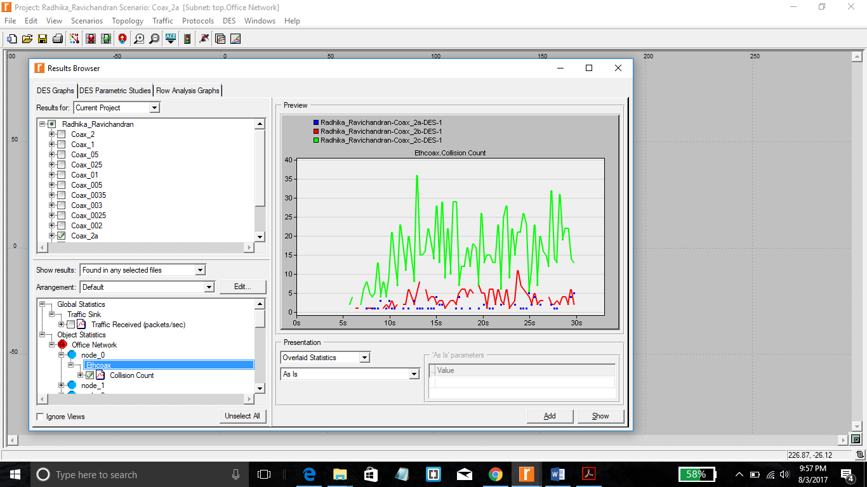

**Figure 3-Collision Count**

Refer Figure 3 which compares the collision count for 3 types of exponential values. As the value of exponential is small, the times of sending packets are larger than before. At the same time, numerous other machines try to send their own packets, as a result, more conflicts happens.

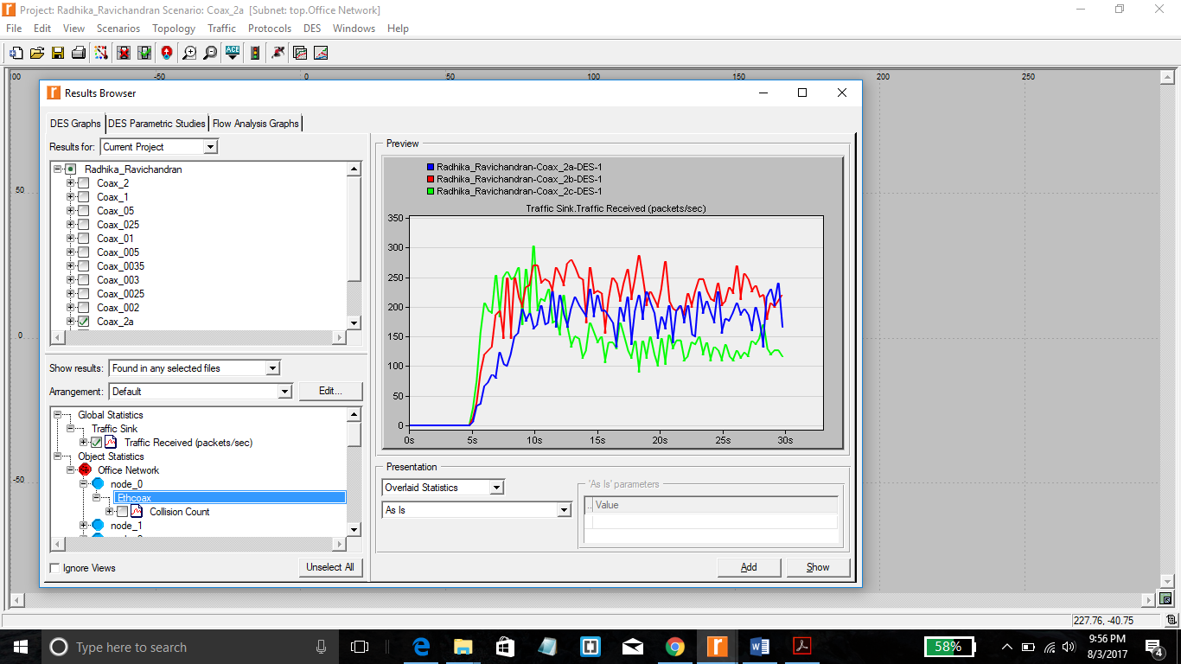

**Figure 4-Traffic Received(Packets/sec)**

Refer Figure 4 which shows that at the beginning, Coax_2a with exponential of 0.1 has the lowest traffic received speed. However, when the load becomes heavier, the speed goes up. The curve of Coax_2b with the value of exponential of 0.05 keeps rising all the time, and it reaches its highest point at the time when the traffic load is heavy. . And the highest point of curve Coax_2c is at the beginning. But the speed drops a little as the traffic load becomes heavier. These three curves show that different exponential will affect the efficiency of the networks.

**3) To study the effect of the number of stations on Ethernet segment performance,**

**create a duplicate of the Coax_0025 scenario. Name the new scenario**

**Coax_Q3. In the new scenario, remove the odd- numbered nodes, a total of 15**

**nodes (node 1, node 3, …, and node 29). Run the simulation for the new scenario.**

**Create a graph that compares node 0’s collision counts in scenarios Coax_0025**

**and Coax_Q3. Explain the graph and comment on the results.**

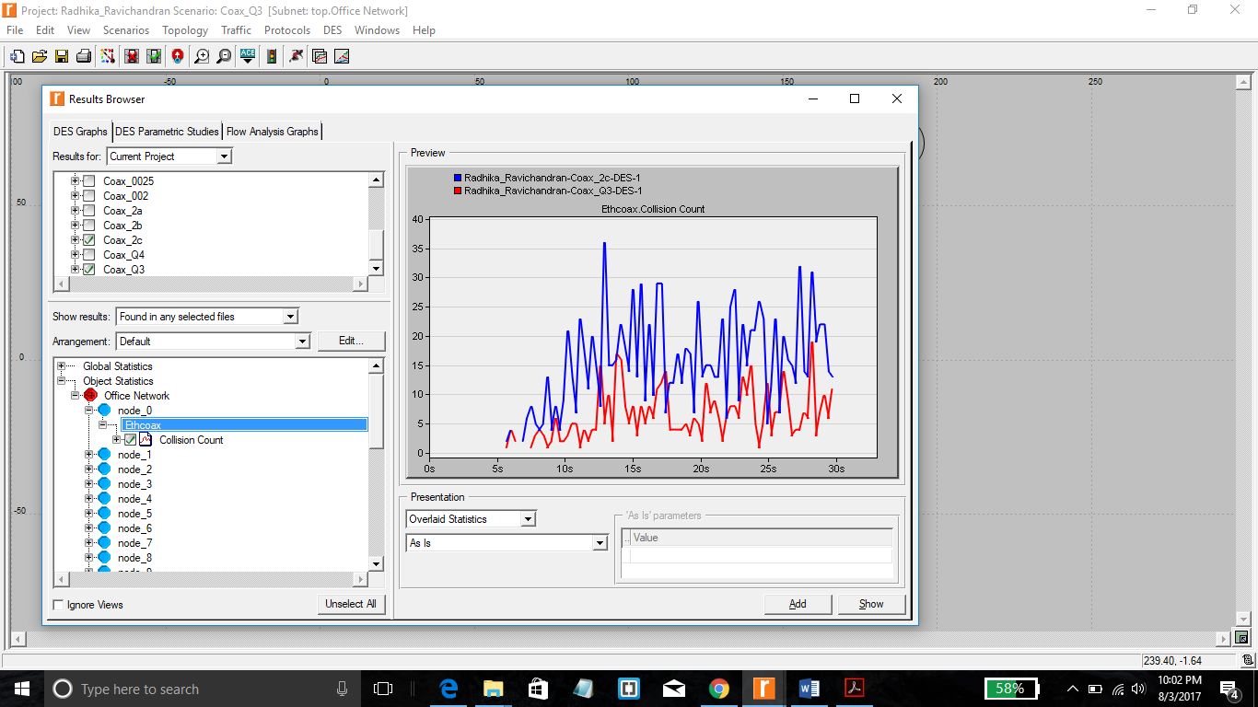

**Figure 5-Collision Count for Coax_Q3**

The number of Coax_Q3 nodes is half of Coax_2c. As fewer computers will make fewer collisions, so we can infer from Figure 5, that the Collision Count for Coax_Q3 keeps decreasing when compared with Coax_2c

**4) In the simulation a packet size of 1024 bytes is used (*Note:* Each Ethernet packet**

**can contain up to 1500 bytes of data). To study the effect of the packet size on**

**the throughput of the created Ethernet network, create a duplicate of the**

**Coax_0025 scenario. Name the new scenario Coax_Q4. In the new scenario**

**use a packet size of 512 bytes (for all nodes). For both Coax_0025 and**

**Coax_Q4 scenarios, choose the following global statistic:**

**Global Statistics→Traffic Sink→Traffic Received (bits/sec). Rerun the**

**simulation of Coax_0025 and Coax_Q4 scenarios. Create a graph that compares**

**the throughput as packets/sec and another graph that compares the throughput**

**as bits/sec in Coax_0025 and Coax_Q4 scenarios. Explain the graphs and**

**comment on the results.**

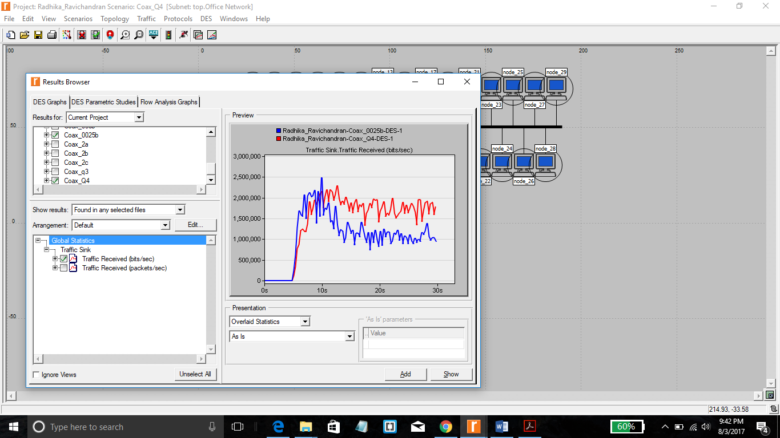

**Figure 6-Traffic Received(bits/sec)**

Refer Figure 6 which shows the traffic received speed in bits/sec. The network with smaller packets (constant 512bytes) has smaller speed at the beginning. However, with the time goes by, the speed maintains a certain value, which is bigger than the network (Coax_2c) with larger packets. This is because of the difference of the packet number. With more packets to be sent, the time efficiency becomes worse. So it is smaller when the load of network is light. As the network load is rising, the network with more sending packets will be more efficient. It is because the smaller size packet will make the collision count drop.

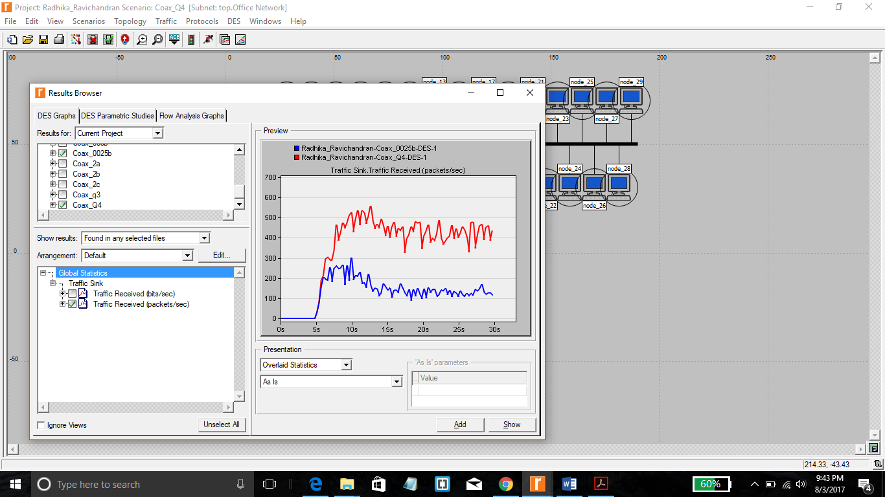

**Figure 7-Traffic Received(Packets/sec)**

Refer Figure 7 which shows the Traffic Received in Packets/sec. The network with smaller packets (constant 512bytes) has smaller speed at the beginning. However, with the time goes by, the speed maintains a certain value and it is always bigger then the network Coax_2c.