Task-01

AEM Installation

Create create a folder in local disk c

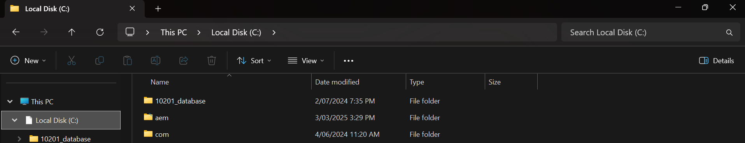

Download the jar file for aem and paste it inside the the folder we created and open command prompt with run as administrator and run the command “java -jar aem-author-p4502.jar” after installation it shows AEM server page

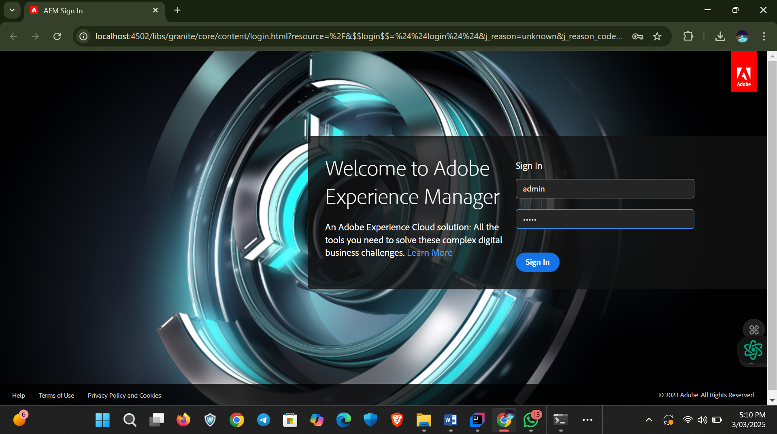

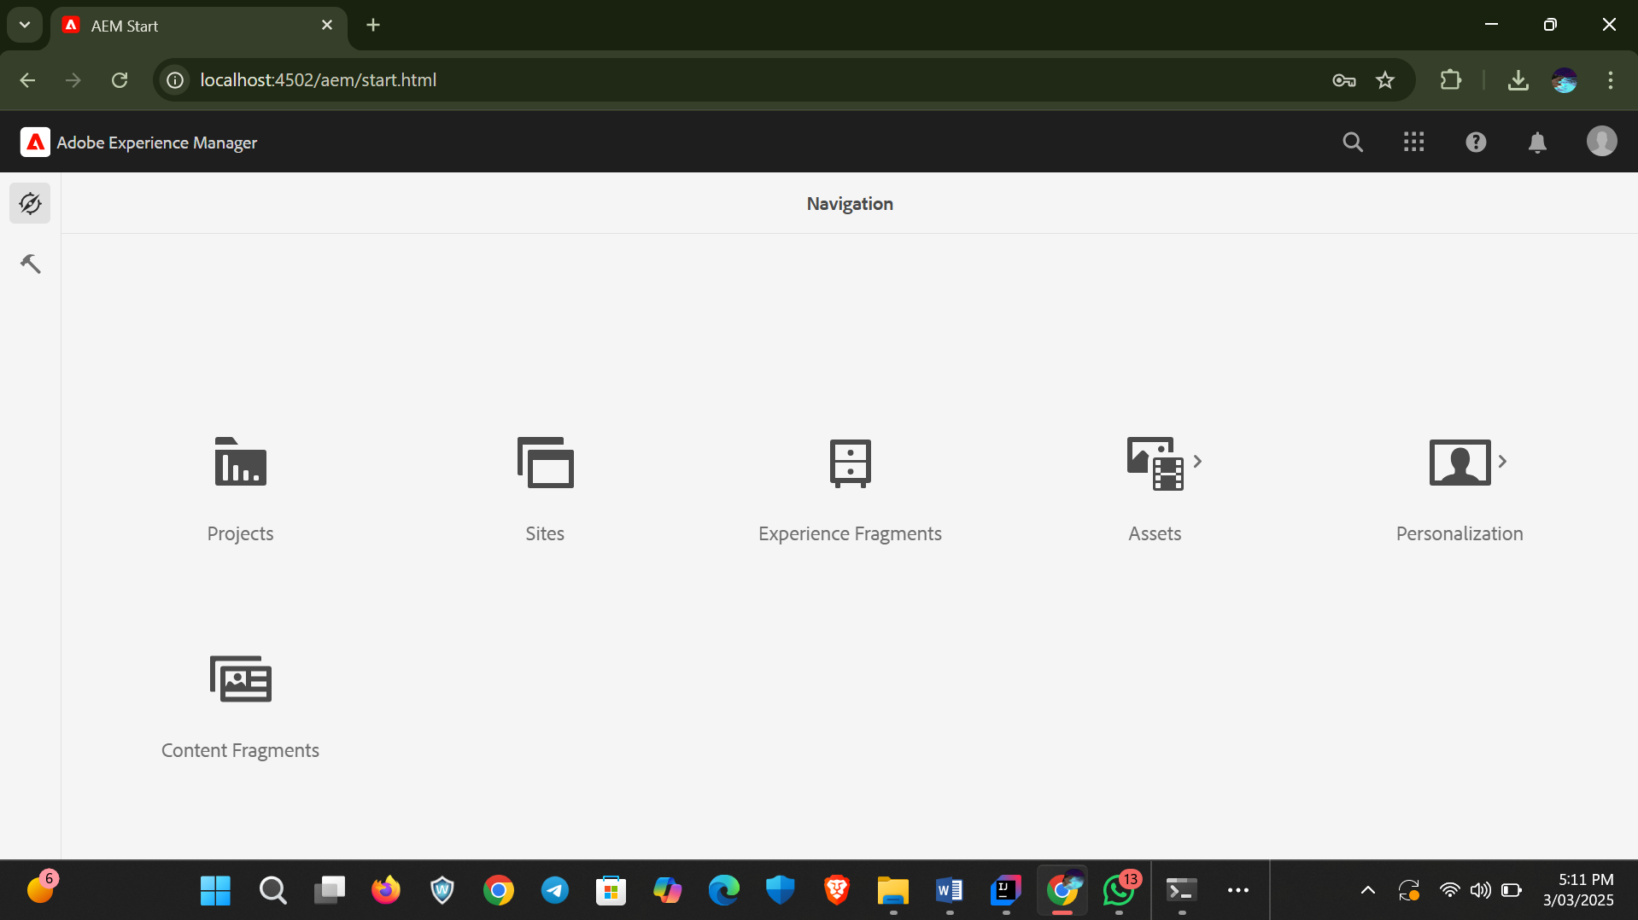

After the create a maven project for connection

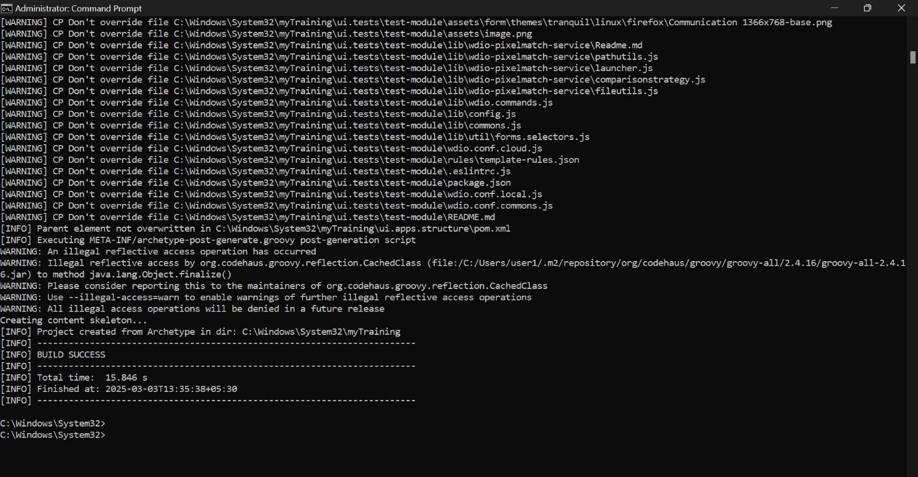

After the project is created open the project in an IDE

