**Task-04**

**Building an E-Magazine/Online Newspaper Platform**

**Output for the website:**

**Page 1:**

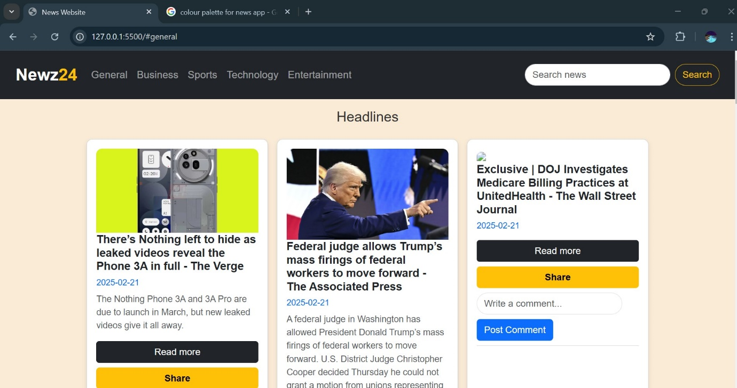

**Business news page:**

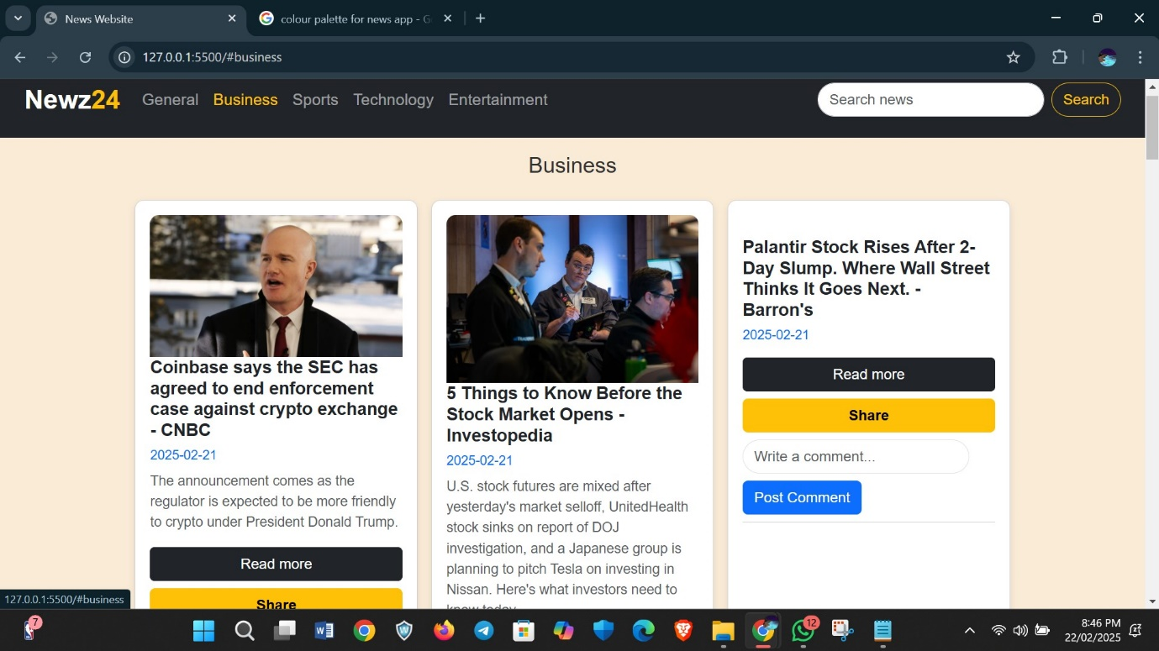

**Sports news page:**

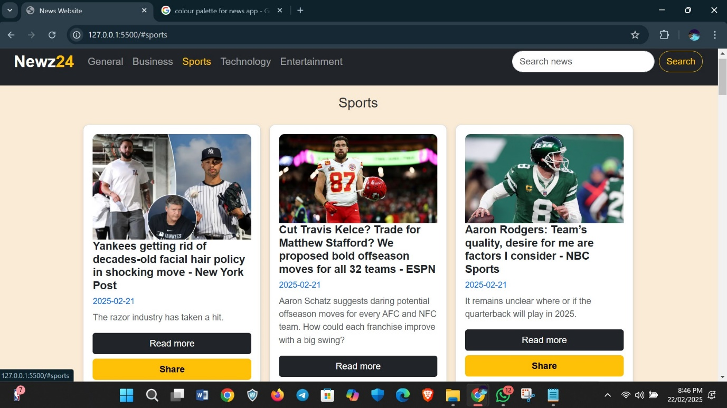

**Technology news page:**

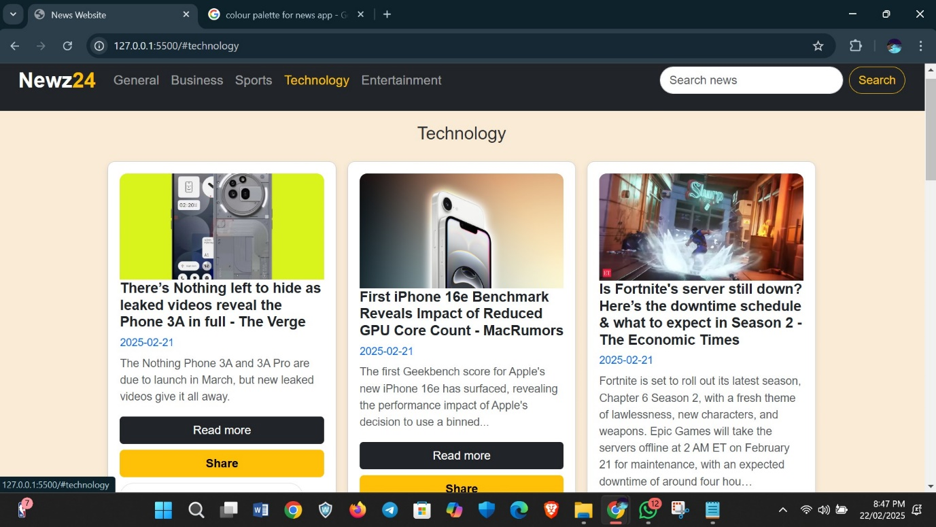

**Entertainment news page:**

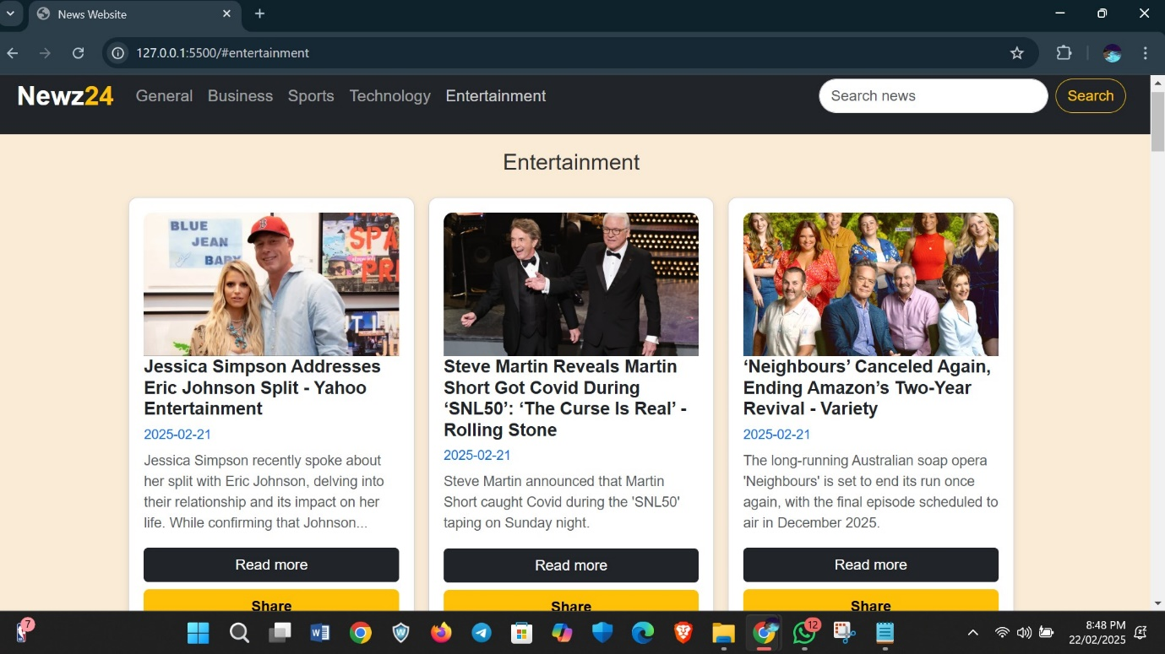

**search engine :**

**if we want to search about any particular category of news, we can use that**

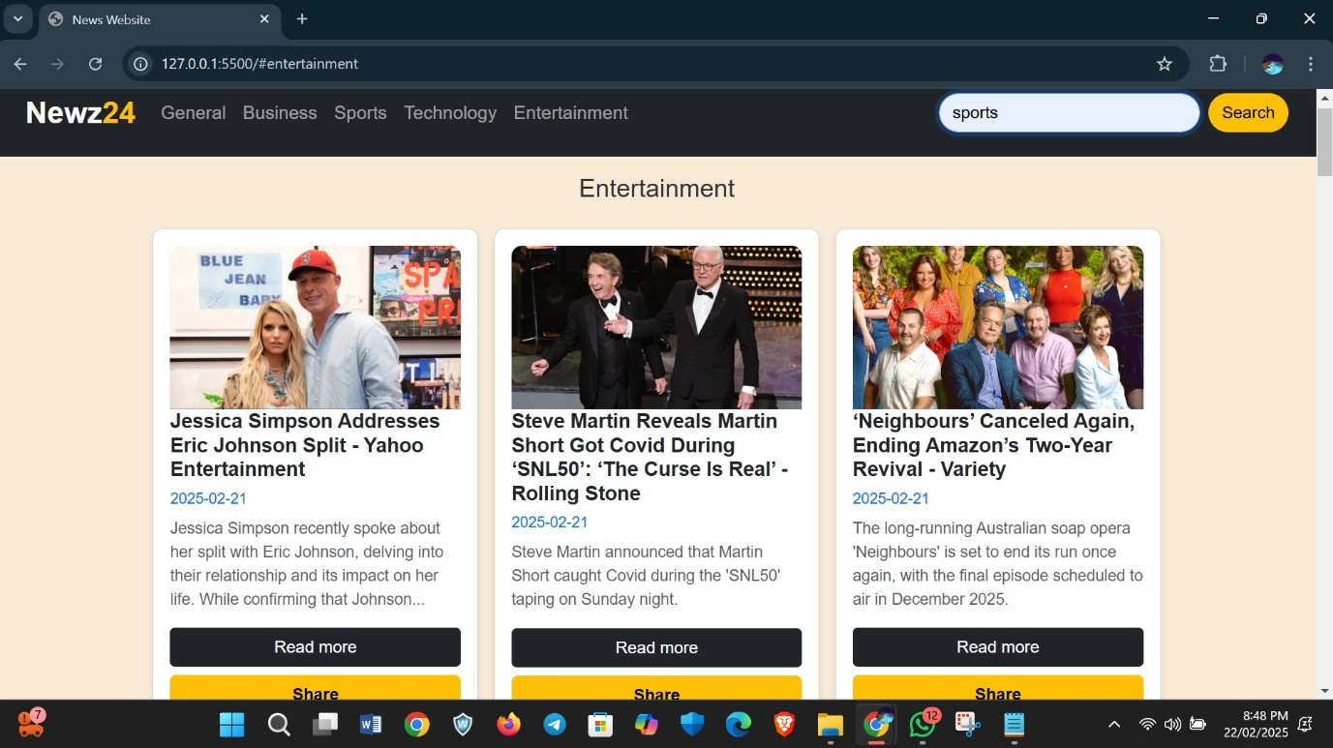

**When we hover or hit the searchbutton it changes into different colour**

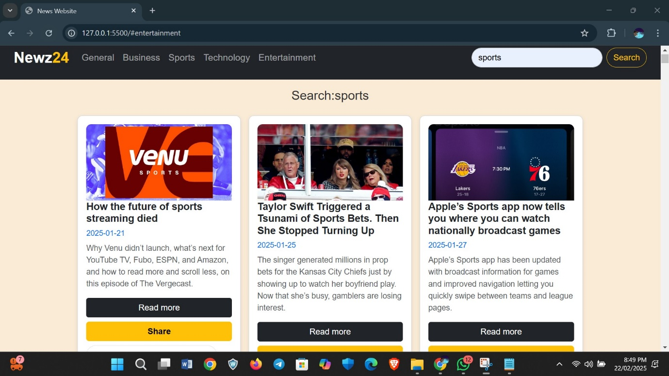

This is how the different news templates looks like

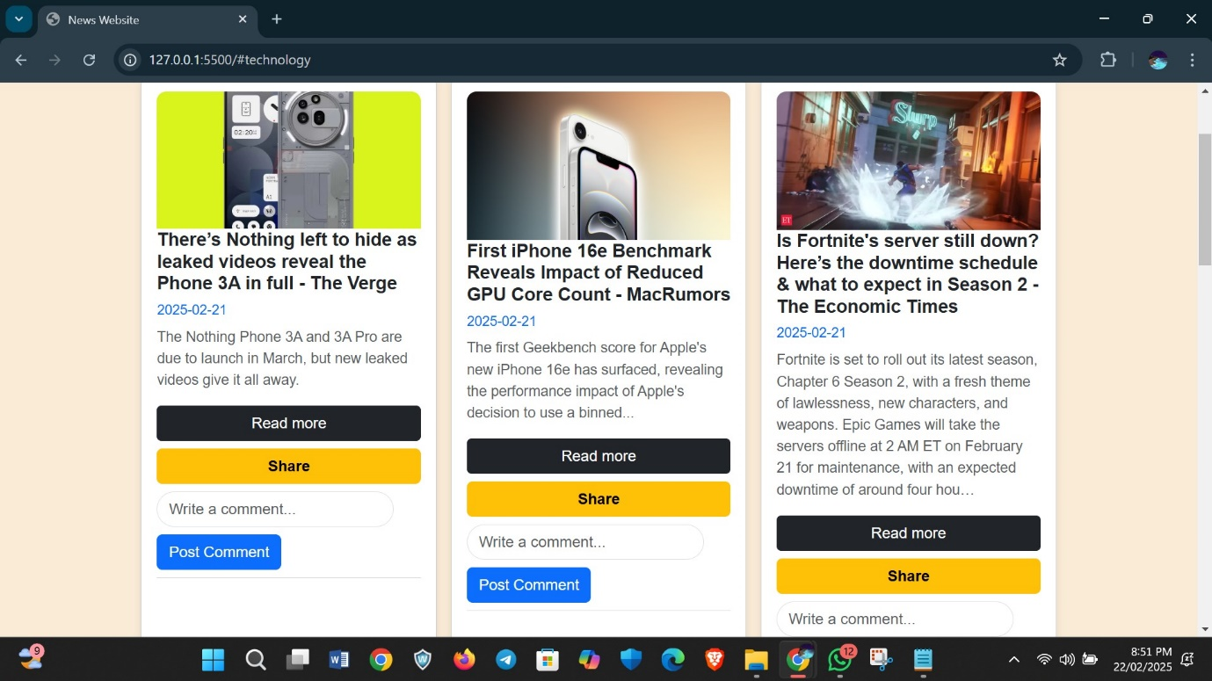

There is a user Interactive option as the user can share and post comment on the every articles

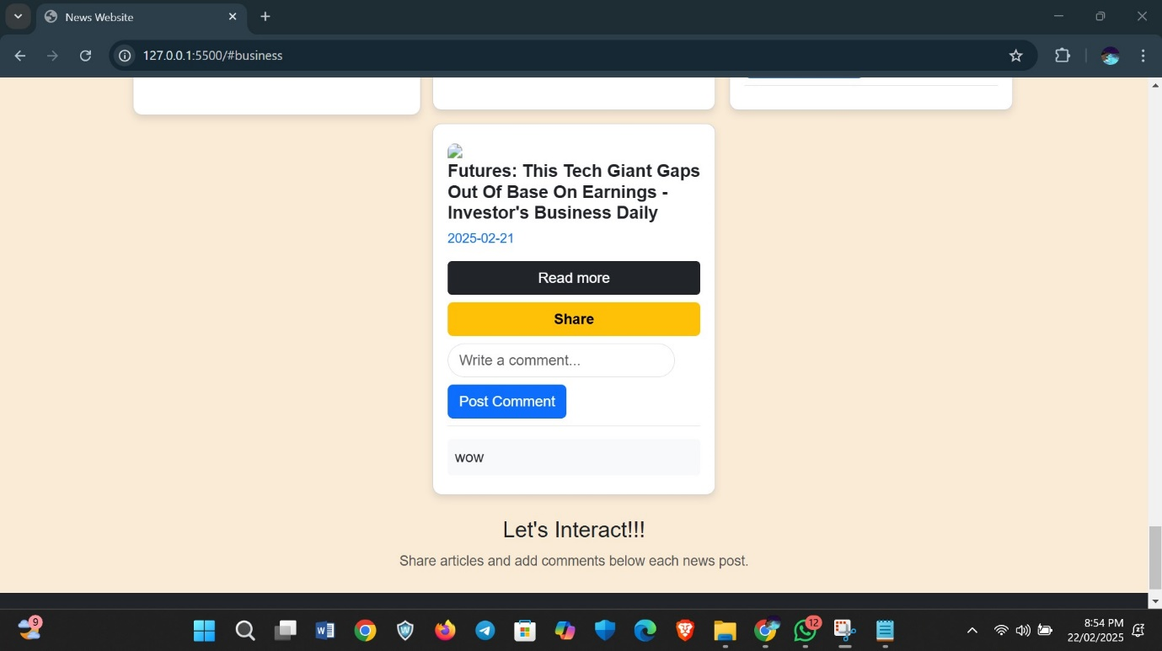

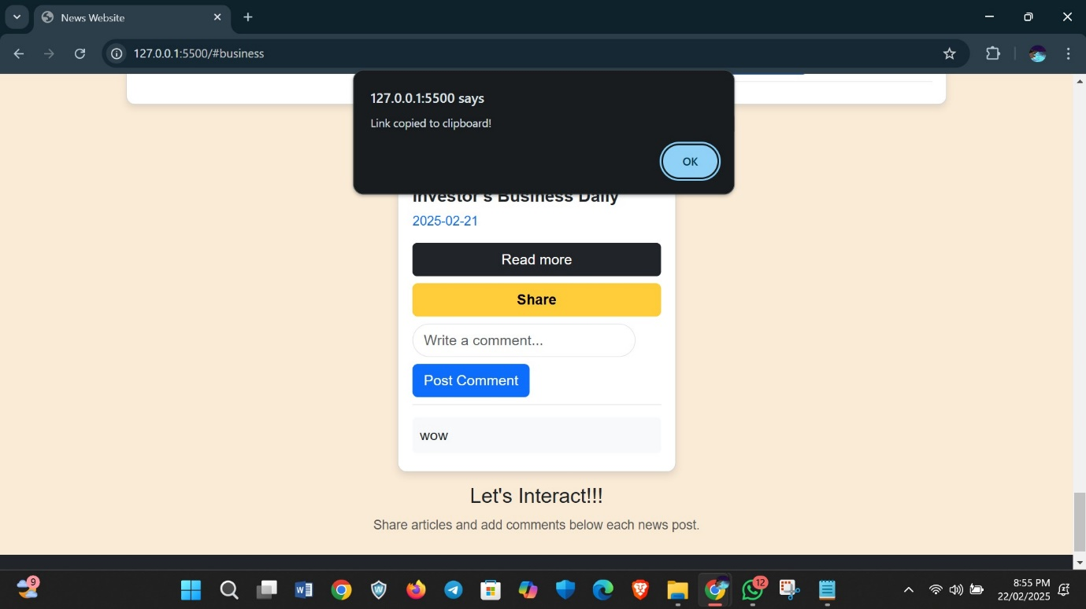

If the user wants to read a specific article in the website the can click on read more as it has hover effect in the button and also navigation into another tab of the full article to the user.

