Project Report

On

"Customer Churn Analysis"

**Submitted to Punjab Technical University, Jalandhar**

**In partial fulfillment of the requirements**

**For the degree of**

B.Tech Computer Science & Engineering

(Session 2019-2023)



**Submitted to: Ass. Prof. Pooja Duggal**

**Submitted by: Radhika (1917631)**

**PCTE INSTITUTE OF ENGINEERING & TECHNOLOGY, LUDHIANA**

**Declaration**

I swore that the work being presented by me in the dissertation titled "Customer Churn Analysis” in partial requirements for the fulfillment of degree of B.Tech Computer Science and Engineering to be submitted in **PCTE INSTITUTE OF ENGINEERING AND TECHNOLOGY, LUDHIANA** affiliated to **PTU,Jalandhar** is authentic record of my own work carried out by me under the supervision of **"Ass. Prof. Pooja Duggal".**

**Acknowledgement**

**On the very outset I would like to thank the almighty GOD for showering his blessing & providing me with the courage, motivation & strength to complete my project.**

**Every Project work demands a lot of hard work, time, patience and concentration. While working on this seminar, apart from these aspects, I have developed necessary skills and attitude, which are always required in a professional field. I am thankful to all those who helped me in completing this project.**

**I express my deep sense of gratitude & indebtness towards my respected Project In-charge "Ass. Prof . Pooja Duggal", and faculty members of PCTE Institute of Engineering and Technology from whom I have learnt the technical skills for completion of this Project. Without their guidance, I would have found it really difficult to undertake the project work. I would like to thank them for their ever available, unconditional help & guidance that they made available throughout the project work.**

**I would also like to acknowledge the encouraging attitude of my friends & other staff members of P.C.T.E family that helped me to complete the project work.**

**Certificate from Organization**

This is to certify that format and quality of presentation of project report submitted by

As one of the requirements for the degree of

**B.Tech Computer Science and Engineering**

is acceptable to

**Department of Computer Science and Engineering,**

**PCTE, Ludhiana**

**Head of Dept.**

**(________)**

**PCTE Institute of Engineering and Technology, Ludhiana**

**Certificate from Internal Guide**

This is to certify that the project title “**Customer Churn Analysis**” submitted for the degree of **B.Tech Computer Science and Engineering** in the project of **PCTE Institute of Engineering and Technology, Ludhiana** affiliated to **PTU, Jalandhar** is a benefited research which is carried out by **myself.** under my supervision and no part of this project has been for any other degree. They have worked very hard and sincerely during this project.

**Project Supervisor**

**(Ass. Prof. Pooja Duggal)**

**(Faculty, PCTE)**

**Ludhiana**

# CONTENTS

1. CONTENTS 6

2. INTRODUCTION TO PROJECT 7

PURPOSE OF THE PROJECT 8

3. STUDY OF EXISTING SYSTEM 9

4. STUDY OF THE PROPOSED SYSTEM 10

PURPOSE OF THE SYSTEM 11

PROBLEMS IN THE EXISTING SYSTEM: 11

SOLUTION OF THESE PROBLEMS 11

5. HARDWARE & SOFTWARE SPECIFICATIONS 12

6. CUSTOMER CHURN ANALYSIS 13

7. OBJECTIVES OF PROJECT 16

8. FEATURES OF PROJECT 17

9. PROJECT PLANNING 18

UNDERSTANDING THE TOPIC 18

MODULAR BREAK-UP OF THE SYSTEM 18

PROCESS LOGIC FOR EACH MODULE 18

FILE STRUCTURE REQUIREMENTS 19

DOCUMENTATION 19

10. SITE MAP 20

11. MODULE WISE DESCRIPTION WITH SCREEN SHOTS 21

# INTRODUCTION TO PROJECT

Customer churn indicates a process in which an existing customer who used the services of the organization stopped using it or shifted to using other services of the same organization which do not provide the organization much revenue. Thus, customer churn can directly impact the revenue made by an organization. The churn problem is not only limited to the telecommunication sector. The gaming sector and tourism sector also face a lot of customer churn problems. In the gaming sector, if a game is a too difficult customer is likely to churn or stop playing that game. On the other hand, if the game is too easy it would be too boring for the customer, hence, would ultimately become a reason for churning from that game. In the tourism sector, If the travel package released by the organization lack adequate rest during the journey customer will be uncomfortable and would churn from that package and will shift to another package. Apart from this, that customer will discourage his friends and relatives to not going with that package. Hence, in the worst- case scenario, the company could also witness an exponential rise in the churn rate. In our project, we would be primarily focussing on the customer churn rate in telecom organizations. The telecommunications sector is one of the main industries accelerating the growth of multiple nations jointly with their services. So, the businesses (both new and established ones) operating within this sector face constant trouble of customer churn. The customer churn problem has been on a rise recently which is directly dependent on the establishment of other telecom organizations providing better services.

## PURPOSE OF THE PROJECT

The retention and acquisition of users are the major concerns in telecom industry. The fast growth of marketplace in every business is giving rise to increased subscriber base. Accordingly, companies have recognized the significance of retaining the customers who is on hand. It has become necessary for service-providers to reduce the churn rate of customers since the inattention might negatively influence profitability of the company. Churn prediction contributes to identify those users who are likely to switch a company over another. Telecom is enduring the problem of ever-increasing churn rate. Accordingly, the current study employs machine learning algorithm on big-data platform. Machine learning algorithm techniques facilitate these telecom firms to be protected with efficient approaches for lessening the rate of churn. Silent churn is one type which is considered complicated to predict since there might have such kind of users who might probably churns in the near future. It must be the aim of the decision-maker and advertisers to lessen the churn ratio since it is a recognized fact that comparatively 4 existing customers are the most beneficial resources for companies than acquiring new one.

# STUDY OF EXISTING SYSTEM

In today’s scenario there already exist several projects detecting customer churn in telecom organizations. Each project consists of some pros and cons. A proposed a churn prediction model that uses classification, as well as clustering techniques to identify the churn customers and provides the factors behind the churning of customers in the telecom sector. Feature selection is performed by using information gain and correlation attribute ranking filter. The proposed model first classifies churn customers data using classification algorithms, in which the algorithm performed well with 88.63% correctly classified instances. Creating effective retention policies is an essential task of the CRM to prevent churners. After classification, the proposed model segments the churning customer's data by categorizing the churn customers in groups using cosine similarity to provide group-based retention offers. This paper also identified churn factors that are essential in determining the root causes of churn. Also . 1 model discuss the development of a model using big data analytics strategy for the dataset provided and using it predictions are made regarding the list of customers with their susceptibility listed in descending order. After getting the list through the techniques mentioned in the previous step, user segmentation and piecewise regression are used to find the highly relevant parameters followed by the division of customers into different categories based on the above-found parameters. Using regression analysis one can estimate the prediction rates for different groups of customers. High computing storage took some time in predicting results and accuracy rates of about 80% were achieved. Based on the results the organization was able to prioritize the customers who shall be given extra attention to influence their mindsets of continuing their relations with thecompany.

# STUDY OF THE PROPOSED SYSTEM

Machine Learning in simple terms is a subset of Artificial Intelligence and Computer Science. It learns through a bunch of data and predicts a certain outcome . The more the data the better will be the accuracy.

Machine learning is mainly subdivided into three parts (1) Supervised Learning (2) Unsupervised learning (3) Semisupervised. We will be using Supervised Learning in our project. As we have already discussed in our introduction slide, our project deals with the problem of customer churn mitigation in telecom organizations. To achieve a particular goal, we should first aim to establish certain milestones and should strive to achieve them one by one, we have also implemented the same strategy in our project and have grouped all tasks into various categories. The categories are as follows:

A**. Capture and Analyze:-** This section mainly aims at the dataset formation process. Under this section formation and understanding of problem statement and business took place respectively. We have researched the customer churn impact on the organization and mapped the strategies to mitigate it. After the problem identification, we identified the type of data needed to build the data set. The exploration of data was carried out and after the data was found it was being extracted and requested from the source to build the data set. The data extraction took place from the Tariff and Usage Data, Customer level data, Recharge Data, etc. After the data extraction job, we aggregated cleaned and transformed the dataset. Now the dataset was all ready for Exploratory data analysis which is part of the Report and Predicts.

**B. Report and Predict** When we dive into the Report and Predict section, we are equipped with a dataset that is ready to be explored further (1) Data Sourcing (2) Data Cleaning (3) Univariate Analysis (4) Bivariate Analysis (5) Derived metrics. After this, we design a predictive model. Once the model has been created, we would be implementing it and the best one will be chosen for deployment which is the part of Engage and Act Section**.**

**C. Engage and Act** Now, this is our final segment which is regarding the deployment of our project. As we have already discussed in our previous section that we will be finalizing a Machine Learning model giving the best results. So now we would be using the Flask tool for the deployment procedures. It’s very important to have easy access to our project so that even a layman can understand what’s going on and also when a particular subscriber is likely to churn. We would also be providing churn drivers and KPIs for tracking and monitoring purposes. Recommendations on monthly churn initiatives may also be provided.

## PURPOSE OF THE SYSTEM

In a business scenario predicting customer churn is where a firm is attempting to retain customer which is much probable to leave the services. For reducing the rate of churn this study classifies which customers are much going to churn probably and which will not churn probably. Since obtaining new customers is challenging it is essential to retain present customers. Churn can be decreased by examining the essential customers past history systematically. Huge amount of data is managed about the customers and on carrying out appropriate examination on the same it is feasible to find probable customers that might churn. The data that is feasible can be examined in varied ways and thereby offers different ways for operators to imagine the churning of customers and avoid the same. The below figure shows the steps used for proposed system.

## PROBLEMS IN THE EXISTING SYSTEM:

* Risk of mismanagement of data.
* Less Security.
* No proper implementation of models and algorithms
* Fewer Users - Friendly.
* Accuracy not guaranteed.
* Not (algorithms and methodologies) in reach of distant users.

## SOLUTION OF THESE PROBLEMS

The development of the new system contains the following activities, which try to automate the entire process keeping in view of the machine learning approach.

1. User friendliness is provided in the application with various controls.
2. The system makes the overall project management much easier and flexible.
3. There is no risk of data mismanagement at any level while the project development is under process.
4. Easily accessible and understandable
5. Users from any part of the world can make use of the system.
6. New system will process accurate results.
7. New system will be much better in performance as compared to existing one.

# HARDWARE & SOFTWARE SPECIFICATIONS

**H/W SYSTEM CONFIGURATION:**

* Processor - Pentium –IV
* Speed - 1.1 Ghz
* RAM - 4GB RAM
* Hard Disk - 20 GB
* Key Board - Standard Windows Keyboard
* Mouse - Two or Three Button Mouse
* Monitor – SVGA

**S/W SYSTEM CONFIGURATION:**

* Python 3.5 in Google Colab is used for data pre-processing, model training and prediction.
* Operating System: windows 7 and above or Linux based OS or MAC OS.

# CUSTOMER CHURN ANALYSIS

Analyzing customer Churn

1. **TITLE OF THE PROJECT:** **Customer Churn Analysis**
2. **DOMAIN:** Machine learning
3. **SUB DOMAIN:** Telecom Churn
4. **PROJECT ARCHITECTURE**: N-Tire Architecture
5. **ABSTRACT OF THE PROJECT:**

The Problem is based on the domain of the Telecom sector where the company wants to predict the Churn of a customer depending upon the previous data of the customer. By churn it is meant that the company wants to predict if a customer would be a defaulter in the next quarter depending upon its previous history.

The main problem is to predict if a customer would be defaulter or not depending upon the previous data of the customer.It is important from a telecom’s perspective in order to maintain business and customer relationship/ Apart from that if someone could be predicted as a defaulter then primitive measures can be taken in order to ensure that such violations do not happen.

The basic approach of solving this problem was first studying the data , then bringing out insights from the dataset and after that I have followed a machine learning pipeline in order to solve the problem.

The ML Pipeline that I have followed is :

* Importing the necessary libraries and the dataset
* Performing Data Preprocessing (Exploratory Data Analysis and Data Manipulation)
* Modelling using Logistic Regression, KNN and Random Forest
* Performing Prediction
* Visualization in between Actual and predicted Values

The environment used was python 3.7 and the libraries such as numpy, pandas, matplotlib , Standard Scaler and Scikit Learn module were used for Scientific computations.

**6. EXISTING SYSTEM:**

* Cannot compare efficiently dataset features and algorithms.
* No use of public platforms and websites
* Risk of mismanagement and of data when the project is under development.
* Less Security.
* No proper coordination between different Analyses and Users.
* Fewer Users – Friendly (Computer officials)
* Difficult to analyze the dataset

**7. PROPOSED SYSTEM:**

The development of the new system contains the following activities, which try to automate the entire process keeping in view the data interpretation, reprocessing, analysis algorithms, and, machine learning approach.

* User friendliness is provided in the application with various control morels.
* The system makes the overall project analysis allowing much easier more and flexible.
* Readily upload the latest updates, allowing users to analyze and interpret the dataset.
* There is no risk of data mismanagement at any level while the project development is under process.
* It provides some quality comparisons between algorithms and features.

**8. MODULES:**

1. Tableau public -Visuals
2. Tableau public- Dashboard with Filters
3. Colab Research – Data Information
4. Colab Research – Data Visuals
5. Colab Research – Data Analysis
6. Colab Research – Algorithms Analysis

**9. KEYWORDS:**

* **Generic Technology Keywords:** Databases, User Interface, Programming
* **Specific Technology Keywords:** GUI , SQL , EXL , CSV ,ML
* **Project Type Keywords:** Analysis, Design, Implementation, Testing
* **SDLC Keywords**: Presentation, Business, Data Access Layers

**10. ENVIRONMENT:**

* **Servers:** 
  + - * **Operating System Server: -** Microsoft Windows 2000 or Higher
* **Clients:** Machine learning explorers,students
* **Tools:** Microsoft Excel, Tableau Public, Colab Research
* **User Interface:** Tableau Public Visual, Colab Reserch Notebook
* **Code Behind:** Python , Data Preprocessing , machine learning algorithms

**11. REQUIREMENTS:**

**H/W SYSTEM CONFIGURATION:**

* Processor - Pentium –IV
* Speed - 1.1 Ghz
* RAM - 4GB RAM
* Hard Disk - 20 GB
* Key Board - Standard Windows Keyboard
* Mouse - Two or Three Button Mouse
* Monitor – SVGA

**S/W SYSTEM CONFIGURATION:**

* Python 3.5 in Google Colab is used for data pre-processing, model training and prediction.
* Operating System: windows 7 and above or Linux based OS or MAC OS.

# OBJECTIVES OF PROJECT

* To explore the customer churn prediction in telecom using machine learning in big data platform
* To investigate the impact of customer churn in telecom industry as a whole
* To discuss the significance of customer churn models in telecom industry
* To compare the algorithms that are effective in reducing churn rate in telecom companies
* Quality Services
* Easy Management & Updating
* Time Saving and improved efficiency

# FEATURES OF PROJECT

1. **Easy Interface:**

Easy to manage, analyze and check the visuals. It is made of very simple interfaces. Any end user with a minimum knowledge of operating the Computer can easily familiar with this software.

1. **Security:**

It is published on a secured website. An unauthorized user cannot log on to this software.

1. **Reliability:**

The analysis is reliable. One can rely on the result produced by this software. We try to remove all the errors from it and make it error-free but it can be error-prone.

1. **Compact Coding:**

It is compact and efficient coded software. It is developed with keeping in mind memory space and speed. It uworksless memory space and work on increasing speed.

1. **No extra skills required:**

A person needs not be a computer professional. If a user with little knowledge of computer can operate this project.

1. **Large database: -**

The very large dataset is used to ensure project accuracy and results.

1. **User Friendly:** -

We develop software which is very user-friendly.

# PROJECT PLANNING

Working on a project implies the need for some common guidelines and standards to be followed. For optimum usage other of the available machine time, it is necessary that every session is planned. Planning of project will include the following:

* Understanding the topic
* Modular break-up of the system
* Process logic for each module
* File structure definition
* Documentation

## UNDERSTANDING THE TOPIC

The field of application as introduced in the project may be a new field. In that case, many technical words may not be clear. So, as soon as the project is allocated to a group, both members should carefully go thru the project to:

* Identify all words and phrases which are not familiar, or which are application-specific
* Understand the logical flow of events in the application

## MODULAR BREAK-UP OF THE SYSTEM

* Identify the various modules in the system
* List them in the right hierarchy
* Identify their priority of development

## PROCESS LOGIC FOR EACH MODULE

For every module, the process logic should be identified so that an outline is ready. The process logic may be clarified in case there are any doubts or problems.

## FILE STRUCTURE REQUIREMENTS

The structure of the tables has been given, but if you wish to add a field(s) you may do so. Identify a Key field to uniquely identify a record; if a single key field is not sufficient to uniquely identify a record, then a composite key field can be used.

* All the validations can be given in the property sheet when you are creating forms to enter data. You may try new validations if you have time.
* If you need to edit or delete records you must use the Access menu options.
* You will learn more if you go thru the Help and Cue-Cards offered by Access.

## DOCUMENTATION

The documentation has to be submitted to the coordinator in the format. The blank report following the case studies is to be filled up, detached from the report and submitted by the given dates. A sample format is:

* Problem statement
* Database design
* Form design
* Validation performed
* Queries used
* Outline of reports
* Problems encountered and how they were tackled
* Suggested enhancements
* Hardware and Software specifications
* Appendix which has all handwritten outlines like form and report designs.

# SITE MAP

1. Tableau public -Visuals
2. Tableau public- Dashboard with Filters
3. Colab Research – Data Information
4. Colab Research – Data Visuals
5. Colab Research – Data Analysis
6. Colab Research – Algorithms Analysis
7. Colab- streamlit App User interface

# MODULE WISE DESCRIPTION WITH SCREEN SHOTS

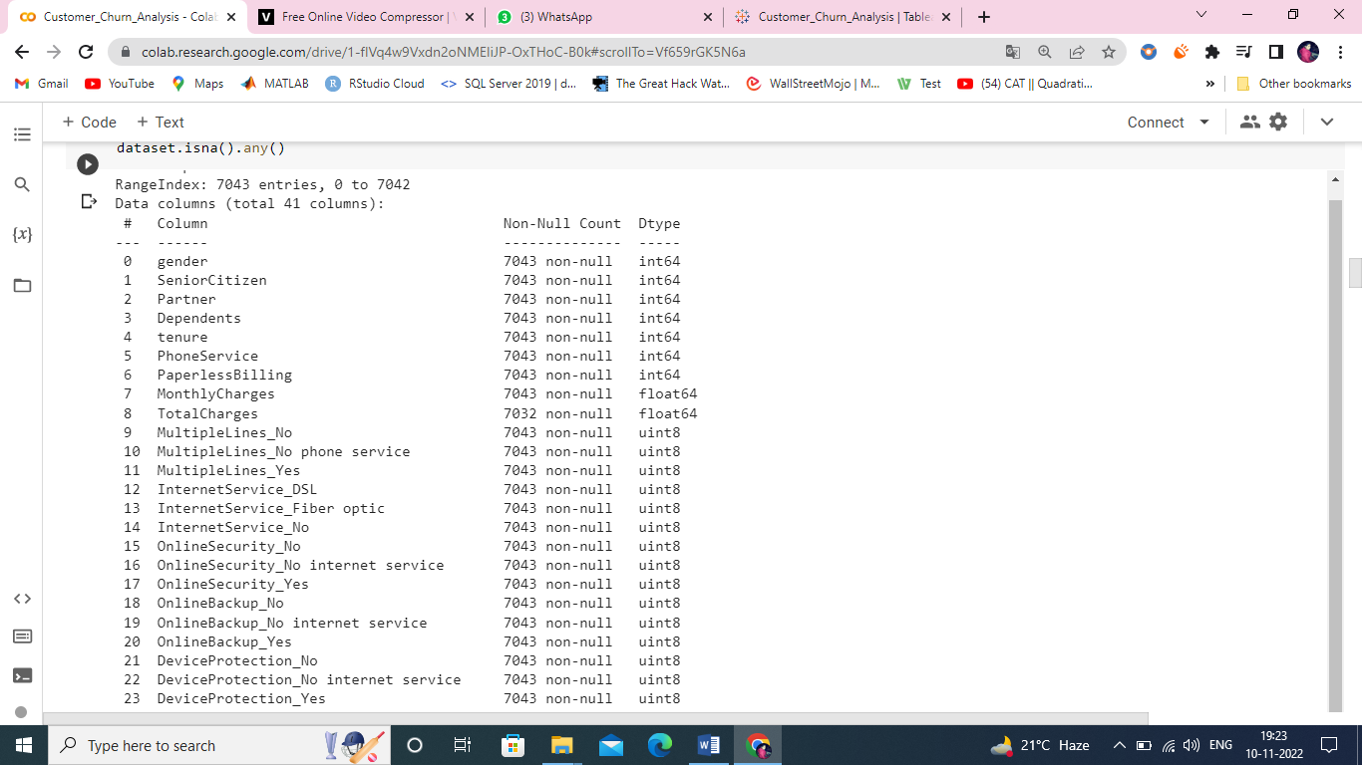

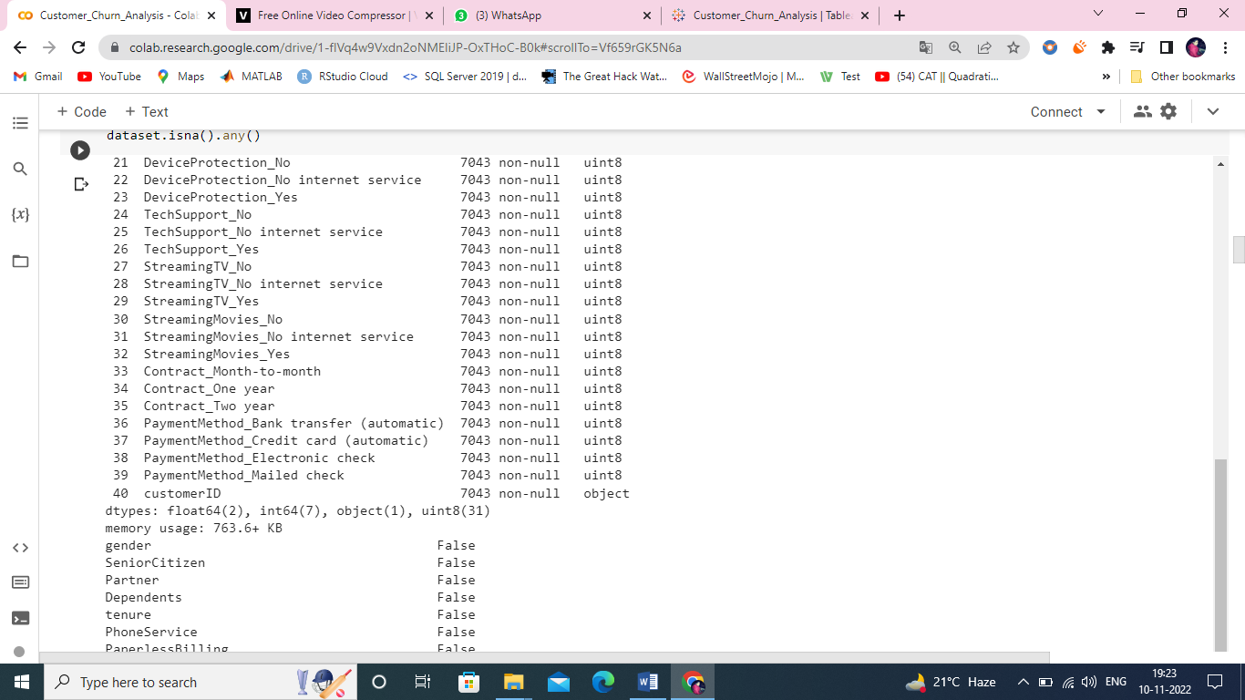

Page name: Customer_Churn_Analysis Python Colab Research

Fields: Dataset information

Process: Scroll user interface (play if required)

Remarks: Available in Colab Research Notebook

Error: Not any

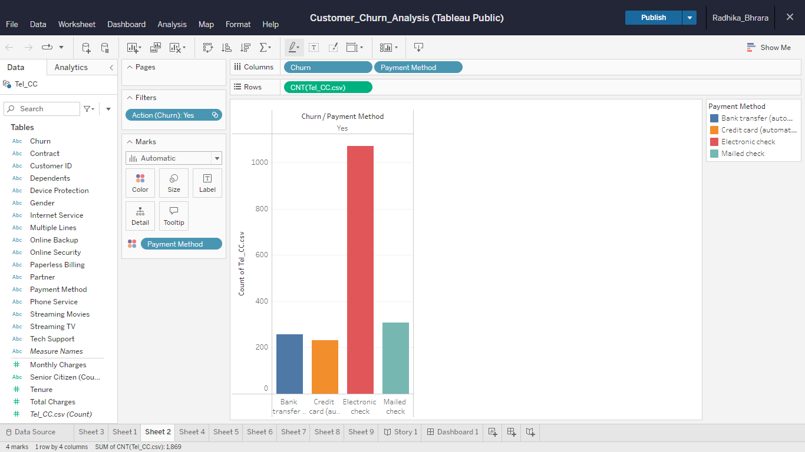

Page name: Customer_Churn_Analysis Tableau Public

Fields: Churn / Payment method visual

Process: Scroll user interface (play if required)

Remarks: Available in Colab Research Notebook

Error: Not any

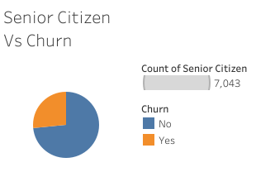

Page name: Customer_Churn_Analysis Tableau Public

Fields: Senior Citizen churn visual

Process: Scroll user interface (play if required)

Remarks: Available in Colab Research Notebook

Error: Not any

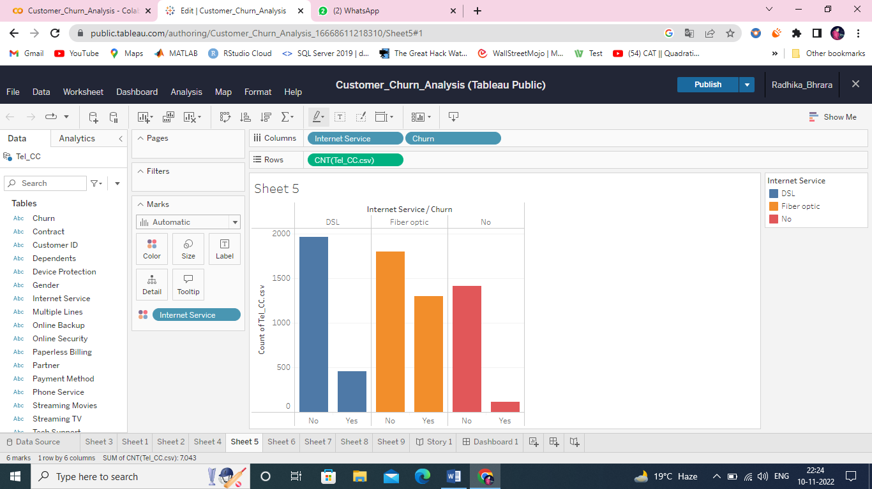

Page name: Customer_Churn_Analysis Tableau Public

Fields: Internet Service Churn Visual

Process: Scroll user interface (play if required)

Remarks: Available in Colab Research Notebook

Error: Not any

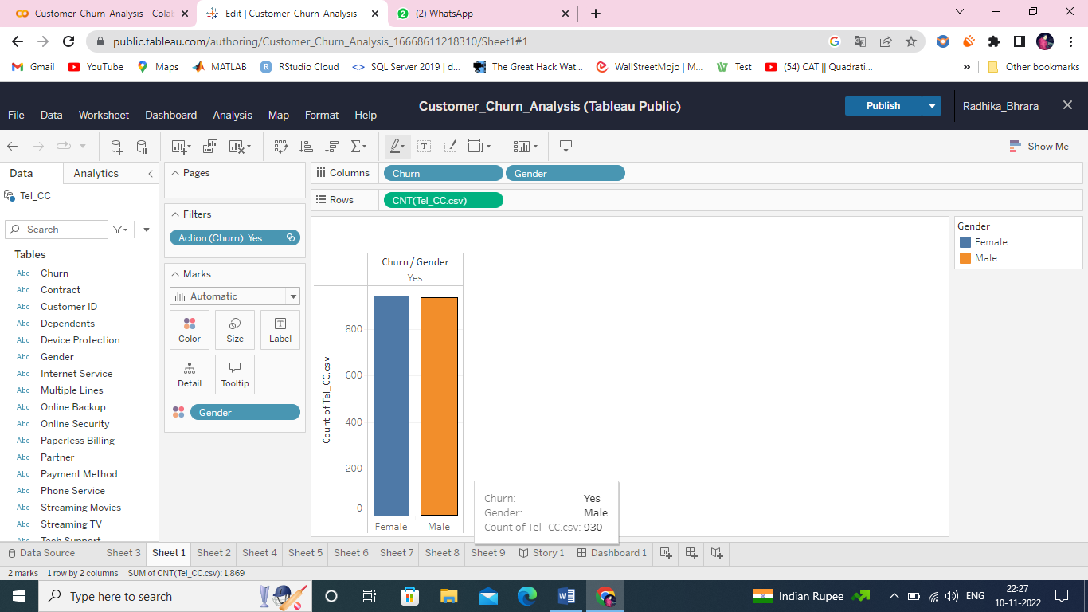

Page name: Customer_Churn_Analysis Tableau Public

Fields: Gender Comparison visual

Process: Scroll user interface (play if required)

Remarks: Available in Colab Research Notebook

Error: Not any

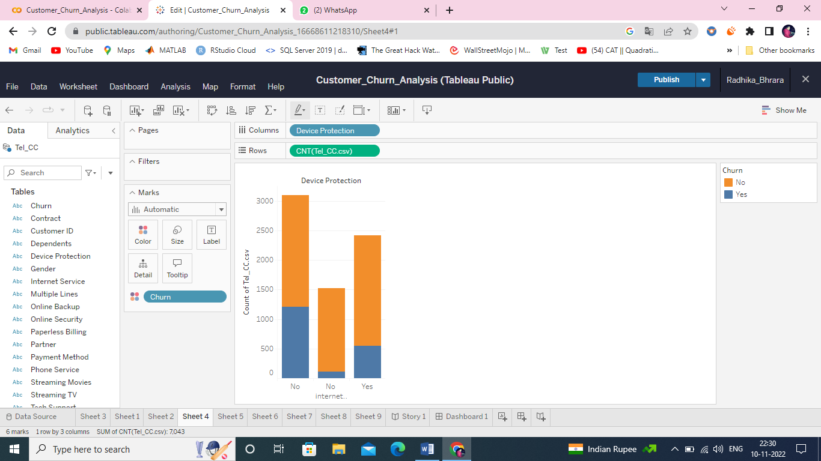

Page name: Customer_Churn_Analysis Tableau Public

Fields: Device Protection visual

Process: Scroll user interface (play if required)

Remarks: Available in Colab Research Notebook

Error: Not any

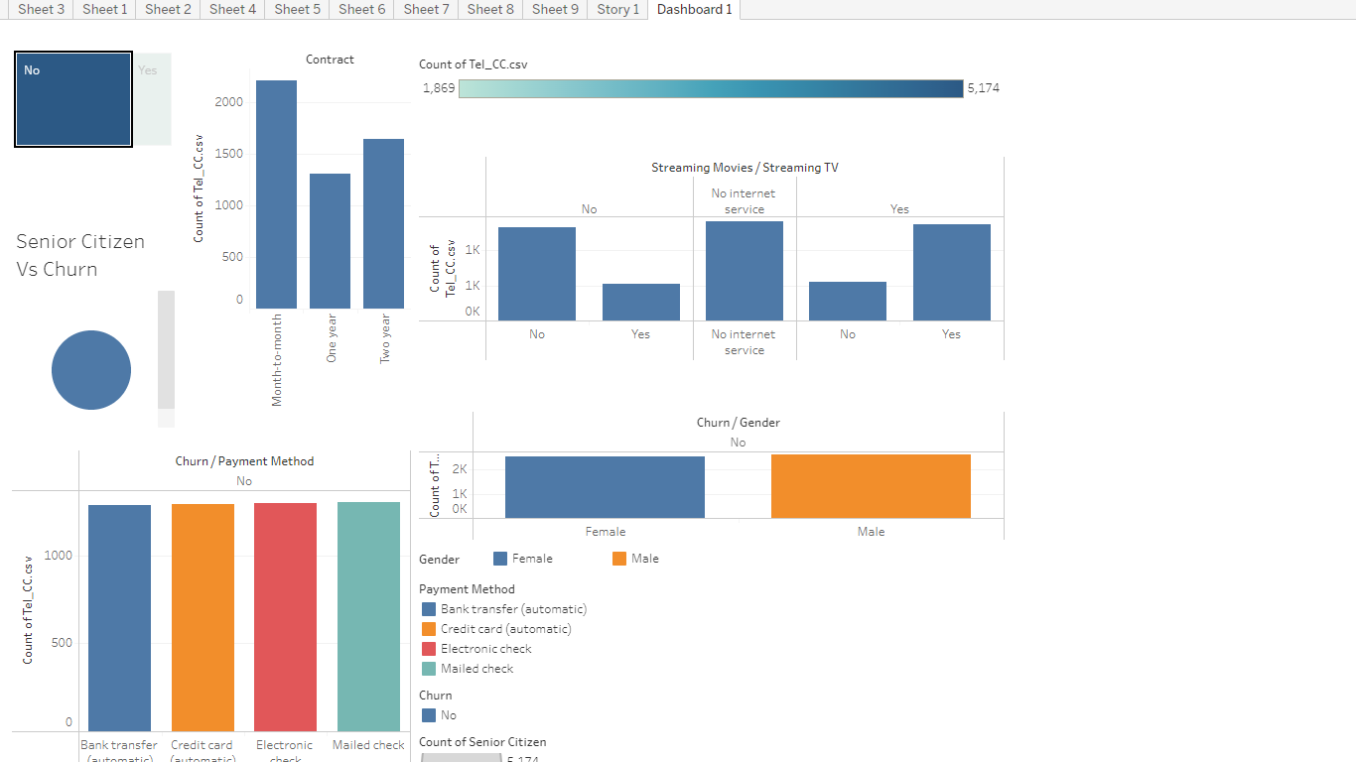

Page name: Customer_Churn_Analysis Tableau Public

Fields: Dataset visual with filter no

Process: Scroll user interface (play if required)

Remarks: Available in Colab Research Notebook

Error: Not any

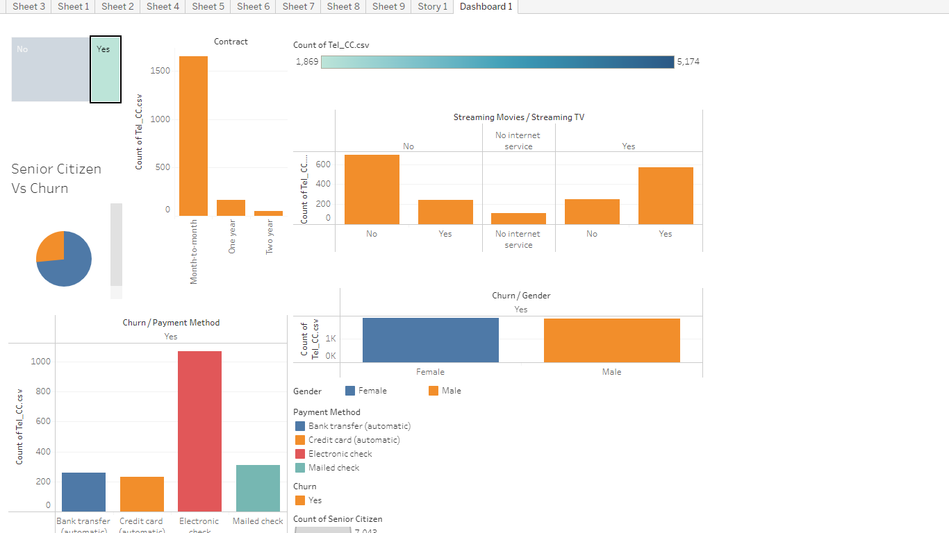

Page name: Customer_Churn_Analysis Tableau Public

Fields: Dataset visual with filter yes

Process: Scroll user interface (play if required)

Remarks: Available in Colab Research Notebook

Error: Not any

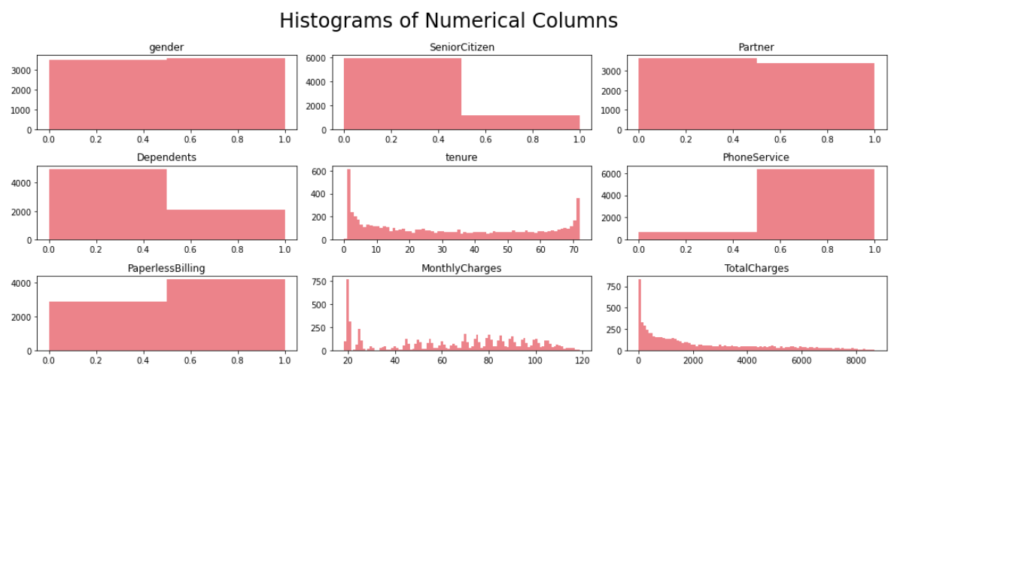

Page name: Customer_Churn_Analysis Python Colab Research

Fields: Histogram of numerical columns

Process: Scroll user interface (play if required)

Remarks: Available in Colab Research Notebook

Error: Not any



Page name: Customer_Churn_Analysis Python Colab Research

Fields: Histogram of numerical columns

Process: Scroll user interface (play if required)

Remarks: Available in Colab Research Notebook

Error: Not any

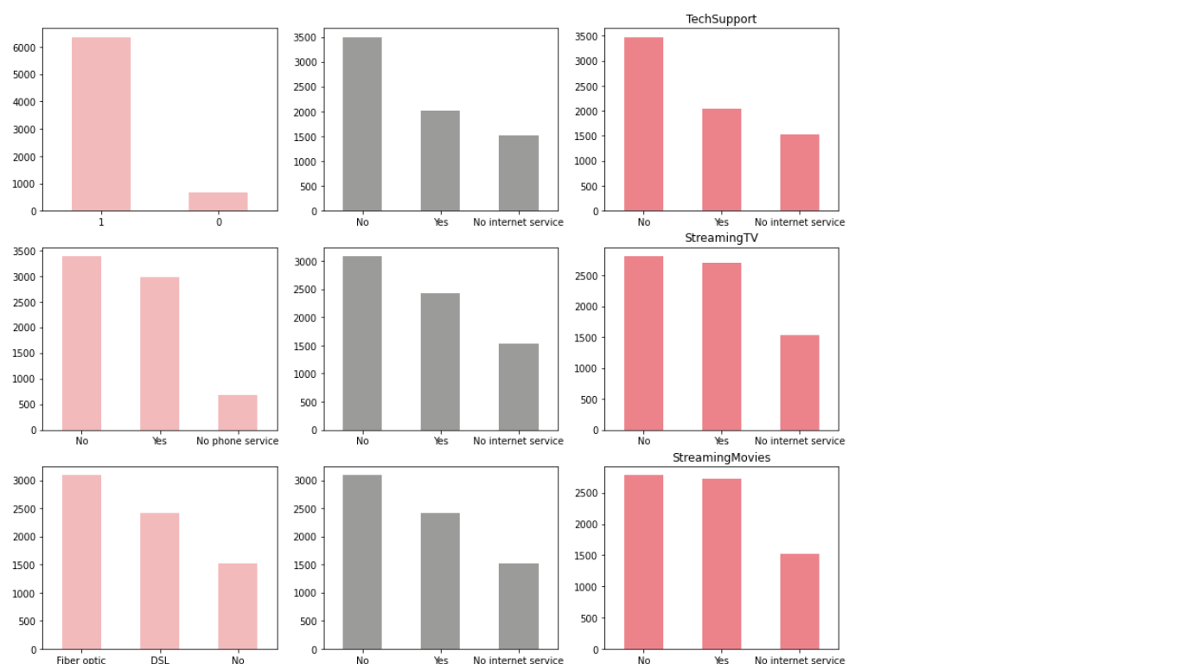

Page name: Customer_Churn_Analysis Python Colab Research

Fields: Categorical dataset visual

Process: Scroll user interface (play if required)

Remarks: Available in Colab Research Notebook

Error: Not any

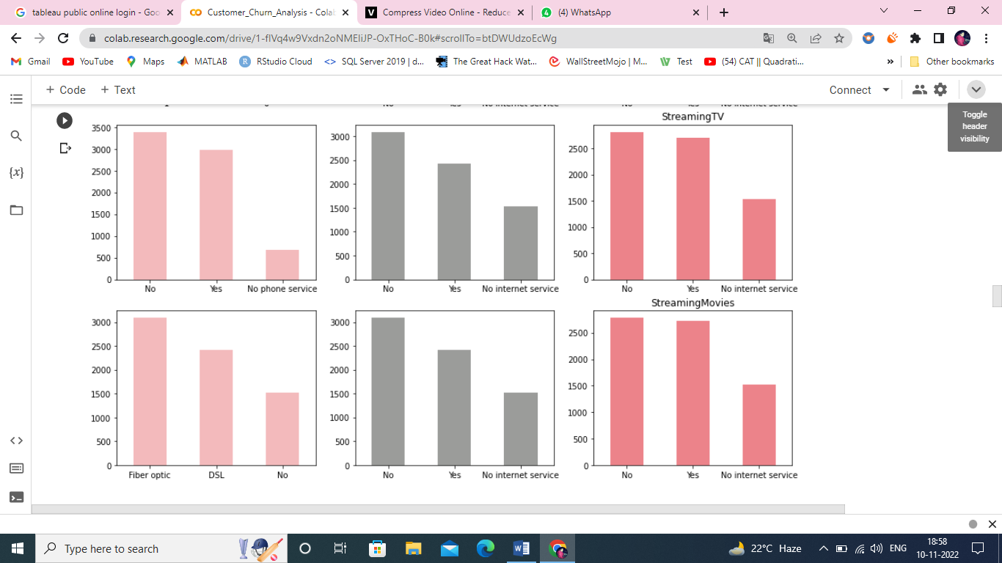

Page name: Customer_Churn_Analysis Python Colab Research

Fields: Categorical dataset visual

Process: Scroll user interface (play if required)

Remarks: Available in Colab Research Notebook

Error: Not any

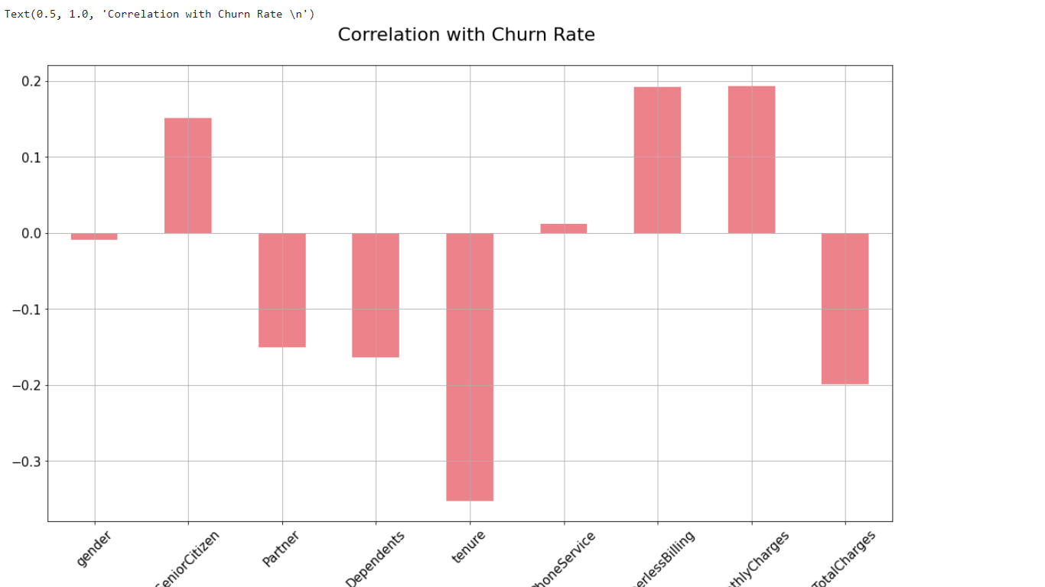

Page name: Customer_Churn_Analysis Python Colab Research

Fields: Correlation with churn rate visual

Process: Scroll user interface (play if required)

Remarks: Available in Colab Research Notebook

Error: Not any

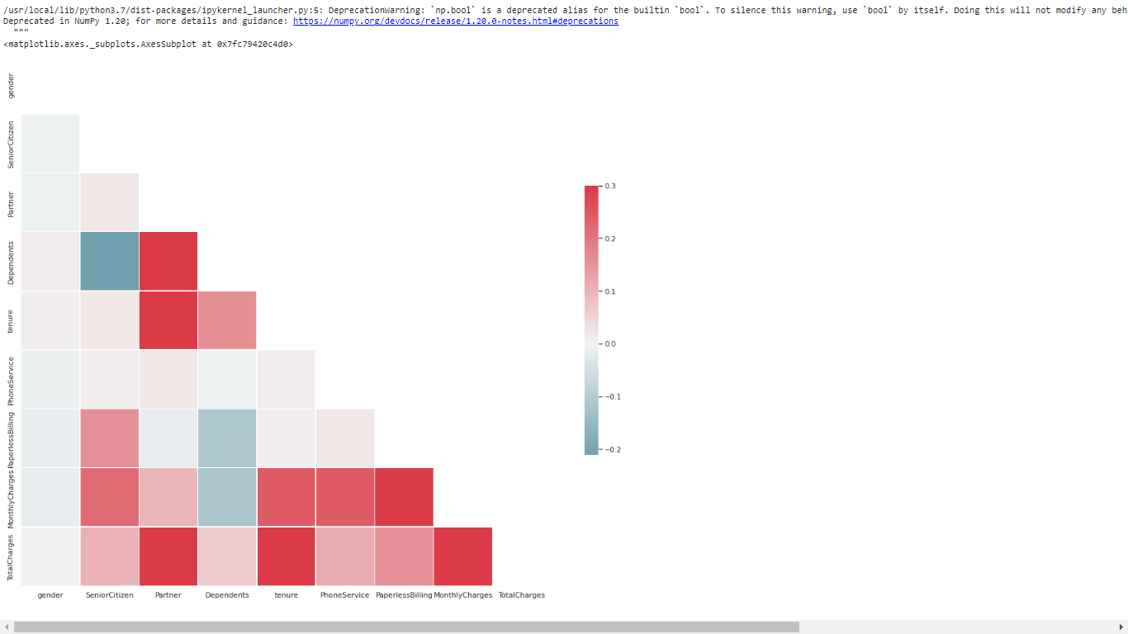Page name: Customer_Churn_Analysis Python Colab Research

Fields: Dataset visual - Heatmap

Process: Scroll user interface (play if required)

Remarks: Available in Colab Research Notebook

Errors: Not Any

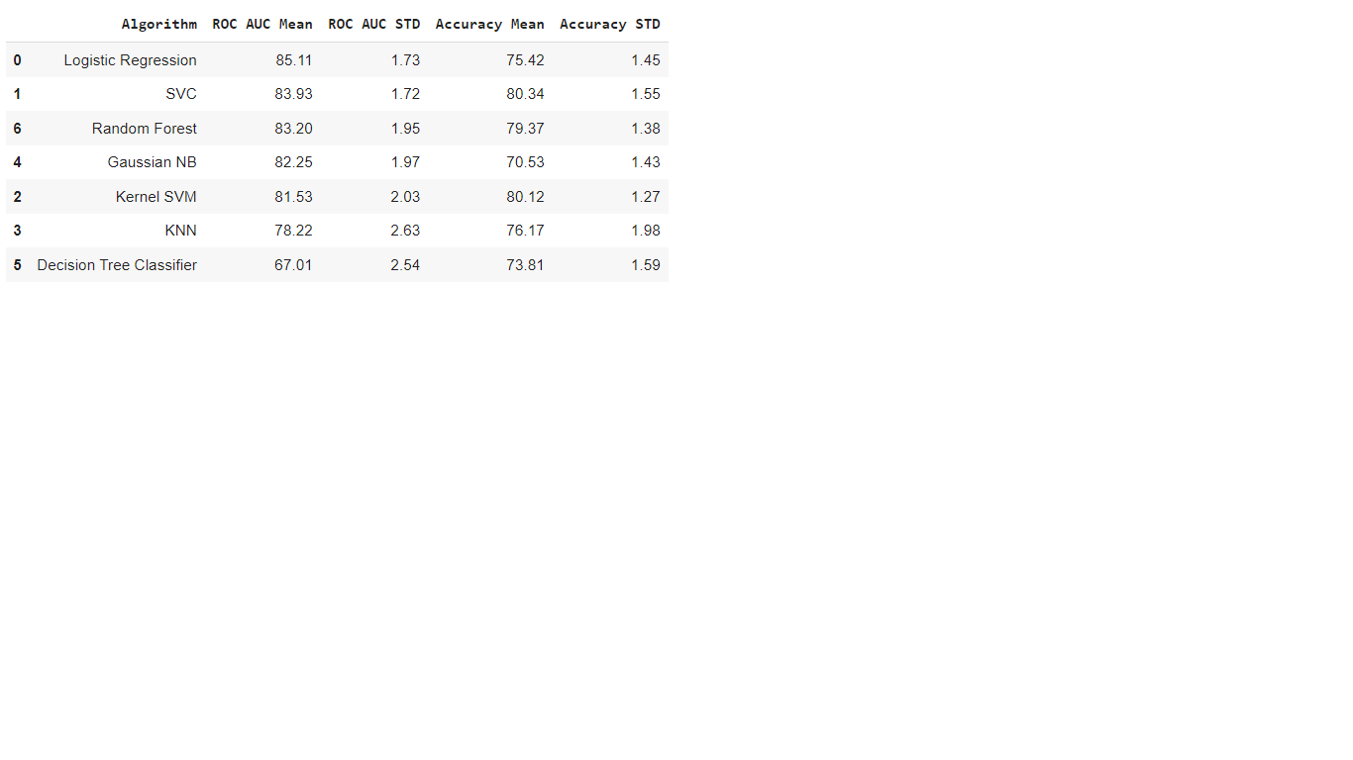

Page name: Customer_Churn_Analysis Python Colab Research

Fields: Algorithm Comparisons

Process: Scroll user interface (play if required)

Remarks: Available in Colab Research Notebook

Errors: Not Any

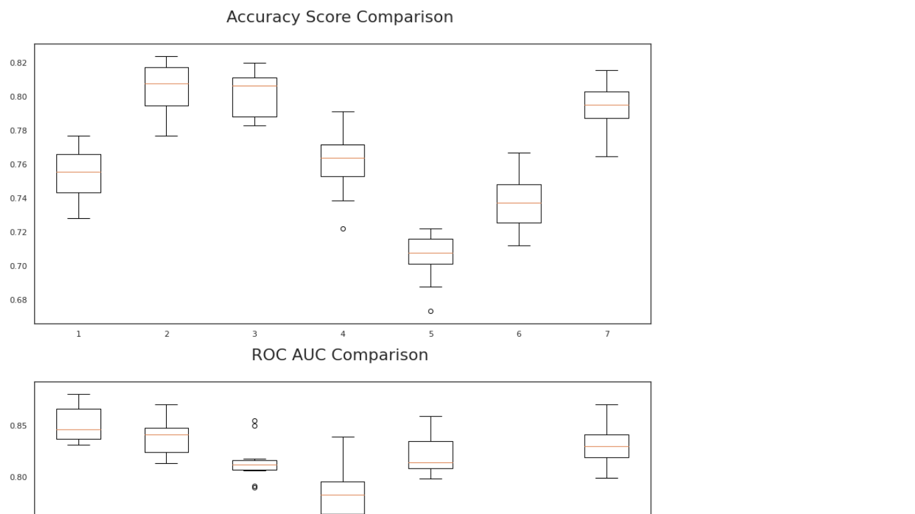

Page name: Customer_Churn_Analysis Python Colab Research

Fields: Accuracy Score Comparison

Process: Scroll user interface (play if required)

Remarks: Available in Colab Research Notebook

Error: Not any

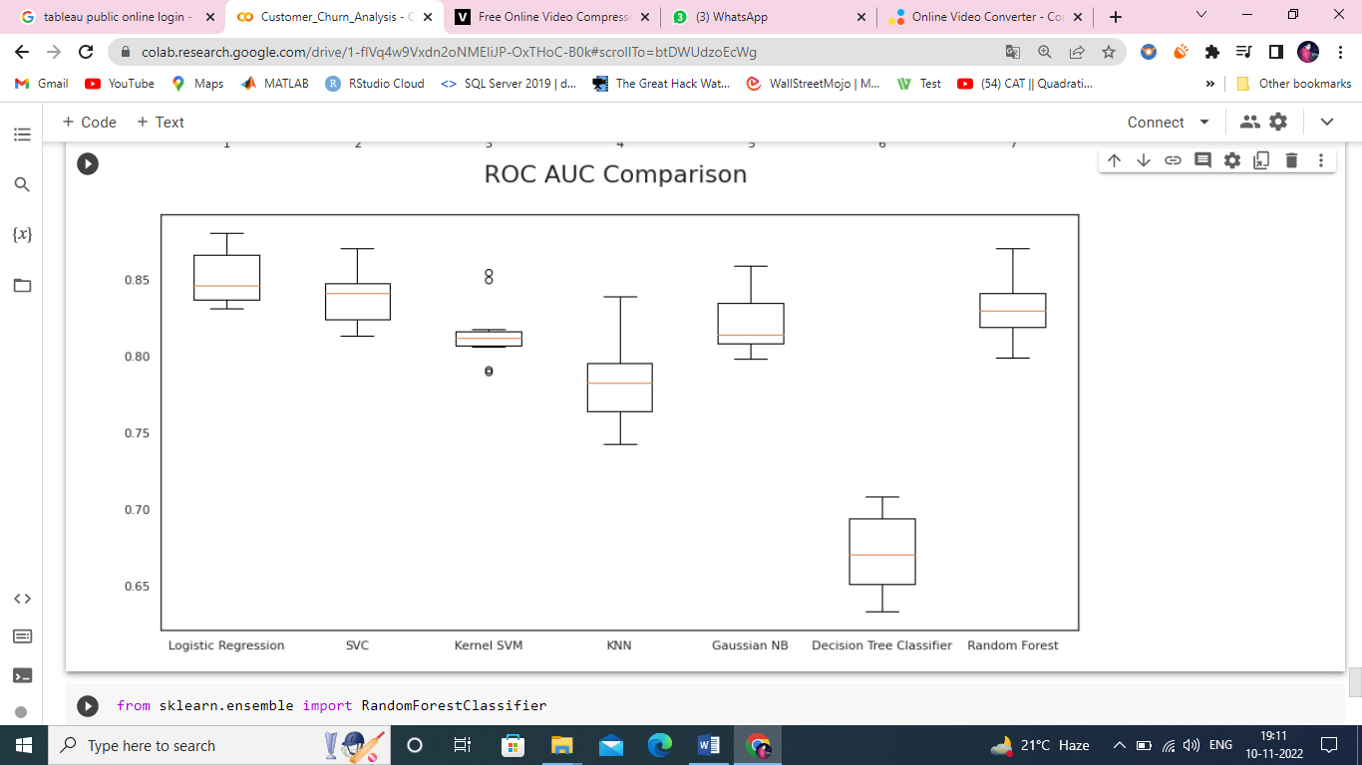

Page name: Customer_Churn_Analysis Python Colab Research

Fields: ROC AUC Comparison

Process: Scroll user interface (play if required)

Remarks: Available in Colab Research Notebook

Error: Not any

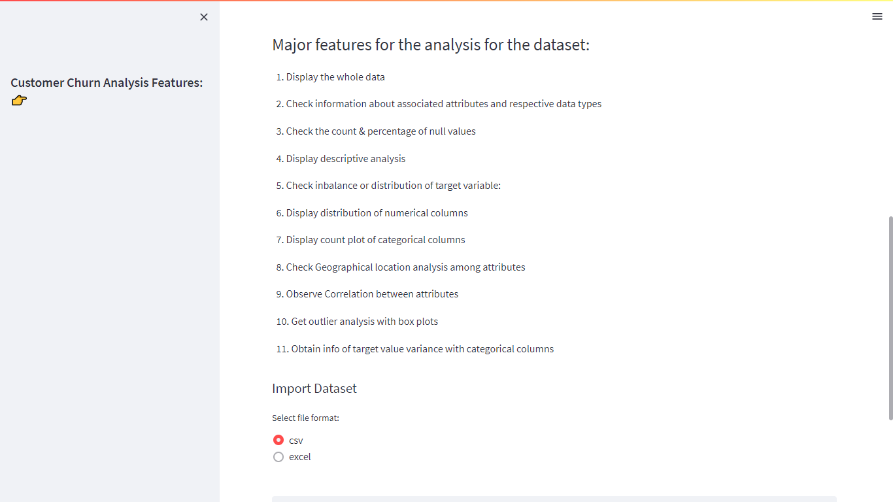Page name: Customer_Churn_Analysis Python Colab Research streamlit app

Fields: Major features & import dataset

Process: Scroll user interface (play if required)

Remarks: Available in Colab Research Notebook

Error: Not any

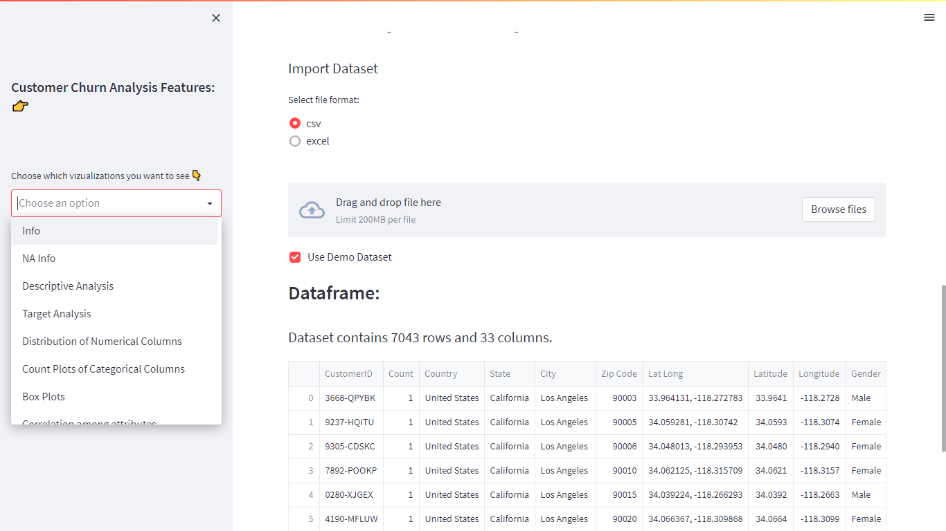

Page name: Customer_Churn_Analysis Python Colab Research

Fields: Streamlit app UI -info about demo dataset & menu box to choose features

Process: Scroll user interface (play if required)

Remarks: Available in Colab Research Notebook

Error: Not any

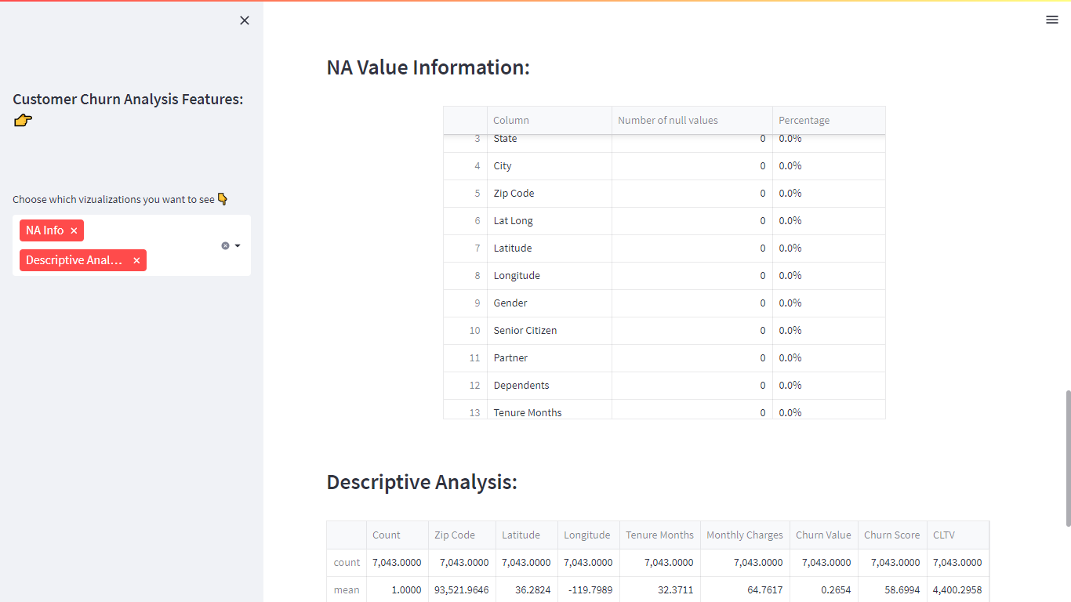

Page name: Customer_Churn_Analysis Python Colab Research

Fields: Streamlit app UI – Null Value information & descriptive Analysis

Process: Scroll user interface (play if required)

Remarks: Available in Colab Research Notebook

Error: Not any

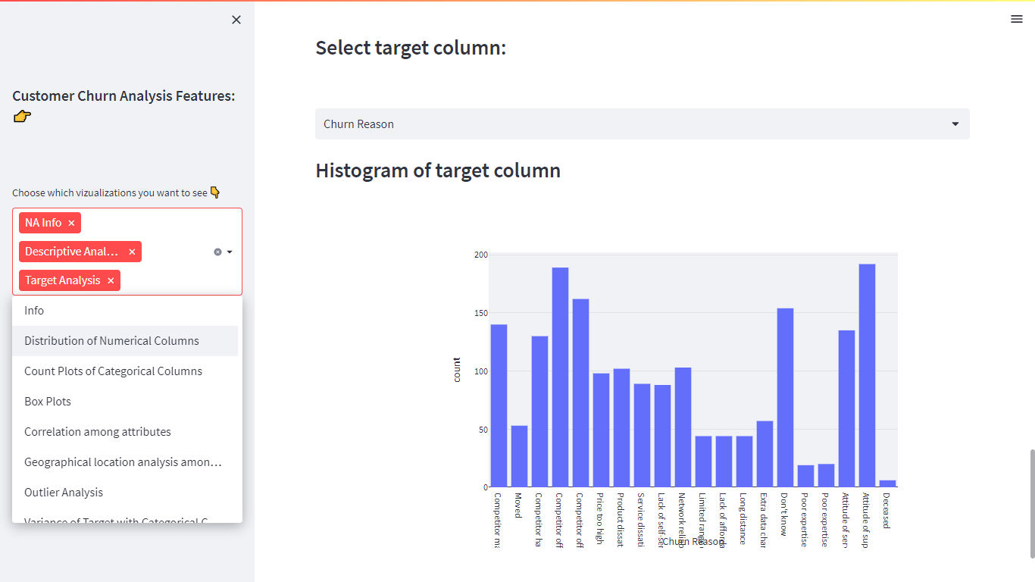

Page name: Customer_Churn_Analysis Python Colab Research

Fields: Streamlit app UI – target variable analysis

Process: Scroll user interface (play if required)

Remarks: Available in Colab Research Notebook

Error: Not any

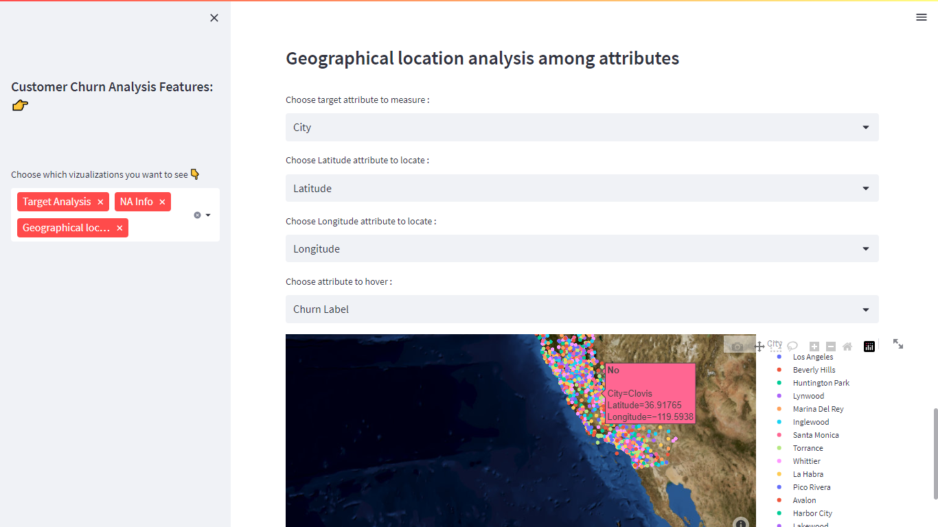

Page name: Customer_Churn_Analysis Python Colab Research

Fields: Streamlit app UI – geographical analysis

Process: Scroll user interface (play if required)

Remarks: Available in Colab Research Notebook

Error: Not any

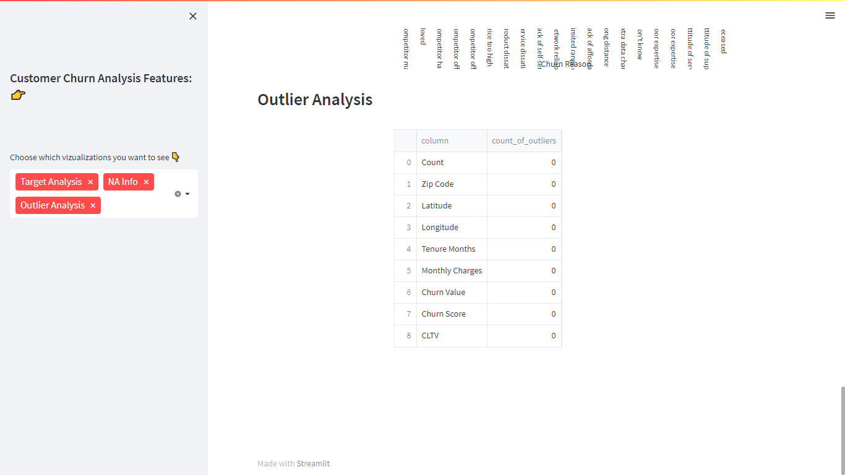

Page name: Customer_Churn_Analysis Python Colab Research

Fields: Streamlit app UI – Outlier Analysis

Process: Scroll user interface (play if required)

Remarks: Available in Colab Research Notebook

Error: Not any

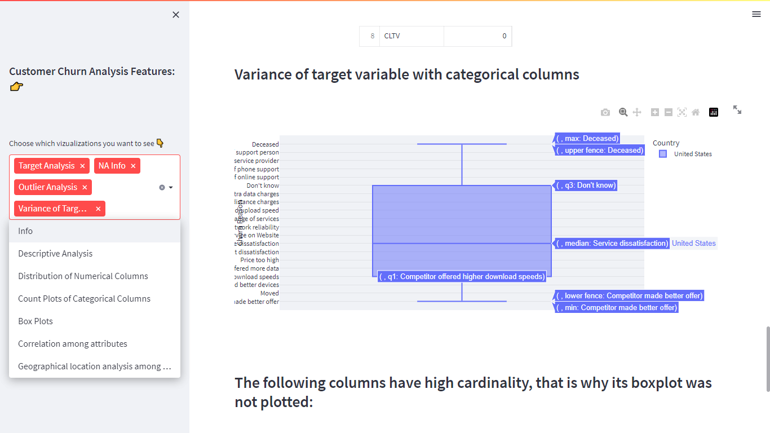

Page name: Customer_Churn_Analysis Python Colab Research

Fields: Streamlit app UI – Variance of target variable

Process: Scroll user interface (play if required)

Remarks: Available in Colab Research Notebook

Error: Not any

**Acknowledgment**

At the very outset, I would like to thank the almighty GOD for showering his blessing & providing

me with the courage, motivation & strength to complete my project.

Every seminar work demands a lot of hard work, time, patience, and concentration. While working

on this seminar, apart from these aspects, I have developed the necessary skills and attitude, which

are always required in a professional field. I am thankful to all those who helped me in completing

this project.

I express my deep sense of gratitude & indebtedness towards my respected Project In-charge Ms.

Pooja Duggal and, other faculty members of PCTE Institute of Engineering and Technology from

whom I have learned DATA ANALYSIS AND DATA SCIENCE without their guidance I would

have found it difficult to undertake the project work. I would like to thank them for their ever

available, unconditional help & guidance that they made available throughout the project work.

I would also like to acknowledge the encouraging attitude of my friends & other staff members of

the P.C.T.E family that helped me to complete the project work.

( Radhika)