Code

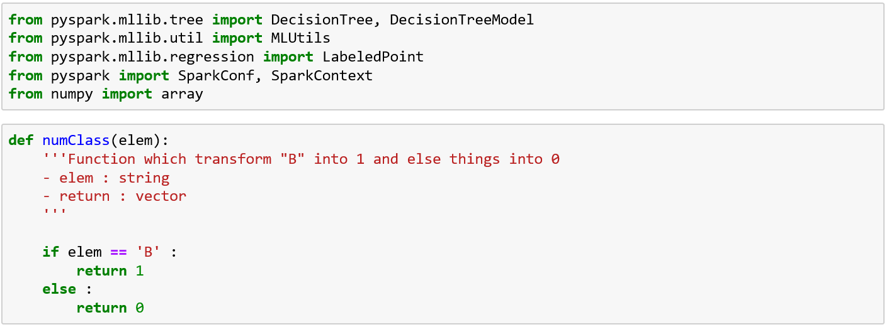

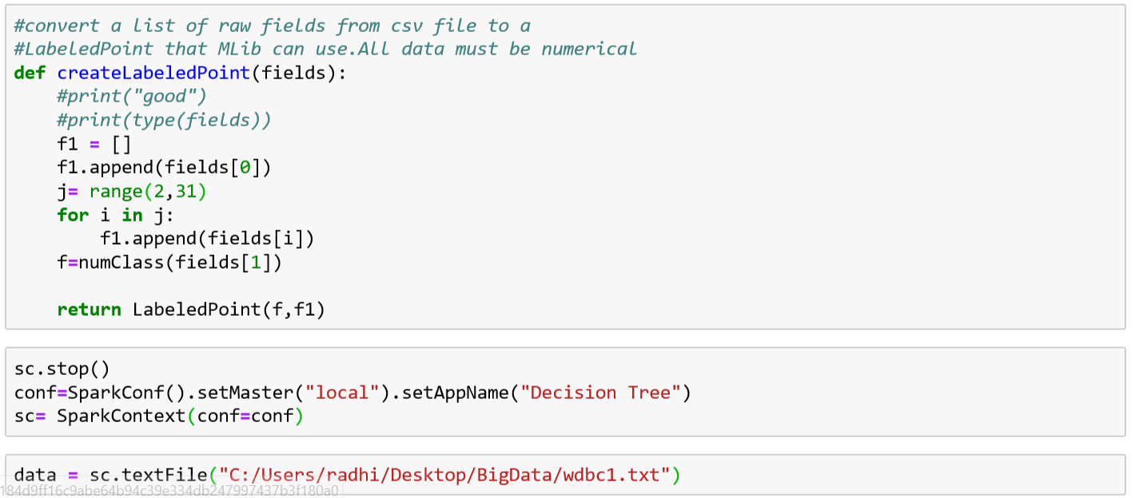

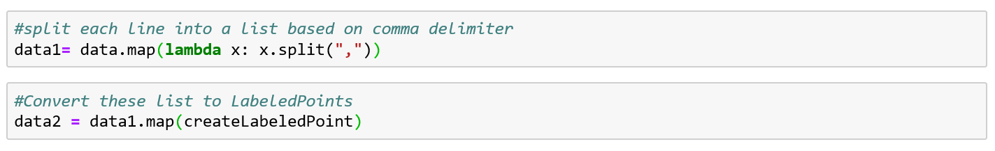

Training and Test data splitting



Choice of parameter and attribute selection metric

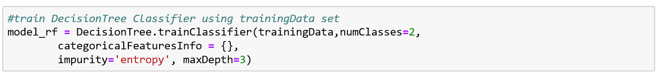

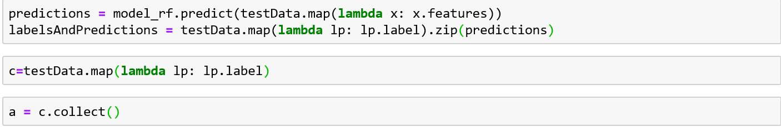



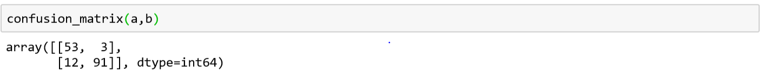

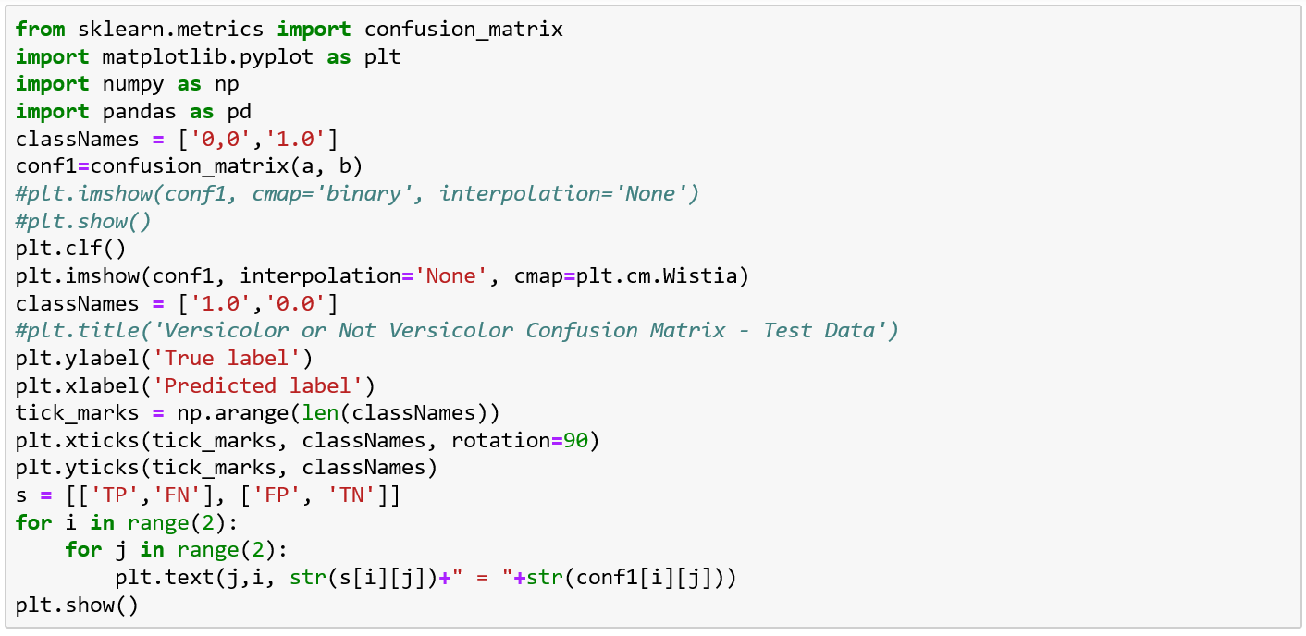

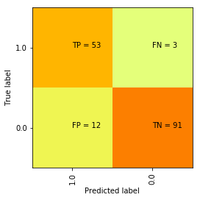

Accuracy = TP+TN/TP+FP+FN+TN

= (53+91)/(53+3+12+91)=0.905

Precision = TP/TP+FP

= 53/65=0.815

Recall = TP/TP+FN

=53/56= 0.946

