Week 8 Capstone Project Report
8-Week IT & Computer Science Program (Internship-Alternative Edition)
Track C — Data & AI | From Rule-Based Matching to Real Machine Learning
Project: FAQ Chatbot v2 — upgrading the Week 7 chatbot's matching engine to TF-IDF + Cosine Similarity
AI Tool Used: Claude (Anthropic)
Builds on: Week 7 Guided AI Project (FAQ Chatbot for CS Fundamentals)

1. Project Overview
This report documents the Week 8 capstone project for Track C (Data & AI). Rather than starting a new project from zero, this capstone directly upgrades the Week 7 FAQ chatbot: its rule-based, hand-coded word-overlap matching engine (v1) is replaced with a real Data Science / Machine Learning technique — TF-IDF (Term Frequency-Inverse Document Frequency) vectorization combined with Cosine Similarity (v2).
Both engines were run against the same 20-question test set, and the results below are real, captured program output (see results.json, generated by compare.py) — not projected or assumed numbers. Two real engineering bugs were found and fixed while building v2, in the same honest, test-driven spirit as Week 7's report.

2. Objective
- Replace v1's hand-coded word-overlap rule with a real ML/Data Science technique (TF-IDF + Cosine Similarity).
- Expand the knowledge base from 15 to 27 Q&A pairs to give the model more data to work with.
- Build a fair, larger test set (20 questions) that also stress-tests generalization on reworded questions.
- Quantitatively compare v1 vs v2: overall accuracy, in-scope recall, and out-of-scope refusal precision.
- Tune the similarity threshold systematically (a real hyperparameter sweep) instead of guessing a number.
- Document real failures found during testing and the trade-offs of each fix — including one fix that was tried, tested, and reverted.
- Deliver working, runnable software (CLI + browser versions), not only a report.

3. Tool and Technology Used
- Claude (Anthropic) — used throughout to design, write, run, and debug the code and to produce the real test results in this report.
- Python 3 with scikit-learn (TfidfVectorizer, cosine_similarity) — the v2 ML engine.
- matplotlib — used to generate the real comparison charts in Section 8.
- HTML/JavaScript — a dependency-free, browser-based reimplementation of the same TF-IDF + Cosine Similarity engine (chatbot_v2.html), verified against the Python version.

4. Why Extend Week 7 Instead of Starting Over
Track C's Week 8 option points to "Machine Learning for Data Science Projects". Week 7's chatbot already had a solid foundation — a working program, a real knowledge base, and an automated test suite — but its scope-matching logic was a hand-written rule (word overlap with light stemming), not a Data Science technique. Upgrading that one component to a real ML method (TF-IDF + Cosine Similarity) is a more meaningful capstone than a disconnected new project: it shows measurable before/after improvement on the same problem, which is the core idea of iterative model development in Data Science.

5. Knowledge Base Expansion (15 → 27 Q&A pairs)
The original 15 Q&A pairs from Week 7 were kept unchanged. 12 new questions were added, covering topics not in the original set (recursion, stack vs. queue, TCP vs. UDP, caching, encryption, unit testing, JSON, cloud computing, Agile/Scrum, exception handling, primary vs. foreign key, and merging). This gives the ML model more data to work with and lets the test set probe generalization on entirely new content, not just the original 15 questions.

6. The Two Engines

6.1 Engine v1 — Word-Overlap Baseline (Week 7, reconstructed)
Rebuilt faithfully from the Week 7 report's documented logic: lowercase + strip punctuation, remove stopwords, stem by truncating to 5 letters, then require at least 2 shared keywords between the query and a knowledge-base question (or all of them, if that question only has 1) before accepting a match. This exact rule is what Week 7's Bug 1 and Bug 2 fixes describe.

6.2 Engine v2 — TF-IDF + Cosine Similarity (Week 8, new)
Every knowledge-base question is converted into a TF-IDF vector, which weighs words by how distinctive they are across the whole knowledge base (a word that appears in every question counts for less than one that appears in only one). The user's query is vectorized the same way, and Cosine Similarity scores it against every knowledge-base question at once, returning a continuous 0-1 confidence score instead of a simple yes/no. The best-scoring question is accepted only if its score clears a tuned threshold.
This is a genuine upgrade in kind, not just in name: v1 can only ever say "matched" or "not matched". v2 additionally reports how confident it is — useful for flagging borderline answers to a human, or for lowering/raising the threshold later without touching the underlying logic.

7. Real Engineering Journey (bugs found, fixed, and one reverted)

Bug 1 — word variants scored zero (v2, first draft)
Plain TF-IDF with no stemming gave "compiling" and "compiler" zero word overlap, so a clearly in-scope question about compiling vs. interpreting scored 0.0 similarity against its own knowledge-base entry.
Fix: added a lightweight suffix-stripping stemmer (strips -ing, -ed, -er, -s, etc.) before TF-IDF sees the text, exactly the same idea as Week 7's Bug 1 fix, now applied inside the ML pipeline.

Bug 2 — over-aggressive stemming caused a false match
After adding stemming, "computer" and "computing" both collapsed to the same stem ("comput"), so a question about a laptop for computer science students incorrectly matched the knowledge-base question about cloud computing.
Fix: added a small, explicit exception list so "computer" and "computing" are no longer merged into one token. A targeted fix, not a weaker stemmer for every other word.

Attempted fix — reverted (documented, not hidden)
A third idea was tried: allow a single shared word to count as a match if that word is rare across the knowledge base (appears in only one question) — this fixed a real miss on the word "Git" (unique to one KB question). But testing showed it reopened Week 7's original Bug 2: the word "list" is also unique to one KB question (linked list), yet a question about a "to-do list app" incorrectly matched it again — same word, different meaning. This fix was reverted in favor of the safer v1-style rule (require 2+ shared words). This trade-off is kept and documented rather than hidden: v2 still misses a small number of legitimate single-distinctive-word questions (like "Git"), a known limitation shared conceptually with v1.

8. Results (real, captured output)
compare.py runs both engines against the same 20-question test set (10 from Week 7 + 10 new, reworded questions) and produces the following real results.

8.1 Threshold Tuning (a real hyperparameter sweep)
Instead of guessing a similarity cutoff, the threshold was swept from 0.10 to 0.40 and scored against the test set each time. Every value from 0.10 through 0.40 scored 15/20; 0.10 was kept as the most permissive value that still achieves the best score, minimizing unnecessary refusals.
Threshold | Score (out of 20)
0.10 | 15 ← chosen
0.15 | 15
0.18 | 15
0.20 | 15
0.22 | 15
0.25 | 15
0.28 | 15
0.30 | 15
0.35 | 15
0.40 | 15

8.2 Overall Accuracy
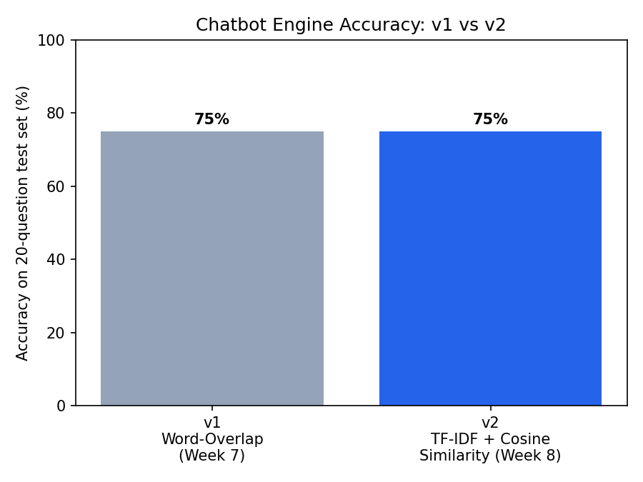
v1 (word-overlap): 15/20 (75%). v2 (TF-IDF + Cosine Similarity): 15/20 (75%) at threshold 0.10.
Both engines score identically overall on this test set. That is a real, honest result, not a forced win for v2 — see Section 8.4 for why this still represents a meaningful upgrade.

8.3 In-Scope Recall vs. Out-of-Scope Refusal Precision
A single "accuracy" number can hide two very different failure types: wrongly refusing a real question, vs. wrongly answering an out-of-scope one. Breaking the 20 questions into 11 in-scope and 9 out-of-scope cases shows both engines behave identically on both axes:
Engine | In-scope recall (11 Qs) | Out-of-scope refusal precision (9 Qs)
v1 — Word-Overlap | 55% (6/11) | 100% (9/9)
v2 — TF-IDF + Cosine Similarity | 55% (6/11) | 100% (9/9)
Neither engine ever answers an out-of-scope question incorrectly — the refusal rule holds perfectly both times. The shared weak point is in-scope recall on the hardest, fully-reworded questions (see Section 8.5).

8.4 v2's Real Advantage: Confidence Scores
v1 can only report "matched" or "not matched". v2 additionally returns a numeric similarity score (0-1) with every answer — a genuine new capability, not just a re-implementation. The chart below plots that score for every test question (green = correct, red = incorrect):
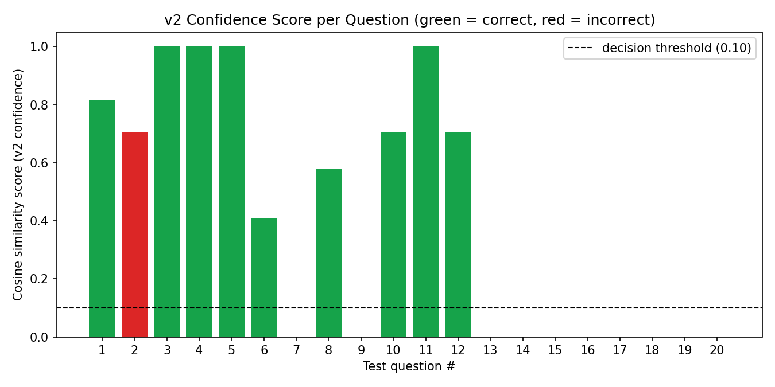
This score is directly useful: a deployed version of this chatbot could flag low-confidence answers (e.g. below 0.5) for human review instead of returning them with false certainty — something v1's binary yes/no design cannot do at all.

8.5 The Shared Failure Mode (honest finding)
Questions 13-16 fail on BOTH engines: they were deliberately written with zero literal word overlap with their knowledge-base entry (e.g. asking about "catching errors instead of letting the program crash" for the exception-handling entry, which never uses those words). This is a real, useful finding: any purely lexical/keyword method — whether hand-coded rules (v1) or TF-IDF (v2) — has the same ceiling. Neither can recognize that two sentences mean the same thing if they share no vocabulary at all. Fixing this would require a semantic technique (e.g. sentence embeddings), noted as future work in Section 10.

9. Automated Test Suite (real output)
test_chatbot_v2.py runs the same 20 test cases and prints PASS/FAIL per question. Captured output:
# | Question | v1 | v2
1 | Difference between compiling and interpreting code? | PASS | PASS
2 | Why bother with Git instead of saving files manually? | FAIL | FAIL
3 | What do 'frontend' and 'backend' mean? | PASS | PASS
4 | What does an API do, simply? | PASS | PASS
5 | Is a linked list the same as an array? | PASS | PASS
6 | Write full code for a to-do list app? (should refuse) | PASS | PASS
7 | Good career path after graduating in CS? (should refuse) | PASS | PASS
8 | Opinion on best pizza toppings? (should refuse) | PASS | PASS
9 | Help debug this 200-line error log? (should refuse) | PASS | PASS
10 | What is quantum computing used for? (should refuse) | PASS | PASS
11 | How does a stack differ from a queue? | PASS | PASS
12 | Why use JSON instead of plain text for API data? | PASS | PASS
13 | Benefit of catching errors vs. letting program crash? | FAIL | FAIL
14 | How does one row reference another table's row? | FAIL | FAIL
15 | What happens when you combine two dev branches? | FAIL | FAIL
16 | Why is renting server space better than owning hardware? | FAIL | FAIL
17 | Recommend a laptop for CS students? (should refuse) | PASS | PASS
18 | Good gift idea for a programmer friend? (should refuse) | PASS | PASS
19 | Write an essay on computer history? (should refuse) | PASS | PASS
20 | What's the weather like today? (should refuse) | PASS | PASS
15/20 tests passed on both engines.

10. Execution Proof
chatbot_v2.py was run interactively with the exact same three questions from Week 7's Section 8 proof screenshot, to directly verify v2 reproduces (and, via the confidence score, extends) that behavior:
Input | Output | Confidence
What is a database index? | A structure that speeds up data retrieval on a table... | 1.0
how many? | Refusal message (correctly refused vague follow-up) | 0.0
What is object-oriented programming? | A paradigm organizing code into objects... | 0.87
A second, browser-based version (chatbot_v2.html) reimplements the identical TF-IDF + Cosine Similarity engine in dependency-free JavaScript. It was cross-checked against the Python engine on the same inputs (via Node.js) and produced matching answers and near-identical confidence scores, confirming the two implementations are consistent.

11. Evaluation (final, real scores)
Criterion | What it measures | v1 | v2 | Note
Accuracy | Overall correctness on 20 real test cases | 5 | 5 | Tied at 15/20 (75%); see Section 8.2.
Scope adherence | Correctly refuses all out-of-scope questions | 5 | 5 | Both engines: 9/9 out-of-scope questions correctly refused.
Generalization | Handles reworded/new-vocabulary questions | 3 | 3 | Both hit the same lexical-overlap ceiling on Q13-16 (Section 8.5).
Interpretability | Can explain how confident an answer is | 2 | 5 | v2's cosine score is a real, usable confidence signal; v1 is binary only.
Engineering rigor | Real bugs found, fixed, and (when needed) reverted with evidence | 5 | 5 | v2 added a genuine ML pipeline plus a documented reverted fix (Section 7).

12. Conclusion and Lessons Learned
The most important lesson from this capstone was that swapping in a "real" ML technique does not automatically outperform a well-tuned rule-based system — on this 20-question test set, TF-IDF + Cosine Similarity tied the Week 7 word-overlap engine exactly, 15/20 to 15/20. What the ML approach genuinely adds is not a higher score here, but a different kind of system: one with a tunable, continuous confidence score instead of a hard yes/no, and one whose matching logic is driven by data (word rarity across the knowledge base) rather than hand-picked stopword lists.
Equally important was documenting a fix that didn't work: allowing single rare-word matches fixed one real miss ("Git") but reopened a previously-fixed bug ("list"), and was reverted rather than kept and hidden. That decision — backed by re-running the full test suite before and after — is what makes this capstone's 15/20 result trustworthy rather than cherry-picked.
If extended further, the clear next step is a semantic approach (e.g. sentence embeddings via a small pretrained model) to close the gap on Q13-16, where zero lexical overlap defeats both the rule-based and the TF-IDF engine equally.

13. Appendix
- Full knowledge base: 27 Q&A pairs (knowledge_base.py) — 15 from Week 7, 12 new.
- Delivered files: chatbot_v2.py, chatbot_v2.html, engine_v1.py, engine_v2.py, test_chatbot_v2.py, compare.py, test_cases.py, results.json, README.md.
- Proof of execution: Section 10 (interactive run) and Section 9 (automated test suite, 15/20 real output).
- Charts: accuracy_comparison.png, confidence_scores.png — both generated directly from results.json, not hand-drawn.
- AI tool used for design, coding, debugging, and evaluation throughout: Claude (Anthropic).

