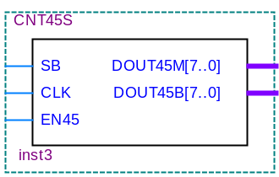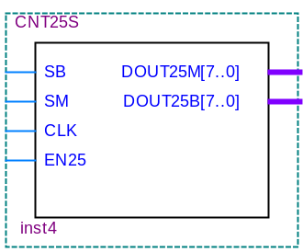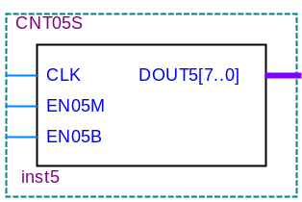
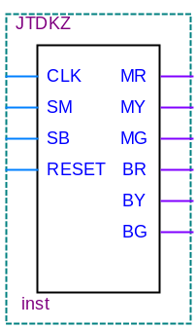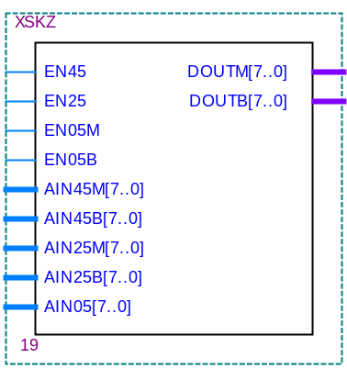
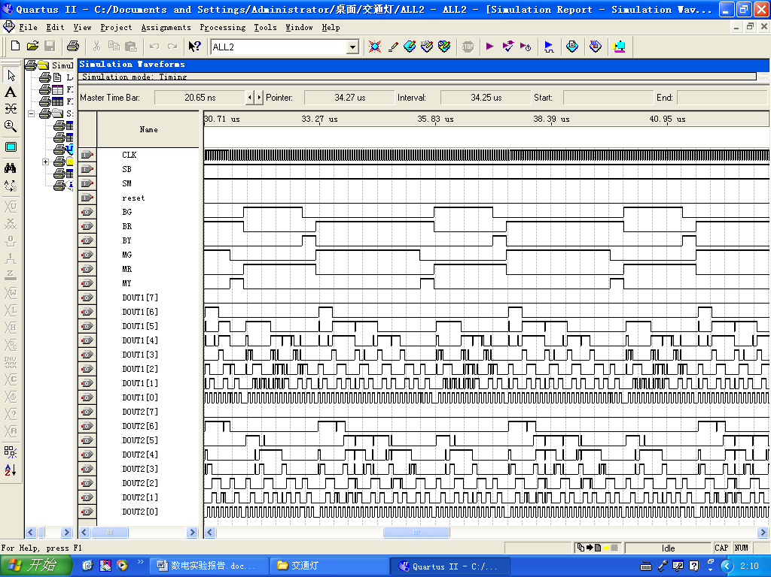
--JTDKZ.VHD
LIBRARY IEEE;
USE IEEE.STD_LOGIC_1164.ALL;
ENTITY JTDKZ IS
PORT(CLK, SM, SB, RESET: IN STD_LOGIC;
MR, MY, MG, BR, BY, BG: OUT STD_LOGIC);
END ENTITY JTDKZ;

ARCHITECTURE ART OF JTDKZ IS
TYPE STATE_TYPE IS(A,B,C,D);
SIGNAL STATE: STATE_TYPE;

BEGIN
CNT:PROCESS(CLK , RESET) IS
VARIABLE S:INTEGER RANGE 0 TO 45;
VARIABLE CLR,EN:BIT;

BEGIN
IF RESET = '1' THEN
S:= 0;
STATE<= A;
ELSIF(CLK'EVENT AND CLK='1')THEN
IF CLR='0' THEN
S:=0;
ELSIF EN='0' THEN
S:=S;
ELSE
S:=S+1;
END IF;

CASE STATE IS
WHEN A=>
MR<='0'; MY<='0'; MG<='1';
BR<='1'; BY<='0'; BG<='0';
IF(SB AND SM)='1' THEN
IF S=45 THEN
STATE<=B; CLR:='0'; EN:='0';
ELSE
STATE<=A; CLR:='1'; EN:='1';
END IF;
ELSIF(SB AND (NOT SM))='1' THEN
STATE<=B; CLR:='0'; EN:='0';
ELSE
STATE<=A; CLR:='1'; EN:='1';
END IF;
WHEN B=>
MR<='0'; MY<='1'; MG<='0';
BR<='1'; BY<='0'; BG<='0';
IF S=5 THEN
STATE<=C;CLR:='0'; EN:='0';
ELSE
STATE<=B; CLR:='1'; EN:='1';
END IF;
WHEN C=>
MR<='1'; MY<='0'; MG<='0';
BR<='0'; BY<='0'; BG<='1';
IF(SM AND SB)='1' THEN
IF S=25 THEN
STATE<=D; CLR:='0'; EN:='0';
ELSE
STATE<=C; CLR:='1'; EN:='1';
END IF;
ELSIF (SM AND (NOT SB)) = '1' THEN
STATE<=D; CLR:='0'; EN:='0';
ELSIF ((NOT SM) AND (NOT SB)) = '1' THEN
STATE<=D; CLR:='0'; EN:='0';
ELSE
STATE<=C; CLR:='1'; EN:='1';
END IF;
WHEN D=>
MR<='1'; MY<='0'; MG<='0';
BR<='0'; BY<='1'; BG<='0';
IF S=5 THEN
STATE<=A;CLR:='0'; EN:='0';
ELSE
STATE<=D; CLR:='1'; EN:='1';
END IF;
END CASE;
END IF;

END PROCESS CNT;
END ARCHITECTURE ART;

--CNT45S.VHD
LIBRARY IEEE;
USE IEEE.STD_LOGIC_1164.ALL;
USE IEEE.STD_LOGIC_UNSIGNED.ALL;
ENTITY CNT45S IS
PORT(SB,CLK,EN45:IN STD_LOGIC;
DOUT45M,DOUT45B:OUT STD_LOGIC_VECTOR(7 DOWNTO 0));
END ENTITY CNT45S;
ARCHITECTURE ART OF CNT45S IS
SIGNAL CNT6B: STD_LOGIC_VECTOR(5 DOWNTO 0);
BEGIN
PROCESS(SB,CLK,EN45) IS
BEGIN
IF SB='0' THEN CNT6B<=CNT6B-CNT6B-1;
ELSIF(CLK'EVENT AND CLK= '1')THEN
IF EN45='1' THEN CNT6B<=CNT6B+1;
ELSIF EN45='0' THEN CNT6B<=CNT6B-CNT6B-1;
END IF;
END IF;
END PROCESS;
PROCESS(CNT6B) IS
BEGIN
CASE CNT6B IS
WHEN "000000"=>DOUT45M<="01000101"; DOUT45B<="01010000";
WHEN "000001"=>DOUT45M<="01000100"; DOUT45B<="01001001";
WHEN "000010"=>DOUT45M<="01000011"; DOUT45B<="01001000";
WHEN "000011"=>DOUT45M<="01000010"; DOUT45B<="01000111";
WHEN "000100"=>DOUT45M<="01000001"; DOUT45B<="01000110";
WHEN "000101"=>DOUT45M<="01000000"; DOUT45B<="01000101";
WHEN "000110"=>DOUT45M<="00111001"; DOUT45B<="01000100";
WHEN "000111"=>DOUT45M<="00111000"; DOUT45B<="01000011";
WHEN "001000"=>DOUT45M<="00110111"; DOUT45B<="01000010";
WHEN "001001"=>DOUT45M<="00110110"; DOUT45B<="01000001";
WHEN "001010"=>DOUT45M<="00110101";DOUT45B<="01000000";
WHEN "001011"=>DOUT45M<="00110100"; DOUT45B<="01101001";
WHEN "001100"=>DOUT45M<="00110011"; DOUT45B<="00111000";
WHEN "001101"=>DOUT45M<="00110010"; DOUT45B<="00110111";
WHEN "001110"=>DOUT45M<="00110001"; DOUT45B<="00110110";
WHEN "001111"=>DOUT45M<="00110000"; DOUT45B<="00110101";
WHEN "010000"=>DOUT45M<="00101001"; DOUT45B<="00110100";
WHEN "010001"=>DOUT45M<="00101000"; DOUT45B<="00110011";
WHEN "010010"=>DOUT45M<="00100111"; DOUT45B<="00110010";
WHEN "010011"=>DOUT45M<="00100110"; DOUT45B<="00110001";
WHEN "010100"=>DOUT45M<="00100101"; DOUT45B<="00110000";
WHEN "010101"=>DOUT45M<="00100100"; DOUT45B<="00101001";
WHEN "010110"=>DOUT45M<="00100011"; DOUT45B<="00101000";
WHEN "010111"=>DOUT45M<="00100010"; DOUT45B<="00100111";
WHEN "011000"=>DOUT45M<="00100001"; DOUT45B<="00100110";
WHEN "011001"=>DOUT45M<="00100000"; DOUT45B<="00100101";
WHEN "011010"=>DOUT45M<="00011001"; DOUT45B<="00100100";
WHEN "011011"=>DOUT45M<="00011000"; DOUT45B<="00100011";
WHEN "011100"=>DOUT45M<="00010111"; DOUT45B<="00100010";
WHEN "011101"=>DOUT45M<="00010110"; DOUT45B<="00100001";
WHEN "011110"=>DOUT45M<="00010101"; DOUT45B<="00100000";
WHEN "011111"=>DOUT45M<="00010100"; DOUT45B<="00011001";
WHEN "100000"=>DOUT45M<="00010011"; DOUT45B<="00011000";
WHEN "100001"=>DOUT45M<="00010010"; DOUT45B<="00010111";
WHEN "100010"=>DOUT45M<="00010001"; DOUT45B<="00010110";
WHEN "100011"=>DOUT45M<="00010000"; DOUT45B<="00010101";
WHEN "100100"=>DOUT45M<="00001001"; DOUT45B<="00010100";
WHEN "100101"=>DOUT45M<="00001000"; DOUT45B<="00010011";
WHEN "100110"=>DOUT45M<="00000111"; DOUT45B<="00010010";
WHEN "100111"=>DOUT45M<="00000110"; DOUT45B<="00010001";
WHEN "101000"=>DOUT45M<="00000101"; DOUT45B<="00010000";
WHEN "101001"=>DOUT45M<="00000100"; DOUT45B<="00001001";
WHEN "101010"=>DOUT45M<="00000011"; DOUT45B<="00001000";
WHEN "101011"=>DOUT45M<="00000010"; DOUT45B<="00000111";
WHEN "101100"=>DOUT45M<="00000001"; DOUT45B<="00000110";
WHEN OTHERS=>DOUT45M<="00000000"; DOUT45B<="00000000";
END CASE;
END PROCESS;
END ARCHITECTURE ART;

--CNT25S.VHD
LIBRARY IEEE;
USE IEEE.STD_LOGIC_1164.ALL;
USE IEEE.STD_LOGIC_UNSIGNED.ALL;
ENTITY CNT25S IS
PORT(SB,SM,CLK,EN25:IN STD_LOGIC;
DOUT25M,DOUT25B:OUT STD_LOGIC_VECTOR(7 DOWNTO 0));

END ENTITY CNT25S;
ARCHITECTURE ART OF CNT25S IS
SIGNAL CNT5B: STD_LOGIC_VECTOR(4 DOWNTO 0);
BEGIN
PROCESS(SB,SM,CLK,EN25) IS
BEGIN
IF SB='0' OR SM='0' THEN
CNT5B<=CNT5B-CNT5B-1;
ELSIF(CLK'EVENT AND CLK= '1')THEN
IF EN25='1' THEN
CNT5B<=CNT5B+1;
ELSIF EN25='0' THEN
CNT5B<=CNT5B-CNT5B-1;
END IF;
END IF;
END PROCESS;
PROCESS(CNT5B) IS
BEGIN
CASE CNT5B IS
WHEN "00000"=>DOUT25B<="00100101"; DOUT25M<="00110000";
WHEN "00001"=>DOUT25B<="00100100"; DOUT25M<="00101001";
WHEN "00010"=>DOUT25B<="00100011"; DOUT25M<="00101000";
WHEN "00011"=>DOUT25B<="00100010"; DOUT25M<="00100111";
WHEN "00100"=>DOUT25B<="00100001"; DOUT25M<="00100110";
WHEN "00101"=>DOUT25B<="00100000"; DOUT25M<="00100101";
WHEN "00110"=>DOUT25B<="00011001"; DOUT25M<="00100100";
WHEN "00111"=>DOUT25B<="00011000"; DOUT25M<="00100011";
WHEN "01000"=>DOUT25B<="00010111"; DOUT25M<="00100010";
WHEN "01001"=>DOUT25B<="00010110"; DOUT25M<="00100001";
WHEN "01010"=>DOUT25B<="00010101"; DOUT25M<="00100000";
WHEN "01011"=>DOUT25B<="00010100"; DOUT25M<="00011001";
WHEN "01100"=>DOUT25B<="00010011"; DOUT25M<="00011000";
WHEN "01101"=>DOUT25B<="00010010"; DOUT25M<="00010111";
WHEN "01110"=>DOUT25B<="00010001"; DOUT25M<="00010110";
WHEN "01111"=>DOUT25B<="00010000"; DOUT25M<="00010101";
WHEN "10000"=>DOUT25B<="00001001"; DOUT25M<="00010100";
WHEN "10001"=>DOUT25B<="00001000"; DOUT25M<="00010011";
WHEN "10010"=>DOUT25B<="00000111"; DOUT25M<="00010010";
WHEN "10011"=>DOUT25B<="00000110"; DOUT25M<="00010001";
WHEN "10100"=>DOUT25B<="00000101"; DOUT25M<="00010000";
WHEN "10101"=>DOUT25B<="00000100"; DOUT25M<="00001001";
WHEN "10110"=>DOUT25B<="00000011"; DOUT25M<="00001000";
WHEN "10111"=>DOUT25B<="00000010"; DOUT25M<="00000111";
WHEN "11000"=>DOUT25B<="00000001"; DOUT25M<="00000110";
WHEN OTHERS=>DOUT25B<="00000000"; DOUT25M<="00000000";
END CASE;
END PROCESS;
END ARCHITECTURE ART;

--CNT05S.VHD
LIBRARY IEEE;
USE IEEE.STD_LOGIC_1164.ALL;
USE IEEE.STD_LOGIC_UNSIGNED.ALL;
ENTITY CNT05S IS
PORT(CLK,EN05M,EN05B:IN STD_LOGIC;
DOUT5: OUT STD_LOGIC_VECTOR(7 DOWNTO 0));END ENTITY CNT05S;
ARCHITECTURE ART OF CNT05S IS
SIGNAL CNT3B: STD_LOGIC_VECTOR(2 DOWNTO 0);
BEGIN
PROCESS(CLK,EN05M,EN05B) IS
BEGIN
IF(CLK'EVENT AND CLK= '1')THEN
IF EN05M='1' OR EN05B='1' THEN
CNT3B<=CNT3B+1;
ELSE
CNT3B<="000";
END IF;
END IF;
END PROCESS;
PROCESS(CNT3B) IS
BEGIN
CASE CNT3B IS
WHEN "000"=>DOUT5<="00000101";
WHEN "001"=>DOUT5<="00000100";
WHEN "010"=>DOUT5<="00000011";
WHEN "011"=>DOUT5<="00000010";
WHEN "100"=>DOUT5<="00000001";
WHEN OTHERS=>--DOUT5<="00000000";
END CASE;
END PROCESS;
END ARCHITECTURE ART;

--XSKZ.VHD
LIBRARY IEEE;
USE IEEE.STD_LOGIC_1164.ALL;
USE IEEE.STD_LOGIC_UNSIGNED.ALL;
ENTITY XSKZ IS
PORT(EN45,EN25,EN05M,EN05B:IN STD_LOGIC;
AIN45M,AIN45B: IN STD_LOGIC_VECTOR(7 DOWNTO 0);
AIN25M,AIN25B,AIN05: IN STD_LOGIC_VECTOR(7 DOWNTO 0);
DOUTM,DOUTB: OUT STD_LOGIC_VECTOR(7 DOWNTO 0));
END ENTITY XSKZ;

ARCHITECTURE ART OF XSKZ IS
BEGIN
PROCESS(EN45,EN25,EN05M,EN05B) IS
BEGIN
IF EN45='1' THEN
DOUTM<=AIN45M(7 DOWNTO 0); DOUTB<=AIN45B(7 DOWNTO 0);
ELSIF EN05M='1' THEN
DOUTM<=AIN05(7 DOWNTO 0); DOUTB<=AIN05(7 DOWNTO 0);
ELSIF EN25='1' THEN
DOUTM<=AIN25M(7 DOWNTO 0); DOUTB<=AIN25B(7 DOWNTO 0);
ELSIF EN05B='1' THEN
DOUTM<=AIN05(7 DOWNTO 0); DOUTB<=AIN05(7 DOWNTO 0);
END IF;
END PROCESS;
END ARCHITECTURE ART;

