Task 1: Implement and Extend Graph Basics
- Undirected Graph
  - 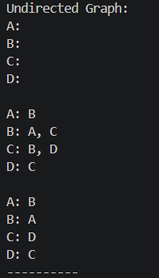
- Directed graph
  - 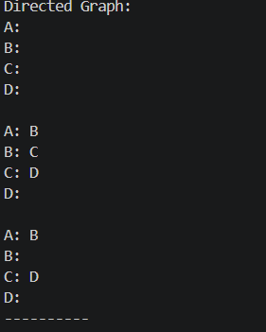
- Weighted graph
  - 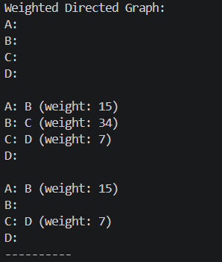

Task 2: Breath First Search (BFS) Implementation
- 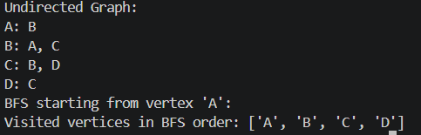
  - Explain…

Task 3: Depth First Search (DFS) Implementation
- 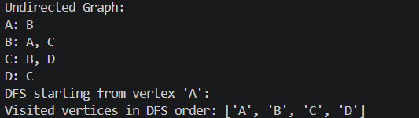
  - Explain…

Task 4: Cycle Detection in Undirected Graphs
- 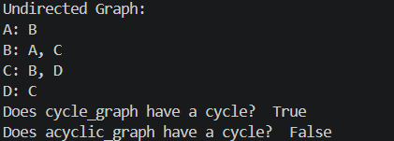
  - Explain… How dfs can detect and why it matters

Task 5: Experiment with Weighted and Directed Graphs
- 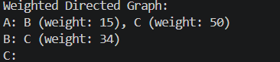

Task 6: Visualization Graph Data Structure with Tkinter
- Visualisation without extra functionality
  - 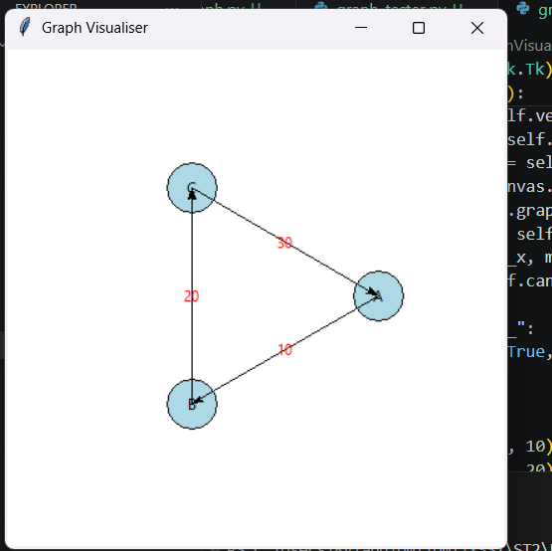
- Adding Verts
  - 