Task 1: Successful test run of a Simple bst using a Contact Directory using BST
- 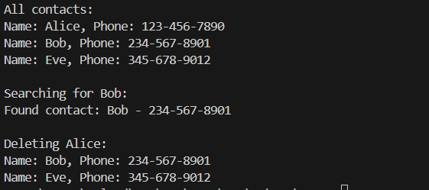

Task 2: GUI visualization of the Contact Directory using BST
- On Open
  - 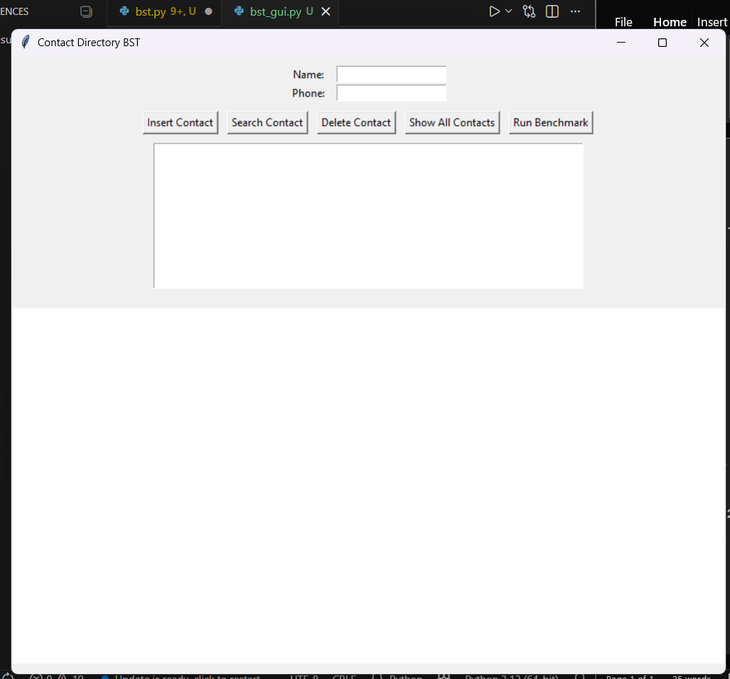
- Insertion
  - 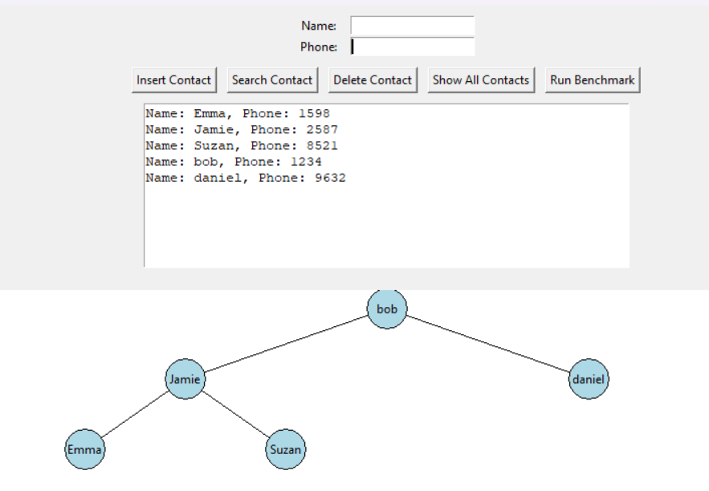
- Search
  - 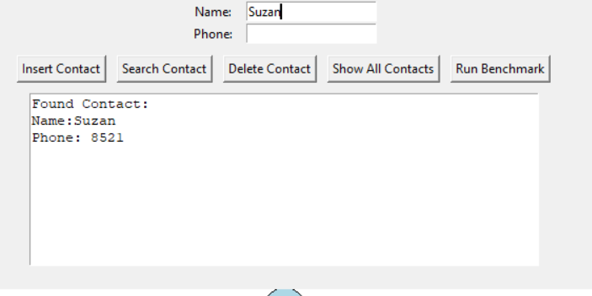
- Delete
  - 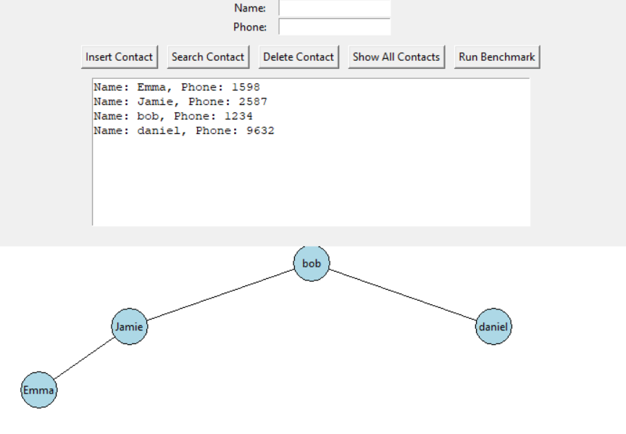
- Show All Contacts
  - 
  - 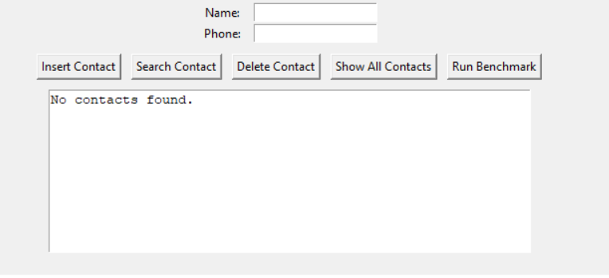
- Benchmark
  - 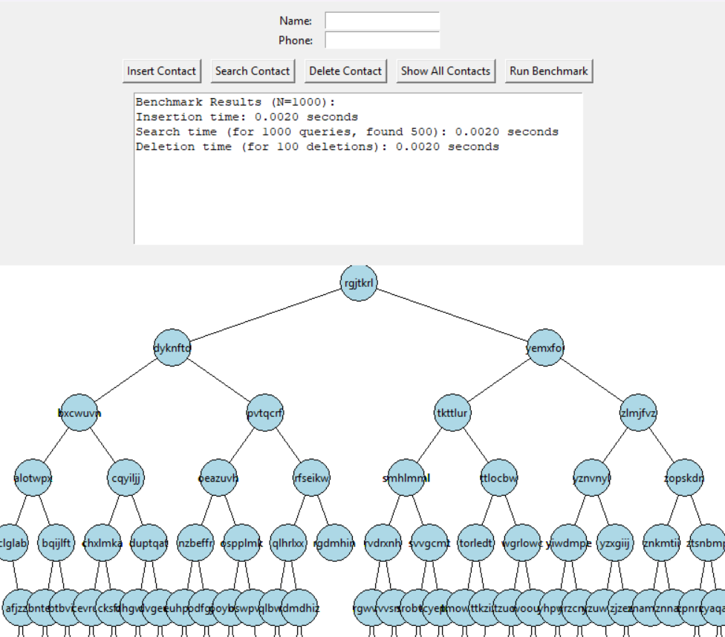

Task 3: AVL binary Search Tree
- Insertion
  - 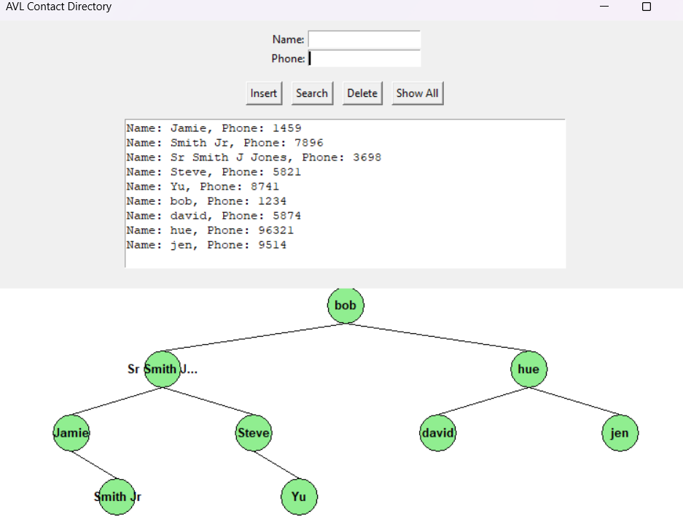
- Search
  - 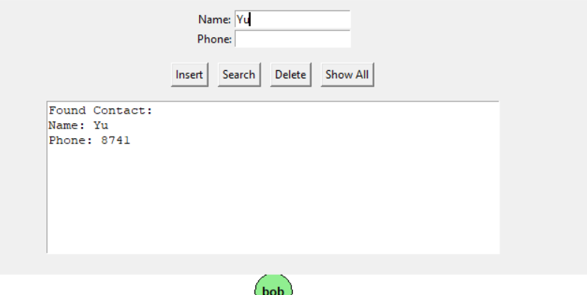
- Deletion
  - 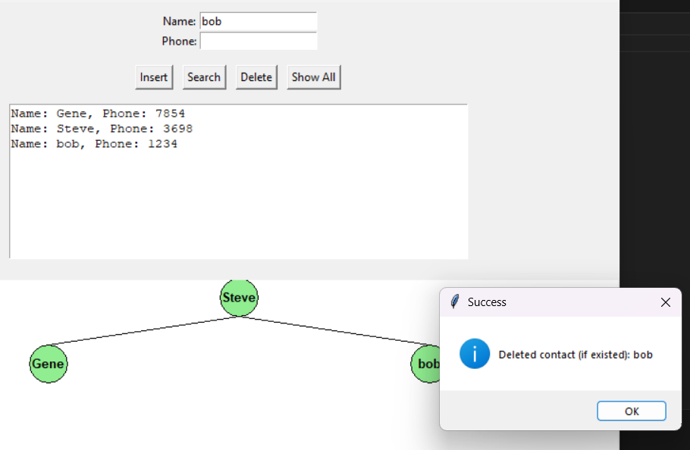
  - 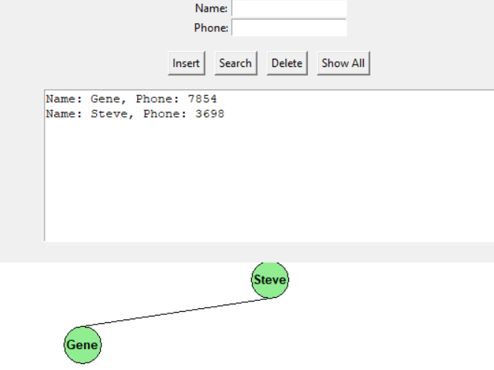
- Show All
  - 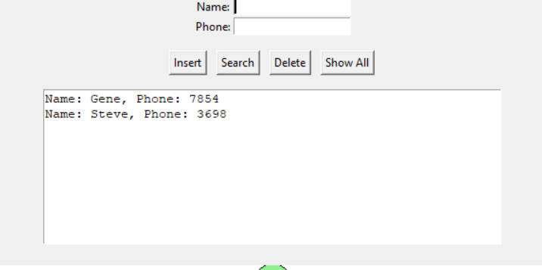
- Rotation
  - 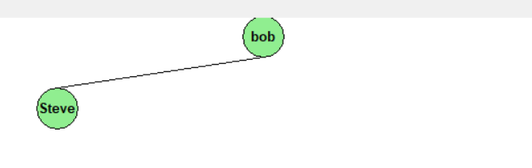
  - 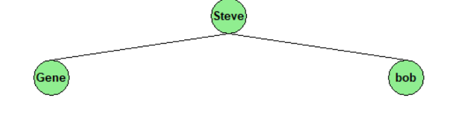

Task 4: Benchmarking AVL Tree with Binary Trees (BST)
- Benchmarking without extra code additions
  - 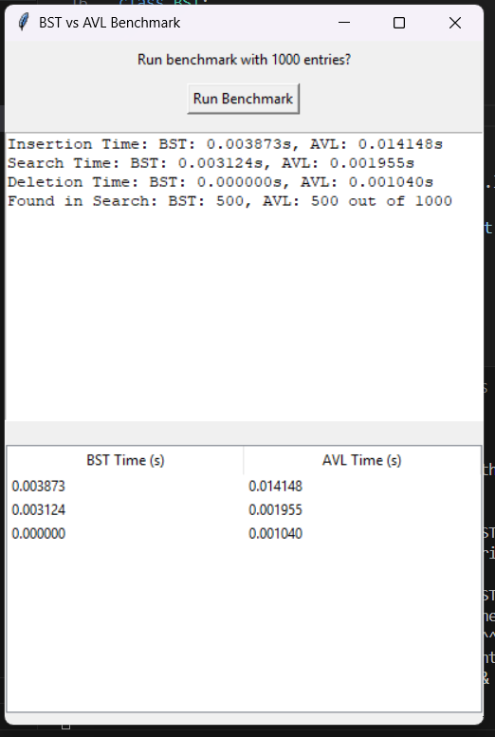
- Benchmarking with mathplot
  - 100
    - 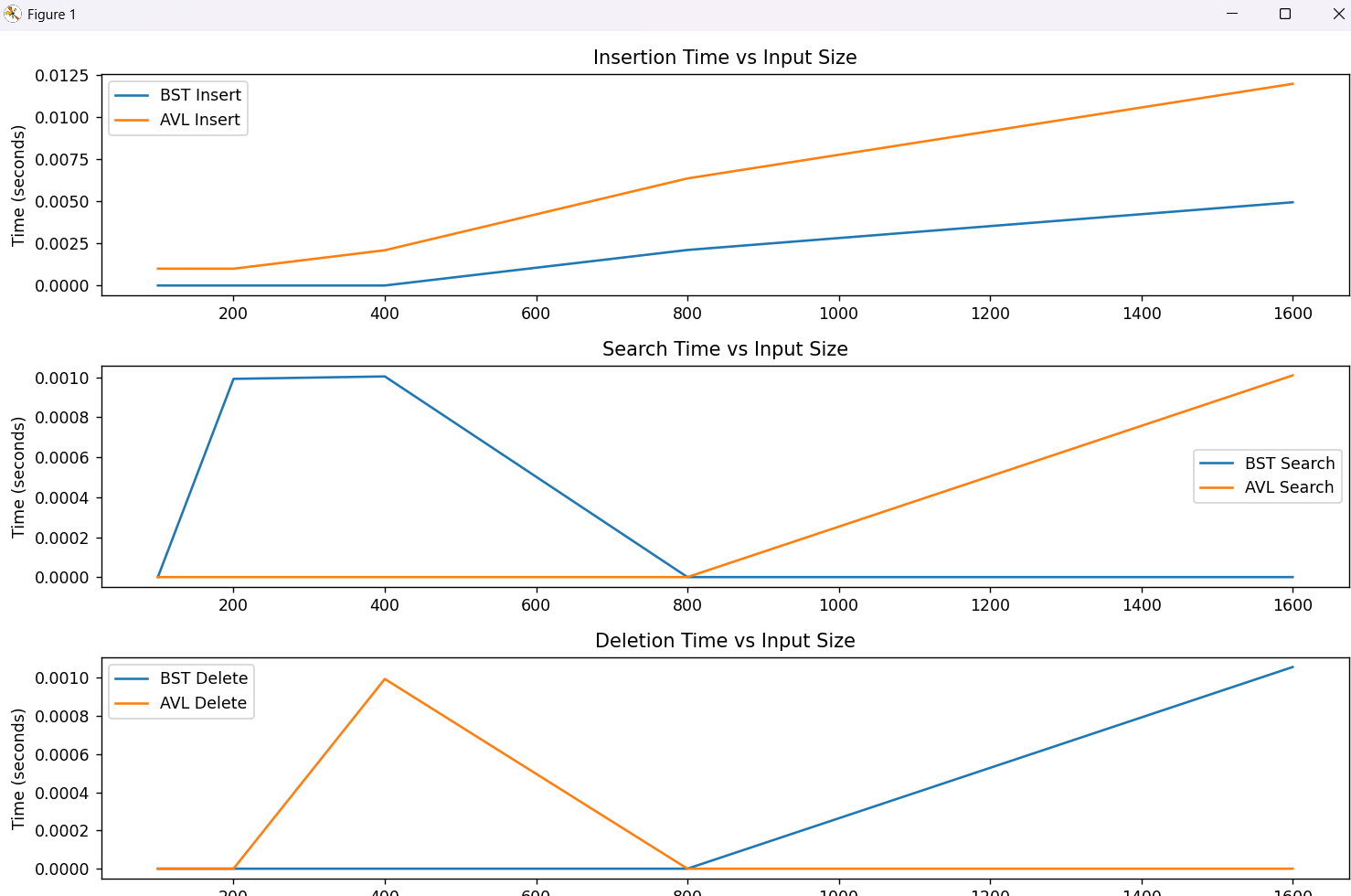
  - 1000
    - 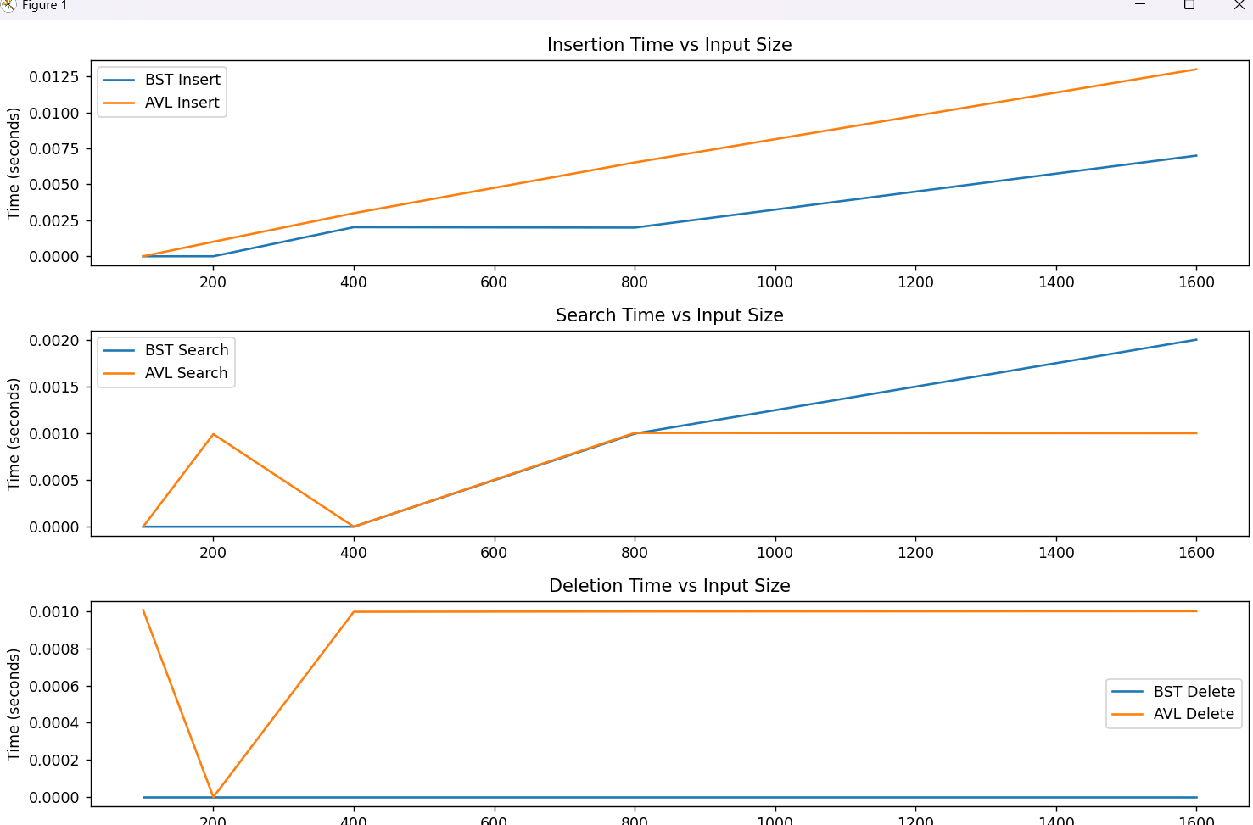
  - 10000
    - 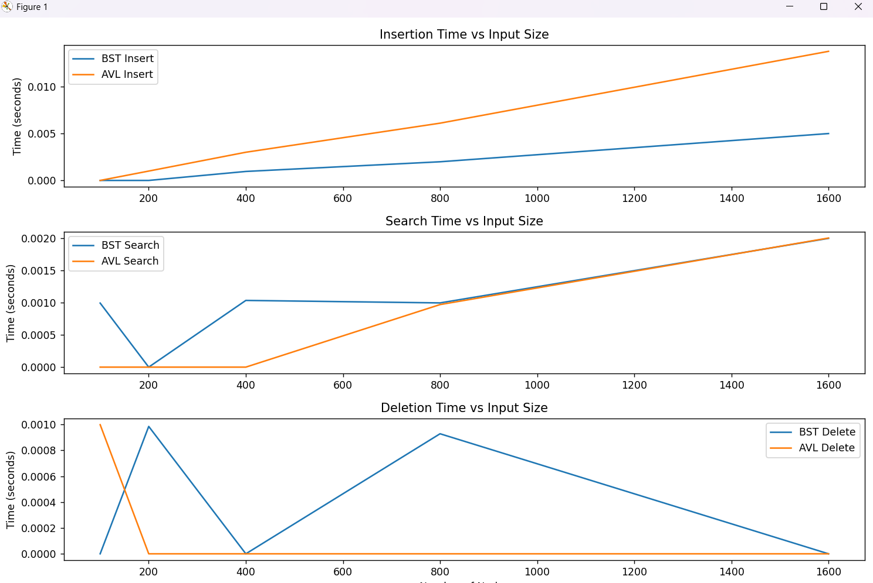

Task 5: Challenge Task: Design, Implement, Visualise and Benchmark the Red-Black-Tree
- To be done

