Task 1:Understanding Simple Data Structures in Python
Screen-Shots of rpg.py
- Player winning
  - 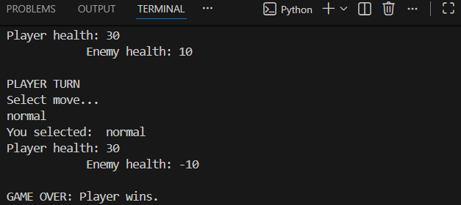
- Player losing
  - 
- Player and Enemy Draw
  - 

Task 2: Understanding Simple Search Algorithms and Measuring their Computational Efficiency in Python
- Linear details
  - Linear search execution time: 1.578345 seconds for length 1000000
  - Linear search execution time: 0.035891 seconds for length 500000
  - Linear search execution time: 0.085346 seconds for length 100000
  - Linear search execution time: 0.000066 seconds for length 100
- Binary details
  - Binary search execution time: 0.000275 seconds for length 1000000
  - Binary search execution time: 0.000253 seconds for length 500000
  - Binary search execution time: 0.000211 seconds for length 100000
  - Linear search execution time: 0.003708 seconds for length 10000
  - Binary search execution time: 0.000178 seconds for length 10000
  - Binary search execution time: 0.000055 seconds for length 100
- Compare Linear VS Binary
  - Why linear is faster than binary
    - Linear is faster than binary as the binary sort must wait for the data to be sorted before it can begin its search unlike linear that can begin immediately.

Task 3: Understanding Simple Sorting Algorithms and Measuring their Computational Efficiency in Python
- Insertion Sort
  - Mm
- Bubble Sort
  - Mm
- Measure and compare the runtimes of Bubble Sort and Insertion Sort
  - mm

