- Screenshot unedited
  - 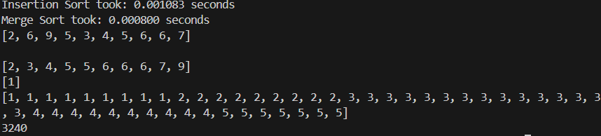
- Basic recursion
  - 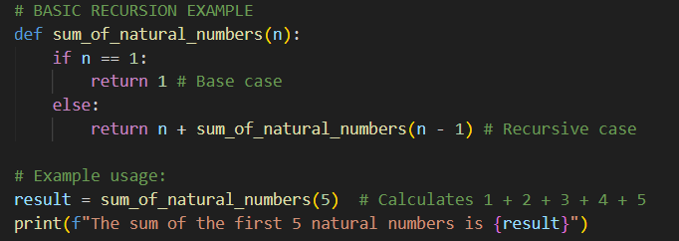
- Fibonacci sequence
  - 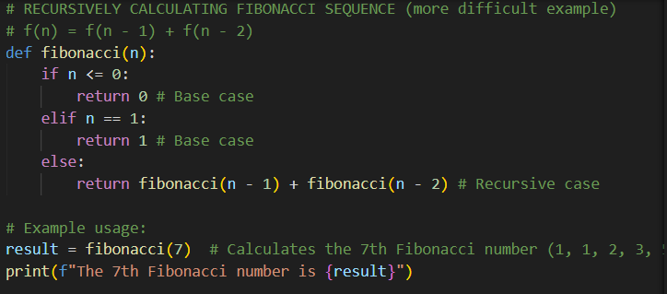
- Factorial computation
  - 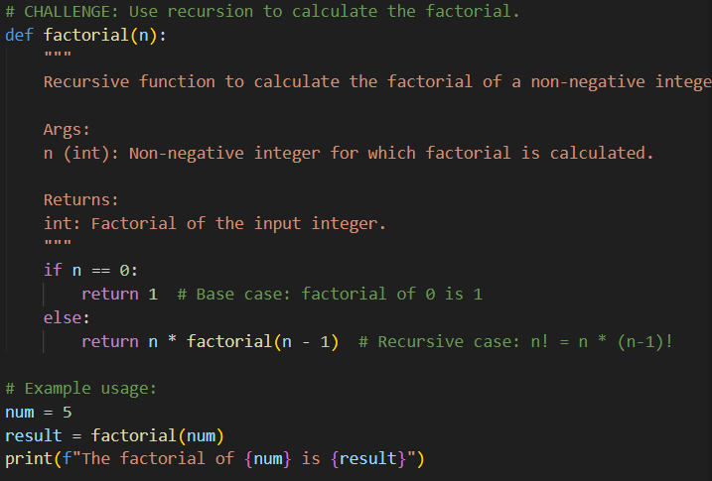
- Convert python code for three cases to iteration
  - Console print
    - 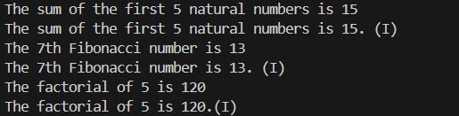
  - Basic I
    - 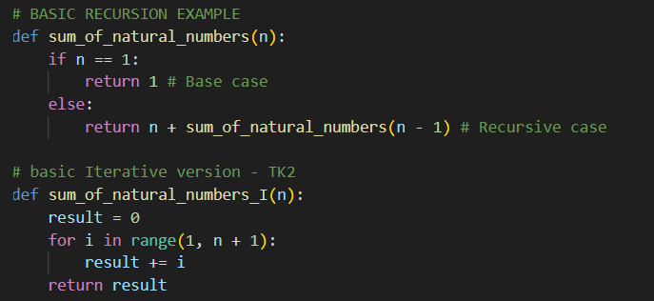
  - Fibonacci I
    - 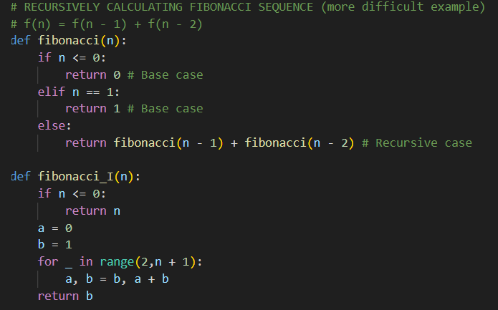
  - Factorial I
    - 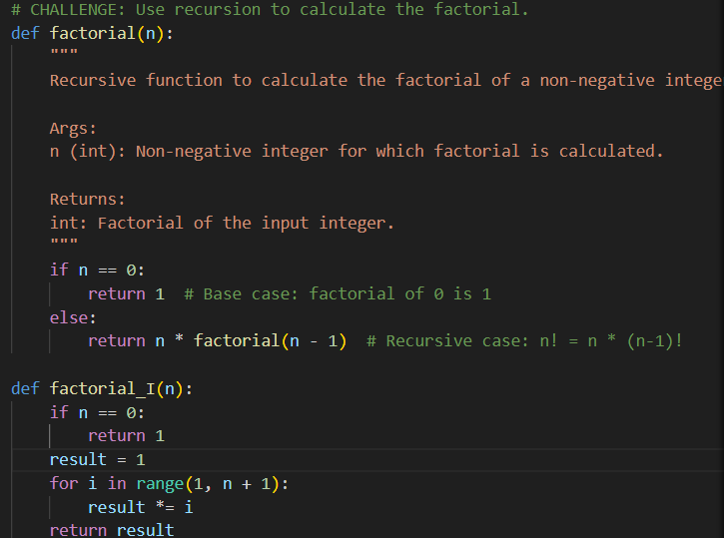
- Compare Iterative vs recursive
  - 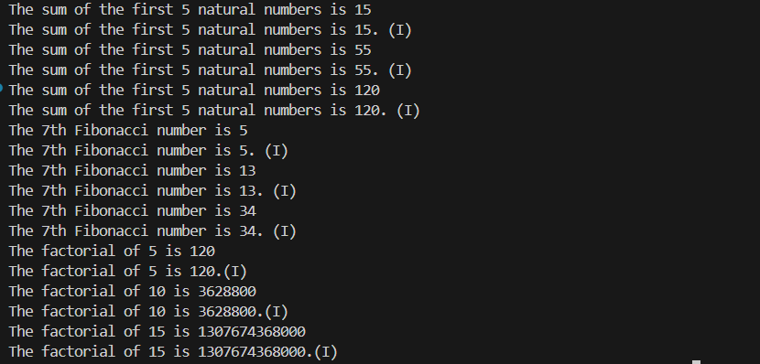

Task 2 Understanding an efficient sorting algorithm
- Test the merge-sort algorithm for different data size
  - 