Any Library you will need for the CV challenge will be right here in this directory, except for Qt5

That is of course optional, as I did make a CLI one.

I wanted to do the CSVtoJSON in C++ but didn't get time for it. I will try to get to it tomorrow.

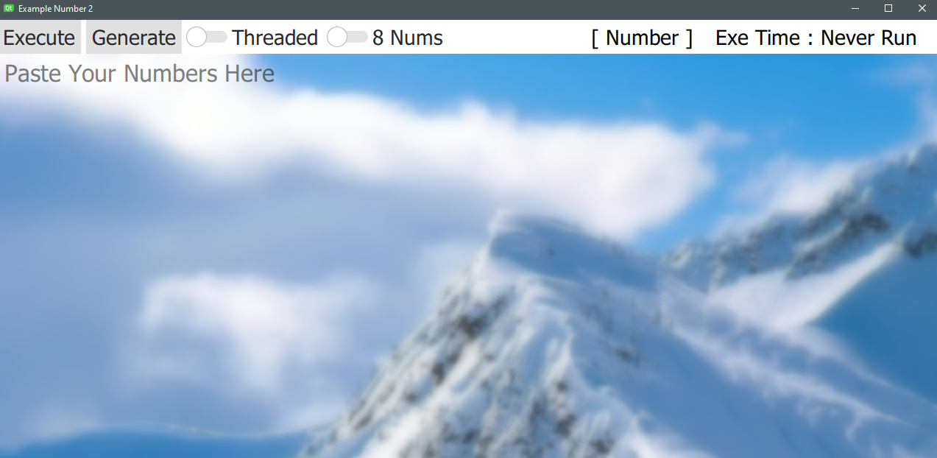

That is the UI and everything should be pretty straight forwrad based on the requirements

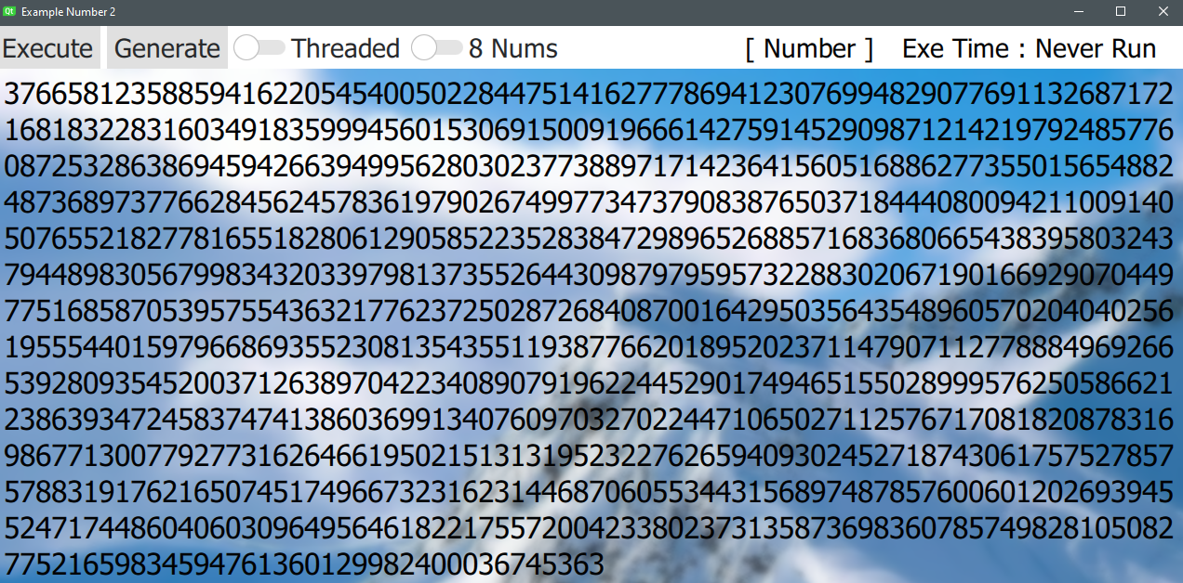

That is actually how it looks when you start it up

It will be ready for parsing when you start off.

The default nums are straight from the example.

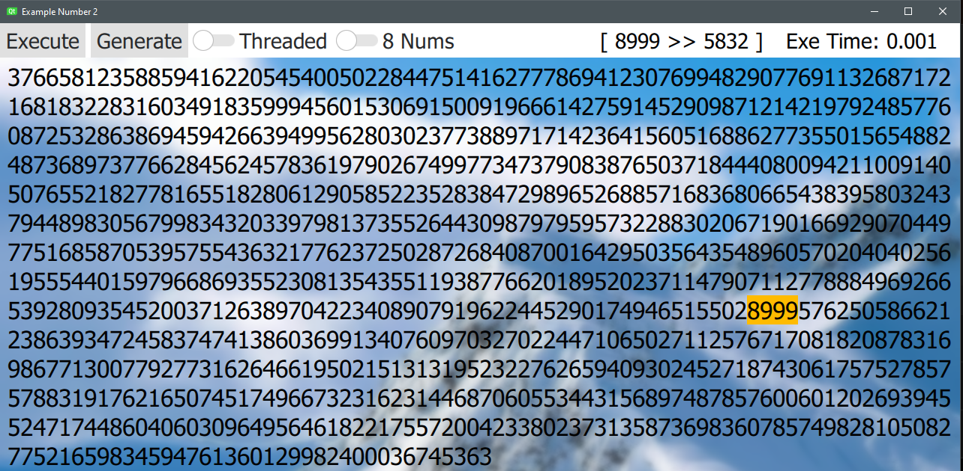

After clicking execute, the highlighted number sequence will show that has the biggest multiplier.

Also, the execution time will be shown.

Because the amount of workload here is so small, the multi-threaded method is slower.

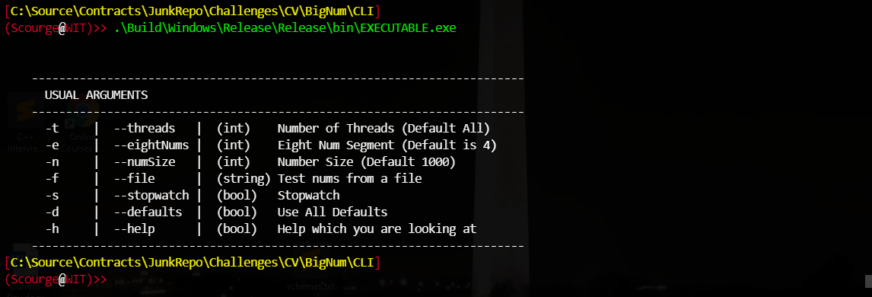

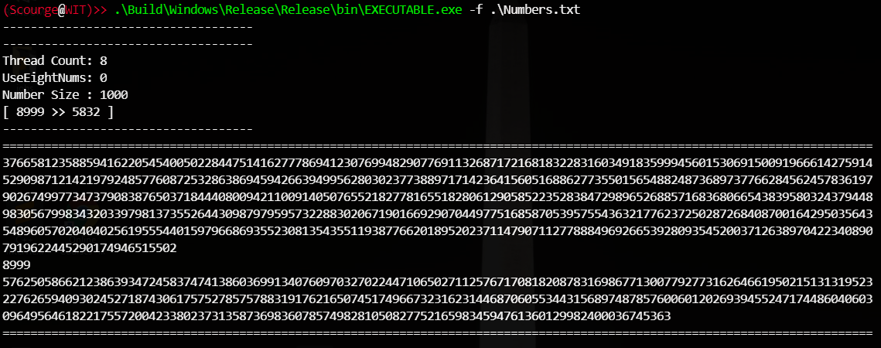

That is what the command line looks like