1. **Design and Implementation of a Low Cost Modern CNC LASER Cutter:**

A CNC LASER cutter was designed and fabricated. It had a bed size of 1square feet and a LASER diode of 2.5watts was used for cutting. Whole body was designed in solidWorks.

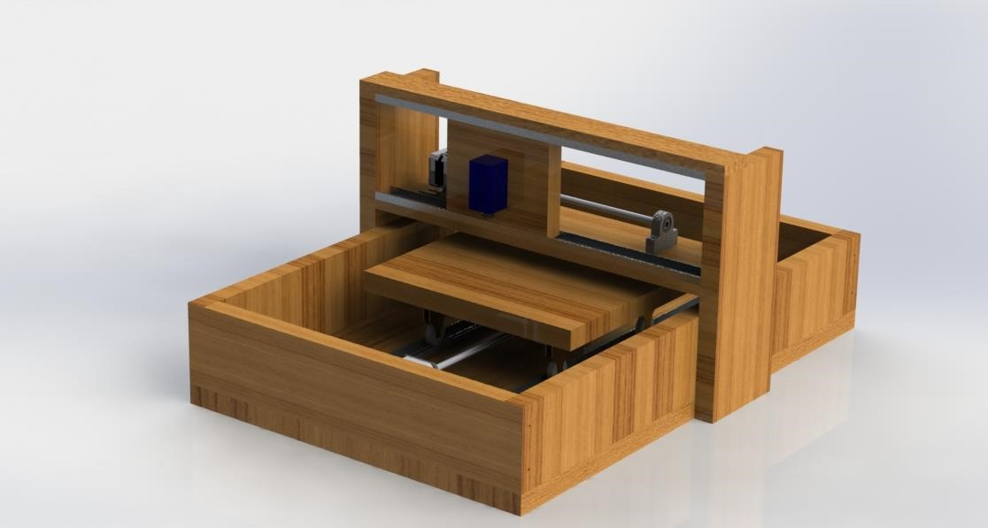

Fig: Design of the LASER Cutter.

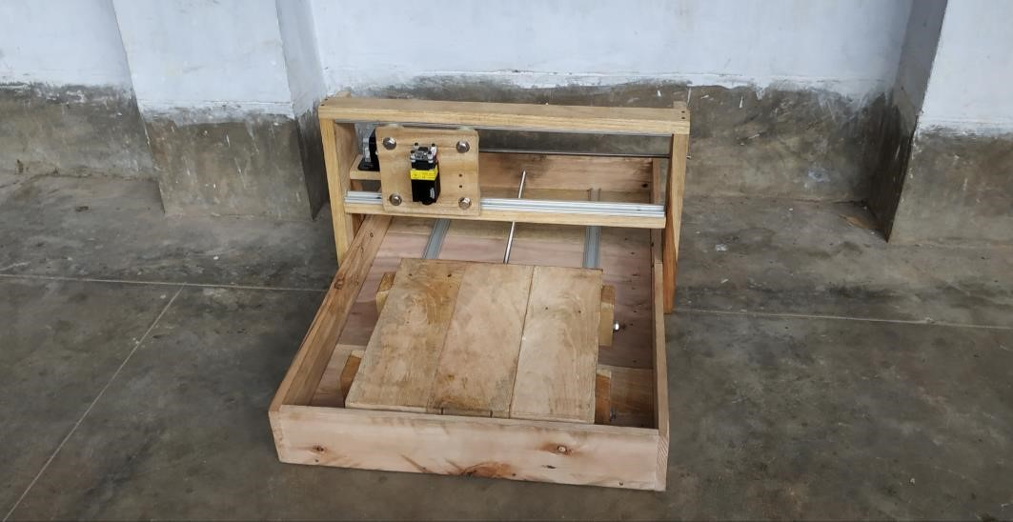

Fig: Fabrication of the LASER Cutter.

**Result:**

The fabricated machine was tested upon various shapes.

|  |  |  |  |
| --- | --- | --- | --- |
| Shape | Difference( mm) | Error (%) | Accuracy (%) |
|  | 0.2mm  0.2mm | 1% | 99% |
|  | 0.0mm  0.2mm | 1% | 99% |
|  | 1.0mm  1.1mm  1.5mm | 5% | 95% |
|  | 0.2mm | 1% | 99% |
|  | 0.0mm  0.0mm  0 Degree  0 Degree | 0% | 100% |

**12. Line Follower Robot:**

A robotic system that is designed to follow a line using a PID controller. This task was achieved using IR sensors as input devices, microcontroller as processing unit and wheel mounted in motors as output of the system.

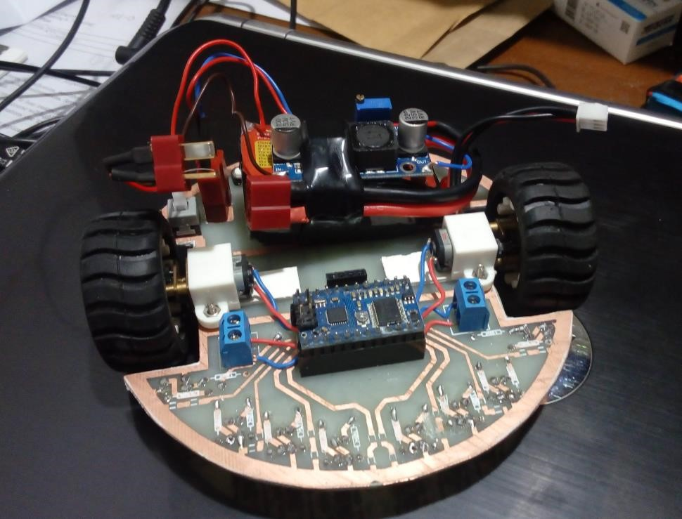

Fig: Line Follower Robot.

1. **Unmanned Aerial Vehicle:**

This drone was built on a 450mm frame with 980KV brushless DC motors. This drone had CC3D controller as its brain and sensing unit. A 9 channel radio was used to operate it.

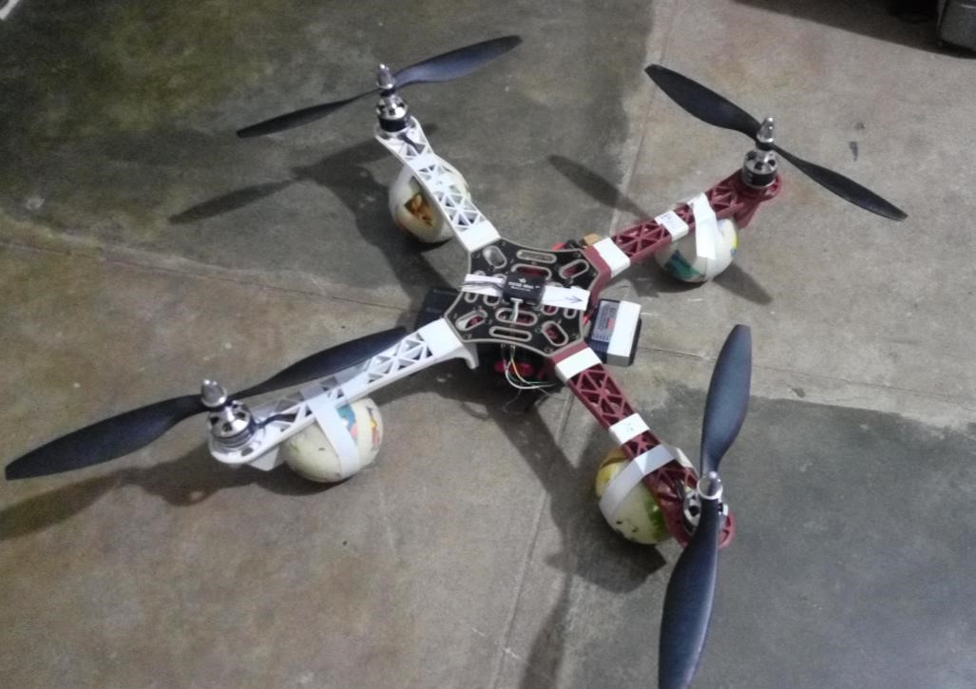

Fig: Quadcopter.

1. **Accident Detection and Prevention System:**

This system had a subtle approach of traffic signal detection using RFID technology. It would help to resolve traffic collision in four way lanes and places where traffic signal is not visible. Besides it involves a collision detection system.

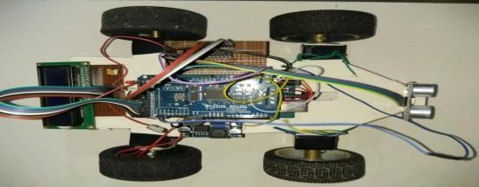

Fig: Car Prototype with Sonar.

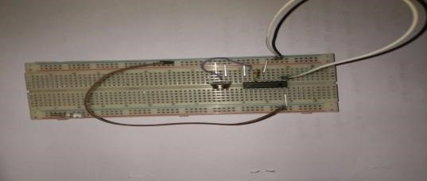

Fig: RF Receiver Circuit.

1. **Soccer Robot:** 
   1. wireless robot designed and fabricated for a soccer robot contest. The robot was controlled using a custom made wireless controller using Bluetooth technology.

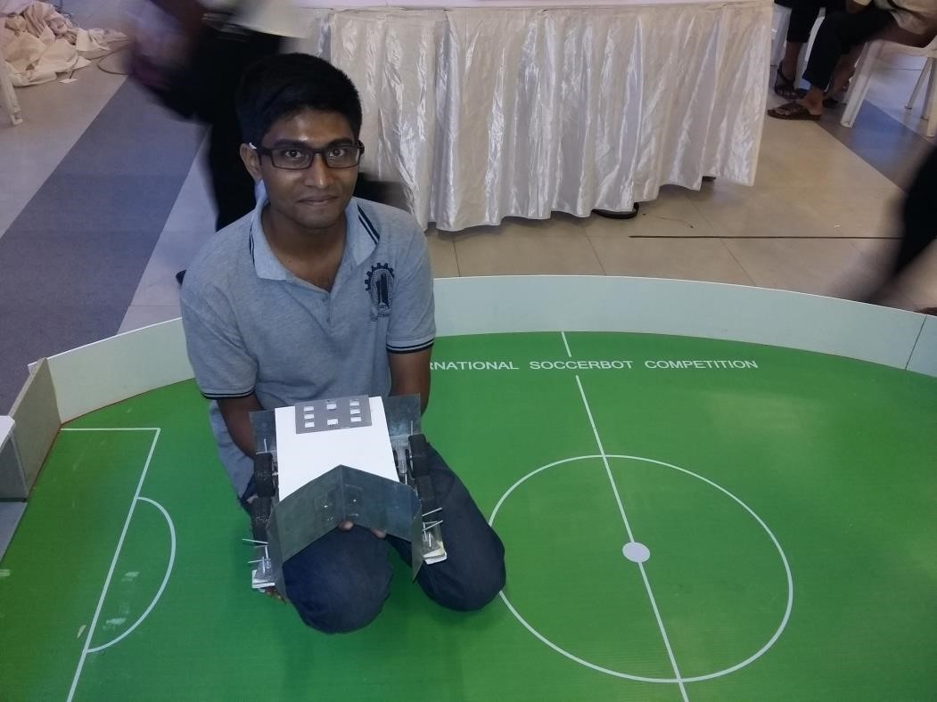

Fig: Internation Soccerbot Competition.

1. **Realtime Online GPS Tracker:**

This system was developed in order to track the location of a vehicle real time online. For this GPS module was used to gather location data then this data was transferred in a web server for online tracking.

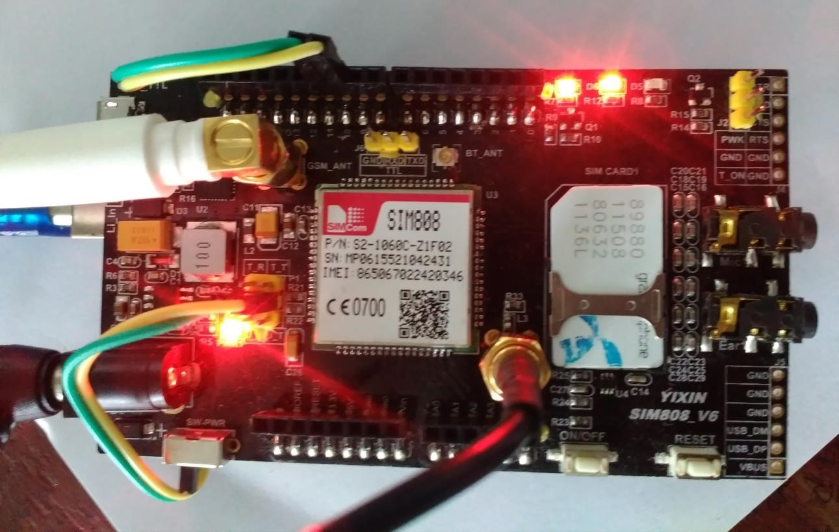

Fig: Hardware of GPS Tracking Device.

1. **Shadow Arm:** 
   1. 5 DOF robotic arm was developed to pick and place object of various shapes. This arm was controlled wirelessly using a pair of Bluetooth and flex sensors were used to obtain angular data from the user.

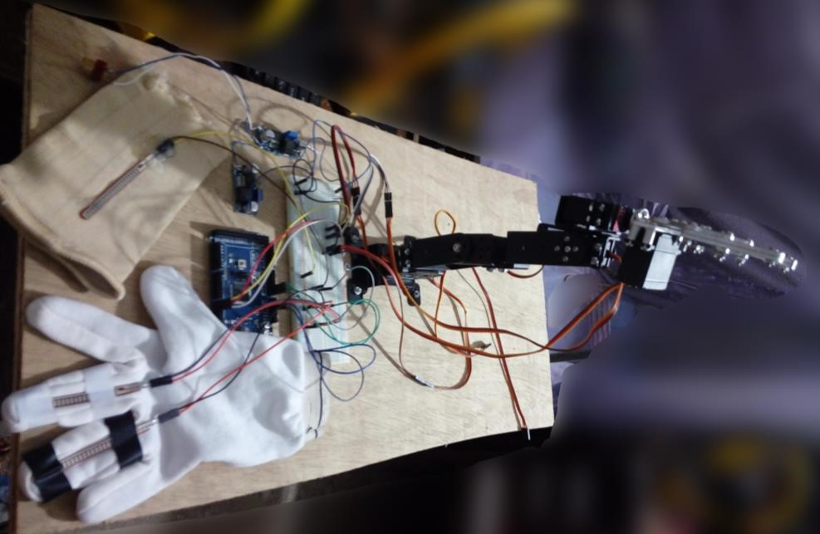

Fig: Shadow Arm

1. **Propeller Display:**

This was a low cost implementation of propeller display using the persistence of vision of human eye.

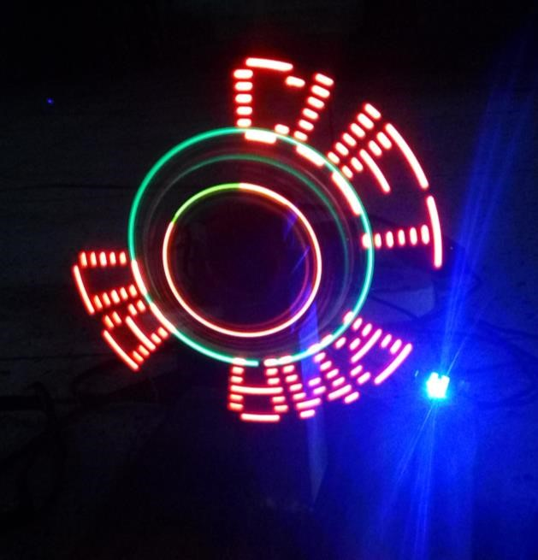

Fig: POV Display.

1. **Study of Peltier Cooling Effect on a Computer CPU:**

This study was done to determine the cooling effect of a 154W peltier module has over a computer CPU. For generating heat a 50W electric heater was used.

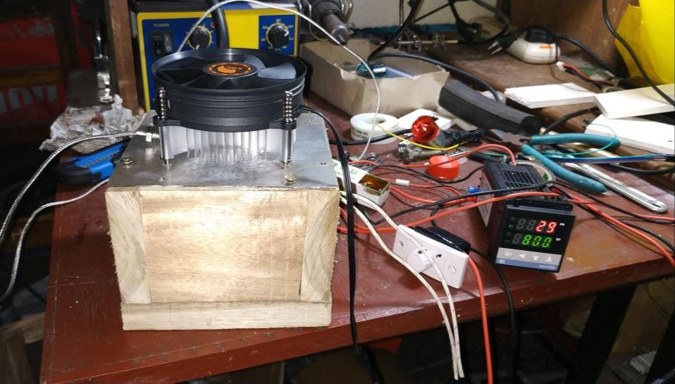

Fig: Study of peltier cooling effect on a CPU.

1. **Footstep Power Generator:**

This project was developed based on the concept of generating electricity from footstep. For generating electrical charge a series of piezo electric ceramics were used.

1. **Door Security Using Face Recognition system:**

This project was done using OpenCV. Using open source library face detection was accomplished then dataset was created by training the system to recognize the face. Face recognition system was combined with a microcontroller based system in order to door security.

1. **Biometric Attendance Monitoring System:**

This system was developed to monitor student attendance using fingerprint. Attendance data was uploaded to a web server to monitor. A pair of zigbee radio was used to communicate between field device and a computer to upload data.

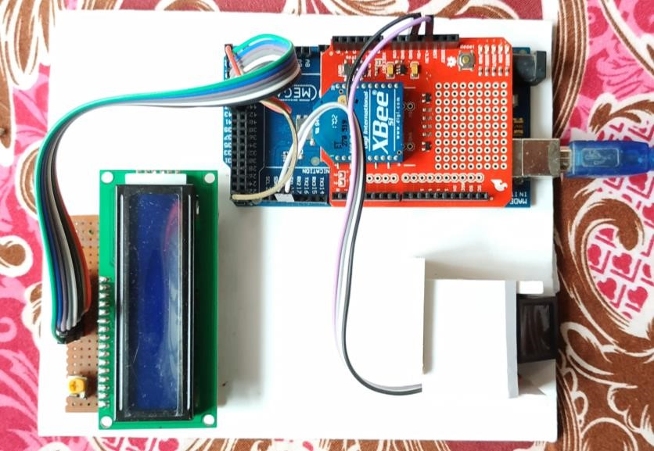

Fig: Biometric Attendance Monitoring System.

1. **Energy Monitoring System:**

This system was developed in order to monitor voltage, current and power factor online and in real-time.

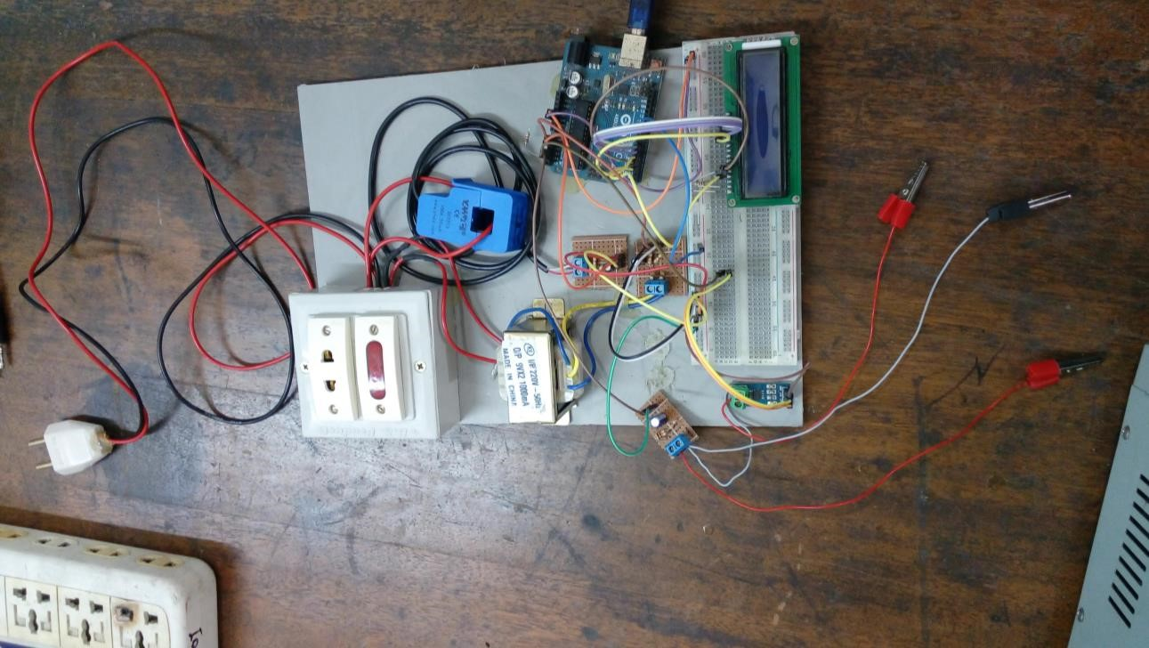

Fig: Energy Monitoring System.

1. **Design and Fabrication of Hover Craft:**

This is a low cost implementation of a hover craft. The body of it was build using thermocol sheet reduce weight. Side skirt was fabricated using polythene. A dedicated BLDC motor (980KV) was used to lift the craft up. In the back of the craft another BLDC motor was used to provide thrust. For directional control a rudder is installed at the back of the craft which is being controlled via a servo motor. For controlling the craft a 6 channel radio was used.

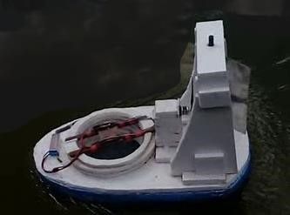

Fig: Hovercraft.

1. **Agricultural Field Data Monitoring System:**

This prototype was developed in order to monitor data of an agricultural field. This would monitor field moisture level, temperature, humidity, CO2 level and log these data to an SD card. Along with that it would upload data to a cloud server. If any data goes out of limit it would notify user with SMS.

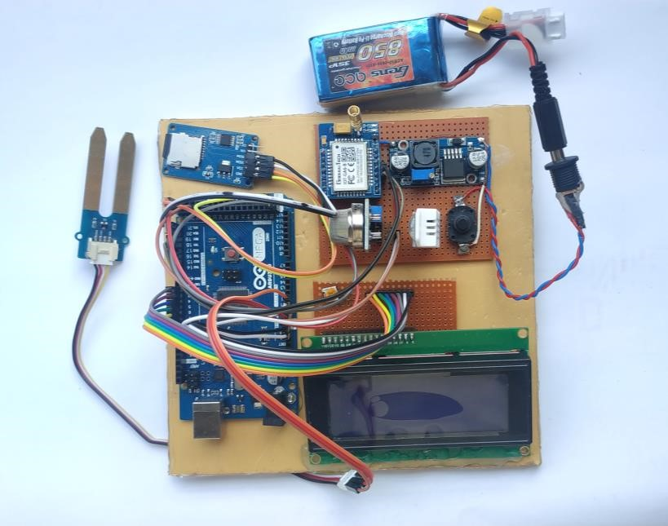

Fig: Agricultural Data Logger.

**Mechanical Design**

I have been working with mechanical design with a plenty long time. During this time I have used solidworks as my main designing software. These are the area that I am confident in:

* + - Solid Modeling.
    - Surfacing.
    - Sheet metal.
    - Plastic molding.
    - Machine Design.

Some of my significant works have been mentioned below.

* 1. **Six Cylinder Petrol Engine:**

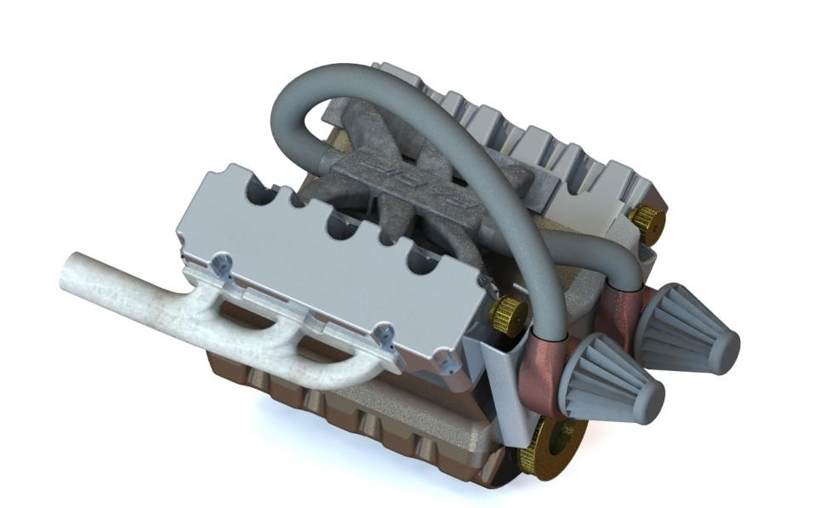

Fig: 6 Cylinder Petrol Engine.

* 1. **Five Cylinder Radial Engine:**

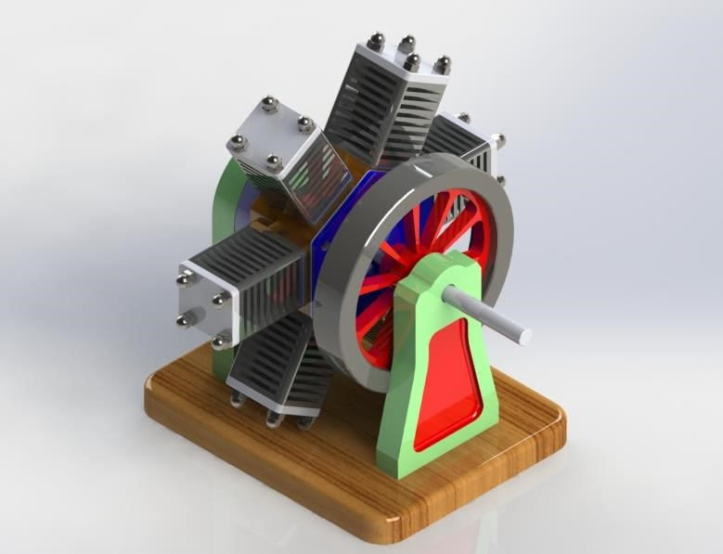

Fig: 5 Cylinder Radial Engine.

* 1. **Wind Mill:**

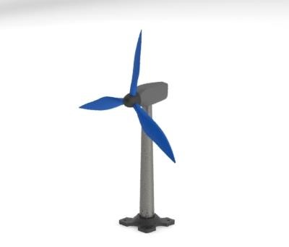

Fig: Wind Mill.

* 1. **Quick Return Mechanism:**

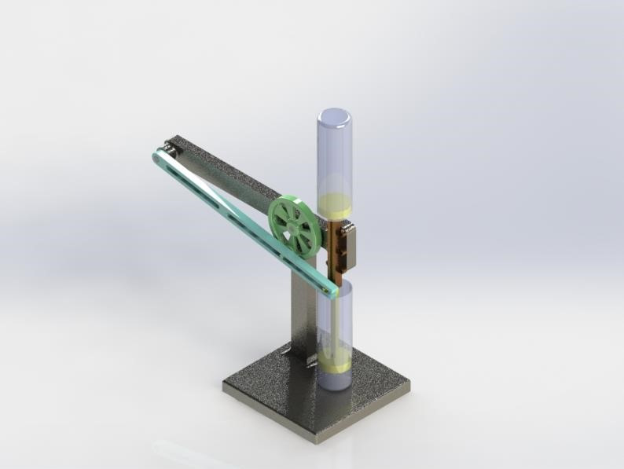

Fig: Quick Return Mechanism.

* 1. **Racing Robot:**

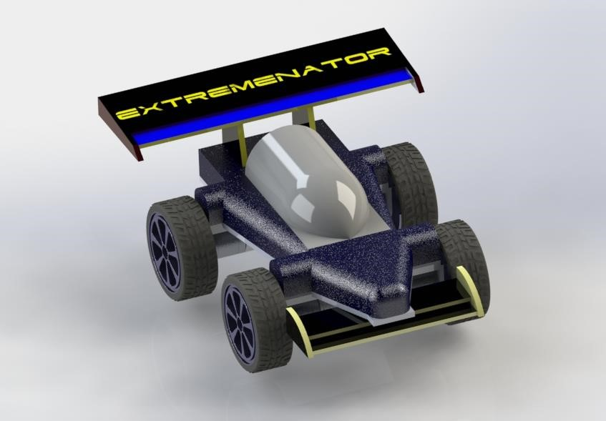

Fig: Racing Robot.

Here is my GrabCAD Link: grabcad.com/radif.uddin.ahmed-1.