Лабораторная работ 1 вариант 3

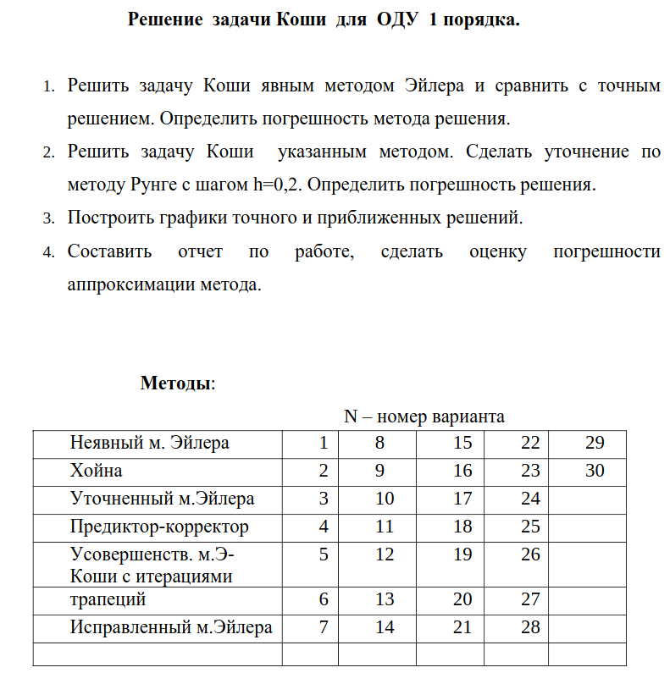

Код программы  
import math

import matplotlib.pyplot as plt

def f(x):

return (x - math.tan((-1+x)/x)) / math.pow(x, 2)

def df(x, y):

return -math.pow(y, 2) - 1/(math.pow(x, 4))

def PrintVectors(x, y, answer, eps):

print(" x | y | answer | eps ")

for i in range(len(x)):

print(f"{x[i]:.6f} | {y[i]:.6f} | {answer[i]:.6f} | {eps[i]:.6f}")

print()

def PrintVectors2(x, y, y2, eps):

print(" x | method | runge | eps ")

for i in range(len(x)):

print(f"{x[i]:.6f} | {y[i]:.6f} | {y2[i]:.6f} | {eps[i]:.6f}")

print()

def runge_kutta(h, xi, yi):

k1 = h * df(xi, yi)

k2 = h * df(xi + h/2, yi + k1/2)

k3 = h * df(xi + h/2, yi + k2/2)

k4 = h * df(xi + h, yi + k3)

y_next = yi + (k1 + 2*k2 + 2*k3 + k4) / 6

return y_next

# Явный метод Эйлера и уточненный метод Эйлера

h1 = 0.1

a = 1.0

b = 2.0

n = int((b-a)/h1) + 1

x = [a + i*h1 for i in range(n)]

answer = [f(xi) for xi in x]

# Явный метод Эйлера

y = [1]

for i in range(1, n):

y.append(y[i-1] + h1*df(x[i], y[i-1]))

eps = [0 for i in range(n)]

for i in range (0,n):

eps[i] = y[i] - answer[i]

norm = 0

for i in range (0,n):

norm += eps[i]**2

norm = math.sqrt(norm)

print("\t\tЯвный метод Эйлера\n")

PrintVectors(x, y, answer, eps)

print("Общая погрешность: ", norm, "\n")

# Уточненный метод Эйлера

y1 = [1.0]

for i in range(1, n):

y_mid = y1[i-1] + h1*df(x[i], y1[i-1])

y1.append(y1[i-1] + h1*df(x[i], y_mid))

# метод Рунге Кутта

h2 = 0.2

y2 = [0 for i in range(n)]

y2[0] = 1.0

y3 = [0 for i in range(n)]

y3[0] = 1.0

for i in range(1, n):

y2[i] = runge_kutta(h2, x[i], y1[i-1])

y3[i] = 0.5 * (y1[i] + y2[i])

eps = [0 for i in range(n)]

for i in range (0,n):

eps[i] = y3[i] - y2[i]

norm = 0

for i in range (0,n):

norm += eps[i]**2

norm = math.sqrt(norm)

print("\tУточненный метод Эйлера\n")

PrintVectors2(x, y2, y3, eps)

print("Общая погрешность: ", norm, "\n")

plt.plot(x, y, label='Явный метод Эйлера')

plt.plot(x, answer, label='Точное решение')

plt.plot(x, y1, label='Уточненный метод Эйлера')

plt.plot(x, y2, label='Уточнение методом Рунге-Кутты с h = 0.2')

plt.legend()

plt.show()

