Installation and usage:
SpectroRadiometer
Marcus Leech
Canadian Centre for Experimental Radio Astronomy
Introduction
This document describes the installation, system requirements, and usage of the Gnu Radio application known as SpectroRadiometer.
System Requirements
This document assumes that you have already installed Ubuntu 24.04 LTS onto your system. The instructions given here would need to be modified for other Linux distributions, and Ubuntu is one of the more popular distributions.
The system hardware should be a fairly-modern, multi-core system, preferably X86-based, but some of the higher-end ARM SBCs, like Raspberry Pi the Odroid N2 and XU4 will also work, albeit at lower sample rates.
There should be at least 2G of system memory, with a basic clock speed of at least 1.4GHz for X86 systems, and 1.8GHz for ARM systems.
Caveats
This document DOES NOT cover basic system installation procedures and requirements. If you aren't familiar with Ubuntu 24.04 installation procedures, and basic system management tasks, you should BECOME FAMILIAR WITH THOSE FIRST.
SDR requirements
The software supports many different SDR hardware platforms:
- USRP products: B2xx series, and N2xx, X3xx and N3xx series
- RTLSDR dongles
- HackRF
- LimeSDR and LimeSDR-mini
- AirSpy R2 and AirSpy mini
This document will NOT cover installation requirements for this hardware, as that information is generally provided by the manufacturers.
Prerequisite Installation revised by Pierre Terrier
There are certain prerequisites for the SpectroRadiometer software that must be satisfied before installing the software.

Development Tools
sudo apt install build-essential
sudo apt install git
sudo apt install python3-pip
pip install --user ephem --break-system-packages

Gnu Radio
sudo apt install gr-osmosdr gnuradio gnuradio*

Application: SpectroRadiometer
In your home directory:
git clone https://github.com/Radio-Source/SpectroRadiometer
cd SpectroRadiometer

SpectroRadiometer is a Python3 script run by

python3 SpectroRadiometer.py (if you use RTL-SDR with default [args])

python3 SpectroRadiometer.py [args*] --> see documentation for [args]

(if you use another type of SDR and or using some [args] differents)

Invoking SpectroRadiometer
The application takes many options and command line parameters:
-h, --help show this help message and exit

--abw=ABW Set Analog bandwidth [default=4.0M]

--antenna=ANTENNA Set Antenna [default=RX2]

--baseline=BASELINE Set Baseline length [default=99.3]

--bbgain=BBGAIN Set Baseband Gain [default=5.0]

--bw=BW Set Bandwidth [default=-1.0M]

--dcg=DCG Set Detector DC Gain [default=100]

--decln=DECLN Set Observing Declination [default=0.0]

--device=DEVICE Set SDR Device Name [default=rtl=0

file=/dev/zero,rate=5e6]

--fftsize=FFTSIZE Set FFT size [default=2048]

--frequency=FREQUENCY

Set Center Frequency [default=1.42041G]

--gain=GAIN Set RF Gain [default=30.0]

--ifgain=IFGAIN Set IF Gain [default=5.0]

--latitude=LATITUDE Set Local Latitude [default=44.9]

--longitude=LONGITUDE

Set Local Longitude [default=-76.03]

--mode=MODE Set Operation Mode [default=total]

--prefix=PREFIX Set Data File Prefix [default=h1]

--ra=RA Set Target RA [default=12.0]

--rfilist=RFILIST Set RFI Frequency List [default=]

--srate=SRATE Set Sample rate [default=2.56M]

--zerotime=ZEROTIME Set SIdereal time for auto baseline set [default=99.3]

--clock=CLOCK Set Clock Source [default=default]
--ppstime=PPSTIME Set Time Source [default=default]

The –abw parameter controls the analog bandwidth, in Hz, on the hardware—this options does nothing on some hardware, and actually sets the pre-ADC bandwidth on others.
The –antenna option controls which antenna port is to be used. Again, this “does nothing” on some hardware, and on others selects which antenna port to use.
The –baseline option is used in interferometer mode to calculate fringe-stopping parameters, and is in meters.
The –bbgain parameter is used to control the baseband gain some hardware supports it, some doesn't.
The –bw parameter controls the DSP filter bandwidth, in Hz, prior to detection.
The –dcg parameter controls a digital “gain” on the detected DC total power output.
The –decln parameter sets the astronomic declination associated with the observation.
The –device parameter specifies the device string to use with the osmosdr hardware source. Further discussion of this later in the document.
The –fftsize parameter sets the number of FFT bins used for spectral determinations. The default value is adequate for most use cases.
The –frequency parameter sets the tuned center frequency, in Hz.
The –gain parameter sets the RF gain of the hardware device, in dB, typically.
The –ifgain parameter sets the IF gian of the hardware device, in dB. This is only supported by some types of hardware.
The –latitude parameter sets the local geographic latitude of the observatory.
The –longitude parameter sets the local geographic longitude of the observatory.
The –mode parameter sets the operating mode. For a single receiver, choose “total”. If you have two receiver channels, then choose either “differential” or “interferometer”.
The –prefix parameter sets the file-name prefix used, including any directories.
The –ra parameter defines the observation RA – used mostly for documenting observations.
The –rfilist parameter specifies a list (separated by commas) of frequencies that contain RFI, and should not be counted when calculating total power across the spectrum.
The –srate parameter specifies the hardware sample-rate. Different hardware supports different rates, and generally higher rates require a faster/better computer host.
The –zerotime parameter can be used to specify an LMST during which no spectral components are expected to show up in the beam--used for (optional) baseline-subtraction in spectral data. This is only really useful for spectral line work, such as with the hydrogen line. If the value is invalid (which is the default), no such baseline-recording will be performed.
The –clock parameter specifies the reference clock source. Not all hardware supports this option.
The –ppstime parameter specifies the source of the 1PPS signal. Not all hardware supports this option.

Device options
The SpectroRadiometer application uses the gr-osmosdr abstraction within Gnu Radio to provide support for many different types of SDR hardware.
The general form is:
--device “hwstring1 hwstring2”

Now, since SpectroRadiometer supports two channels, in many cases, with only a single receiver, the 2nd hwstring, above should be: “file=/dev/zero,rate=20e6”.
Single RTL-SDR
For a single RTL-SDR device, the –device option looks like:
--device “rtl=index-or-name file=/dev/zero,rate=20e6”

Recall that for RTL devices, one can either specify the device index which is simply the index from the order in which RTL devices were enumerated at boot time, or you can use the serial-number of the device, like “SKY1” or “ASTRON”, etc. See the rtl_eeprom tool for setting the serial number to allow unique device identification.
Dual RTL-SDR
With a dual-RTLSDR configuration, you can do differential measurements, with one device perhaps terminated in a load, or connected to a reference dish feed, or reference antenna, etc:
--device “rtl=index-or-name1 rtl=index-or-name2”
The key thing to understand is that the first device is always the notional sky channel and the 2nd device is always the notional reference channel.
You will also specify:
--mode differential

On the command line, to indicate that differential observations should be used.
Single AirSpy
To use an AirSpy:
--device “airspy=0 file=/dev/zero,rate=20e6”

You will need to specify a –srate option that is compatible with the hardware. For AirSpy R2, available rates are 10e6 and 2.5e6. For AirSpy Mini available rates are 3.0e6 and 6.0e6.
USRP B2xx
For a USRP B200, using the osmocom-UHD driver:
[single channel]
--device “uhd,type=b200,num_recv_frames=128,subdev='A:A' file=/dev/zero,rate=20e6”

[dual channel]
--device “uhd,type=b200,num_recv_frames=256,nchan=2,subdev='A:A A:B'”

In the 2nd, dual-channel case, this can be in support of either differential or interferometer mode. Use the –mode option appropriately.
The B2xx series is very sample-rate agile, so it's possible to pick a sample rate that's very close matching the compute hardware and local-RFI environment.
USRP1 with WBX/SBX/CBX/RFX cards
For a USRP1, using the osmocom-UHD driver:
--device “uhd,type=usrp1,num_recv_frames=128,subdev=A:0 file=/dev/zero,rate=20e6”

Dual channel support has not been tested on the USRP1, and requires different FPGA firmware.
Sample rates can be any proper integer fraction of 64MHz, but rates above 8Msps aren't really supported.
LimeSDR
For a LIMESDR-USB (NOT the mini):
[single channel]
--device “soapy,driver=lime”

[dual channel]
--device “soapy,driver=lime,nchan=2”

Both differential and interferometer modes are supported.
You will also have to specify the appropriate antenna port, using the –antenna option. My preference is to use the “LNAW” port:
--antenna LNAW

The LimeSDR is reasonably sample-rate agile, very much like the USRP B210 in this regard.
Other Hardware
Other hardware that is supported by gr-osmosdr will probably also work, but hasn't been tested explicitly with SpectroRadiometer.

User Interface
The application provides a GUI, based on the standard Qt widgets provided by Gnu Radio.
Main Window
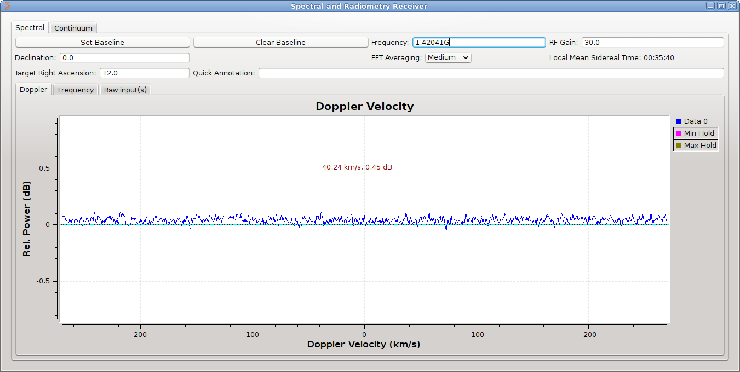
This panel provides access to various spectral plots, showing (possibly base-lined) Doppler and Frequency views of the same spectrum, as well as “raw” spectral information from both devices.
In the case of the Doppler and Frequency spectral displays, only the notional “Sky1” channel spectrum is displayed (or the 1st channel in the case of interferometry).
The display itself is governed by the behavior of a Qt plot widget. The middle mouse button pops up a menu to control such things as auto-scaling, axis limits, etc. More can be found in Gnu Radio documentation.
The FFT Averaging control controls the averaging applied to the displayed spectral information. The Set Baseline records a notional baseline spectrum, which is subtracted from the incoming spectrum to provide a flattening and RFI-excision function for display purposes. The Clear Baseline function clears this recorded baseline.
The Frequency and RF Gain controls set the appropriate parameters in the hardware. Like most such numerical inputs, exponential notation is accepted (1420.4058e6, for example).
The Quick Annotation input is used to add time-stamped annotation to an annotation file that is an adjunct to the observing data.

Continuum Window
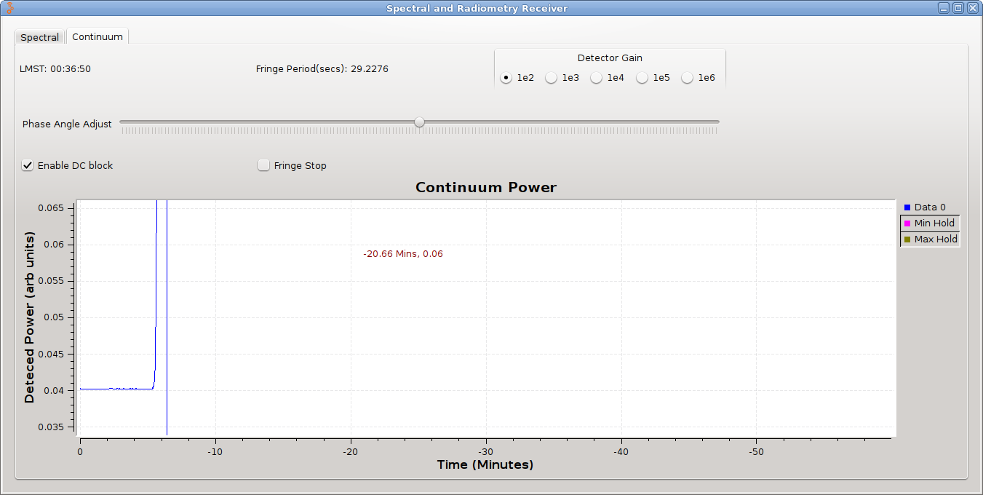
This panel shows the Continuum Total Power, Differential Power, or Correlation depending on the operating mode of the software. For simplicity, only the Cos component of the complex correlation (interferometer mode) is displayed, but both Cos and Sin components are actually logged.
The Enable DC Block control applies only to interferometer mode and applies a high-pass (DC block) component to the correlation calculations. Since useful observations will have a decidedly-non-zero fringe rate, this helps to filter out long-term DC offset drift.
The Phase Angle Adjust control is used to adjust the relative phase angle between the two channels, and again is only applied in interferometer mode.
The Fringe Stop control is used to apply a fringe-stopping rotation to the relative phase-angle between the two channels in interferometer mode. It must have correct inputs for baseline-length, frequency, declination and target RA, and local latitude and longitude in order to operate correctly.
The DC Gain control is used to apply a simple numerical multiplier to the values displayed and logged in the data files for the various continuum data products: total-power for A and B, Differential, and the complex correlations.
The display is again a Qt plot display, and the same controls as in the spectral display can be used—middle mouse button pops up a control panel menu, etc.

Data Files
The application produces data files for both spectral and total-power/differential/interferometer data.
Files are written with whatever prefix was specified with the –prefix option, described earlier, and a generated name. A new file is begun at 00:00:00 UTC.
The spectral data are written into files:
YYYYMMDD-spec.csv

Each record in the file consists of a record header:
UTC(HH,MM,SS),LMST(HH,MM,SS),frequency-in-MHz,bandwidth-in-Hz,declination,
Followed by a large number (FFT size) of comma-separated values in dB.
These records are produced every 20 seconds.
The total-power/differential/interferometer records are produced in a file:
YYYYMMDD-tp.csv

Each record in the file consists of a record header:
UTC(HH,MM,SS),LMST(HH,MM,SS),frequency-in-MHz,bandwidth-in-Hz,declination,
Followed by various items of data:
tpa,tpb,diff,corr_cos,corr_sin

Where tpa,tpb is the total power calculated for the first and second channels, diff is the difference of these channels (a-b). When in single-receiver mode, the tpb channel will always be 0, and therefore the diff channel will be the same as the tpa channel. The corr_cos and corr_sin are the cosine and sine components of the complex correlation of the two channels—these will only be meaningful when in interferometer mode.
These records are produced every 2 seconds.

See: https://github.com/Radio-Source/SpectroRadiometer

