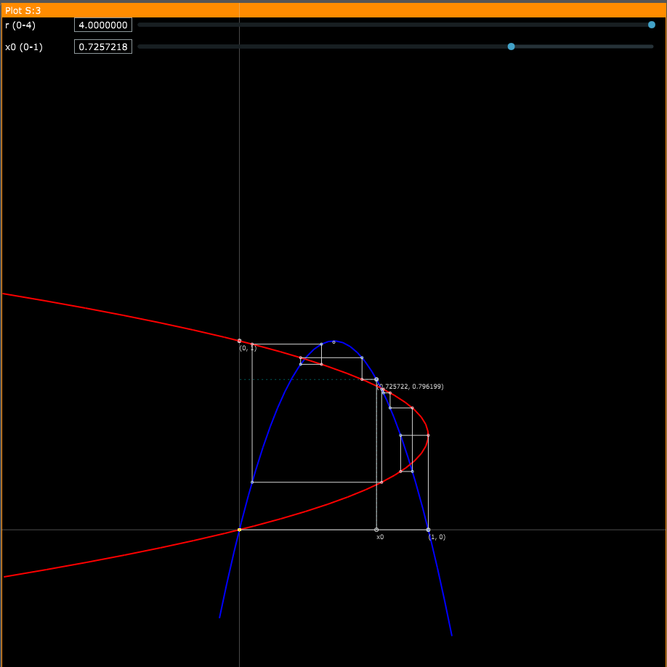

The Feigenbaum Constant (4.669) - Numberphile
https://www.youtube.com/watch?v=ETrYE4MdoLQ&ab_channel=Numberphile
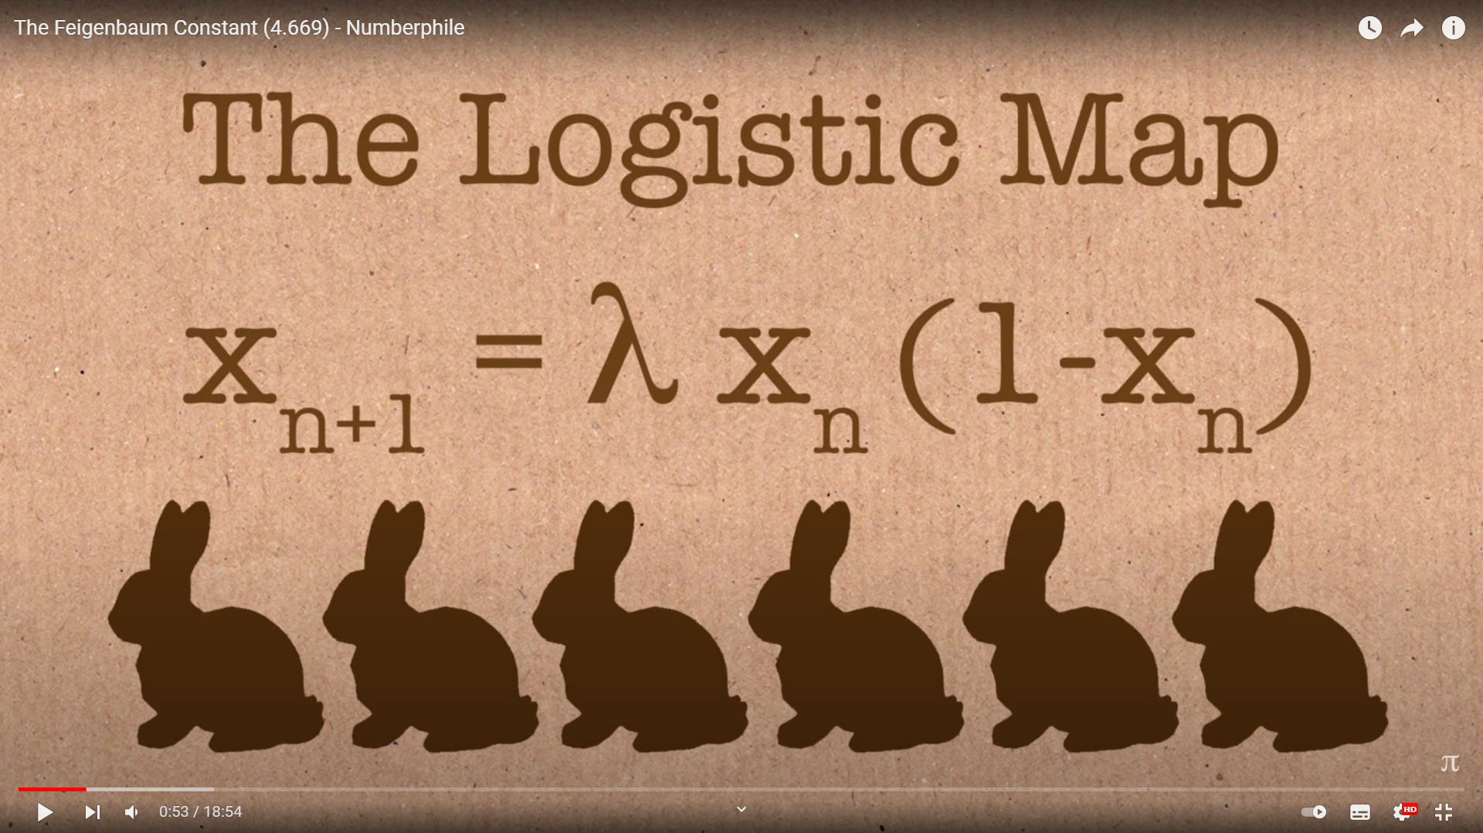

This equation will change how you see the world (the logistic map)
https://www.youtube.com/watch?v=ovJcsL7vyrk&t=96s&ab_channel=Veritasium
