**Keywords**

1. Bi-phase Manchester encoder
   1. Developed in Manchester University, 1949, the Manchester encoding is a data encoding scheme for binary data. The encoding scheme looks at the transitions instead of the value of the signal

A 1 is a transition from 1 to 0 (1-> 0)

A 0 is a transition from 0 to 1 (0 -> 1)

Very important!

Bi-phase Manchester encoding runs just as fast as the clock

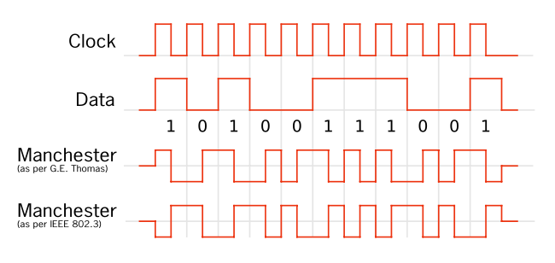

Fig. 1: Different conventions of the Manchester encoding

* 1. You might say that this is very similar to BPSK… Well apparently it is just a different form of BPSK, only difference, the carrier signal is a square wave

1. Coherent phase detection
2. Phase locked loop
   1. System that will output a signal whose phase is related to the phase of the input signal. The PLL contains an oscillator and compares the phase of the input signal to the phase of the oscillator
3. Automatic gain control
4. Automatic frequency control
5. Upper and lower sidebands
6. Q of a filter
7. Phase detectors
8. NRZI (Non Return to Zero Inverted)
   1. This encoding scheme is not very complicated it states:

A zero (0) is represented by no transition

A one (1) is represented by some transition

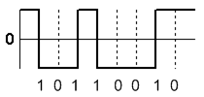

NRZI

1. AX.25
2. BPSK
   1. Although we all know it, let’s try to get a formal definition for BPSK

First let’s look at PSK, Phase Shift Keying

Let’s we have a message, call it $m\left(t\right)$, and we have a carrier signal $c\left(t\right)=A_{c}sin\left(ω_{c}t+φ\right)$, well the process of phase modulation will be the following:

$$A_{c}sin\left(ω_{c}t+φ+m\left(t\right)\right)$$

Back to BPSK, in BPSK, the modulated signal will have two phases separated by 180 degrees as illustrated below

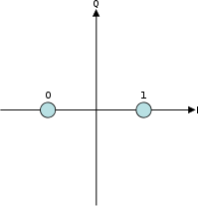

BPSK: In the figure, a phase of 0 radians is equivalent to a logical one while $π radians$ is equal to a 0