Z13
RESEARCH SUMMARY
Reconstruction of the research path, experimental instrument, and current validation status
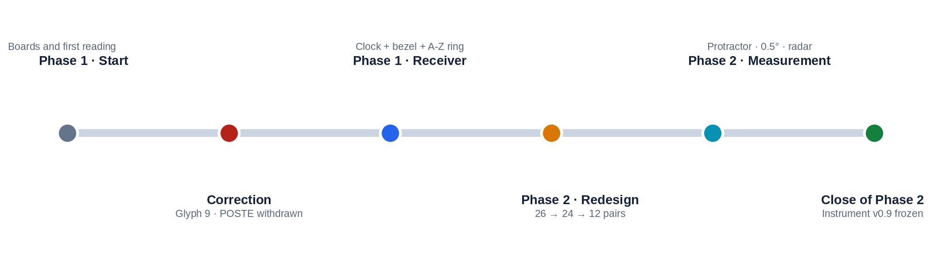
Research and direction: the author
Contact: radiozodiac13@gmail.com
ESSENTIAL STATEMENT
This report does not claim a solution to Z13. It presents a research path, several reproducible observations, and three simulators so that others can measure them, criticize them, and try to break them.

01 | SCOPE AND TERMINOLOGY
This document summarizes the full Phase 1 and Phase 2 records. It preserves the advances, corrections, limitations, and rejected paths needed to evaluate and reproduce the method.
REQUIRED TERMINOLOGICAL DISTINCTION
“The author” refers exclusively to the person who developed and directed this research. “The sender of Z13” or “the person who physically authored Z13” refers to whoever composed or sent the cryptogram. It is not assumed that this person is necessarily the same person behind all crimes attributed to Zodiac.

Label | Use in this report
DOCUMENTED | Historical fact or status fixed by the preserved working materials.
OBSERVED | A visible or measurable relationship in a specific configuration.
DERIVED | A mathematical result obtained from an explicit rule.
HYPOTHESIS | An open interpretation that still allows alternatives.
WITHDRAWN | A path retained for traceability, but not valid as a current result.
The names Arthur Leigh Allen and Gary Francis Poste are retained solely because they were public comparison targets during the research. Their presence does not amount to an identification or an accusation.
RESEARCH CRITERION
The instrument and the history of how it was built are presented here, not as a certainty. The value of the package depends on whether its rules can be reproduced without knowing in advance the name one hopes to find.

02 | PROCESS MAP
The development was deliberate but not linear: each new observation forced a return to earlier decisions.

Stage | Main question | Result
Phase 1 · start | Can Z13 be read as a two-dimensional structure? | POSTE appears in a flawed representation.
Phase 1 · correction | Is symbol 9 copied correctly? | No: POSTE is withdrawn and the model is restarted.
Phase 1 · mechanism | What if Z13 indicates what to do, not only what to read? | A circular receiver is built: ring, clock, bezel, and hands.
Phase 2 · structure | How can incompatibilities between 26 letters and clock scales be reduced? | The 24-letter / 12-pair branch is opened.
Phase 2 · measurement | Can the instrument express angular positions? | 0°–360° protractor, 0.5° resolution, and radar analogy.
Close of Phase 2 | Which architecture should be frozen so that others can test it? | v0.9: clock, bezel, protractor, and simultaneous 24L/26L rings.
READING THE PROCESS
Discarded branches are not erased. They make it possible to distinguish a seductive coincidence from a genuine correction and show which decisions preceded each candidate.

03 | PHASE 1: POSTE AND THE CORRECTION OF SYMBOL 9
The first attractive result was also the first demonstration that graphic fidelity had to take precedence over the result.
The first version used a 5×5 grid and a derived reproduction of Z13. In that image, position 9 appeared to be a black circle. That element supported the POSTE reading.
DECISIVE CORRECTION
When comparing reproductions, the author required a return to the original image. Position 9 was not a black O: it repeated the same circular glyph found at positions 5 and 7. The element supporting POSTE disappeared, and the reading was withdrawn.

Before | Evidence requiring review | After
Symbol 9 treated as O | Three occurrences of the same glyph at 5, 7, and 9 | O ceases to exist as a literal letter.
POSTE as provisional output | Material dependence on an incorrect image | POSTE is invalidated in Phase 1.
Continue refining the grid | The graphic basis is unreliable | The mechanism is restarted from a corrected reproduction.
The methodological value of this episode was not obtaining a word, but stopping a promising explanation when its visual support disappeared.
Other Phase 1 branches were also recorded without being elevated to rules: a Fibonacci exploration - proposed and later discarded by the author - structural AEN/NAM readings, R–K / R–M / R–S10 tests, and the parallel hypothesis that the Zodiac identity may have been shared by more than one person.
STATUS
POSTE in Phase 1: WITHDRAWN. Its later reappearance as G.F.R.POSTE comes from a different architecture and must be evaluated separately.

04 | PHASE 1: BUILDING THE CIRCULAR RECEIVER
The question changed from “what letters does it produce?” to “what kind of instrument could organize the operations?”
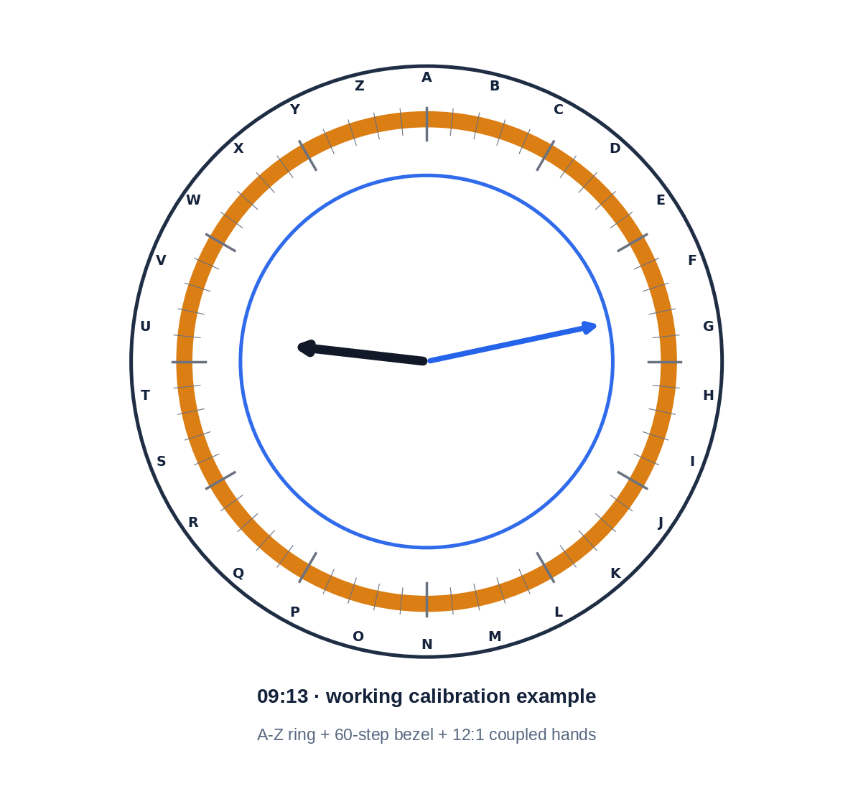
Component | Working function | Status at the close of Phase 1
A–Z ring | Distributes 26 letters and rotates independently. | Operational; origin not fixed by Z13.
Bezel | Provides 60 positions of 6° and a movable zero. | Operational.
Hands | Convert one position into two directions coupled at 12:1. | Operational.
09:13 | 9 is associated with Sagittarius and 13 with the number of symbols in Z13. | Later hypothesis; not prescribed by the code.
PHASE 1 OPERATIONAL CONCLUSION
The “radio” had been built: an architecture capable of rotating, measuring, and relating positions. The frequency was still missing - that is, an internal rule that would produce an output without retrospective assistance.

Arthur Leigh Allen was the dominant test target at the close of Phase 1. The 09:13 and AEN/ALLEN associations, along with other tests, were identified after that candidate had been selected; they are therefore not treated as independent validation.

05 | PHASE 2: FROM 26 LETTERS TO 24 AND 12 PAIRS
Phase 2 attempted to reduce degrees of freedom and make the letters compatible with real clock scales.
Layer | Rule | Measure
Center | M remains as position 13. | Central reference, not a peripheral letter.
Reference | Z / Zodiac is separated as an external mark. | It must be justified from the source material.
24L ring | A–L and N–Y; A at position 1 on the 24-hour clock. | 360°/24 = 15° per letter.
12-pair ring | A/N, B/O, …, L/Y. | 360°/12 = 30° per pair.
26L ring | Full A–Z; A at 0°. | 360°/26 = 13.8461538° per letter.
Common control | The bezel and rings can rotate in 6° control steps. | The rotation step is not the spacing between letters.
REQUIRED PRECISION
On the 24L ring, the letters are spaced 15° apart, but the ring is controlled in 6° steps. On the 26L ring, the letters are spaced 13.8461538° apart, but it too is controlled in 6° steps. Confusing letter spacing with control step would produce a false mathematical description.

The 26 → 24 → 12-pair transition resolves a geometric incompatibility within the model. It has not yet been demonstrated that Z13 itself instructs the exclusion of M and Z from the perimeter, so the final version retains the 24L and 26L rings simultaneously.
CLOSING DECISION
No single variant is forced. v0.9 freezes both so that the comparison remains visible, measurable, and reproducible.

06 | INDEPENDENT REAPPEARANCE OF G.F.R.POSTE
The reading returns in Phase 2 through a route independent of the erroneous O from Phase 1.
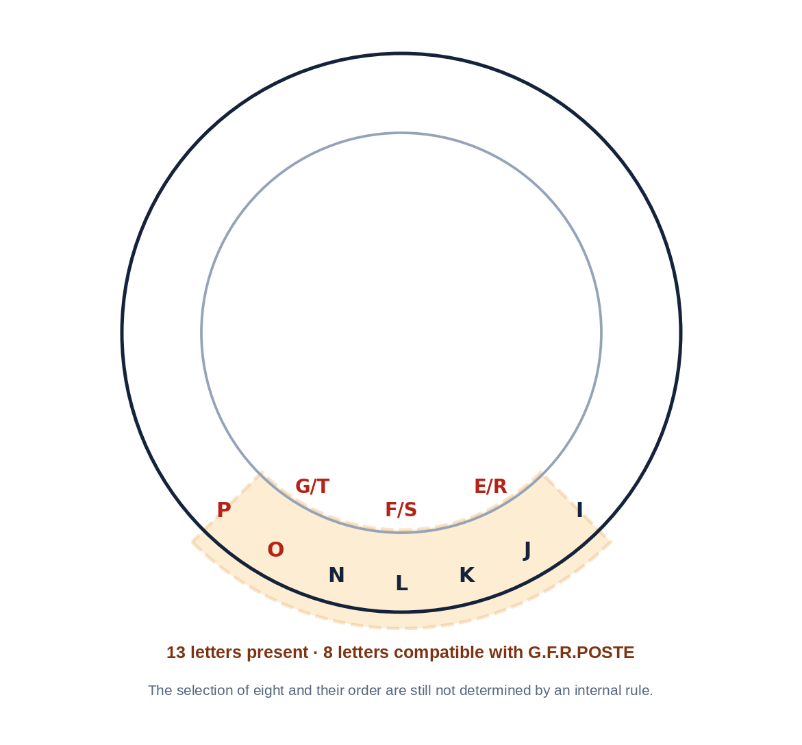
In the intermediate instrument’s base position, a 90° sector contains seven outer letters - I, J, K, L, N, O, P - and three inner pairs - E/R, F/S, G/T. Counted individually, they make thirteen letters.
Within those thirteen appear exactly G, F, R, P, O, S, T, and E, which can form G.F.R.POSTE. The observation is of interest because Allen was the dominant candidate in the previous stage and because this reappearance does not depend on the misrepresented symbol at position 9.
CENTRAL LIMITATION
The architecture still does not contain a demonstrated rule that selects eight letters from the thirteen or imposes the order G.F.R.POSTE. The name is therefore a historical candidate reading, not a decoded output.

A candidate G → P relationship was also recorded when operating a specific configuration. It must be reproduced from reset using a fixed starting rule before it can acquire evidential value.

07 | FINAL INSTRUMENT V0.9 AND VERIFIABLE MATHEMATICS
The architecture is frozen to separate mechanical operation from any cryptographic interpretation.
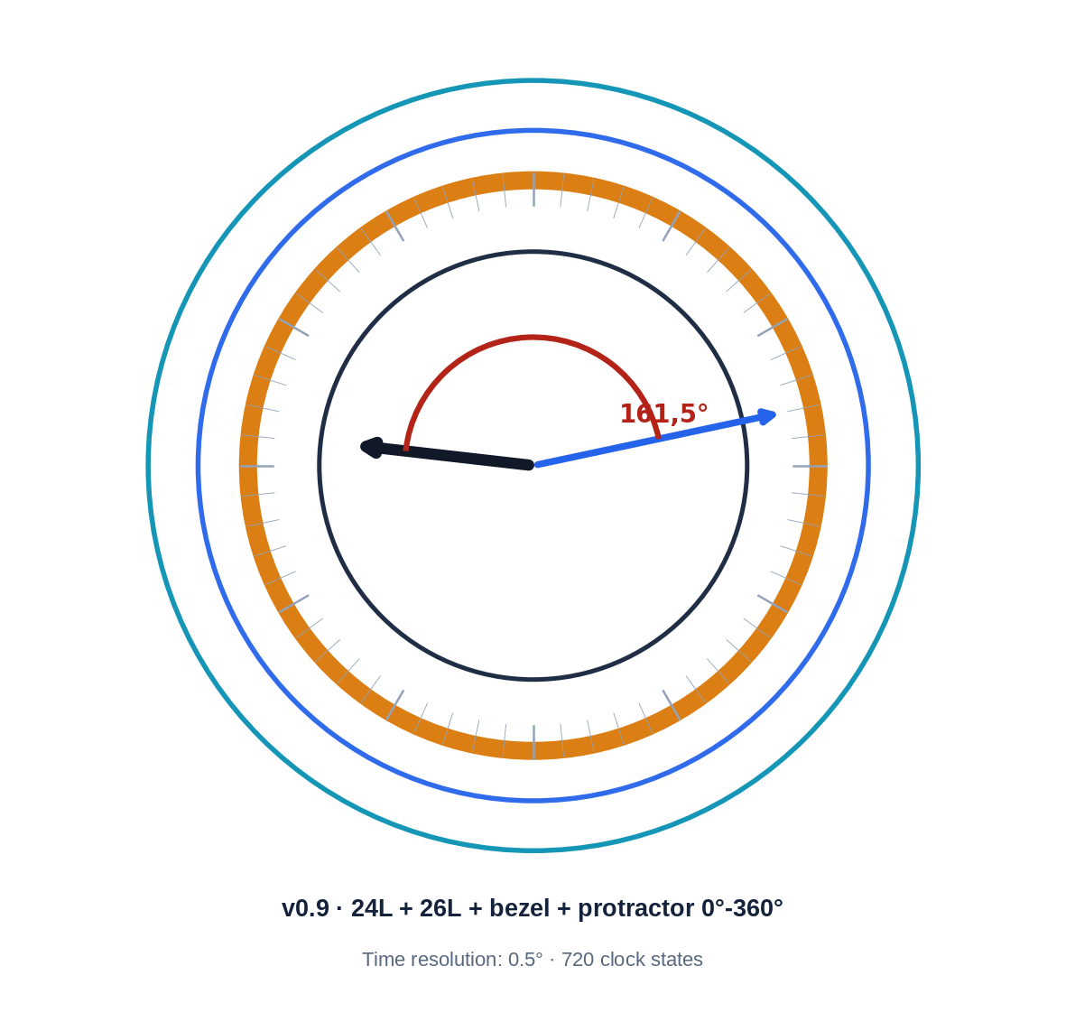
Quantity | Calculation | Result
Hour hand at 09:13 | 9×30° + 13×0.5° | 276.5°
Minute hand at 09:13 | 13×6° | 78°
Direct difference | |276.5° − 78°| | 198.5°
Smaller angle | 360° − 198.5° | 161.5°
0.5° grid | 276.5/0.5 · 78/0.5 · 161.5/0.5 | 553 · 156 · 323
Time states | 12 h × 60 min | 720
Raw control states | 720 × 60 × 60 × 60 | 155,520,000
WHAT 0.5° MEANS
It is the angular resolution of the hour hand for each elapsed minute. It is a reproducible mechanical property of the clock and a precise function within this tool; it is not presented as a universal priority in horology or as evidence of decoding.

The 155,520,000 states are raw combinations of the four controls - time, bezel, 26L ring, and 24L ring - not 155,520,000 distinct cryptographic solutions.

08 | HALLOWEEN CARD, 13-HOLE POSTCARD, AND RADAR READING
The actual chronology of the ideas must be preserved because it prevents attributing influence to an element that it did not have.
Actual research sequence | Classification
1. The author consciously analyzes dots and glyphs on the Halloween Card. | Origin of the graphic line of inquiry.
2. The dots suggest zodiacal positions or coordinates. | Positional hypothesis.
3. That need leads to the addition of the protractor. | Instrument design decision.
4. Angular reading leads to the radar analogy. | Later interpretation.
5. The complete 13-Hole Postcard is consciously examined after the technical close of v1.8. | Later comparison; not the origin.
DOCUMENTARY CORRECTION
A preliminary version incorrectly attributed the decision to add the protractor and radar to the 13-Hole Postcard. That causal sequence was corrected: the conscious origin was the Halloween Card; the 13-Hole was incorporated later as comparison material.

The resemblance to a PPI radar display is functional: a common center, 0°–360° azimuth, vectors, concentric rings, and sweep. But a complete radar point requires at least azimuth and radial distance. The current tool measures directions and angles; it does not yet define a rule for distance, contact, or sweep.
DUAL-READING HYPOTHESIS
The clock could generate time states and a second radar-like layer could interpret them spatially. This remains an open hypothesis until there is a single, reproducible rule derived from the source material.

09 | THE THREE SIMULATORS
They are not three competing tools: they document three different moments in the same research path.
No. | File | Function | Status
1 | Radio_Z13_Simulator_1_Circular_Receiver.html | Reproduces the first receiver with an A–Z ring, bezel, and 12:1 coupled hands; retains 09:13 as a historical hypothesis. | Historical · Phase 1
2 | Radio_Z13_Simulator_2_GFRPOSTE_Sector.html | Shows the thirteen-letter sector and highlights the subset compatible with G.F.R.POSTE; explicitly states that the selection rule remains unresolved. | Historical · Phase 2
3 | Radio_Z13_Simulator_3_Instrument_v0_9.html | Frozen tool with clock, bezel, 0°–360° protractor, and 24L/26L rings. | Current · v0.9
WHY ALL THREE ARE INCLUDED
The first shows the birth of the receiver; the second documents the reappearance of G.F.R.POSTE without concealing the missing rule; the third provides the most complete instrument for new tests.

Each simulator preserves the documented configuration of its corresponding research stage. Each included file has its own SHA-256 hash.
All permit private and public use, study, modification, and redistribution. Derived versions and published results must credit the author of the Z13 project and identify the simulator used.
ATTRIBUTION AND COLLABORATION CONTACT
radiozodiac13@gmail.com

10 | WHAT IS STILL NEEDED TO VALIDATE OR REFUTE THE MODEL
The tool has been built; the reading rule has not.
Test | Success criterion | Failure criterion
Origin and orientation | Z13 or associated communications fix a zero without choosing it afterward. | The position depends on the candidate being sought.
Sector selection | A single rule defines the 13-letter sector from reset. | The sector is chosen because it contains useful letters.
8/13 selection | The rule selects exactly eight letters. | The selection is made manually.
Reading order | The procedure produces an unambiguous order. | The letters are rearranged to form a name.
Null controls | The result outperforms false sequences and control names. | Comparable results appear easily.
Blind reproduction | Third parties obtain the same result from fixed instructions. | They need to know the candidate in advance.
Radar layer | Azimuth, radius, and a contact rule are defined. | Only visual resemblance exists.
EXPERTISE NEEDED
Cryptanalysis, computational geometry, statistics, documentary history of the communications, radar/navigation systems, and blind-test design. The aim is not for a specialist to confirm the hypothesis, but to identify the exact point where it works or breaks.

Future collaboration should preserve a prior record of parameters, expected results, and rejection criteria. Without that control, the instrument’s combinatorial range can produce attractive coincidences by chance.

11 | CONCLUSION
The result of the two phases is a research instrument, not a demonstrated name.
BEFORE LOOKING FOR THE FREQUENCY,
THE RADIO HAD TO BE BUILT.
Phase 1 built the circular receiver. Phase 2 expanded its measuring capability, retained incompatible variants for comparison, and froze a tool with four controls: time, bezel, 24L ring, and 26L ring.
The radio has been built in the author’s way and is now open to independent validation. The “station” being sought should not necessarily be framed as the killer: it may be the identity deliberately transmitted by the sender of Z13, whether or not that identity corresponds to the same person behind all the events.
FINAL STATUS
Phase 1 closed without a solution. Phase 2 closed with the v0.9 instrument frozen. G.F.R.POSTE remains a historical candidate reading. The clock–radar relationship and the Z13 + Halloween Card + 13-Hole Postcard set remain open lines of research.

Agreement is not requested. Testing is: measure, reproduce, compare, and explain precisely where each rule fails. If something survives, the work continues. If something breaks, it is recorded and the work continues anyway.
USE AND CONTACT
Private and public use, study, modification, and redistribution are permitted with attribution to the author of the Z13 project. Contact for clarification or collaboration: radiozodiac13@gmail.com

END OF RESEARCH SUMMARY · RESEARCH CONTINUES

