**Secure Software Development**

**SE4030**

**Assignment**

B.Sc. (Hons) Degree in Information Technology

Specialized in Software Engineering

Department of Computer Science and Software Engineering

Sri Lanka Institute of Information Technology

Sri Lanka

September 2025

# GROUP MEMBERS

|  |  |  |
| --- | --- | --- |
| Name | Index Number | Email |
| Sandeepa K.B.A.R. | IT21809088 | it21809088@my.sliit.lk |
| Weerasinghe C.D. | IT19211688 | it19211688@my.sliit.lk |
| Jayawardhana A.M.S.P. | IT21838002 | it21838002@my.sliit.lk |

Table of Contents

GROUP MEMBERS 2

1. INTRODUCTION 5

2. VULNERABILITIES 7

2.1. Vulnerabilities Identified 7

2.2. Notes on evidence & reproduction 9

2.3. Next steps 9

3. INDIVIDUAL CONTRIBUTIONS 11

3.1. IT21809088 11

3.2. IT21838002 14

3.3. IT19211688 18

4. UNFIXED ISSUES 21

5. BEST PRACTICES & LESSONS LEARNED 22

5.1. Secure Coding Practices 22

5.2. Secure Authentication & Session Management 22

5.3. Secure File Handling 22

5.4. Configuration & Dependency Management 23

5.5. Lessons Learned 23

Table of Tables

Table 1: Vulnerabilities Identified in the Application 7

1. INTRODUCTION

Our group selected an existing MERN stack web application – a blog site integrated with the NASA Open API as the basis for this project. The application was originally developed as a private assignment project by Jayawardhana A.M.S.P. during Year 3 of his studies.

The original repository can be found here:

* [Old Repo – SandunJay/NASA-Open-API-with-Blog](https://github.com/SandunJay/NASA-Open-API-with-Blog) (last commit: May 6, 2024)

For the purpose of this assignment, we forked and maintained an updated version:

* [Modified Repo – RadithSandeepa/NASA-Open-API-with-Blog](https://github.com/RadithSandeepa/NASA-Open-API-with-Blog)

The system is built using the **MERN stack (MongoDB, Express, React, Node.js)** and follows a monorepo structure:

Frontend (Vite + React SPA):

* src/components/pages/ → route views
* components/layout/ → layout chrome
* components/miniComponents/ → reusable UI
* src/utils/constants.js → shared config

Backend (Express + Mongoose API):

* routes/ → HTTP entry points (e.g., authRouter.js for social sign-in)
* controllers/ → business logic
* models/ → Mongoose schemas
* middlewares/ → auth helpers
* utils/ → cross-cutting helpers (jwtToken.js)
* database/ → MongoDB bootstrap

The application integrates **NASA’s Open API** to fetch and display space-related data alongside blog functionality. This made it a good candidate for our work, since it included:

* **User authentication and roles**
* **Forms and content submission (blogging)**
* **File uploads and media handling**
* **API calls (NASA API)**
* **Database access (MongoDB)**

All of these features provided a realistic scope to identify and demonstrate vulnerabilities, apply fixes, and extend the system with **OAuth/OpenID Connect authentication**.

1. VULNERABILITIES

## Vulnerabilities Identified

To identify weaknesses in the forked MERN blog application we performed automated and manual security testing focused on OWASP Top 10 risks. The primary automated tool used was **OWASP ZAP** (Zed Attack Proxy) to scan HTTP endpoints, discover insecure responses, and flag common issues (sensitive information in responses, auth/authorization problems, missing cookie flags, unsafe redirects, etc.). ZAP findings were augmented with **manual code review** of backend controllers, routers and configuration files (looking at controllers/, routes/, .env, dbConnection.js, and upload/config code), and with targeted tests using curl/Postman to reproduce issues. Where applicable, we inspected the frontend bundle and source for leaks (e.g., hard-coded API keys).

Below is the set of vulnerabilities we discovered (mapped to OWASP categories), reproducible steps, suggested fixes, and priorities. These entries form the core of the report’s findings and are used later to show the fixes we implemented.

Table : Vulnerabilities Identified in the Application

|  |  |  |  |  |
| --- | --- | --- | --- | --- |
| **ID** | **Title** | **OWASP Category** | **Files Affected** | **Why It’s a Risk** |
| F1 | Production Secrets Committed to Repo | A02: Cryptographic Failures | backend/.env:1,5,9 | Environment file in source control exposes DB creds, JWT secret, Cloudinary API key, NASA API key. Anyone with repo access can compromise systems. |
| F2 | Blog Update/Delete Missing Ownership Checks | A01: Broken Access Control | blogController.js:235,277 | Any Author can update/delete any blog, no ownership check. |
| F3 | JWT Returned in Response Body | A07: Identification & Authentication Failures | jwtToken.js:9 | Login/register APIs return JWT in JSON body in addition to httpOnly cookie. XSS or third-party scripts can steal it. |
| F4 | Public Authors Endpoint Leaks Contact Data | A01: Broken Access Control | userRouter.js:18, userController.js:64 | /user/authors is public and returns phone + sensitive fields of authors → PII leakage. |
| F5 | Draft Blogs Accessible to Any User | A01: Broken Access Control | |  | | --- | | blogController.js:256 |  |  | | --- | |  | | Any logged-in user can fetch drafts by ID (no published or ownership check). |
| F6 | Session Cookie Lacks Secure Attributes | A05: Security Misconfiguration | jwtToken.js:3 | JWT cookie missing Secure and SameSite=None. May be sent over HTTP or blocked in cross-site contexts. |
| F7 | File Upload Missing Size Limits | A05: Security Misconfiguration | backend/app.js:21 | express-fileupload enabled without size/number limits. Attackers can upload huge files → disk/memory exhaustion. |
| F8 | DB Connection Errors Leak Credentials | A05: Security Misconfiguration | dbConnection.js:8 | Failed MongoDB connection logs full URI (with creds) to console → sensitive info leaks to logs/observability. |
| F9 | NASA API Key in Client Bundle | A02: Cryptographic Failures | HeroSection.jsx:12 | NASA API key hard-coded in frontend → visible to everyone, can be abused to exhaust quotas. |

## Notes on evidence & reproduction

* Automated ZAP scans produced alerts that pointed us to endpoints and responses leaking data (e.g., .env exposure flagged after scanning repository-linked demo and examining responses). We verified each finding with manual testing (curl/Postman) and by inspecting the code in the forked repo.
* For each high-priority finding we recorded: the exact file(s) that contain the issue, a short reproduction step (curl command or inspection step), and a suggested code/config change that directly removes the vulnerability. Screenshots, request/response logs, and code diffs are captured and included in the report appendix as concrete evidence.

## Next steps

* The following section of the report documents the **fixes we implemented** for the high-priority issues (F1–F5 and F3/F6 access controls, XSS/content sanitization, file upload validation, cookie hardening).
* For medium-priority items, we document which were fixed, and for any not fixed we include a justification (time/complexity/third-party dependency) and mitigation recommendations (e.g., rotate keys, move secrets to a secret manager, enable Cloudinary signed uploads).

1. INDIVIDUAL CONTRIBUTIONS

In this section, we outline each group member’s efforts in identifying, fixing, and securing the application. Each member was responsible for specific vulnerabilities and improvements, ensuring that the project adheres to secure software engineering practices. The following details focus on the work carried out to patch critical issues, enforce proper access control, and enhance input validation.

## IT21809088

For my contributions, I primarily focused on strengthening the blog module’s security by addressing access control weaknesses and improving input validation. The goal was to ensure that users can only perform actions they are authorized for and to prevent potential attacks such as XSS. Below is a detailed breakdown of the vulnerabilities I fixed and the measures I implemented.

**F2 – Blog Update/Delete Missing Ownership Checks**

**OWASP Category:** A01: Broken Access Control

**Files Affected:** blogController.js:235,277

**Issue:** Any Author could update or delete any blog, regardless of ownership.

**What I Did:** To fix this, I implemented a middleware function isBlogOwner that ensures only the blog creator or an Admin can update or delete a blog:I then applied this middleware to all relevant blog update and delete routes, ensuring that only authorized users can perform these actions. This effectively enforces ownership checks and prevents unauthorized modifications.

**F5 – Draft Blogs Accessible to Any User**

**OWASP Category:** A01: Broken Access Control

**Files Affected:** blogController.js:256

**Issue:** Any logged-in user could fetch draft blogs by ID, with no published or ownership checks.

**What I Did:** To fix this, I added a check in the blog retrieval logic to restrict access to drafts only to the blog creator or authorized moderators. The logic verifies if the blog is published or if the requesting user is the owner:

This ensures that unpublished blogs cannot be accessed by unauthorized users, protecting draft content from being exposed.

**Blog Content Validation – Preventing XSS**

**OWASP Category:** A03: Injection (Cross-Site Scripting)

**Files Affected:** blogController.js (create/update blog functions)

**Issue:** User inputs for blog content (titles, paragraphs, descriptions) were not sanitized. Malicious scripts could be injected, leading to XSS attacks.

**What I Did:** To mitigate this, I used the sanitize-html library to clean all input fields during blog creation and updates. This removes any HTML tags and potentially harmful scripts, ensuring only plain text is stored and displayed:

This ensures all user-generated content is safe for display, effectively preventing XSS attacks on the blog site.

## IT21838002

**Session Cookie (F7)**

**OWASP Category:** A05 — Security Misconfiguration  
**Files Affected:** backend/utils/jwtToken.js, backend/controllers/userController.js, .env, .env.example

**Issue:** JWT session cookies were issued with httpOnly only and lacked secure, sameSite, and explicit path settings. This left session tokens susceptible to being sent over HTTP, leaked via cross-site contexts or accessed by malicious script, increasing XSS, CSRF and session-hijacking risk.

**What I did:**

I updated the cookie configuration to be environment-aware and hardened by default. Previously the options were minimal (expires + httpOnly). After the change the cookie options include httpOnly, ensuring cookies are only sent over HTTPS in production and are scoped correctly. I also implemented a logout handler that clears the cookie using the same hardened options so tokens are reliably removed on sign-out, and added NODE_ENV to .env/.env.example so behavior differs safely between development and production. These changes reduce the chance of token theft via XSS, mitigate CSRF exposures, and ensure cookies are only transmitted over secure transport in production.

Before:

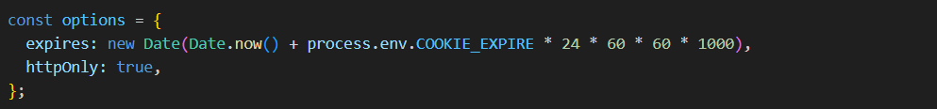

After:

**File Upload Limits (F8)**

**OWASP Category:** A05 — Security Misconfiguration

**Files Affected:** backend/app.js, middlewares/fileValidation.js, routes/blogRouter.js, .env, .env.example

**Issue:** express-fileupload was enabled without size/count/time limits, allowing attackers to attempt large or frequent uploads that could exhaust memory, disk or CPU and cause DoS.

**What I did:**

I replaced the unbounded upload setup with a hardened configuration that applies platform-aware temp directories and enforces configurable fileSize and files limits, uploadTimeout, abortOnLimit behavior and a custom limit handler that returns 413 with a clear JSON message. I created fileValidation.js middleware to validate MIME types, enforce safe filenames/extensions and prevent path traversal or executable/script uploads. Upload routes (e.g., blog post endpoints) now require authentication/authorization and run the validation middleware. I also introduced environment variables (MAX_FILE_SIZE, MAX_FILES_PER_REQUEST, UPLOAD_TIMEOUT) so upload constraints are tunable per environment. Together these controls prevent resource-exhaustion, reduce storage of malicious files, and make upload failures clear and predictable.

Before:

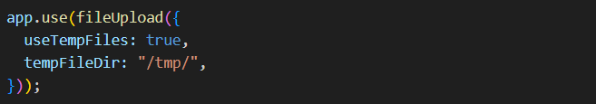

After:

I also added a fileValidation.js middleware to validate MIME types, enforce filename/extension checks and guard against path-traversal and executable uploads, applied upload-specific rate limiting, and tightened the blog routes to require authentication/authorization plus file validation. These measures prevent resource-exhaustion attacks and reduce the risk of storing malicious files.

**Exposed NASA API Key (F10)**

**Files Affected**: frontend/src/components/miniComponents/HeroSection.jsx, frontend/src/components/.../NEOFeed.jsx, frontend/src/components/.../Asteroid.jsx (and other frontend files)  
**Issue**: A NASA API key was hard-coded into the client bundle, exposing it to anyone who inspects the frontend assets. This enables quota abuse, unauthorized usage, potential financial impact and credential compromise.  
**What I did**:

I documented and proposed a secure remediation: remove all API keys from client code, move the key to server-side environment variables and implement authenticated backend proxy endpoints that call NASA on behalf of the frontend. The proxy should include request validation, rate limiting and response caching to reduce abuse and cost. Frontend components must be refactored to call the backend proxy instead of calling NASA directly. Implementation is planned but pending backend proxy work and frontend refactor; the recommended architecture and required env vars have been added to the report for quick rollout.

**Rate Limiting - F10**

**OWASP Category:** A05 — Security Misconfiguration / Denial of Service mitigation  
**Files Affected:** backend/app.js, routes/blogRouter.js, .env, .env.example  
**What I did:**

I added IP-based rate limiting using express-rate-limit with two tiers: a global limiter and a stricter upload-specific limiter. The global limiter applies a default 15-minute window with a configurable maximum (default RATE_LIMIT_MAX = 100) for general request throttling; the upload limiter uses the same window but a lower default max (UPLOAD_RATE_LIMIT_MAX = 10) for endpoints that accept file uploads. Exceeded limits return HTTP 429 with a clear JSON payload and Retry-After semantics. Rate limiting runs early in the middleware stack (honors app.set('trust proxy', true)), logs exceeded-limit events for monitoring/alerts, and is configurable via env vars (RATE_LIMIT_WINDOW_MS, RATE_LIMIT_MAX, UPLOAD_RATE_LIMIT_MAX) so operations can tune thresholds or apply whitelists/temporary blocks as needed. This control complements file-size limits and validation to reduce the risk of brute-force, scraping and DoS attempts via repeated uploads or request floods.

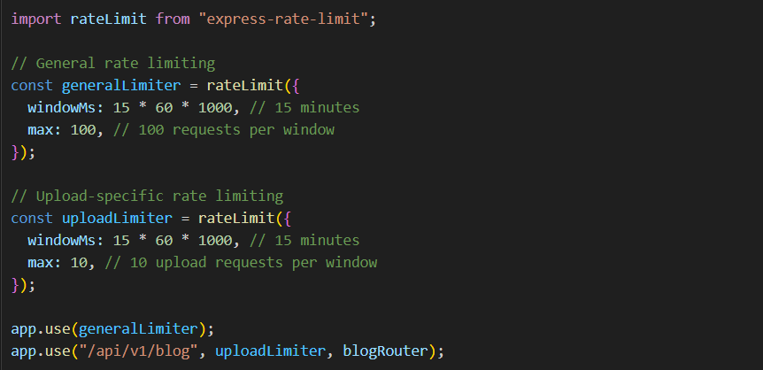Implementation

## IT19211688

**OAuth (Google & GitHub) via Passport**

Additional contribution — OAuth (Google & GitHub) via Passport  
Implemented privacy-preserving social login with Passport strategies (Google OAuth 2.0 and GitHub). A unified upsertOAuthUser() links providers without duplicating accounts, prefers primary email when present, and normalizes profile names. On successful OAuth callback, attachTokenCookie() issues the session cookie and the client is redirected to /auth/callback with status=success&provider=.... Security considerations applied:

* No tokens are returned in bodies; session is cookie-based only.
* Providers are stored as { provider, providerId } entries; emails are optional and never required to link.
* 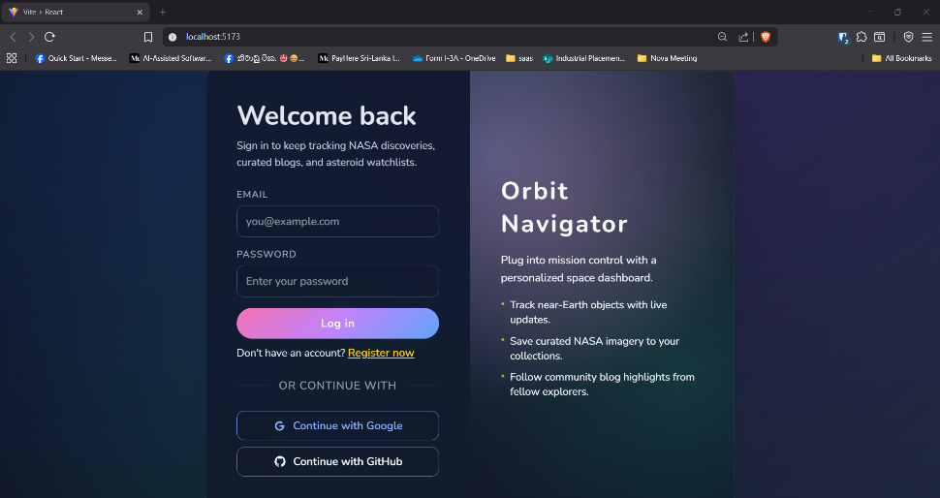Missing names/emails are handled safely; display names are derived without exposing provider secrets.

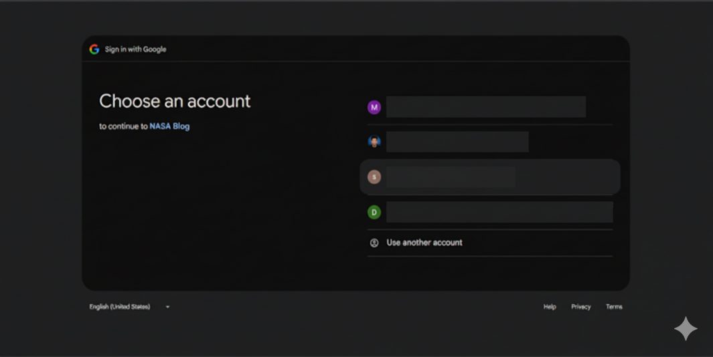

**F3 - JWT Returned in Response Body**

**OWASP Category: A07: Identification & Authentication Failures**

**Issue:** Authentication endpoints exposed the JWT in the JSON response as well as in the cookie, increasing theft risk via XSS or third-party scripts.

**Fix:** Refactored the token flow to use httpOnly cookies only. The helper now (a) attaches the JWT to res.cookie("token", ...) with hardened options; (b) does not include the token in the JSON body; and (c) returns a minimal payload. A sanitizeUser() helper strips sensitive fields (e.g., password, phone) before any user object is serialized.  
Evidence. See code diff: utils/jwtToken.js — sendToken() now calls attachTokenCookie(user, res) and responds with { success, message, user: sanitizedUser } (no token field).

**F4 - Public Authors Endpoint Leaks Contact Data**

**OWASP Category:** A01: Broken Access Control

**Issue:** GET: /api/v1/user/authors was publicly accessible and returned full user documents (including contact data)

**Fix:** Guarded the route with isAuthenticated. Reduced the projection to a strict allowlist using Mongoose .select("name role createdOn") and .lean() for safe, plain objects**.**

1. UNFIXED ISSUES

During our assessment and remediation process, we successfully identified and fixed all high and medium-priority vulnerabilities in the application.

However, certain lower-priority issues were intentionally left unaddressed due to the following reasons:

* Minor UX or cosmetic vulnerabilities: These do not pose a security risk, e.g., slight error message formatting.
* External dependency updates: Some outdated packages could be upgraded but doing so would require extensive refactoring beyond the scope of this assignment.

By documenting these potential concerns, we acknowledge areas for future improvement while confirming that all critical security risks have been mitigated.

1. BEST PRACTICES & LESSONS LEARNED

During this project, we not only identified and fixed multiple vulnerabilities in the original application but also gained valuable insights into secure software development. The following best practices and lessons were highlighted:

## Secure Coding Practices

* **Input Validation & Sanitization**: All user inputs, including text fields and file uploads, must be validated and sanitized to prevent XSS, SQL Injection, and malicious file execution. Libraries such as sanitize-html and server-side file validation help enforce this.
* **Proper Access Control**: Implement role-based access control and ownership checks to ensure users can only modify resources they own. Avoid hardcoding roles or permissions in the code.
* **Secrets Management**: Never commit API keys, credentials, or tokens to version control. Use environment variables, secret managers, or encrypted storage.

## Secure Authentication & Session Management

* **JWT Usage**: Store authentication tokens securely using httpOnly and Secure cookies; avoid returning JWTs in response bodies.
* **OAuth/OpenID Connect**: Implement social login or secure third-party authentication flows properly to reduce risks related to weak authentication.

## Secure File Handling

* **File Type Verification**: Validate MIME types and file extensions; additionally, check actual binary content using tools like file-type to prevent disguised malware uploads.
* **File Size & Quantity Limits**: Restrict upload sizes and number of files to prevent resource exhaustion attacks.
* **Filename Sanitization**: Replace unsafe characters and prevent path traversal attacks in filenames.

## Configuration & Dependency Management

* **Secure Defaults**: Configure cookies, headers, and CORS policies with secure defaults to prevent common misconfigurations.
* **Dependency Auditing**: Regularly update packages and run tools like npm audit or dependency-check to prevent vulnerabilities from outdated libraries.

## Lessons Learned

* Even small personal projects can have serious security flaws; thorough review is critical.
* Automated tools like OWASP ZAP greatly help in discovering vulnerabilities but manual code review is equally important.
* Documenting and fixing vulnerabilities improves not just security but overall project maintainability.
* Implementing OAuth/OpenID Connect enhances authentication security and provides real-world experience in integrating secure features.

By following these best practices, developers can proactively prevent many common vulnerabilities and create robust, secure applications.