**Requirement**: Associate “.qfl” (quicktest function library) and/or “.vbs” file to QTP at runtime so that this file gets associated and executed first when QTP test execution starts.

**Problem Statement:**

1. Unable to associate .qfl/.vbs to an open QTP Test at run-time.
2. Unable to create an add-in for QTP so that when we select the add-in from add-in list the files gets associated to QTP automatically to QTP’s settings in the resource tab.

**What have we done so far?**

Modified QTP’s settings file in the temp location so as to attach the .vbs/.file to tests but then this solution is only getting applied to any new test that are getting created i.e. files are getting associated to one new tests that are being created. This logic is not getting applied to old tests.

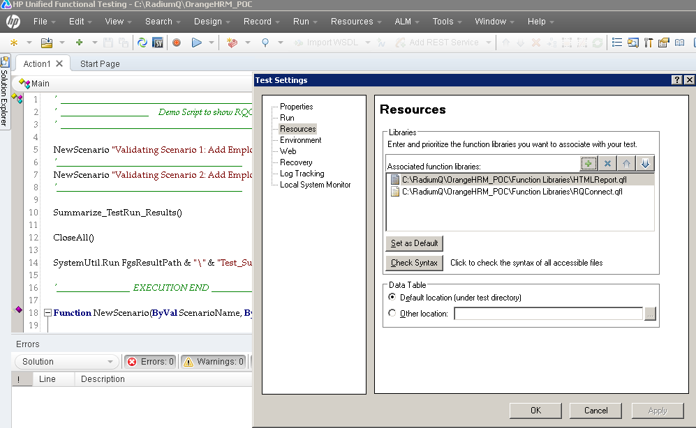

Then tried creating an ADD-IN using Extensibility Accelerator but this works only for performing operations on objects not adding new files to test settings.

Finally tried to creating a PLUG-IN for QTP on the UI and then link it to add-in i.e. only when “Reconnect” is selected from under the “Web” as shown below..an option on UFT UI to appear “Reconnect” selecting this would automatically like the 2 files to UFT test.

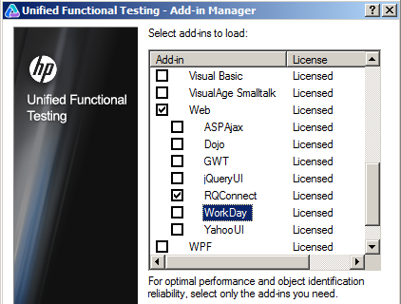

Ex: When User Selects UFT Mobile from Add-in, an option the UFT UI gets enabled “UFT Mobile”, selecting which the Perfecto Mobile page came up. I tried something in similar terms which when selected would append the .qfl/.vbs file to current QTP/UFT test but no luck.

