AlgoDat: Exercise 05

3. The greedy best first search algorithm does not factor in the cost to the next node, merely the node’s heuristic. Considering this, it would traverse the graph like this:

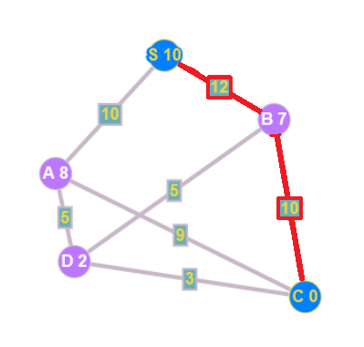

From S, the algorithm has the choice between A(8) and B(7), so it goes to B.

From B7, it has the choice between D(2) and C(0), so it goes to C.

Total path cost: 22

4. The A\* algorithm factors in BOTH the cost to the next node and the node’s heuristic, by adding up those values and choosing the lower sum. Considering this, it would travers the graph like this:

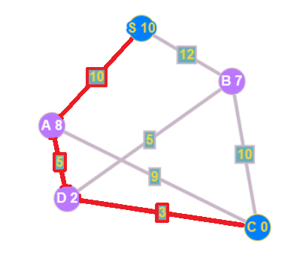

From S, the algorithm has the choice between A(8+10) and B(7+12), so it goes to A.

From A, it has the choice between C(0+9) and D(2+5), so it goes to D.

From D, it has the choice between C(0+3) and B(7+5), so it goes to C.

Total path cost: 18