Lucrarea de laborator nr. 7

Gram Radmila, IS31R
Coder, decoder, unitate de memorie permanenta

Scopul lucrării:
- Studierea elementelor combinaţionale (coder, decoder) în regim static.
- Studierea elementelor combinaţionale (coder, decoder) în regim dinamic.
- Studierea și programarea unităţii de memorie permanentă.
Experimentul nr. 1. Decoder

Tabelul 1. Tabelul de adevăr al decoderului
Nr. d/o | Intrarile |  |  |  | Iesirile
Nr. d/o | A | B | C | D | F₁₅ | F₁₄ | F₁₃ | F₁₂ | F₁₁ | F₁₀ | F₉ | F₈ | F₇ | F₆ | F₅ | F₄ | F₃ | F₂ | F₁ | F₀
0 | 0 | 0 | 0 | 0 | 0 | 0 | 0 | 0 | 0 | 0 | 0 | 0 | 0 | 0 | 0 | 0 | 0 | 0 | 0 | 1
1 | 0 | 0 | 0 | 1 | 0 | 0 | 0 | 0 | 0 | 0 | 0 | 0 | 0 | 0 | 0 | 0 | 0 | 0 | 1 | 0
2 | 0 | 0 | 1 | 0 | 0 | 0 | 0 | 0 | 0 | 0 | 0 | 0 | 0 | 0 | 0 | 0 | 0 | 1 | 0 | 0
3 | 0 | 0 | 1 | 1 | 0 | 0 | 0 | 0 | 0 | 0 | 0 | 0 | 0 | 0 | 0 | 0 | 1 | 0 | 0 | 0
4 | 0 | 1 | 0 | 0 | 0 | 0 | 0 | 0 | 0 | 0 | 0 | 0 | 0 | 0 | 0 | 1 | 0 | 0 | 0 | 0
5 | 0 | 1 | 0 | 1 | 0 | 0 | 0 | 0 | 0 | 0 | 0 | 0 | 0 | 0 | 1 | 0 | 0 | 0 | 0 | 0
6 | 0 | 1 | 1 | 0 | 0 | 0 | 0 | 0 | 0 | 0 | 0 | 0 | 0 | 1 | 0 | 0 | 0 | 0 | 0 | 0
7 | 0 | 1 | 1 | 1 | 0 | 0 | 0 | 0 | 0 | 0 | 0 | 0 | 1 | 0 | 0 | 0 | 0 | 0 | 0 | 0
8 | 1 | 0 | 0 | 0 | 0 | 0 | 0 | 0 | 0 | 0 | 0 | 1 | 0 | 0 | 0 | 0 | 0 | 0 | 0 | 0
9 | 1 | 0 | 0 | 1 | 0 | 0 | 0 | 0 | 0 | 0 | 1 | 0 | 0 | 0 | 0 | 0 | 0 | 0 | 0 | 0
10 | 1 | 0 | 1 | 0 | 0 | 0 | 0 | 0 | 0 | 1 | 0 | 0 | 0 | 0 | 0 | 0 | 0 | 0 | 0 | 0
11 | 1 | 0 | 1 | 1 | 0 | 0 | 0 | 0 | 1 | 0 | 0 | 0 | 0 | 0 | 0 | 0 | 0 | 0 | 0 | 0
12 | 1 | 1 | 0 | 0 | 0 | 0 | 0 | 1 | 0 | 0 | 0 | 0 | 0 | 0 | 0 | 0 | 0 | 0 | 0 | 0
13 | 1 | 1 | 0 | 1 | 0 | 0 | 1 | 0 | 0 | 0 | 0 | 0 | 0 | 0 | 0 | 0 | 0 | 0 | 0 | 0
14 | 1 | 1 | 1 | 0 | 0 | 1 | 0 | 0 | 0 | 0 | 0 | 0 | 0 | 0 | 0 | 0 | 0 | 0 | 0 | 0
15 | 1 | 1 | 1 | 1 | 1 | 0 | 0 | 0 | 0 | 0 | 0 | 0 | 0 | 0 | 0 | 0 | 0 | 0 | 0 | 0

Functii logice ale decoderului cu numărul de intrări M=4:

- F₀=$\overline{a}$*$\overline{b}$*$\overline{c}$*$\overline{d}$
- F₁=$\overline{a}$*$\overline{b}$*$\overline{c}$*d
- F₂=$\overline{a}$*$\overline{b}$*c*$\overline{d}$
- F₃=$\overline{a}$*$\overline{b}$*c*d
- F₄=$\overline{a}$*b*$\overline{c}$*$\overline{d}$
- F₅=$\overline{a}$*b*$\overline{c}$*d
- F₆=$\overline{a}$*b*c*$\overline{d}$
- F₇=$\overline{a}$ *b*c*d
- F₈=a*$\overline{b}$*$\overline{c}$*$\overline{d}$
- F₉=a*$\overline{b}$*$\overline{c}$*d
- F₁₀=a*$\overline{b}$*c*$\overline{d}$
- F₁₁=a*$\overline{b}$*c*d
- F₁₂=a*b*$\overline{c}$*$\overline{d}$
- F₁₃=a*b*$\overline{c}$*d
- F₁₄=a*b*c*$\overline{d}$
- F₁₅=a*b*c*d

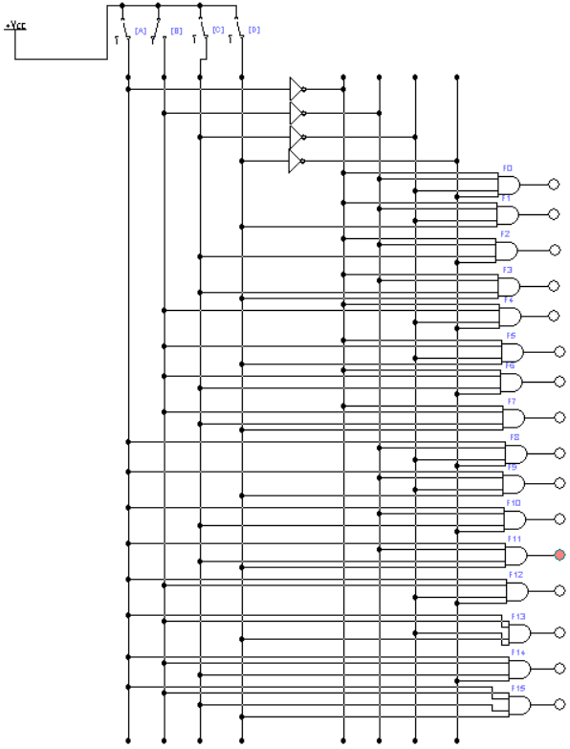
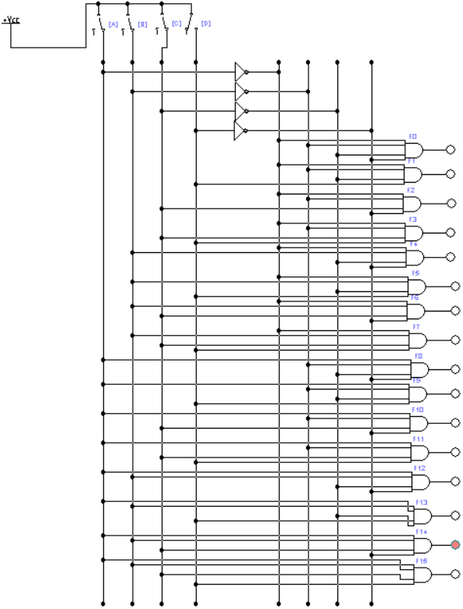
Regim static.

Fig. 1. Schema electrica a decoderului (regim static)

Regim dinamic.

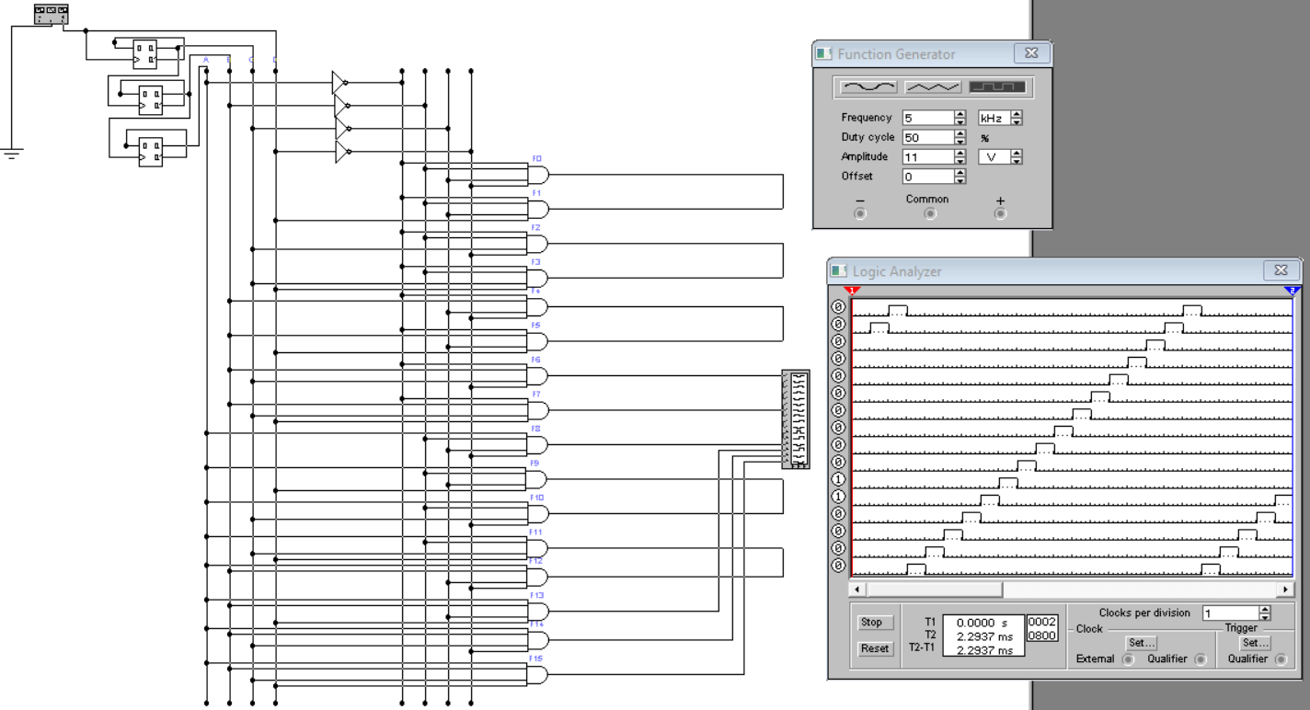
Fig. 2. Schema electrica a decoderului (regim dinamic)

Experimentul nr. 2. Coder
Tabelul 2. Stările pentru coder
Nr | Intrarile |  |  |  |  |  |  |  |  |  |  |  |  |  |  |  |  |  | Iesirile
Nr | X₁₆ | X₁₅ | X₁₄ | X₁₃ | X₁₂ | X₁₁ | X₁₀ | X₉ | X₈ | X₇ | X₆ | X₅ | X₄ | X₃ | X₂ | X₁ | X₀ | F₄ |  | F₃ | F₂ | F₁ | F₀
0. | 1 | 1 | 1 | 1 | 1 | 1 | 1 | 1 | 1 | 1 | 1 | 1 | 1 | 1 | 1 | 1 | 0 | 0 |  | 0 | 0 | 0 | 0
1. | 1 | 1 | 1 | 1 | 1 | 1 | 1 | 1 | 1 | 1 | 1 | 1 | 1 | 1 | 1 | 0 | 1 | 0 |  | 0 | 0 | 0 | 1
2. | 1 | 1 | 1 | 1 | 1 | 1 | 1 | 1 | 1 | 1 | 1 | 1 | 1 | 1 | 0 | 1 | 1 | 0 |  | 0 | 0 | 1 | 0
3. | 1 | 1 | 1 | 1 | 1 | 1 | 1 | 1 | 1 | 1 | 1 | 1 | 1 | 0 | 1 | 1 | 1 | 0 |  | 0 | 0 | 1 | 1
4. | 1 | 1 | 1 | 1 | 1 | 1 | 1 | 1 | 1 | 1 | 1 | 1 | 0 | 1 | 1 | 1 | 1 | 0 |  | 0 | 1 | 0 | 0
5. | 1 | 1 | 1 | 1 | 1 | 1 | 1 | 1 | 1 | 1 | 1 | 0 | 1 | 1 | 1 | 1 | 1 | 0 |  | 0 | 1 | 0 | 1
6. | 1 | 1 | 1 | 1 | 1 | 1 | 1 | 1 | 1 | 1 | 0 | 1 | 1 | 1 | 1 | 1 | 1 | 0 |  | 0 | 1 | 1 | 0
7. | 1 | 1 | 1 | 1 | 1 | 1 | 1 | 1 | 1 | 0 | 1 | 1 | 1 | 1 | 1 | 1 | 1 | 0 |  | 0 | 1 | 1 | 1
8. | 1 | 1 | 1 | 1 | 1 | 1 | 1 | 1 | 0 | 1 | 1 | 1 | 1 | 1 | 1 | 1 | 1 | 0 |  | 1 | 0 | 0 | 0
9. | 1 | 1 | 1 | 1 | 1 | 1 | 1 | 0 | 1 | 1 | 1 | 1 | 1 | 1 | 1 | 1 | 1 | 0 |  | 1 | 0 | 0 | 1
10 | 1 | 1 | 1 | 1 | 1 | 1 | 0 | 1 | 1 | 1 | 1 | 1 | 1 | 1 | 1 | 1 | 1 | 0 |  | 1 | 0 | 1 | 0
11. | 1 | 1 | 1 | 1 | 1 | 0 | 1 | 1 | 1 | 1 | 1 | 1 | 1 | 1 | 1 | 1 | 1 | 0 |  | 1 | 0 | 1 | 1
12. | 1 | 1 | 1 | 1 | 0 | 1 | 1 | 1 | 1 | 1 | 1 | 1 | 1 | 1 | 1 | 1 | 1 | 0 |  | 1 | 1 | 0 | 0
13. | 1 | 1 | 1 | 0 | 1 | 1 | 1 | 1 | 1 | 1 | 1 | 1 | 1 | 1 | 1 | 1 | 1 | 0 |  | 1 | 1 | 0 | 1
14. | 1 | 1 | 0 | 1 | 1 | 1 | 1 | 1 | 1 | 1 | 1 | 1 | 1 | 1 | 1 | 1 | 1 | 0 |  | 1 | 1 | 1 | 0
15. | 1 | 0 | 1 | 1 | 1 | 1 | 1 | 1 | 1 | 1 | 1 | 1 | 1 | 1 | 1 | 1 | 1 | 0 |  | 1 | 1 | 1 | 1
16. | 0 | 1 | 1 | 1 | 1 | 1 | 1 | 1 | 1 | 1 | 1 | 1 | 1 | 1 | 1 | 1 | 1 | 1 |  | 0 | 0 | 0 | 0

Functiile logice ale coderului:
F4 = $\overline{X16}$
F3 = $\overline{X15*X14*X13*X12*X11*X10*X9*X8}$
F2 = $\overline{X15*X14*X13*X12*X7*X6*X5*X4}$
F1 = $\overline{X15*X14*X11*X10*X7*X6*X3*X2}$
F0 = $\overline{X15*X13*X11*X9*X7*X5*X3*X1}$

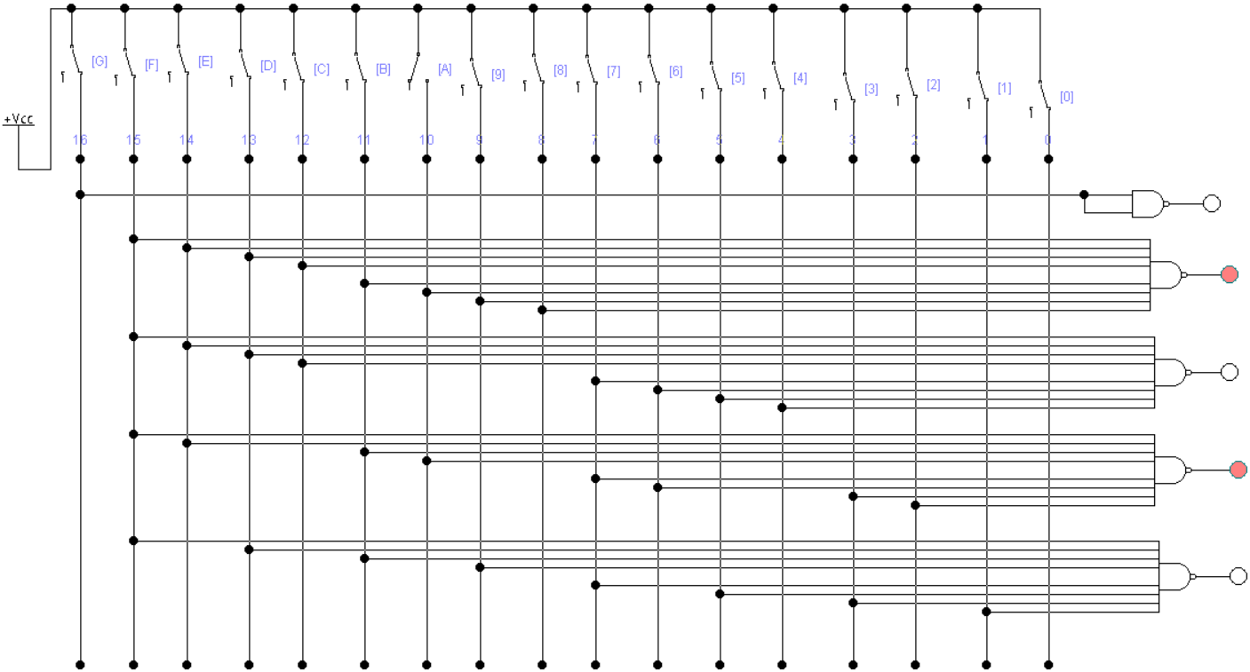
Regim static.

Fig. 3. Schema electrica a coderului (regim static)
Regim dinamic.

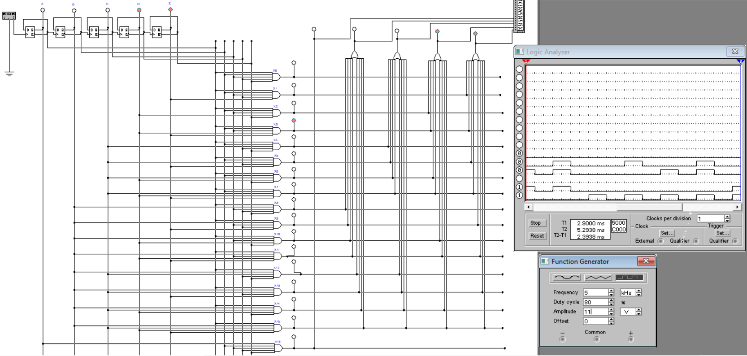
Fig. 4. Schema electrica a coderului (regim dinamic)
Experimentul nr. 3. Unitatea de memorie permanentă
Regim static.
Tabelul 3. Variantele programelor pentru unitatea de memorie permanentă

A₃ A₂ A₁ A₀ | D₄ D₃ D₂ D₁ D₀
0000 | 01111
0001 | 11000
0010 | 10100
0011 | 01100
0100 | 10111
0101 | 11000
0110 | 01101
0111 | 01101
1000 | 00111
1001 | 01010
1010 | 00001
1011 | 11010
1100 | 00010
1101 | 00111
1110 | 10010
1111 | 01110

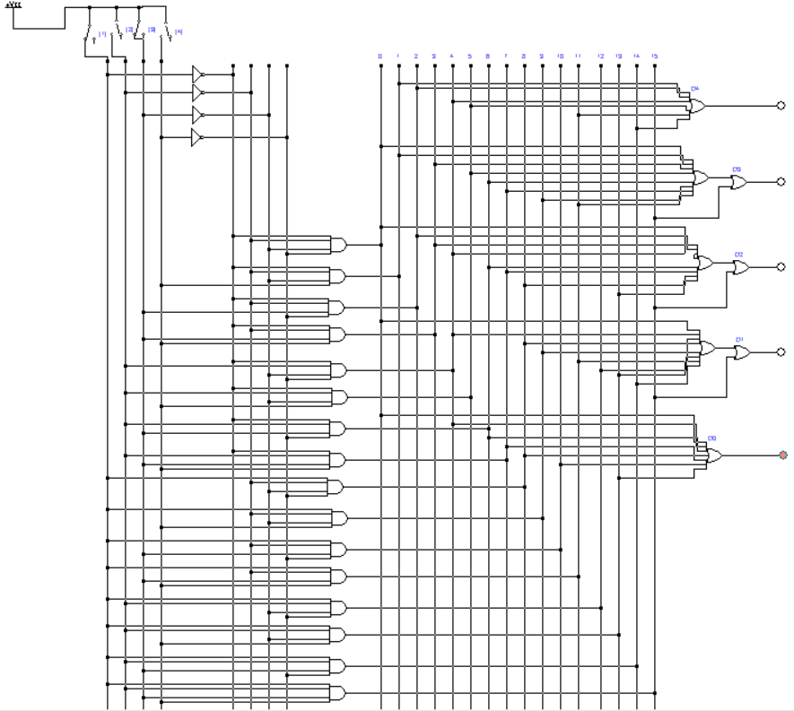
Fig. 5. Unitatea de memorie permanenta (regim static)
Regim dinamic

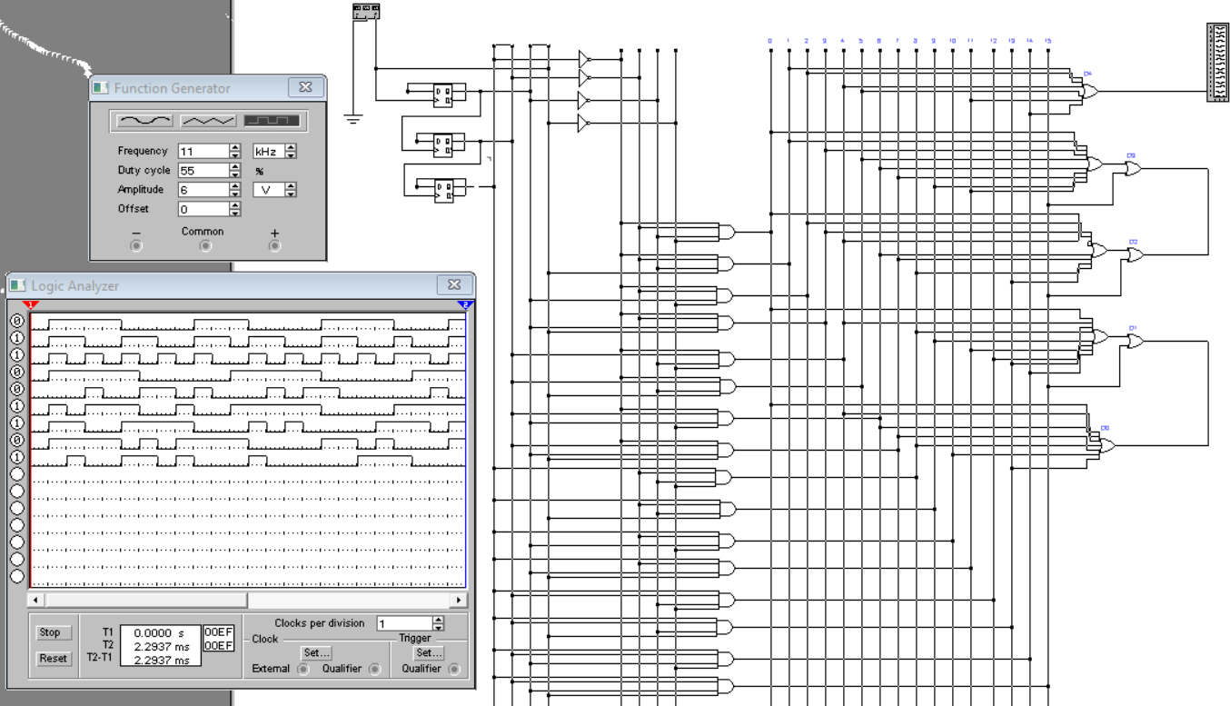
Fig. 6. Unitatea de memorie permanenta (regim dinamic)

