Examen
Arhitectura calculatorului
Varianta 19
Ex1: Completati tabelul starilor si minimizati functia logica prin metoda Karnough. Construiti schema electrica a dispozitivului conform functiei logice minimizate.
F(a,b,c,d) = ∑(0,4,5,6,7,8,9,10,12,13)
Nr.  d/o | Argumenți |  |  |  | Funcția
Nr.  d/o | a | b | c | d | F(a,b,c,d)
0 | 0 | 0 | 0 | 0 | 1
1 | 0 | 0 | 0 | 1 | 0
2 | 0 | 0 | 1 | 0 | 0
3 | 0 | 0 | 1 | 1 | 0
4 | 0 | 1 | 0 | 0 | 1
5 | 0 | 1 | 0 | 1 | 1
6 | 0 | 1 | 1 | 0 | 1
7 | 0 | 1 | 1 | 1 | 1
8 | 1 | 0 | 0 | 0 | 1
9 | 1 | 0 | 0 | 1 | 1
10 | 1 | 0 | 1 | 0 | 1
11 | 1 | 0 | 1 | 1 | 0
12 | 1 | 1 | 0 | 0 | 1
13 | 1 | 1 | 0 | 1 | 1
14 | 1 | 1 | 1 | 0 | 0
15 | 1 | 1 | 1 | 1 | 0

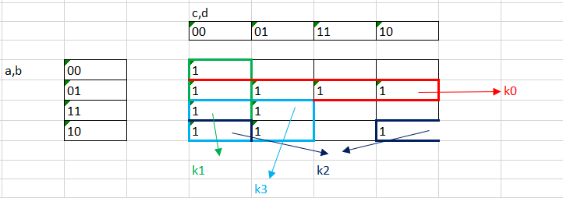
K0=c’d’; k1=a’b; k2=ac’; k3=ab’d’
c’d’ + a’b + ac’ + ab’d’
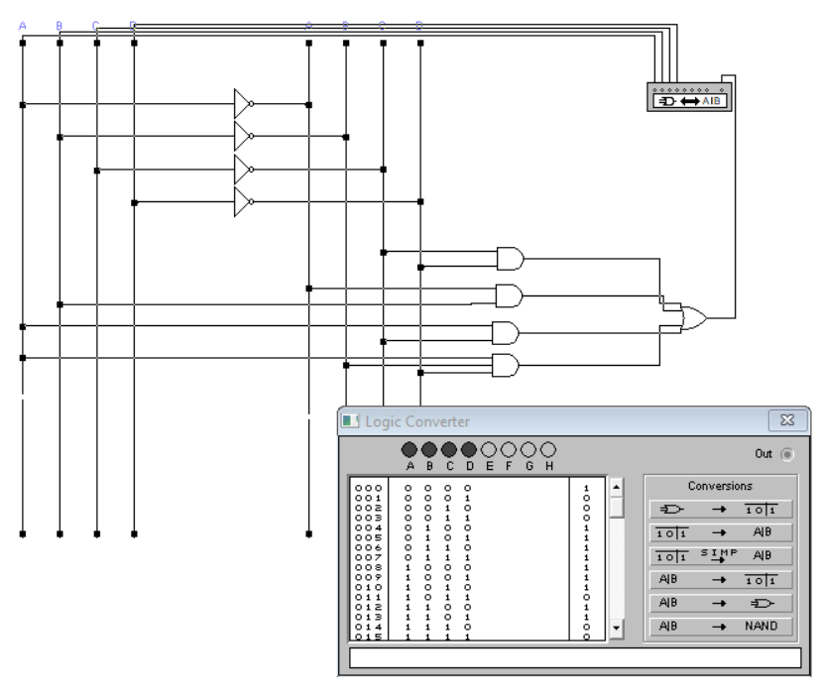

Ex.2 Transformati functia logica din FCNC in FCND si prezentati functia obtinuta prin metoda numerica.
f(a,b,c,d) = (a+b+c+d)(a+b+c+d’)(a+b’+c+d’)(a+b’+c’+d’)(a’+b+c+d)
П = (0,1,5,7,8);
∑ = (2,3,4,6,9,10,11,12,13,14,15,16);
Ex.3 Construiti schema electrica din bistabili D si completati tabelul starilor a unui contor reversive pentru care Nmax = 1111₂
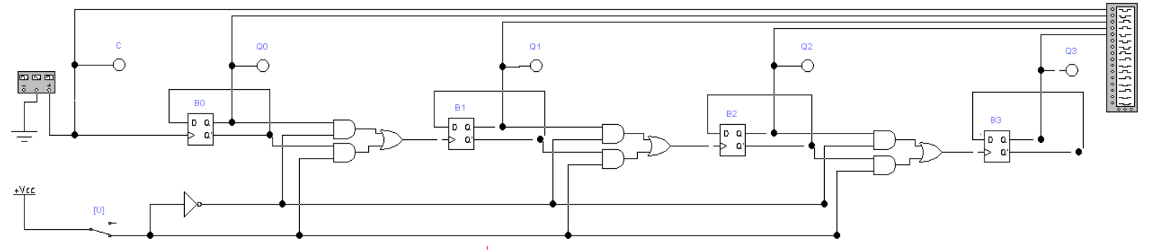
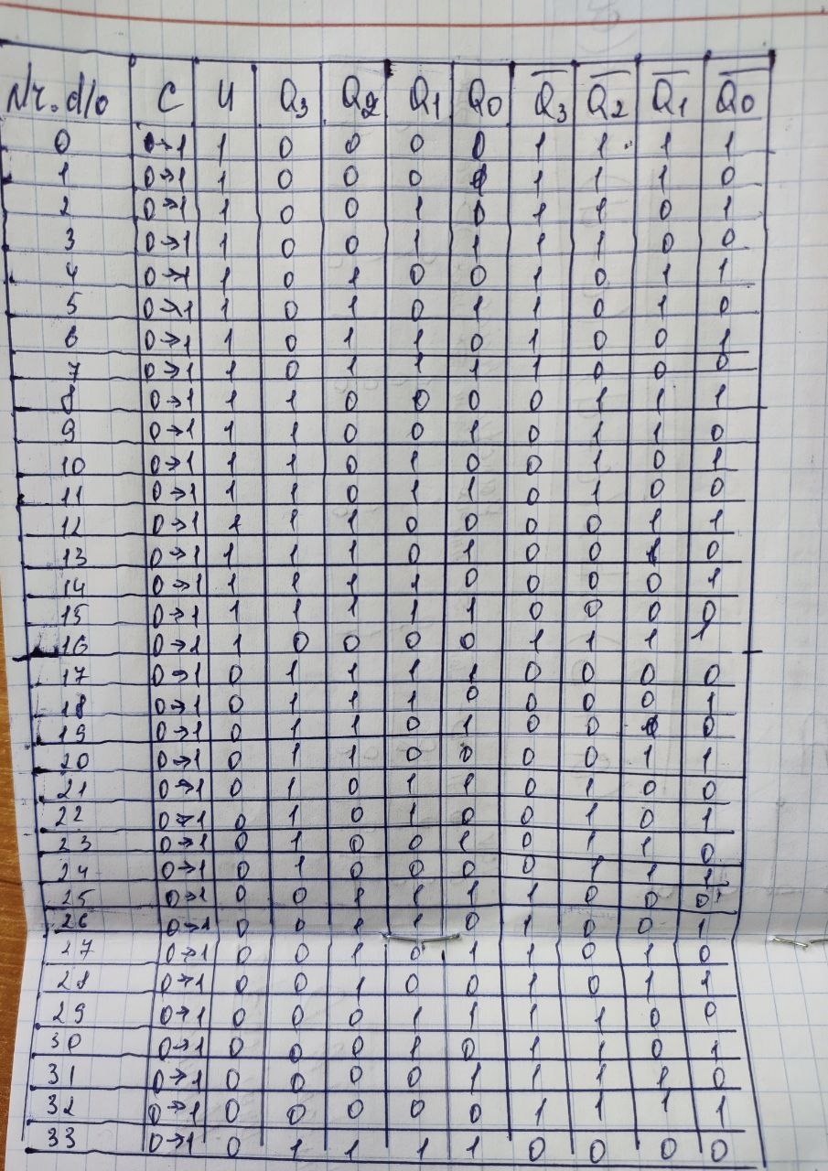

Ex.4 Prezentati tabelul starilor, functiile logice si schema electrica a unui decoder care are m = 5 intrari si n = 9 iesiri.
Nr. d/o | Intrarile |  |  |  |  | Iesirile
Nr. d/o | A | B | C | D | E | F0 | F1 | F2 | F3 | F4 | F5 | F6 | F7 | F8
0 | 0 | 0 | 0 | 0 | 0 | 1 | 0 | 0 | 0 | 0 | 0 | 0 | 0 | 0
1 | 0 | 0 | 0 | 0 | 1 | 0 | 1 | 0 | 0 | 0 | 0 | 0 | 0 | 0
2 | 0 | 0 | 0 | 1 | 0 | 0 | 0 | 1 | 0 | 0 | 0 | 0 | 0 | 0
3 | 0 | 0 | 0 | 1 | 1 | 0 | 0 | 0 | 1 | 0 | 0 | 0 | 0 | 0
4 | 0 | 0 | 1 | 0 | 0 | 0 | 0 | 0 | 0 | 1 | 0 | 0 | 0 | 0
5 | 0 | 0 | 1 | 0 | 1 | 0 | 0 | 0 | 0 | 0 | 1 | 0 | 0 | 0
6 | 0 | 0 | 1 | 1 | 0 | 0 | 0 | 0 | 0 | 0 | 0 | 1 | 0 | 0
7 | 0 | 0 | 1 | 1 | 1 | 0 | 0 | 0 | 0 | 0 | 0 | 0 | 1 | 0
8 | 0 | 1 | 0 | 0 | 0 | 0 | 0 | 0 | 0 | 0 | 0 | 0 | 0 | 1
9 | 0 | 1 | 0 | 0 | 1 | 0 | 0 | 0 | 0 | 0 | 0 | 0 | 0 | 0
10 | 0 | 1 | 0 | 1 | 0 | 0 | 0 | 0 | 0 | 0 | 0 | 0 | 0 | 0
11 | 0 | 1 | 0 | 1 | 1 | 0 | 0 | 0 | 0 | 0 | 0 | 0 | 0 | 0
12 | 0 | 1 | 1 | 0 | 0 | 0 | 0 | 0 | 0 | 0 | 0 | 0 | 0 | 0
13 | 0 | 1 | 1 | 0 | 1 | 0 | 0 | 0 | 0 | 0 | 0 | 0 | 0 | 0
14 | 0 | 1 | 1 | 1 | 0 | 0 | 0 | 0 | 0 | 0 | 0 | 0 | 0 | 0
15 | 0 | 1 | 1 | 1 | 1 | 0 | 0 | 0 | 0 | 0 | 0 | 0 | 0 | 0
16 | 1 | 0 | 0 | 0 | 0 | 0 | 0 | 0 | 0 | 0 | 0 | 0 | 0 | 0
17 | 1 | 0 | 0 | 0 | 1 | 0 | 0 | 0 | 0 | 0 | 0 | 0 | 0 | 0
18 | 1 | 0 | 0 | 1 | 0 | 0 | 0 | 0 | 0 | 0 | 0 | 0 | 0 | 0
19 | 1 | 0 | 0 | 1 | 1 | 0 | 0 | 0 | 0 | 0 | 0 | 0 | 0 | 0
20 | 1 | 0 | 1 | 0 | 0 | 0 | 0 | 0 | 0 | 0 | 0 | 0 | 0 | 0
21 | 1 | 0 | 1 | 0 | 1 | 0 | 0 | 0 | 0 | 0 | 0 | 0 | 0 | 0
22 | 1 | 0 | 1 | 1 | 0 | 0 | 0 | 0 | 0 | 0 | 0 | 0 | 0 | 0
23 | 1 | 0 | 1 | 1 | 1 | 0 | 0 | 0 | 0 | 0 | 0 | 0 | 0 | 0
24 | 1 | 1 | 0 | 0 | 0 | 0 | 0 | 0 | 0 | 0 | 0 | 0 | 0 | 0
25 | 1 | 1 | 0 | 0 | 1 | 0 | 0 | 0 | 0 | 0 | 0 | 0 | 0 | 0
26 | 1 | 1 | 0 | 1 | 0 | 0 | 0 | 0 | 0 | 0 | 0 | 0 | 0 | 0
27 | 1 | 1 | 0 | 1 | 1 | 0 | 0 | 0 | 0 | 0 | 0 | 0 | 0 | 0
28 | 1 | 1 | 1 | 0 | 0 | 0 | 0 | 0 | 0 | 0 | 0 | 0 | 0 | 0
29 | 1 | 1 | 1 | 0 | 1 | 0 | 0 | 0 | 0 | 0 | 0 | 0 | 0 | 0
30 | 1 | 1 | 1 | 1 | 0 | 0 | 0 | 0 | 0 | 0 | 0 | 0 | 0 | 0
31 | 1 | 1 | 1 | 1 | 1 | 0 | 0 | 0 | 0 | 0 | 0 | 0 | 0 | 0

1. F0 = $\overline{a}*\overline{b}*\overline{c}*\overline{d}*\overline{e}$
2. F1 = $\overline{a}* \overline{b}*\overline{c}*\overline{d}*e$
3. F2 = $\overline{a}*\overline{b}*\overline{c}*d*\overline{e}$
4. F3 = $\overline{a}*\overline{b}*\overline{c}*d*e$
5. F4 = $\overline{a}*\overline{b}*c*\overline{d}*\overline{e}$
6. F5 = $\overline{a}*\overline{b}*c*\overline{d}*e$
7. F6 = $\overline{a}*\overline{b}*c*d*\overline{e}$
8. F7 =$\overline{a}*\overline{b}*c*d*e$
9. F8 = $\overline{a}*b*\overline{c}*\overline{d}*\overline{e}$
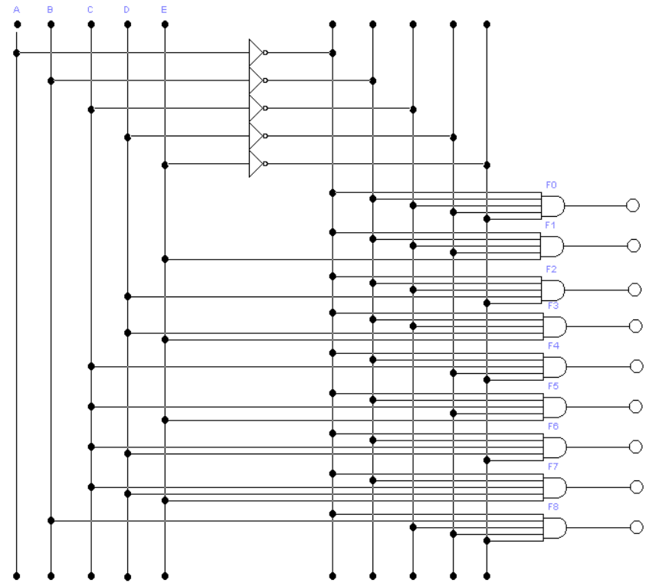

Ex.5 Prezentati algoritmul si construiti schema electrica principiala a unitati de scadere de tip paralel de ordinul 4 pentru care rezultatul D > 0.
D(d₃,d₂,d₁,d₀) = A(a₃,a₂,a₁,a₀) – B(b₃,b₂,b₁,b₀) = 1101₂ – 1000₂ = 0101₂
