Car Accident

Severity Report

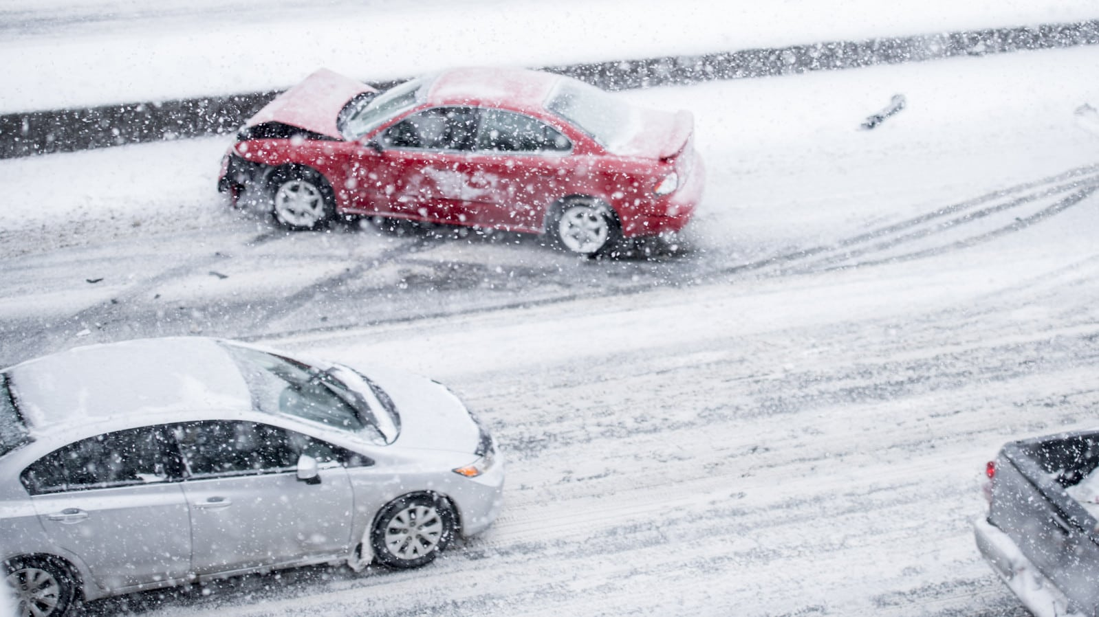

Student: Course:

Rishabh Shinde Applied Data Science Capstone

# Introduction to the Problem

Weather acts through visibility impairments, precipitation, high winds, and temperature extremes to affect driver capabilities, vehicle performance (i.e., traction, stability, and maneuverability), pavement friction, roadway infrastructure, crash risk, traffic flow, and agency productivity. The table below, summarizes the impacts of various weather events on roadways, traffic flow, and operational decisions.

Prediction of future weather conditions has significant impact on social and economic areas of human life. By gathering the weather data, meteorology opens the possibility of analyzing significant patterns in large amounts of data. Over 150 thousand lives annually are claimed due to the climate changes in temperature and precipitation trends

Climate changes also affect traffic flow. By changing external conditions in which transport takes place and which affect the health or concentration of driver’s unfavorable meteorological conditions can lead to traffic accidents, injuries, and death. World Health Organization indicates that the number of road traffic deaths is troublesome and has plateaued at 1.25 million per year.

This study tries to determine the correlation between weather conditions and traffic accident occurrences by analyzing collected data. Data analysis is one of the activities of data science focused on obtaining important information from collected data

# Business Understanding

|  |
| --- |
| To reduce the frequency of car collisions in a community, an algorithm must be developed to predict the severity of an accident given the current weather, road and visibility conditions. When conditions are bad, this model will alert drivers to remind them to be more careful or possible change travel date, mode or time, so that it would be safer. |

# Target Audience

The target audience for this project would be:

* Daily commuters, who have travel on a regular basis for work. This project would warn them of possible dangers while driving based on the weather condition, road conditions and the time of the day
* It would also help the first responders like ambulance and firefighter services. The system could help them stay prepared in advance by indicating them of high chances of accidents that could take place.

Thus, ensuring anyone in need could receive their help without much delay

# Data Understanding

The data has been retrieved and processed through various sources, and database.

The main source being the data-collisions csv file

Our predictor or target variable will be 'SEVERITYCODE' because it is used measure the severity of an accident from 0 to 5 within the dataset. Attributes used to weigh the severity of an accident are 'WEATHER', 'ROADCOND' and 'LIGHTCOND'.

## SEVERITYCODE

Severity codes are as follows:

1. Little to no probability (Clear conditions)
2. Very Low probability (chance or damage property)
3. Low Probability - Chance of Injury
4. Mild Probability - Chance of Serious Injury
5. High Probability - Chance of Fatality

## WEATHER

* Overcast: Overcast sky conditions occur when clouds cover all or most of the sky and cause low visibility conditions
* Rains: Heavy or moderate rainfall, which causes roads to be slippery
* Clear: Clear weather conditions

## ROADCOND

This attribute refers to the road condition for a day

* Wet: Usually refers to wet and snowy conditions on a day
* Dry: Normal road conditions

## LIGHTCOND

This attribute gives information of light conditions when the accident took place and will be useful in predicting in what conditions an accident is probable.

* Daylight: Indicates daylight conditions
* Dark with Street Lights on: Dark conditions but streetlight source was present
* Dark without Street Lights: Pitch dark conditions, only head lights to guide the way
* Dawn: Early Morning, day starts getting more light
* Dusk: late evening, light from the day reduces

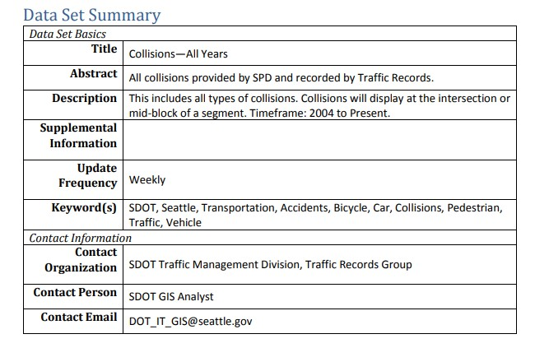

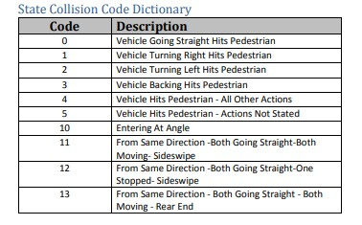

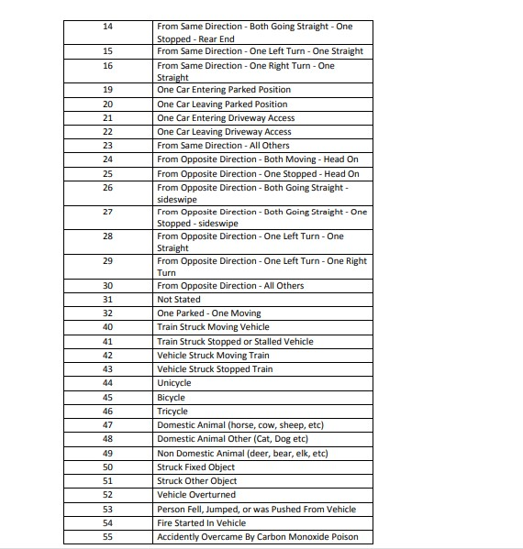

|  |
| --- |
|  |

## Data Balancing and Cleaning

Data is unbalanced and cannot be directly used for analysis

In its original form, this data is not fit for analysis. For one, there are many columns that we will not use for this model. Also, most of the features are of type object when they should be numerical type.

We must use label encoding to covert the features to our desired data type.

## Understanding the data

Data Cleaning is an essential step because we must identify which data features are important for our analysis and which attributes are not.

So, it is essential that we go through each attribute carefully and determine how important it is and whether it can be used

# Feature Selection

The main features used are:

* SEVERITYCOND
* WEATHER
* LIGHTCOND
* ROADCOND
* JUNCTIONTYPE

Features dropped:

'X', 'Y', 'OBJECTID', 'INCKEY', 'COLDETKEY', 'REPORTNO', 'STATUS', 'INTKEY', 'LOCATION', 'EXCEPTRSNCODE', 'EXCEPTRSNDESC', 'SEVERITYDESC', 'SDOT_COLCODE', 'SDOT_COLDESC', 'SDOTCOLNUM', 'INCDTTM', 'COLLISIONTYPE', 'INATTENTIONIND', 'UNDERINFL', 'PEDROWNOTGRNT', 'SPEEDING', 'ST_COLCODE', 'ST_COLDESC', 'HITPARKEDCAR'

Number of Accidents v/s Weather:

The graph determines the most of accidents take place in clear weather, and other weather conditions which also cause some of the accidents are Overcast and Rain.

So we can ignore the other weather conditions

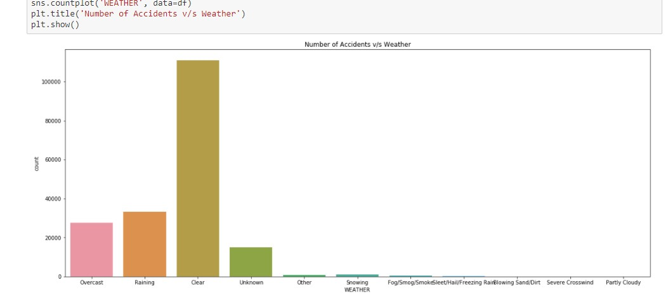

Number of Accidents v/s Road Conditions:

Most of the accidents took place on dry road conditions, and the other condition which also caused a few accidents was wet road conditions, other conditions can be ignored

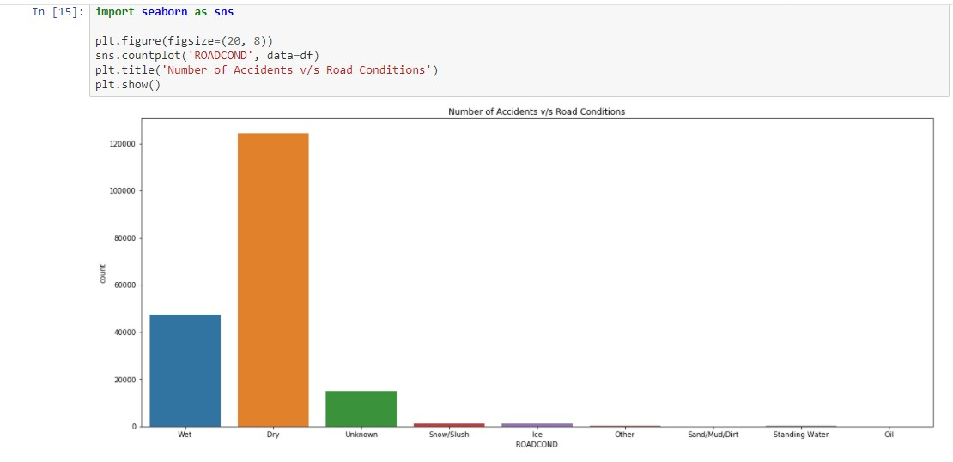

Number of Accidents v/s Light Conditions:

Most of the accidents were caused during daylight, the other major cause of accidents was Dark with streetlights on, the other features can be ignored

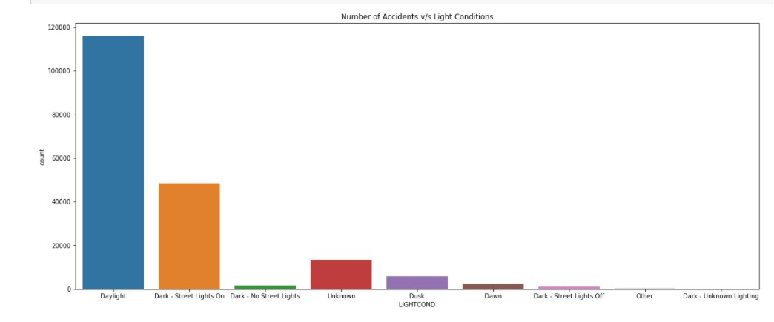

Number of Accidents v/s Junction Types:

From this we can see that most of the accident were caused in mid blocks

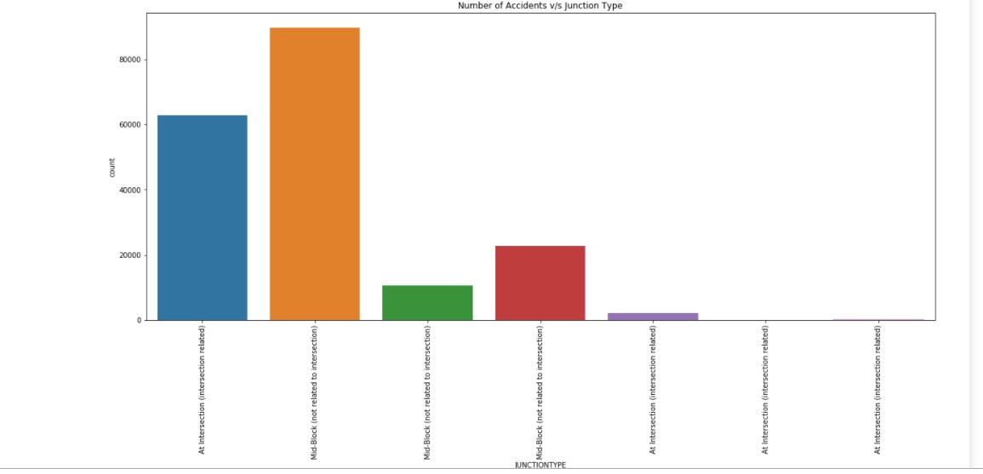

Number of Accidents v/s Speeding, Distraction and Influence of alcohol

From the graphs we saw that these factors did not contribute to a major number of accidents, thus these attributes can be dropped.

Speeding

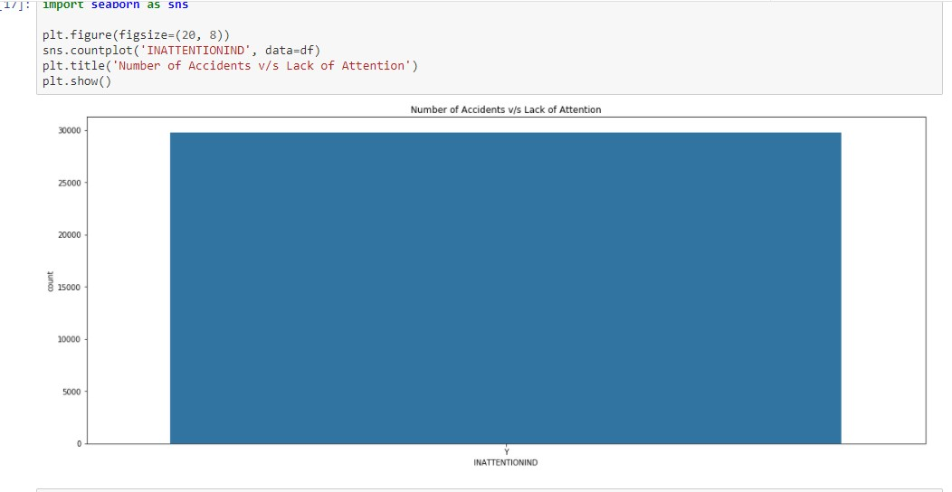

Distracted Driver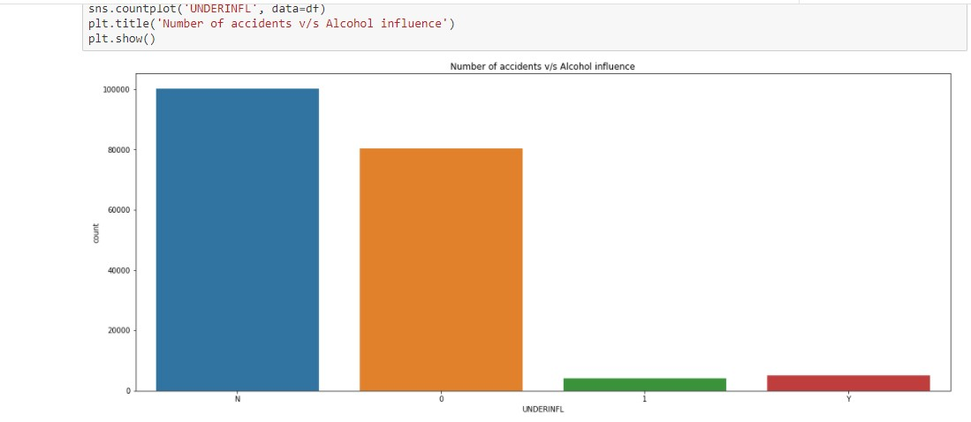

Influence of alcohol

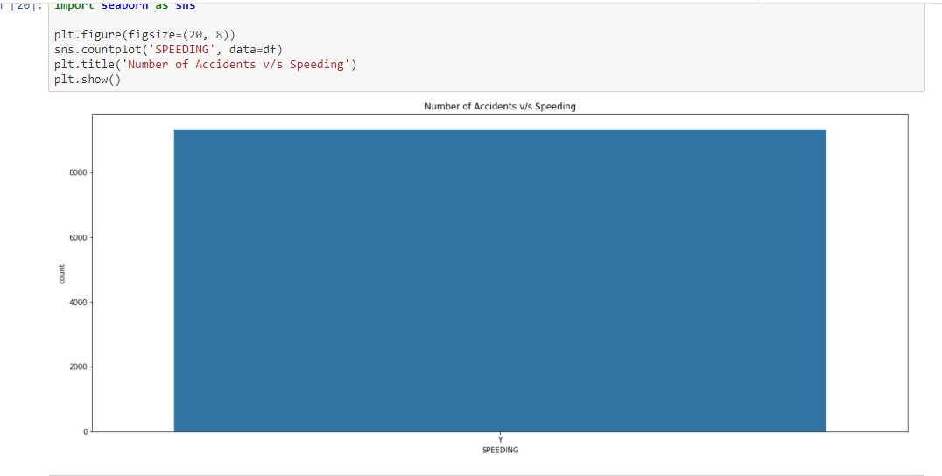

Number of Accidents v/s Number of Accidents

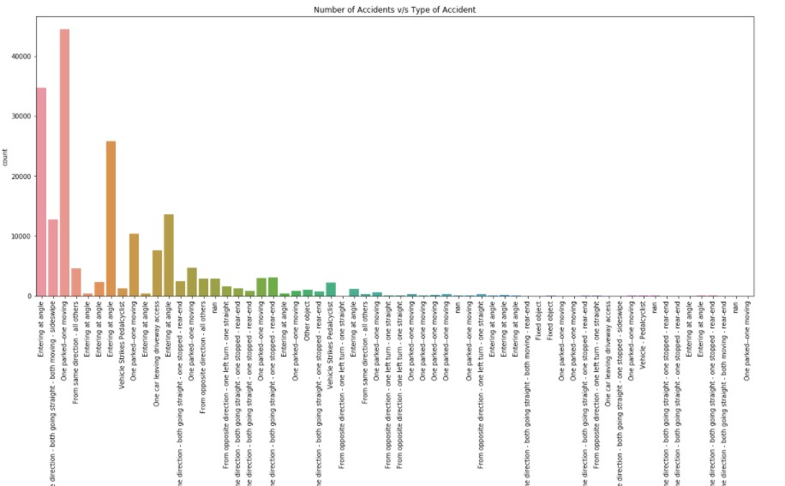

# Data Preprocessing

## Converting categorical data to numeric data

Since most of the data like ‘WEATHER’, ‘ROADCOND’, ‘LIGHTCOND’ are all categoric

They must be converted to numeric type so they can be fed as feature set for Classifier Models:

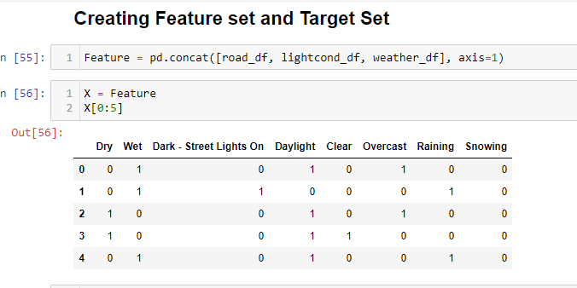

## Normalization of the Data

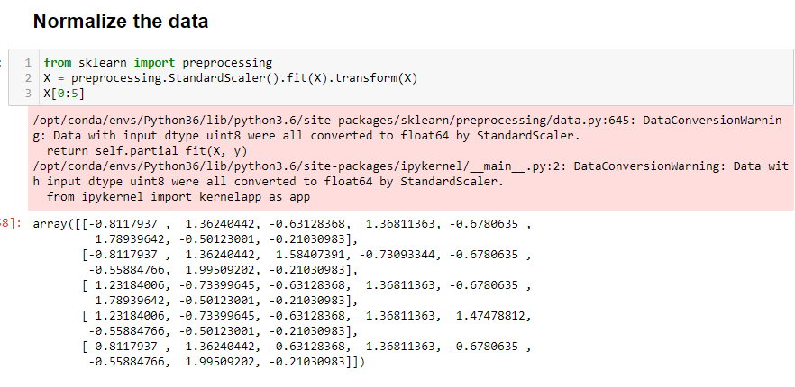

## Split into Test and Train Model

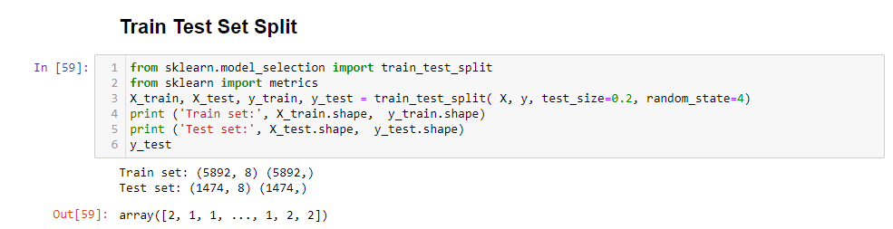

## Classification Algorithms

I applied various classification algorithms which include:

* KNN Model
* Decision Tree
* Support Vector Machine
* Logistic Regression

All the 4 models gave similar results but I found Logistic Regression to be the most effective and Accurate:

The following were the scores:

KNN

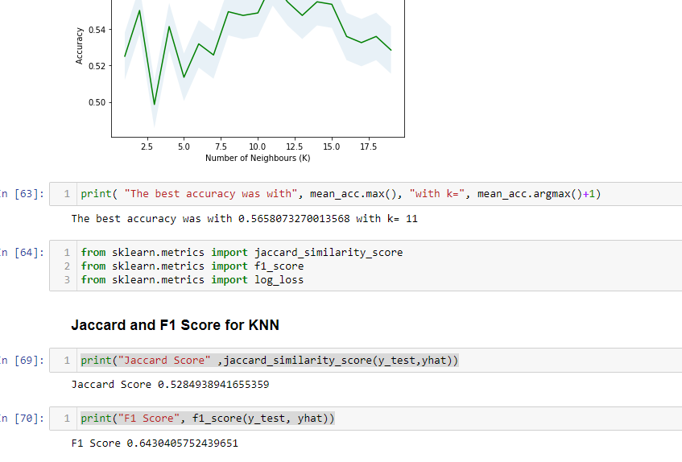

Decision Tree:

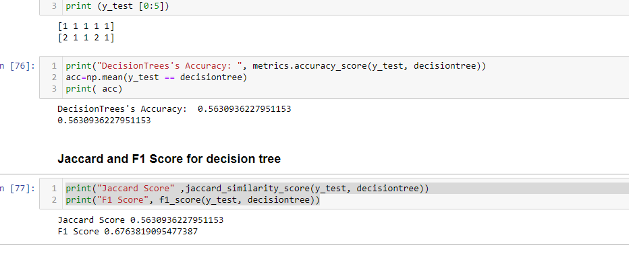

Support Vector Machine:

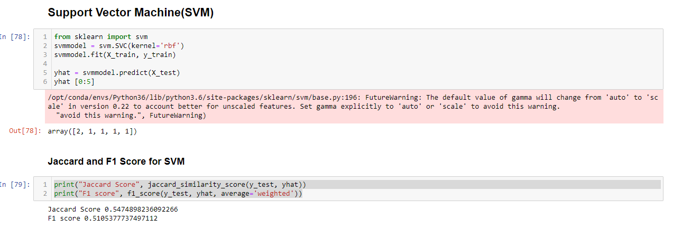

Logistic Regression:

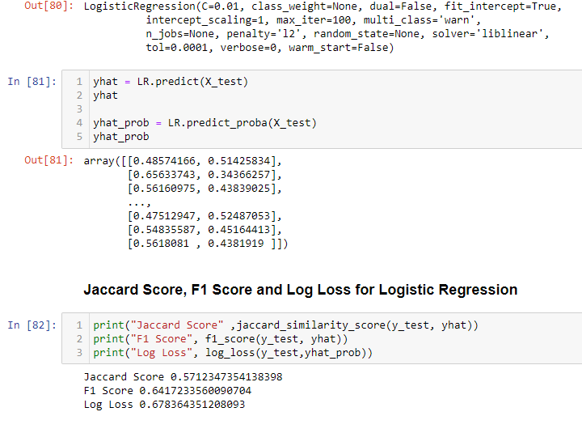

# Conclusion:

Using the existing dataset of the course, some remarkable insights have been obtained. At the beginning it was guessed that the severity of an accident could be predicted by the weather or speeding conditions. Using different methods for estimation of the severity based on the existing dataset it could be observed, that only small amount of information can be gained by predictions.