Predicting the price of cabbages through time series of price and external factors
15146312 Park, Gangmin
15146302 Kang, Euihyeon
15146304 Ku, Seunghyo
Abstract
This study introduces the process for predicting the cabbage price. For the purpose of forecasting, the data are based on cabbage and radish prices and time series data of weather, import volumes and import prices. Data collected over four years from 2015 to 2018 are averaged over a week to predict a week ago from now. Prediction models are evaluated using Gradient Boosting Regression, KNN Regression, Support Vector Regression, Linear Support Vector Regression, Linear Regression, Random Forest Regression, and Decision Tree Regression. For the best-predicted model, the R_square was approximately 64% and this result of study is expected to help farmers and consumers through pricing forecasts.
1. Introduction
The cabbage kimchi is a Korean traditional food. According to a 2013 National Health Nutrition Survey analysis, cabbage kimchi is still loved by Koreans as the third most popular food of all [1]. Figure 1 shows the monthly change in cabbage prices from 2015 to 2018. Cabbage, an essential ingredient for making cabbage kimchi, has maintained steady demand, but the price of cabbage can be seen to change irregularly.
The factors that change the price of cabbage would be kimchi-making before winter, weather factors such as heavy rain or heavy snow, the price of radish, the amount of cabbage imported and the import price.
A related study of predicting wholesale prices of onions used data such as past wholesale prices, production and cultivation areas of onion[2]. In the study [2], prices were estimated using the ARDI (autoregressive and distributed lags) model, but in this study, we wanted to select more accurate model among seven models including Linear Support Vector Regression.
Another study used data of past cabbage prices and the frequency of agricultural weather keywords associated with crop growth in documents containing cabbage as key data [3]. In this study, however, weather data such as temperature and precipitation considering the growth of crops were used, as well as amount of imported agricultural products and radish prices that could affect the demand and supply of cabbages.
2. Analytics
2.1 Data
Table 1 shows the independent variables for predicting the price of cabbage, and the data for past cabbage prices are agricultural trade data from 2015 to 2018 collected by KAMIS. The data include the average transaction price and the Normal Year price of cabbage. Normal Year means that average price expending maximum and minimum values in the data for the five-year period based on this year's data. In addition, we also collected price data for cabbages and radishes due to their high importance in the agricultural market [4]. As shown in Figure 1, the agricultural trade data are time series data and therefore the price of cabbage can be predicted by this data alone, but additional weather data and imported agricultural product data have been collected to take into account other variables that do not include time series data. Table 2 is the weather data and was collected over the period from 2015 to 2018. Agricultural trade data and weather data were collected in Seoul, Daejeon, Daegu, Gwangju and Busan.
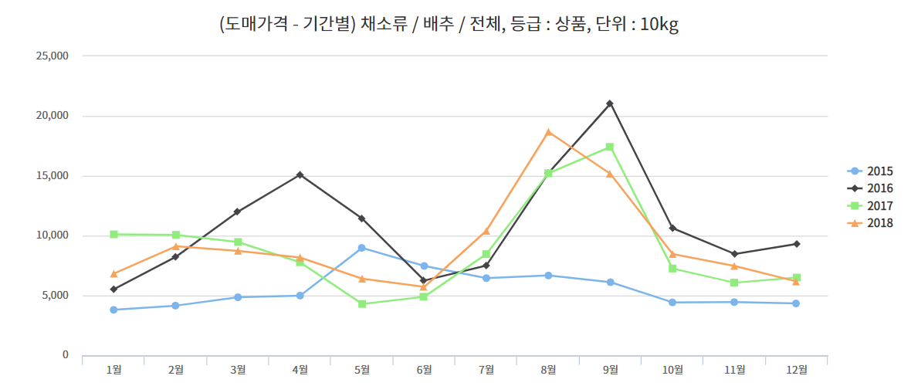
Figure 1. Monthly cabbage transaction price (10kg) graph from 2015 to 2018
Cabbage Average
Cabbage Normal year
Radish Average
Radish Normal year
Table 1. Agricultural Trade Data
Average Temperature | Duration of Bright Sunshine
Lowest Temperature | Solar Radiation Quantity
Highest Temperature | Maximum Depth of Snow Cover
Precipitation | Maximum Depth of New Snowfall
Wind Speed | Amount of Cumulus
Dew Point | Average Temperature of Ground
Relative Humidity | Total Low Evaporation
Vapor Pressure | Total Large Evaporation
Spot Atmospheric Pressure | Amount of Middle and Lower Cloud
Sea-level Pressure
Table 2. Weather Data
Cabbage import weight
Cabbage amount of import
Table 3. Imported agricultural product data
The data set used in this study contains missing values. The processing of missing values is defined according to the characteristics of the variables, and each is handled differently. The first missing value type is appeared when there are no events occurred. For example, in the case of the Maximum Depth of snow cover, the amount of snow is measured, so there is no value in the day when it is not snowing. In this case, fill the missing value with zero. The second type is appeared when there are not recorded. For example, in the case of an amount of cumulus and an amount of middle and lower cloud in 2017, there is no measurement of approximately 160 days. Therefore, the average of the other year's measurements is obtained and filled. The last type is the case where it cannot be determined. If the variable’s values are missing without a particular pattern, it is impossible to determine. Weather data are time series data that maintains the trend of previous data, so in this case the missing values are filled by referring to the data from the previous one.
Agricultural trade data and weather data exist five data based on each region. Since this study is aimed at predicting universal cabbage prices, an average of five regional data is obtained and used. It will then generate data sets from 2015 to 2018 by integrating agricultural trade data, imported agricultural product data and weather data.
The purpose of this study is to predict the price of cabbage in a week, so the average of the time series data over a given period of time is obtained and used as an independent variable. Because all independent variables are time series data, we averaged all independent variables over a week and estimated the price at the present time through the variables from two weeks to a week before the present time.
Data filled with missing values are a total of 981 data with an even distribution of 248, 246, 243, 244 data per year. The data are all numeric value. Figure 2 shows the mean temperature distribution for 2015. Figure 3 shows the distribution of average temperatures from 2015 to 2018. Most weather data have been found to be highly correlated with average temperature data. Weather data also reflect seasonal characteristics on a yearly basis. Figure 4 shows the average price of cabbages and radishes from 2015 to 2018. Through Figure 3 and Figure 4, we can verify a similar graph shape and seasonal characteristics every year.
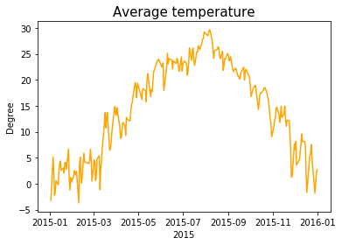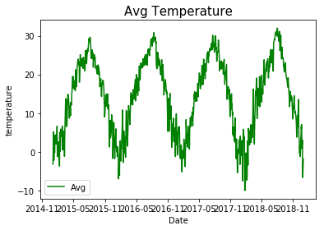
Figure 2. Average temperature in 2015 Figure 3. Average temperature from 2015 to 2018
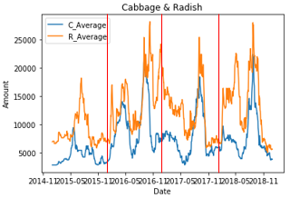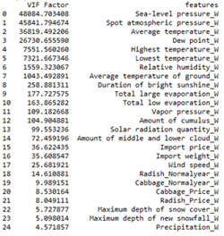
Figure 4. Average price of cabbages and radishes from 2015 to 2018
Figure 5. VIF of independent variables
Multicollinearity is measured in this study to identify independent variables to be used for pricing forecasting.
Figure 5 shows the result of measuring the multicollinearity of each variable about all independent variables. From Sea-level pressure (index 0) to Radish_NormalYear (index 18), the VIF factor exceeds 10. These variables are not suitable for models to predict accurate results. Therefore, the variables are removed one by one to measure their multicollinearity, taking into account the effects between each independent variable.
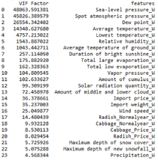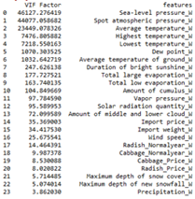
(a)when Highest temperature was removed (b) when Highest Relative Humidity was removed
Figure 6. VIF factor of variable sets when a variable who has more than 10 multicollinearity was removed
Figure 6 shows the result of measuring the multicollinearity when each (a)Highest temperature and (b)Highest Relative Humidity are removed from a set of variables with greater than 10 multicollinearity. In this study, all variables in a set of variables whose multicollinearity is greater than 10 were removed one by one to confirm the multicollinearity, but no apparent change was found. This is because, as identified in the EDA step, each independent variable has a similar distribution shape.
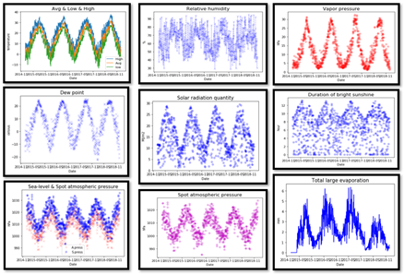
Figure 7. the graphs of independence variables whose multicollinearity is greater than 10
Figure 7 shows a graphical representation of some of the independent variables whose multicollinearity is greater than 10. Each independent variable shows a similar graph shape. Therefore, in this study, the method of measuring the multicollinearity was used by removing all independent variables with greater than 10 multicollinearity and adding them again one by one. Figure 8 shows a pseudo algorithm that selects variables that keep the multicollinearity less than 10.
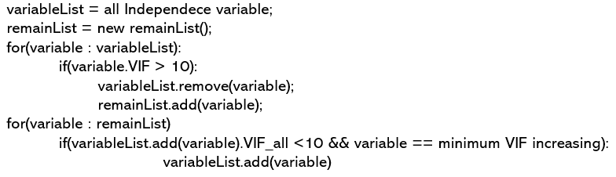
Figure 8. Pseudo algorithm of VIF variable selection
2.2 model
The independent variables used in this study are all time series data. Therefore, we separate validation into 2018 data and train into 2017 data from 2015.
Backward elimination technique is used for feature selection in separated train set. When the first time the radish normal year was removed, the R2_square increased. But when the other variable was removed sequentially, R2_square was decreased. Therefore, only the radish normal year was removed from the train set.
Because the variables used in this study are all numerical variables, Linear Support Vector Regression, Linear Regression, KNN Regression, Gradient Boosting Reform, Random Forest Regression, Support Vector Regression, and Decision Tree Regression were used for evaluation. A model was run using the cabbage price at the current time as a target variable and the data averaged from two weeks ago to a week ago as an independent variable.
2.3 result
Table 4 show the results of running each model.
 | Method | Score
1 | Gradient Boosting Regression | 0.64004
2 | KNN Regression | 0.617634
3 | Support Vector Regression | 0.595854
4 | Linear Support Vector Regression | 0.571686
5 | Linear Regression | 0.565908
6 | Random Forest Regression | 0.503584
7 | Decision Tree Regression | 0.213532
Table 4. Results of running each model
Gradient Boosting Regression had the highest score of 64%, followed by 61.8% of the K-NN Regression and 59.6% of the Support Vector Regression.
3. Conclusion
This study shows that the price of cabbages after one week can be predicted using the time series data of weekly average data consisted of the cabbage price, radish price, weather data, and cabbage import data.
In 2.1 it shows processes for data collection and preprocessing. In 2.2 it shows several used models and evaluations of them. In 2.3 it shows predicted results.
With cabbage prices, weather data and agriculture import data, we could predict the price of cabbages at about 64% R_square, but we expect better prediction results when factors such as the production, consumption or production area of cabbages are given which is not considered in this study.
reference
[1]: Korea Health Industry Development Institute(KHIDI). National Food & Nutrition Statistics 2013: based on 2013 Korea National Health and Nutrition Examination Survey. Korea Health Industry Development Institute(KHIDI). 2015
[2]: Kuk-Hyun Nam, Young Chan Choe, A Study on Onion Wholesale Price Forecasting Model, 한국농촌지도학회, 2018
[3]: Jang, SooHee ,Chun, Heuiju ,Cho, Inho ,Kim, DongHwan, A study on cabbage wholesale price forecasting model using unstructured agricultural meteorological data, 한국데이터정보과학회지, 2017
[4]: Ji-Yun, Park, Young-Gu, Park, The Development of Chinese Cabbage and Radish Forecast Models, 한국농촌경제연구원, 2013

