1. Compile and runs the program
   1. The shell program can compile and run successfully

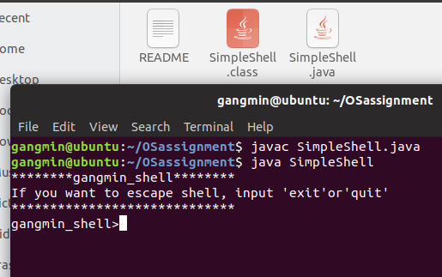

1. ProcessBuilder object
   1. ProcessBuilder object is correctly created, ps, ls, and cat command works

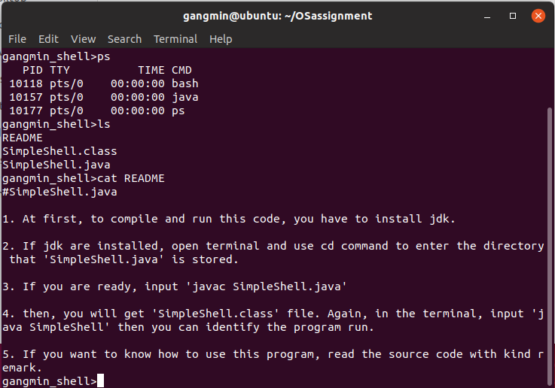

1. Exit and quit
   1. Exit and quit works

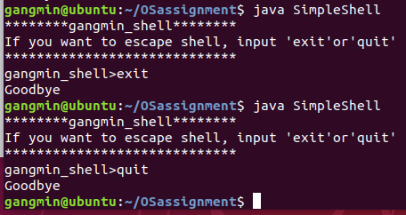

1. Change directory to /home/user
   1. **cd** followed by **pwd,** You are able to change directory to /home/user directory and display it. (absolute path is working)

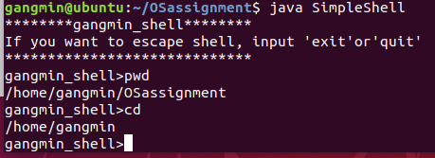

1. Handle absolute path
   1. **cd /home** You are able to change directory to /home

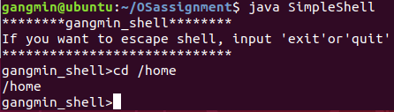

1. Relative path
   1. then **cd user** You are able to change directory to /home/user (relative path is working)

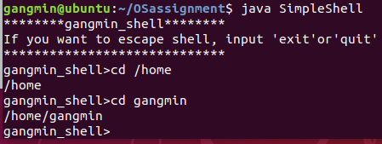

* 1. cd again and type **cd /user/Project1** or any existing folder. You are able to change directory to /home/user/Project1

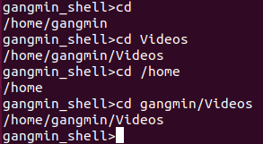

* 1. cd .. You are able to change directory to /home/user

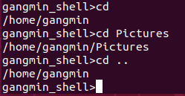

1. Error handling
   1. **cd fakeDirectory** Error message for invalid path



1. history
   1. ‘history <number>’ works well

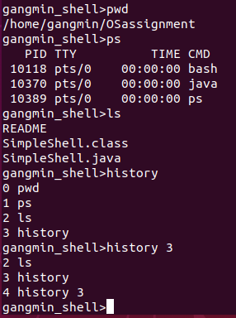

* 1. ‘history !!’ works well

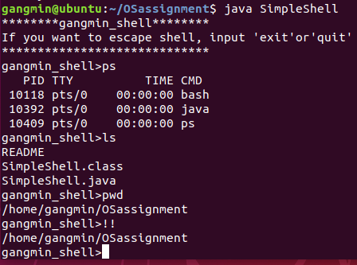

* 1. ‘history !<number>’ works well

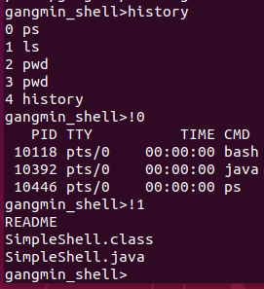

**What did you learn?**

1. How far did you get in this project? What grade are you expecting? Did you find the milestones in the description helpful? Do you think you could have gotten the project working as well as you did without the milestones?

* It took about 8 hours to understand the problem, including programming and documentation.
* I implemented everything I intended. If I understand correctly, I will get 100 points.
* It was helpful to run the Sample OSprocess code attached as a picture. Without this code, there would have been some difficulty.

1. Do you feel like a better programmer now that you’ve completed this project? How does this compare to programming project that you’ve had in prior class?

* In fact, it was helpful in terms of how to cleanly manage errors and deal with processes rather than programming aspects. Compared to other projects that required simple algorithms, I could get a complete result.

1. Describe 3 problems (relating to this assignment) that arose while you were working on this project and explain how you solved them.

* I did not know exactly about the methods of the File, ProcessBuilder class. So I checked and resolved how to use emthod through the Java API documentation.
* I did not know how to use linux commands such as ls, history, and cd. Especially, I did not know the meaning of command like cd .. or !5. I tried to search Google and run it directly in Linux shell.
* I did not know what to write in the README file. I looked at the components of the open source README file in the git and wrote a description of the runtime environment and how to run it.

1. How long did you spend on this assignment? Give me specifics. For example:

|  |  |  |  |
| --- | --- | --- | --- |
| **Date** | **Time** | **Activities** | **Outcomes** |
| 4.08 | 2hours | Understand problem and write source code | I could understand the problem and create the skeleton. |
| 4.09 | 4hours | Write source code and error handling | I was able to write code and debug it to fix the error. |
| 4.12 | 2hours | Write documents and answer the questions. | I wrote a document and answered the question. |

1. Total hours spent. Try to be honest and do not exaggerate here.

* Approximately 8 hours