Development of a mobile application for controlling the time of dog’s walk
Radomir Sobic¹, Sofya S. Kozlova²,
Department of Computer Systems and Technologies
National Research Nuclear University MEPhI (Moscow Engineering Physics Institute)
Moscow, Russian Federation
¹radomirsobic7@gmail.com, ²sofiaco@yandex.ru

Ilya S. Kozlov³
P.G. Demidov Yaroslavl State
Yaroslavl, Russia
³a-1000.cozlov@yandex.ru

Abstract——This article is devoted to the development of a mobile application for controlling the time and duration of a dog’s walk. The primary goal was a research of the parameters on how much a dog needs to walk depending on what breed it is. This publication consists of two phases: collection and analysis of data and development of a mobile application based on the data that was collected.
Keywords—database, mobile application, analysis, characteristics of dog breeds.
I. INTRODUCTION
Living in the 21st century, man strives to use all the opportunities provided by developed technology, which is widely applied in all forms of human activity. Developed technology, which advances every day and expands the range of its possibilities, not only helps to solve scientific tasks but also helps people in everyday activities. The use of mobile applications has become commonplace, that is almost impossible to imagine a day without their use. Mobile applications are used for learning, scientific work, entertainment, everyday activities, etc. The dog, as man's best friend, needs a lot of attention and time. Fast lifestyle and lack of time is something that 21st-century man is getting used to. As a result, it sometimes happens that a person forgets about the dog. Having a dog is a huge responsibility, but it also brings a lot of joy and a lot of positive emotions to its owner [1]. The rapid advancement of technology also has negative consequences for humans. But we should strive to reduce them and to make the best use of the technology available to us. The development of applications, which help in everyday life activities, is one of the ways to reduce the negative consequences. Pet applications also belong to the group of useful applications that help us daily, not harming our health, but on the contrary, helping us. Considering all the above examples, it is not surprising that there are a large number of applications for pets, especially for dogs. The variety of these applications allows owners to take better care of their dogs in the shortest time. Given the times we live in, these apps are helpful for both dogs and humans, because the owner takes care of his dog for a much shorter time than before.
Why is a dog walk so important? As already mentioned, the dog has a positive effect on the emotional, mental, and physical health of man. Due to the fast lifestyle and lack of time, caused by the volume of work and the pace of the 21st century, many people forget about their health, giving priority to some other things. Lack of physical activity and obesity is a problem for many people around the world. Lack of physical activity leads to several health problems such as heart disease, high blood pressure, lack of energy, etc. According to the study, physical activity and walking were 57% to 77% higher among dog owners compared with those not owning dogs [2]. From the above parameters, it is clear that the dog encourages the owner to physical activity. Without dogs as pets, it is clear that physical occupation, not only of individuals but of society as a whole, would be at a low level. Evidence suggests that owning a dog reduces the risk of death caused by diseases caused by lack of physical activity. Therefore, dogs as pets play a vital role in the health of society and their importance should not be underestimated[3].
The list of mobile applications for dogs is huge, we have listed only a few. For example, the application “11Pets” provides the user with the necessary information about all the important events of his pet, such as going to the vet, birthday, information about the health of the pet, etc. The emphasis of this app is on the health of the dog, giving the user an insight into the medical history of his pet. “Dog Food Recipes” application contains an outsized number of recipes, intended for dogs of various ages. With this application, it is much easier for the user to cook healthy and tasty food for his pet. Those were just some of the examples that show how mobile applications for dogs are very advanced, they provide the user with all the possibilities to take care of their pet in the best way.
What is the authenticity of the research and project? Research is based on how to make an application that will, depending on race, determine how much physical activity a dog needs. Any dog, regardless of breed, needs daily physical activity, but in different quantities. Naturally, excessive physical activity can also negatively affect the health of the dog. The application will remind the owner when to walk the pet in order to provide him with the necessary physical activity. Just before the end of the walk, the user receives a notification about the end of physical activity, to avoid excessive physical activity. The only task of the user is to enter the walking time of the dog. The owner does not have to worry about when and for how long he should walk his dog. That is what the application does.
II. RESEARCH MATERIALS AND METHODS
The solution of this project was approached from two sides: analytical and technical:
- data collection and analysis
- development of a mobile application based on the data that was collected
In the process of data collection, various sources were used: books, journals, scientific texts, encyclopedias. Data on the amount of physical activity a dog needs daily varies from author to author. That is why all the collected data were analyzed to determine which are the most optimal data that would fit into the research and the project.
The encyclopedia, written by several renowned experts in this field, from different countries of the world, was chosen as the most suitable source. The encyclopedia contains data on the anatomy of the dog, care, characteristics of each species, socialization, training, health, nutrition, etc. In short, the encyclopedia educates the reader about different races and helps us choose the race that suits us[4]. This encyclopedia lists the total daily time activity required for a race. As a norm for data entry, we used the fact that each dog should go outside at least twice a day and not less than fifteen minutes. The program is designed so that no walk is less than fifteen minutes, and the walks are evenly distributed at intervals of one hour, thirty, and fifteen minutes, depending on how much physical activity the dog needs. The first walk is the longest and no walk lasts more than an hour (which is very important, because there must be no physical overload of the dog) [5]. A piece of the program, which divides the time into intervals with certain norms that are listed, is below.
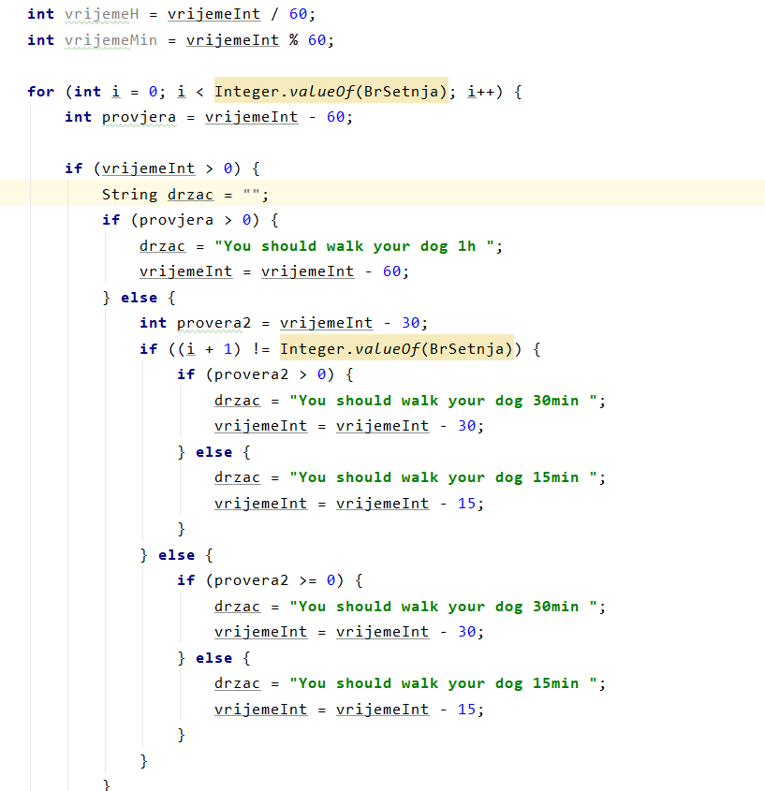
Fig. 1. A program that divides the total time into intervals
As with most projects associated with application development, the java language, and also the Android Studio development environment was used for implementation. An SQLite database was used to store the analyzed data. Why exactly was it used? SQLite is one in every of the foremost commonly used databases, thanks to its efficiency and ease. This database comes built into most of the computers and mobile applications we use. When creating applications, SQLite was often used because of its very simple implementation in Android Studio, which means it is not required any administrative support for setting up the database. Because of its stand-alone architecture (which means it is requiring minimal support from the OS and external libraries), SQLite does not require a server, but data is written and read directly from files on disk [6].
The data, which was collected during the research process, is stored in a special (external) SQLite file containing the table. An existing (pre-populated with data) SQLite database is attached using the SQLiteAssetHelper library. The table contains the following information: breed name, how many minutes, and how many times the dog should walk per day. Data on the time and amount of daily walks were of the integer type, so that the search in the database would be faster and so that the application would work more effectively. Using primary keys, each line has a unique ID which makes it quicker and easier to search.
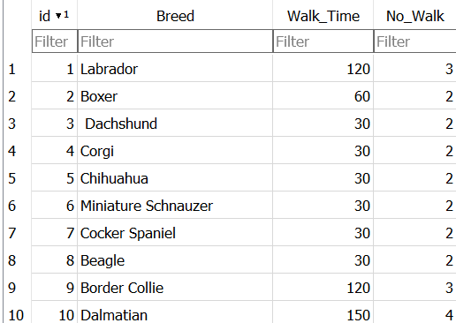

Fig. 2. Example table where they are: a unique ID, breed name, and numbers that indicate the time and amount of daily walks for the dog.
When it is necessary to access a database, within our application, we must provide access to read this database. Access is provided through a Cursor interface, which allows data to be read as a result of a query. The essential purpose of a cursor is to point to a single row of the result fetched by the query. We load the line indicated by the cursor object. By using a cursor plenty of memory will be saved.
For querying the data (database), it was used “rawQuery()” method, which is not used for modifying the database, only for reading the data. As an input, it is used SQLite select statement. The search result is performed by first determining, with the help of the "from" command, the table where the data is stored. Then, with the help of the "where" command, the exact condition is determined under which the "select" command will return the contents of the column as a result. The “where” command can be viewed as a filter, which determines the search result. If the object of the where command (dog breed) matches the user's entry, the search result will be the contents of the columns indicated by the "select" command, which are the time and amount of the walk. Finally, the “rawQuery” method returns a cursor object that points to a specific line [7]. The part of the code that explains this procedure is below.

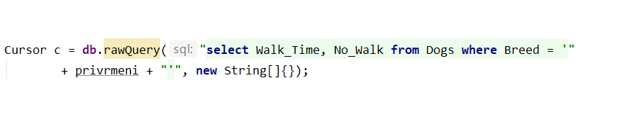 Fig. 3. The line indicated by the cursor is loaded

III. Results
On the home screen of the application, there is a calendar, and in the lower right corner, there is an icon in the shape of the letter "i" (information). When this icon is clicked, a small text box appears to ask us to enter the breed of our dog. User input is not case sensitive, so even if the user inadvertently enters uppercase or lowercase letters, the program will easily recognize the entry and find the breed in the database.
.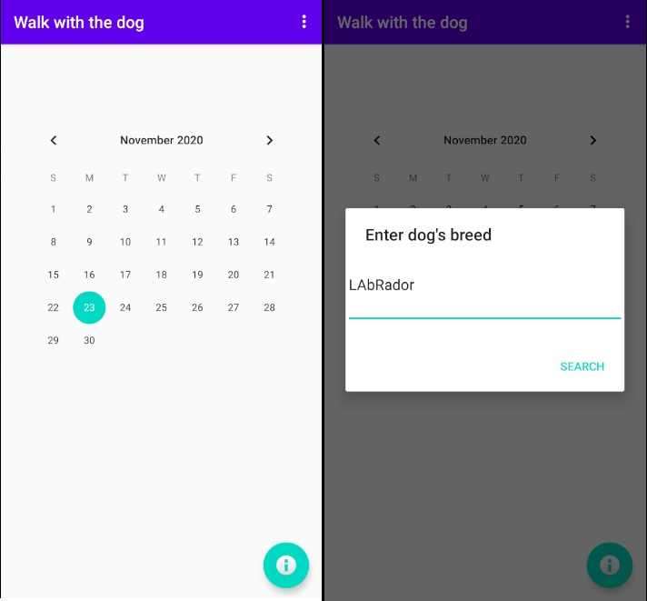
Fig. 4. Calendar and user input
After the user enters the breed of his dog (in our case Labrador), within the same text box, the recommended metrics for the given breed appear: how many dogs should walk per day and how many times. After that, the user clicks the "put data into calendar" button and thus passes the information to the program that the data with that breed should be processed. This means that when the user clicks on a specific date, walk information appears at the bottom of the screen. If the user has not entered the time for one of the walks, on the right, next to the information about the length of the walk, there will be “xx:xx”, which means that the user has not yet entered the time for the given walk. You can see an example of this below.
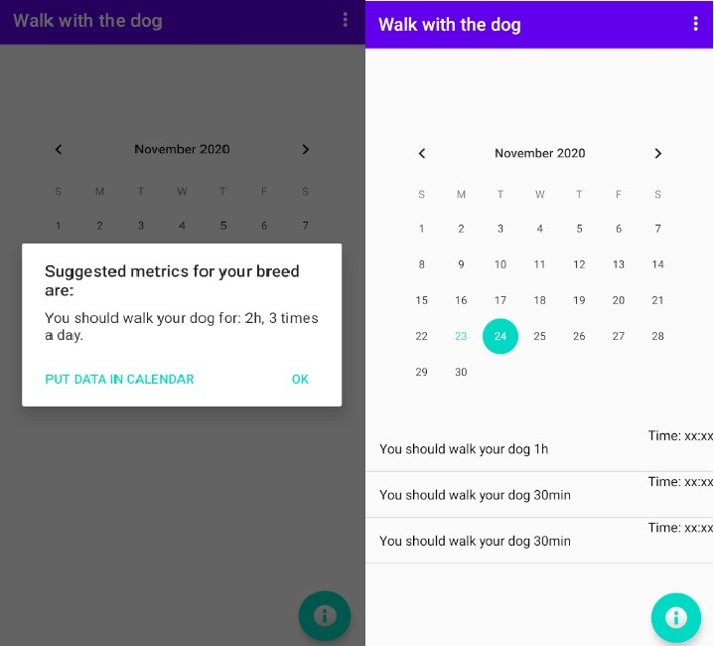
Fig. 5. Suggested metrics and information about walks
The user enters a specific time for each of the walks and this time will be repeated for as many days as the user selects in the settings. The settings are located in the upper right corner. Here the user determines for how many next days he wants to receive notifications for walks. This means that if the user sets the number of days to six (e.g.) in the settings, he will receive information (notification) about the walk for the next six days. This number can be changed at any time. After setting the number of days for which to receive walking information, the user enters the time by simply clicking on the part of the screen where the walking information is located. A new interface appears in front of the user. After inserting and clicking on the "save" button, the time is successfully added and it can be seen by returning to the previous interface. Where xx: xx was, the time entered will now be. If (as in our Labrador example) there are 3 walks, the user can enter the time for each of them according to the same principle.
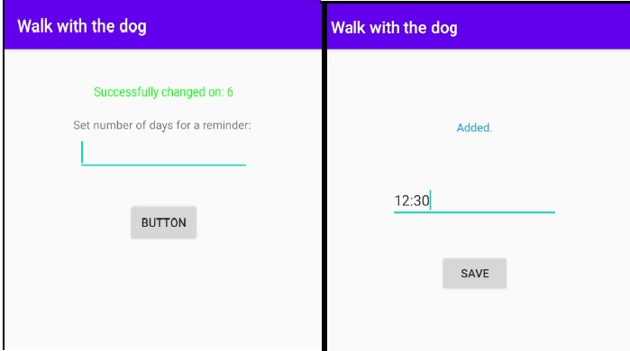
Fig. 6. Settings and time input
After the user has entered the walking time, the rest of the work is completed by the application. In order for the owner not to forget about walking his dog, which is incredibly important for the dog's health, the application sends a notification so that it does not happen. The user receives notifications about each walk. The notification appears fifteen minutes before the walk. In this way, the application warns the user about the onset of the walk and prevents him from forgetting about his pet's physical activity. After that, the user is left to walk and have fun with his pet, thus providing him with the physical activity he needs. If the user forgets about the time of the walk, the application is there to note it. Ten minutes before the end of the walk, a notification appears on the phone notifying the user that the walk is over in ten minutes. Thanks to the notifications, the user does not have to worry about when it is time to walk the dog and how long it lasts. That job is done for him by the application.
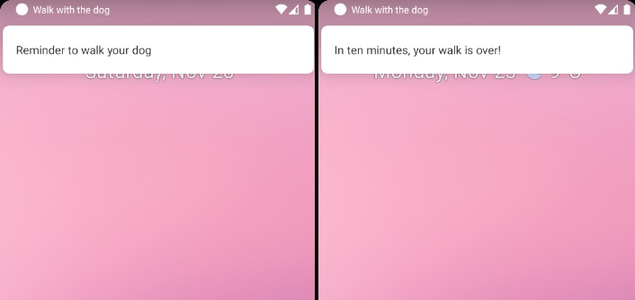
Fig. 7. Notification for the beginning and end of the walk

IV. Discussion and Conclusions
As a result of working on the project, it is an application that, based on research work and simplicity, allows the user to quickly and efficiently, with minimal time, take care of the physical activity of his dog. Application “Walk with the dog” allows the owner to spend as little time as possible thinking about walking his dog, allowing him to choose a comfortable time and the number of days for which he wants to receive notifications. In order for the owner not to get into a situation where, due to obligations and lack of time, he forgets to walk his dog, notifications are there to remind the user about the beginning and end of the walk. With just a few steps, the owner can plan his dog's walks in a few days and thus save a lot of time!
“The love of a dog is a pure thing. He gives you a trust which is total. You must not betray it."( Michel Houellebecq)

References

[1] D. Pop, A. Rusu, V. Pop-Vancia, I. Papuc, R. Constantinescu, and M. Vioara, “Physiological Effects of Human-Animal Positive Interaction in Dogs -Review of the Literature,” Bull. Univ. Agric. Sci. Vet. Med. CLUJ-NAPOCA. Anim. Sci. Biotechnol., vol. 71, p. 102, Nov. 2014, doi: 10.15835/buasvmcn-asb:10398.
[2] “Understanding Dog Owners’ Increased Levels of Physical Activity: Results From RESIDE | AJPH | Vol. 98 Issue 1.” https://ajph.aphapublications.org/doi/full/10.2105/AJPH.2006.103499 (accessed Oct. 30, 2020).
[3] C. Westgarth, R. M. Christley, C. Jewell, A. J. German, L. M. Boddy, and H. E. Christian, “Dog owners are more likely to meet physical activity guidelines than people without a dog: An investigation of the association between dog ownership and physical activity levels in a UK community,” Sci. Rep., vol. 9, no. 1, pp. 1–10, Dec. 2019, doi: 10.1038/s41598-019-41254-6.
[4] “The Complete Dog Breed Book | DK US.” https://www.dk.com/us/book/9781465429766-the-complete-dog-breed-book/ (accessed Nov. 02, 2020).
[5] “How often should you walk your dog? The answer! | Tractive.” https://tractive.com/blog/en/health/how-often-should-you-walk-your-dog (accessed Oct. 07, 2020).
[6] “About SQLite.” https://www.sqlite.org/about.html (accessed Nov. 17, 2020).
[7] “SQLite SELECT - Querying Data From a Single Table.” https://www.sqlitetutorial.net/sqlite-select/ (accessed Nov. 18, 2020).

